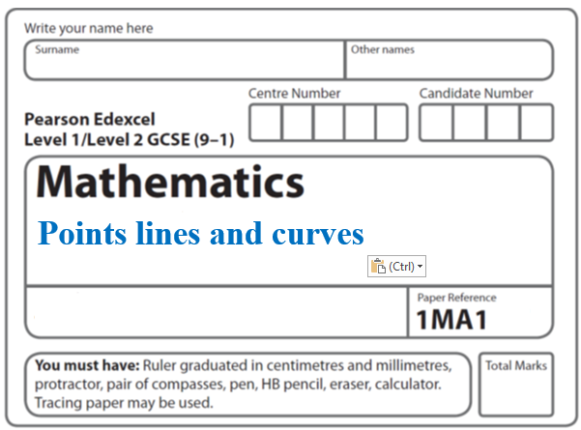**Instructions**

**Match the graph to equation**

* Use **black** ink or ball-point pen.
  + **Fill in the boxes** at the top of this page with your name,  
    centre number and candidate number.
* Answer **all** questions.
* Answer the questions in the spaces provided  
  *– there may be more space than you need.*
* You must **show all your working.**
* Diagrams are **NOT** accurately drawn, unless otherwise indicated.
* If your calculator does not have a *π* button, take the value of *π* to be3.142

unless the question instructs otherwise.

**Information**

* The total mark for this paper is **21**. There are **8** questions.
* Questions have been arranged in an ascending order of mean difficulty, as found by all students in the June 2017–November 2019 examinations.
* The marks for **each** question are shown in brackets  
  *– use this as a guide as to how much time to spend on each question.*

**Advice**

* Read each question carefully before you start to answer it.
* Keep an eye on the time.
* Try to answer every question.
* Check your answers if you have time at the end.

**1**

**

The graphs of *y* against *x* represent four different types of proportionality.

Match each type of proportionality in the table to the correct graph.

|  |  |
| --- | --- |
| **Type of proportionality** | **Graph letter** |
| *y*  *x* |  |
| *y*  *x*2 |  |
| *y* |  |
| *y* |  |

(**Total for Question 1 is 2 marks)**

**___________________________________________________________________________**

**2** Here are some graphs.



In the table below, match each equation with the letter of its graph.

|  |  |
| --- | --- |
| **Equation** | **Graph** |
| *y =* sin *x* |  |
| *y* = *x*3 + 4*x* |  |
| *y* = 2*x* |  |
| *y* = |  |

**(Total for Question 2 is 3 marks)**

**___________________________________________________________________________**

**3** Here are four graphs.

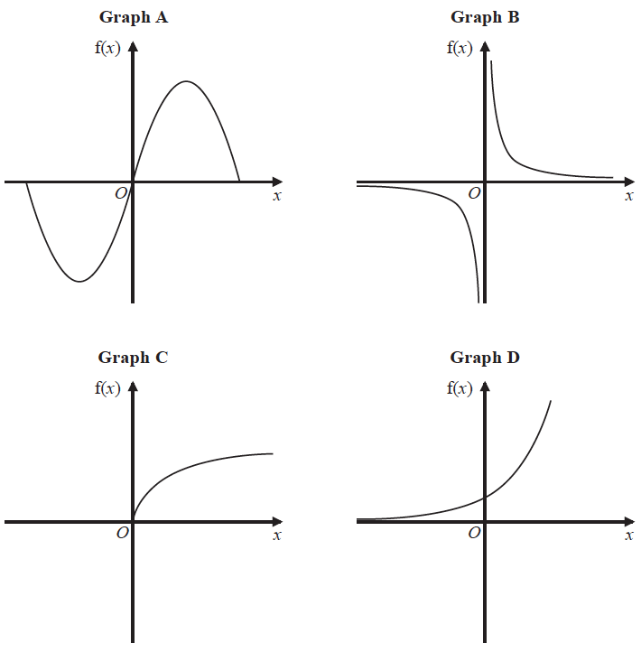

The graphs represent four different types of function f.

Match each description of the function in the table to the letter of its graph.

|  |  |
| --- | --- |
| **Description of function** | **Graph** |
| f(*x*) is inversely proportional to *x* |  |
| f(*x*) is a trigonometrical function |  |
| f(*x*) is an exponential function |  |
| f(*x*) is directly proportional to |  |

**(Total for Question 3 is 2 marks)**

**___________________________________________________________________________**

**4** Here are six graphs.

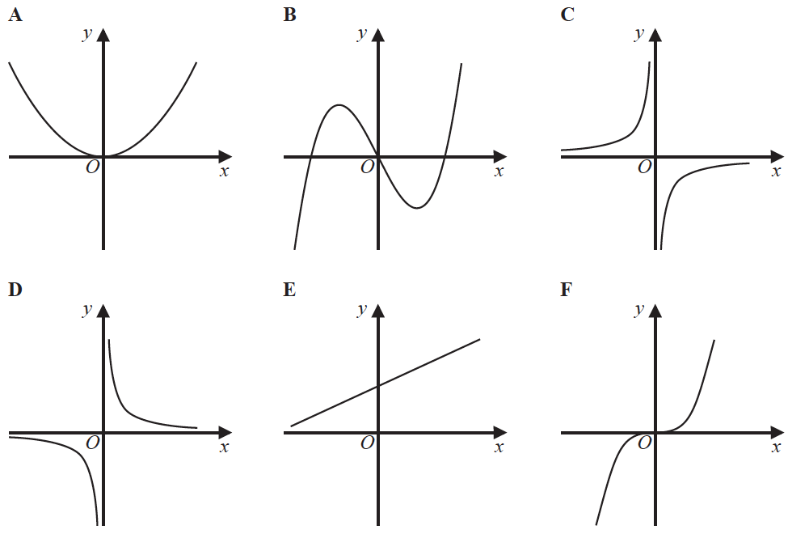

Write down the letter of the graph that could have the equation

(*a*) *y* = *x*3

.......................................................

**(1)**

(*b*) *y* = 

.......................................................

**(1)**

**(Total for Question 4 is 2 marks)**

**___________________________________________________________________________**

**5** Here are six graphs.

**

Write down the letter of the graph that could have the equation

(i) *y* = 2*x*

.......................................................

(ii) *y* = *x*3 − 3*x*

.......................................................

**(Total for Question 5 is 2 marks)**

**___________________________________________________________________________**

**6** Here are five graphs.

Each graph shows either direct proportion or inverse proportion.



The table shows five equations.

|  |  |
| --- | --- |
| **Equation** | **Graph** |
| *y* = *kx*3 | ................................... |
| *y* = *k* | ................................... |
| *y* = *kx*2 | ................................... |
| *y* = | ................................... |
| *y* = *kx* | ................................... |

Match the letter of each graph to its equation.

**(Total for Question 6 is 3 marks)**

**___________________________________________________________________________**

**7** Here are seven graphs.

**

Complete the table below with the letter of the graph that could represent each given equation.

|  |  |
| --- | --- |
| **Equation** | **Graph** |
| *y* = 3*x* |  |
| *y* = tan *x*° |  |
| *y* = *x*3 + *x*2 + 2 |  |
| **y =** |  |

**(3)**

**(Total for Question 7 is 6 marks)**

**___________________________________________________________________________**

**8** At a depth of *x* metres, the temperature of the water in an ocean is *T* °C.

At depths below 900 metres, *T* is inversely proportional to *x*.

*T* is given by



(*a*)Work out the difference in the temperature of the water at a depth of 1200 metres and

the temperature of the water at a depth of 2500 metres.

.......................................................°C

**(3)**

Here are four graphs.



One of the graphs could show that *T* is inversely proportional to *x*.

(*b*)Write down the letter of this graph.

.......................................................

**(1)**

**(Total for Question 8 is 4 marks)**

**___________________________________________________________________________**

**TOTAL MARKS FOR PAPER: 21**