**GCSE Mathematics**

**Practice Tests: Set 7**

**Paper 2H (Calculator)**

**Time: 1 hour 30 minutes**

You should have: Ruler graduated in centimetres and millimetres, protractor, pair of compasses, pen, HB pencil, eraser, calculator. Tracing paper may be used.

**Instructions**

* Use **black** ink or ball-point pen.
* **Fill in the boxes** at the top of this page with your name,  
  centre number and candidate number.
* Answer **all** questions.
* Answer the questions in the spaces provided

– *there may be more space than you need*.

* **Calculators may be used.**
* Diagrams are NOT accurately drawn, unless otherwise indicated.
* You must **show all your working out.**

**Information**

* The total mark for this paper is 80
* The marks for **each** question are shown in brackets  
  – *use this as a guide as to how much time to spend on each question*.

**Advice**

* Read each question carefully before you start to answer it.
* Keep an eye on the time.
* Try to answer every question.
* Check your answers if you have time at the end.

**Answer ALL questions.**

**Write your answers in the spaces provided.**

**You must write down all the stages in your working.**

**1.** *M* = 3*x*2 – *nx*

Work out the value of *M* when *x* = –2 and *n* = 5

*M* = ................................

**(Total for Question 1 is 2 marks)**

**___________________________________________________________________________**

**2.** Mortar mix is made by mixing cement, sand and quicklime in the ratio 1 : 2 : 3

(a) Work out the volume of sand needed to make 2.1 m3 of mortar mix.

............................ m3

**(2)**

Julie has 0.75 m3 of quicklime.

She has plenty of sand and cement.

(b) Work out the greatest volume of mortar mix she could make.

............................ m3

**(2)**

**(Total for Question 2 is 4 marks)**

**___________________________________________________________________________**

**3.**



In the isosceles triangle *ABC*,

*AB* = *AC*

angle *B* = (3*x* + 32)°

angle *C* = (87 – 2*x*)°

Work out the value of *x*.

You must show your working.

*x* = ................................

**(Total for Question 3 is 4 marks)**

**___________________________________________________________________________**

**4.** (a) Calculate the exact value of 

……………………..

**(1)**

(b) Write your answer to part (a) in standard form.

……………………..

**(1)**

(c) Write your answer to part (a) to 2 significant figures.

……………………..

**(1)**

**(Total for Question 4 is 3 marks)**

**___________________________________________________________________________**

**5.**

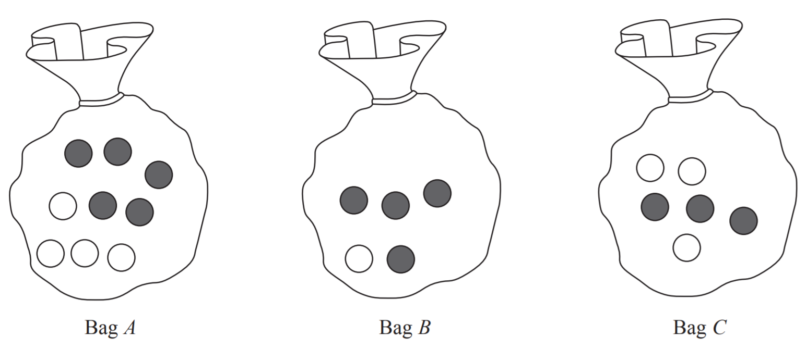

Three bags of counters are used in a game.

At the start of the game Bag A contains 5 red counters and 4 white counters.

Bag B contains 4 red counters and 1 white counter.

Bag C contains 3 red counters and 3 white counters.

The game begins by taking at random a counter from Bag A.

If the counter is red, a counter is then taken at random from Bag B.

If the counter taken from Bag A is white, a counter is taken at random from Bag C.

(a) Complete the probability tree diagram.

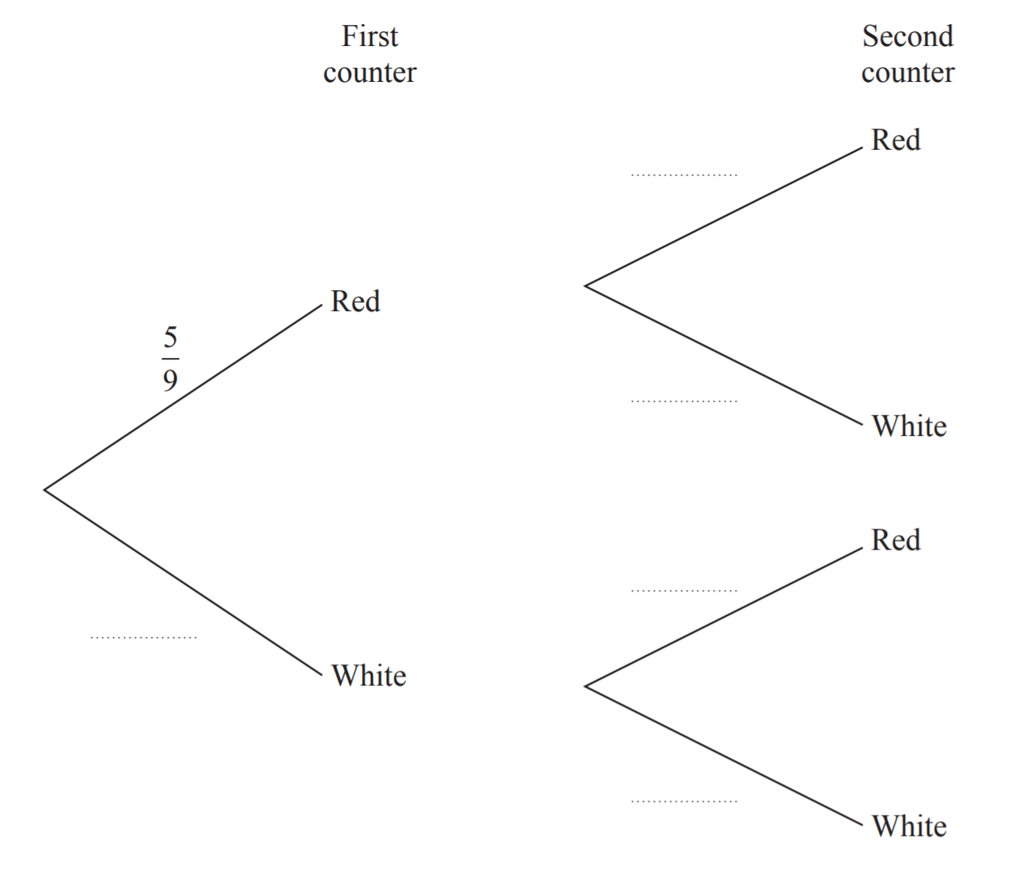

**(3)**

(b) Show that the probability that the second counter taken is red is twice the probability that the second counter taken is white.

**(5)**

**(Total for Question 5 is 8 marks)**

**___________________________________________________________________________**

**6.** (a) Factorise *x*2 – 16

……………………………

**(1)**

(b) Factorise 9*x*2 – 6*x* + 1

……………………………

**(2)**

(c) Simplify 

……………………………

**(3)**

**(Total for Question 6 is 6 marks)**

**___________________________________________________________________________**

**7.** The diagram shows a sector of a circle of radius 7 cm.

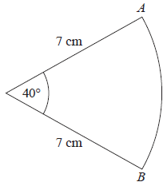

Work out the length of arc *AB*.

Give your answer correct to 3 significant figures.

……………….…….. cm

**(Total for Question 7 is 2 marks)**

**___________________________________________________________________________**

**8.** The fraction, *p*, of an adult’s dose of medicine which should be given to a child who weighs *w*kg is given by the formula



Use the formula  to find the weight of a child whose dose is the same as an adult’s dose.

……………………… kg

**(Total for Question 8 is 3 marks)**

**___________________________________________________________________________**

**9.** The graph of *y* = f(*x*) is drawn on the grid.

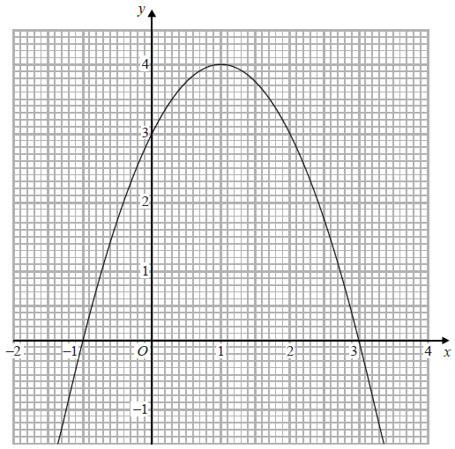

1. Write down the coordinates of the turning point of the graph.

(………. , ………..)

**(1)**

1. Write down the roots of f(*x*) = 0

…………………………………….

**(1)**

1. Write down the value of f(0.5)

…………………….

**(1)**

**(Total for Question 9 is 3 marks)**

**___________________________________________________________________________**

**10.** (a)  of the members of a tennis club are men.

 of these men are right-handed.

Work out the fraction of the members of the tennis club who are right-handed men.

......................................

**(2)**

(b)  of the members of a badminton club are women.

 of the members of the badminton club wear glasses.

Work out the smallest possible number of members of the badminton club.

......................................

**(2)**

**(Total for Question 10 is 4 marks)**

**___________________________________________________________________________**

**11.** Solve  = 

You must show your working.

*y* = ..............................................................

**(Total for Question 11 is 4 marks)**

**___________________________________________________________________________**

**12.** The line with equation *y* = 2*x* is drawn on the grid.

(*a*)On the same grid, draw the line with equation 4*x* + 3*y* = 12

**(2)**



(*b*)Show, by shading on the grid, the region defined by all four inequalities

*y*  ≤ 2*x*

4*x* + 3*y* ≤ 12

*y* ≥ −3

*x*  ≤ 4

**(3)**

**(Total for Question 12 is 5 marks)**

**___________________________________________________________________________**

**13.** Given that *c* is positive, make *c* the subject of *a* = .

*c* = .............................................................

**(Total for Question 13 is 4 marks)**

**___________________________________________________________________________**

**14.** Alison is using the quadratic formula to solve a quadratic equation.   
She substitutes values into the formula and correctly gets

*x* = 

Work out the quadratic equation that Alison is solving. 

Give your answer in the form *ax*2 + *bx* + *c* = 0, where *a*, *b* and *c* are integers.

………………………………..

**(Total for Question 14 is 3 marks)**

**___________________________________________________________________________**

**15.** Here is a speed-time graph for a car.

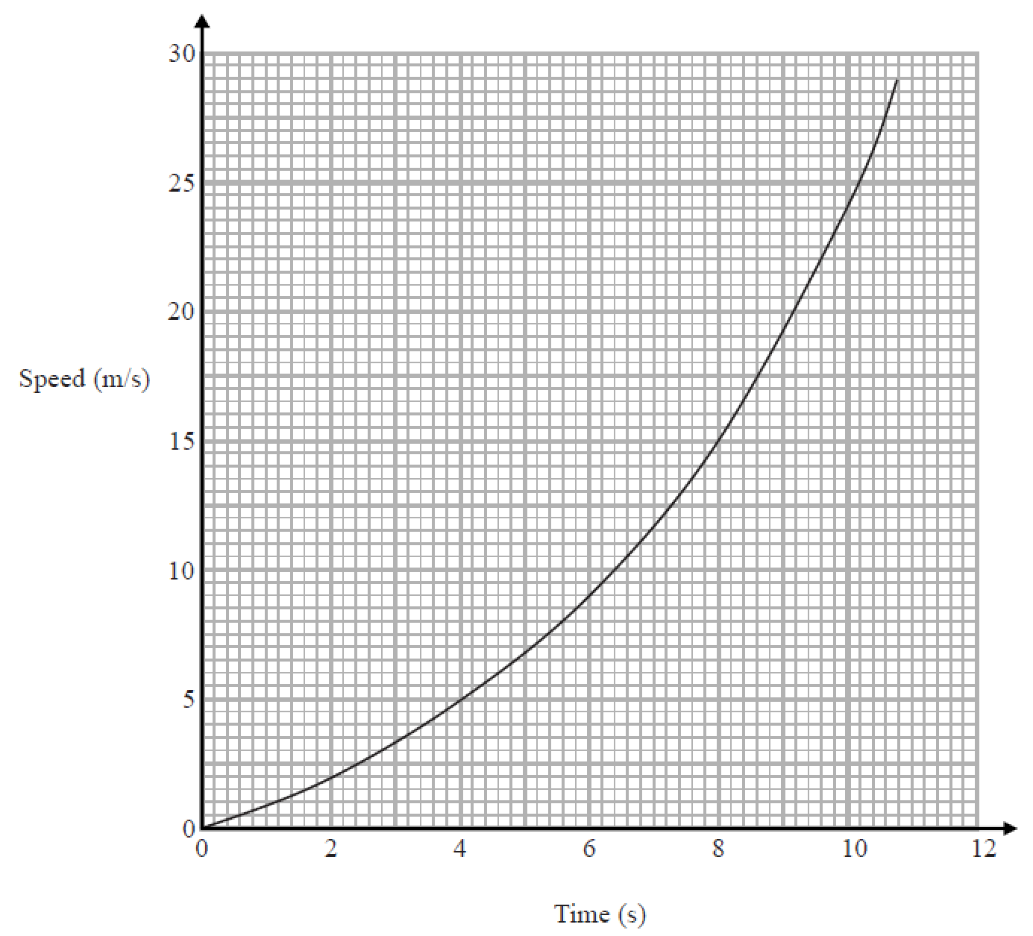

(a) Work out an estimate for the distance the car travelled in the first 6 seconds.

…....................................................m

**(3)**

(b) Is your answer to (a) an underestimate or an overestimate of the actual distance?

Give a reason for your answer.

………………………………………………………………….…………………………..

………………………………………………………………….…………………………..

**(1)**

(c) Calculate an estimate for the gradient of the graph when *t* = 8 seconds.

You must show how you get your answer.

.......................................................

**(2)**

(d) Describe fully what your answer to part (c) represents.

………………………………………………………………….…………………………..

………………………………………………………………….…………………………..

**(1)**

**(Total for Question 15 is 7 marks)**

**___________________________________________________________________________**

**16.** There are 15 boys and 9 girls in a mixed hockey team.

One of the boys and one of the girls are going to be chosen to collect the cup.

(a) Work out the number of different pairs that can be chosen.

.................................

**(2)**

Two of the boys are going to be chosen to play in an all boys team.

Sam thinks the number of different pairs that can be chosen is 210  
Tom thinks the number of different pairs that can be chosen is 105

(b) Who is correct, Sam or Tom?  
 Give a reason for your answer.

…...........................................................................................................................................

…...........................................................................................................................................

**(1)**

**(Total for Question 16 is 3 marks)**

**___________________________________________________________________________**

**17.** *a* : *b* = 5 : 8 and *b* : *c* = 6 : 25

Find, in its simplest form, *a* : *b* : *c*

*a* : *b* : *c* = ………………………………

**(Total for Question 17 is 3 marks)**

**___________________________________________________________________________**

**18.** Rana wants to estimate the number of balls in a bag.

On Monday Rana removes 120 balls from the bag.   
She puts a mark on each ball.

She then puts all 120 balls back in the bag.

On Tuesday Rana removes 20 balls from the bag.   
8 of these balls have a mark on them.

Work out an estimate for the total number of balls in the bag.   
You must write down any assumptions you have made.

...........................................................

**(Total for question 18 is 4 marks)**

**___________________________________________________________________________**

**19.** *m* = 8 × 109*n*,where *n* is an integer.

Express  in standard form.

Give your answer, in terms of *n*, as simply as possible.

.......................................................

**(Total for Question 19 is 3 marks)**

**___________________________________________________________________________**

**20.**



Ashok has six coins in his pocket.

He has one 5 cent coin, two 10 cent coins and three 20 cent coins.

He takes at random a coin from his pocket.

He records its value and puts the coin back into his pocket.

He then takes at random a second coin from his pocket and records its value.

(a) Calculate the probability that he takes two 20 cent coins.

…………....................

**(2)**

(b) Calculate the probability that the second coin he takes has a higher value than the first coin he takes.

.........................................

**(3)**

**(Total for Question 20 is 5 marks)**

**___________________________________________________________________________**

**TOTAL FOR PAPER IS 80 MARKS**

**BLANK PAGE**