**Points, Lines and Curves**

**Instructions**

* Use **black** ink or ball-point pen.
  + **Fill in the boxes** at the top of this page with your name,  
    centre number and candidate number.
* Answer **all** questions.
* Answer the questions in the spaces provided  
  *– there may be more space than you need.*
* You must **show all your working.**
* Diagrams are **NOT** accurately drawn, unless otherwise indicated.
* If your calculator does not have a *π* button, take the value of *π* to be3.142

unless the question instructs otherwise.

**Information**

* The total mark for this paper is **58**. There are **17** questions.
* Questions have been arranged in an ascending order of mean difficulty, as found by all students in the June 2017–November 2019 examinations.
* The marks for **each** question are shown in brackets  
  *– use this as a guide as to how much time to spend on each question.*

**Advice**

1. Read each question carefully before you start to answer it.
2. Keep an eye on the time.
3. Try to answer every question.
4. Check your answers if you have time at the end.

**1** (*a*)Complete the table of values for *y* = 4*x* – 6

|  |  |  |  |  |  |  |
| --- | --- | --- | --- | --- | --- | --- |
| *x* | −1 | 0 | 1 | 2 | 3 | 4 |
| *y* |  |  | −2 |  |  | 10 |

**(2)**

(*b*)On the grid, draw the graph of *y* = 4*x* – 6 for values of *x* from −1 to 4

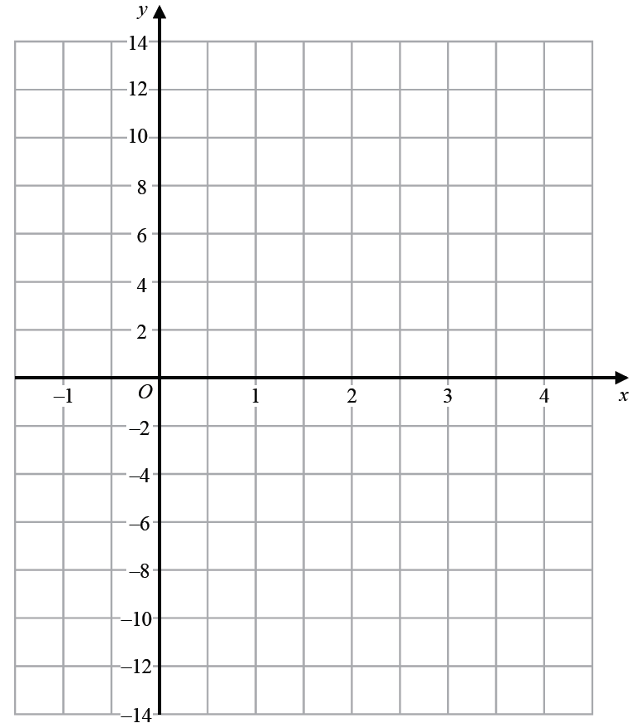

**(2)**

**(Total for Question 1 is 4 marks)**

**___________________________________________________________________________**

**2**

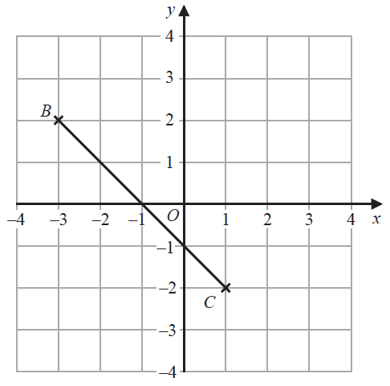

(*a*)Plot the point with coordinates (3, 2)

Label this point *A*.

**(1)**

(*b*)Write down the coordinates of the midpoint of *BC*.

(............................ , ............................)

**(1)**

**(Total for Question 2 is 2 marks)**

**___________________________________________________________________________**

**3** On the grid below, draw the graph of *y* = 2*x* – 3 for values of *x* from –2 to 4

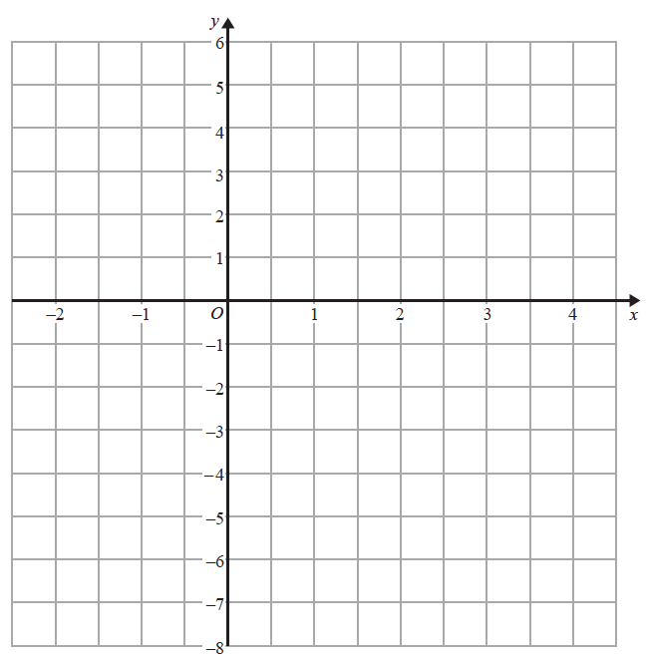

**(Total for Question 3 is 3 marks)**

**___________________________________________________________________________**

**4** Here are six straight line graphs.



Match each equation in the table to the correct graph.

Write the letter of the graph in the table.

|  |  |
| --- | --- |
| **Equation** | **Graph** |
| *y* = 2 |  |
| *y* = *x* |  |
| *x* + *y* = 2 |  |

(**Total for Question 4 is 2 marks**)

**___________________________________________________________________________**

**5** (*a*)Complete the table of values for  **

|  |  |  |  |  |  |  |  |  |
| --- | --- | --- | --- | --- | --- | --- | --- | --- |
| *x* | 0.5 | 1 | 1.5 | 2 | 3 | 4 | 5 | 6 |
| *y* |  | 6 |  | 3 |  | 1.5 |  |  |

**(2)**

(*b*)On the grid below, draw the graph of **  for values of *x* from 0.5 to 6.



**(2)**

**(Total for Question 5 is 4 marks)**

**___________________________________________________________________________**

**6**



(*a*)Write down the coordinates of point *A*.

( .......................... , ..........................)

**(1)**

(*b*)On the grid, mark with a cross (**×**) the point (2, 3)

Label this point *B*.

**(1)**

(*c*)On the grid, draw the line with equation *x* = −4

**(1)**

**(Total for Question 6 is 3 marks)**

**___________________________________________________________________________**

**7** (*a*)Complete the table of values for *y* =  *x* − 1

|  |  |  |  |  |  |  |
| --- | --- | --- | --- | --- | --- | --- |
| *x* | −2 | −1 | 0 | 1 | 2 | 3 |
| *y* | −2 |  |  |  | 0 |  |

**(2)**

(*b*)On the grid, draw the graph of *y* =  *x* – 1 for the values of *x* from −2 to 3



**(2)**

(*c*)Use your graph to find the value of *x* when *y* = 0.3

*x* = .......................................................

**(1)**

**(Total for Question 7 is 5 marks)**

**___________________________________________________________________________**

**8**



(*a*)Write down the coordinates of the point *A*.

( .......................... , ..........................)

**(1)**

(*b*)(i) Plot the point with coordinates (2, 9).

Label this point *B*.

**(1)**

(ii) Does point *B* lie on the straight line with equation *y* = 4*x* + 1?

You must show how you get your answer.

......................................................................................................................................................

......................................................................................................................................................

**(1)**

(*c*)On the grid, draw the line with equation *x* = –2

**(1)**

**(Total for Question 8 is 4 marks)**

**___________________________________________________________________________**

**9** Here are the equations of four straight lines.

Line A *y* = 2*x* + 4

Line B 2*y* = *x* + 4

Line C 2*x* + 2*y* = 4

Line D 2*x* – *y* = 4

Two of these lines are parallel.

Write down the two parallel lines.

Line ............................ and line............................

**(Total for Question 9 is 1 mark)**

**10** A pattern is made from four identical squares.

The sides of the squares are parallel to the axes.

**

Point *A* has coordinates (6, 7)

Point *B* has coordinates (38, 36)

Point *C* is marked on the diagram.

Work out the coordinates of *C*.

(................................ , ................................)

(**Total for Question 10 is 5 marks**)

**___________________________________________________________________________**

**11** On the grid below, draw the graph of *y* = 1 − 4*x* for values of *x* from −3 to 3.



(**Total for Question 11 is 3 marks**)

**12** Here is the graph of *y* = *x*2 – 2*x* – 3

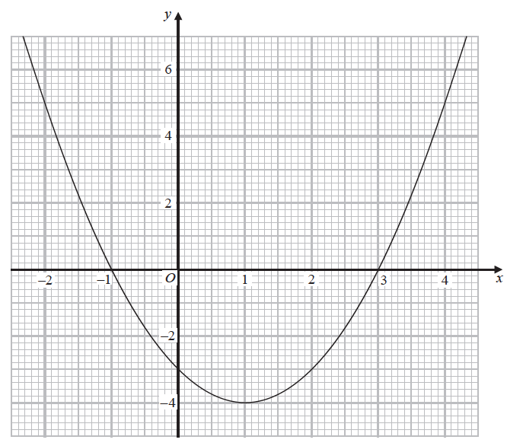

(*a*)Write down the coordinates of the turning point on the graph of *y* = *x*2 – 2*x* – 3

(....................... , .......................)

**(1)**

(*b*)Use the graph to find the roots of the equation *x*2 – 2*x* – 3 = 0

..........................................................................................

**(2)**

**(Total for Question 12 is 3 marks)**

**___________________________________________________________________________**

**13** The line **L** is shown on the grid.



Find an equation for **L**.

......................................................

(**Total for Question 13 is 3 marks**)

**14** The equation of the line L1 is *y* = 3*x* – 2

The equation of the line L2 is 3*y* – 9*x* + 5 = 0

Show that these two lines are parallel.

**(Total for Question 14 is 2 marks)**

**___________________________________________________________________________**

**15** (*a*)Complete the table of values for *y* = *x*2 – *x* – 6

|  |  |  |  |  |  |  |  |
| --- | --- | --- | --- | --- | --- | --- | --- |
| *x* | –3 | –2 | –1 | 0 | 1 | 2 | 3 |
| *y* | 6 |  |  | – 6 |  |  |  |

(**2**)

(*b*)On the grid, draw the graph of *y* = *x*2 – *x* – 6 for values of *x* from –3 to 3.

(**2**)



(*c*)Use your graph to find estimates of the solutions to the equation *x*2 – *x* – 6 = –2

.................................................................................

(**2**)

(**Total for Question 15 is 6 marks**)

**___________________________________________________________________________**

**16** *A* is the point with coordinates (5, 9)

*B* is the point with coordinates (*d*, 15)

The gradient of the line *AB* is 3

Work out the value of *d*.

.......................................................

**(Total for Question 16 is 3 marks)**

**___________________________________________________________________________**

**17** (*a*)Complete this table of values for *y* = *x*2 + *x* – 4

|  |  |  |  |  |  |  |  |
| --- | --- | --- | --- | --- | --- | --- | --- |
| *x* | –3 | –2 | –1 | 0 | 1 | 2 | 3 |
| *y* |  | –2 | –4 |  | –2 |  |  |

**(2)**

(*b*)On the grid, draw the graph of *y* = *x*2 + *x* – 4 for values of *x* from –3 to 3



**(2)**

(*c*)Use the graph to estimate a solution to *x*2 + *x* – 4 = 0

.......................................................

**(1)**

**(Total for Question 17 is 5 marks)**

**TOTAL MARKS FOR PAPER: 58**