**GCSE Mathematics**

**Practice Tests: Set 7**

**Paper 3F (Calculator)**

**Time: 1 hour 30 minutes**

You should have: Ruler graduated in centimetres and millimetres, protractor, pair of compasses, pen, HB pencil, eraser, calculator. Tracing paper may be used.

**Instructions**

* Use **black** ink or ball-point pen.
* **Fill in the boxes** at the top of this page with your name,  
  centre number and candidate number.
* Answer **all** questions.
* Answer the questions in the spaces provided

– *there may be more space than you need*.

* **Calculators may be used.**
* Diagrams are NOT accurately drawn, unless otherwise indicated.
* You must **show all your working out.**

**Information**

* The total mark for this paper is 80
* The marks for **each** question are shown in brackets  
  – *use this as a guide as to how much time to spend on each question*.

**Advice**

* Read each question carefully before you start to answer it.
* Keep an eye on the time.
* Try to answer every question.
* Check your answers if you have time at the end.

**Answer ALL questions.**

**Write your answers in the spaces provided.**

**You must write down all the stages in your working.**

**1.** 35% of the students at a school walk to school.

Work out the percentage of the students who do **not** walk to school.

.......................................................%

**(Total for Question 1 is 1 mark)**

**___________________________________________________________________________**

**2.** Here is a list of numbers.

|  |  |  |  |  |
| --- | --- | --- | --- | --- |
| 10 | 21 | 28 | 36 | 43 |

Which of these is a square number?

.......................................................

**(Total for Question 2 is 1 mark)**

**___________________________________________________________________________**

**3.**

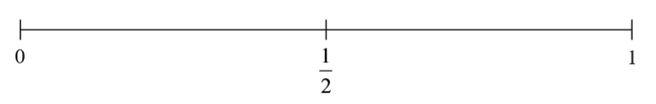

On the probability scale above, mark with a cross (x), the probability that a fair ordinary dice will land on a 6.

**(Total for Question 3 is 1 mark)**

**___________________________________________________________________________**

**4.** Write  as a decimal.

.......................................................

**(Total for Question 4 is 1 mark)**

**___________________________________________________________________________**

**5.** Here are some patterns made from sticks.

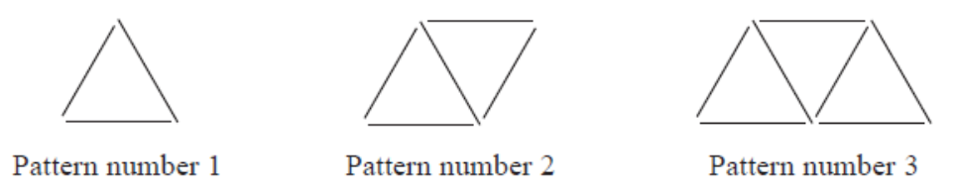

(a) Complete the table.

|  |  |  |  |  |  |
| --- | --- | --- | --- | --- | --- |
| **Pattern number** | 1 | 2 | 3 | 4 | 5 |
| **Number of sticks** | 3 | 5 | 7 |  |  |

**(2)**

(b) How many sticks make Pattern number 15?

...........................................................

**(1)**

Maria wants to work out how many sticks make Pattern number 50

(c) Write down a method she can use.

...............................................................................................................................................

**(1)**

Sam says that he will not be able to make a pattern with 80 sticks

(d) Is Sam correct?

You must give a reason for your answer.

...............................................................................................................................................

...............................................................................................................................................

...............................................................................................................................................

**(1)**

**(Total for Question 6 is 5 marks)**

**___________________________________________________________________________**

**6.** The dual bar chart shows information about the amount of time Sophie and Zach spent on the Internet on each of 6 days last week.

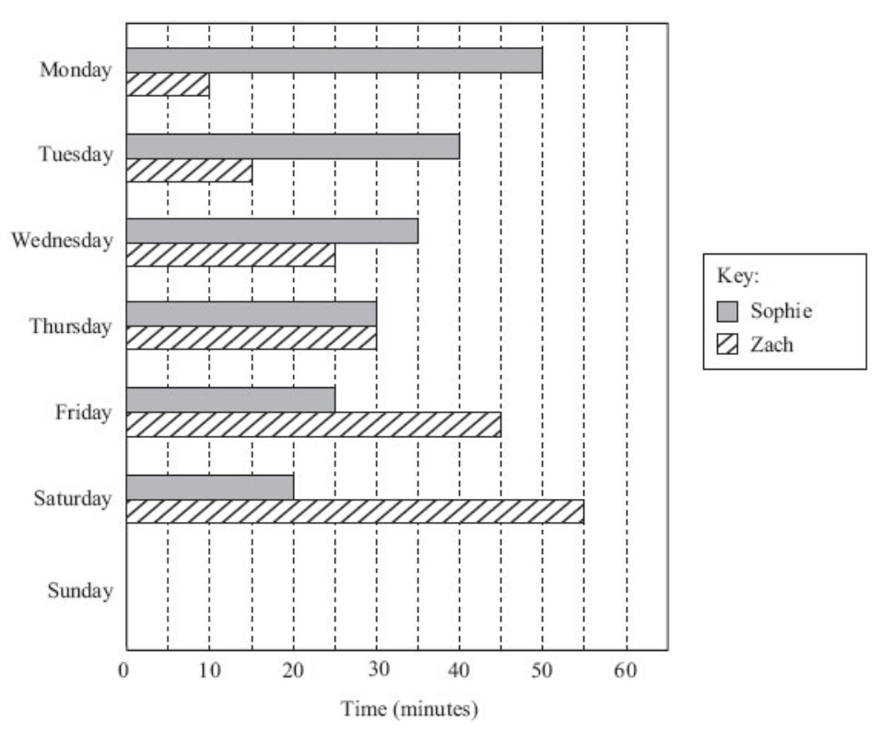

On one of these days, Sophie and Zach spent the same amount of time on the Internet.

(a) Which day?

……………………….. .

**(1)**

On Sunday, Sophie spent 15 minutes on the Internet and Zach spent 60 minutes on the Internet.

(b) Complete the dual bar chart.

**(2)**

**(Total for Question is 6 is 3 marks)**

**___________________________________________________________________________**

**7.** Here are the first four terms of a number sequence.

|  |  |  |  |
| --- | --- | --- | --- |
| 6 | 10 | 14 | 18 |

(a) The number 101 is **not**a term in this sequence.  
       Explain why.

………………………………………………………………………………………………

………………………………………………………………………………………………

**(1)**

(b) Write an expression, in terms of *n*, for the *n*th term of this sequence.

……………………….. .

**(2)**

**(Total for Question 7 is 3 marks)**

**___________________________________________________________________________**

**8.**

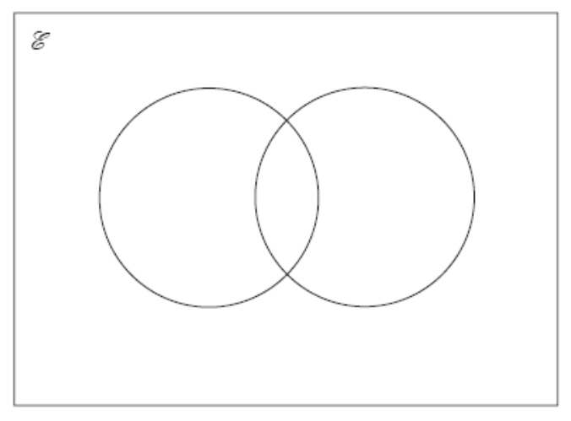

 = {even numbers less than 30}.  
*A* = {2, 4, 8, 10, 12}   
*B* = {2, 6, 8, 28}

(a)   Complete the Venn diagram to represent this information.

**(2)**

A number is chosen at random from the universal set.

(b)   What is the probability that the number is in the set *A* ∩ *B*?

...........................................................

**(2)**

**(Total for Question 8 is 4 marks)**

**___________________________________________________________________________**

**9.** (a) Simplify    3(4*x* + 2) – 2(3*x* + 1)

...........................................................

**(1)**

(b)  Simplify    (*a*4)5

...........................................................

**(1)**

**(Total for Question 9 is 2 marks)**

**___________________________________________________________________________**

**10.** *ABCD* is a rectangle.

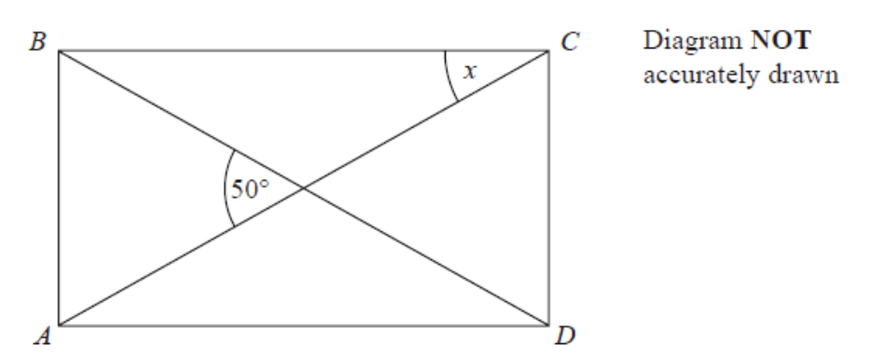

*AC* and *BD* are straight lines.   
The angle between *AC* and *BD* is 50°.

Work out the size of the angle marked *x*.

........................................................... °

**(Total for Question 10 is 3 marks)**

**___________________________________________________________________________**

**11.** (a)   Write      4.7 × 10−1      as an ordinary number.

...........................................................

**(1)**

(b)   Work out the value of     (2.4 × 103) × (9.5 × 105)

Give your answer in standard form.

...........................................................

**(2)**

**(Total for Question 11 is 3 marks)**

**___________________________________________________________________________**

**12.** The ratio of the number of boys to the number of girls in a school is 4:5

There are 60 girls in the school.

Work out the total number of students in the school.

......................................................

**(Total for Question 12 is 3 marks)**

**___________________________________________________________________________**

**13.** The ratio of Mark’s age to Reeta’s age is 3 : 5

Mark’s age is 24 years.

(a) Work out Reeta’s age.

........................... years

**(2)**

The ratio of John’s age to Zahra’s age is 1 : 4

The sum of their ages is 45 years.

(b) Work out Zahra’s age.

........................... years

**(2)**

**(Total for Question 13 is 4 marks)**

**___________________________________________________________________________**

**14.** On the grid, draw the graph of *y*= 2*x*+ 1 from *x*= –1 to *x*= 3

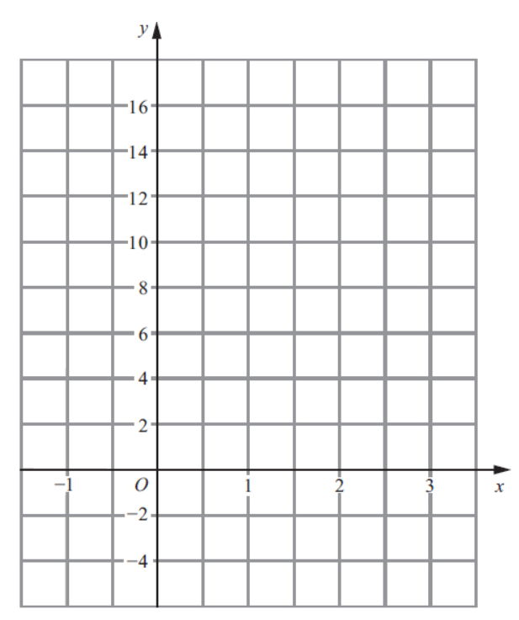

**(Total for Question 14 is 3 marks)**

**___________________________________________________________________________**

**15.** Jane says,

“If you add any two different prime numbers the answer will always be an even number.”

Jim is wrong.

Explain why.

......................................................................................................................................................

......................................................................................................................................................

**(Total for Question 15 is 2 marks)**

**___________________________________________________________________________**

**16.** Here is part of an advert for a driving school.

|  |
| --- |
| 8 out of 10 of the people we teach  pass the driving test first time |

Alison talked to 56 people who had been taught to drive by the driving school.

43 of these people passed the driving test first time.

Does this support what is said in the advert?

You must show how you get your answer.

**]**

**(Total for Question 16 is 3 marks)**

**___________________________________________________________________________**

**17.** The price of all rail tickets increased by 5 %.

The price of a rail ticket from London to Ipswich increased by £2.30

Work out the price of the ticket before the increase.

£ .......................................................

**(Total for Question 17 is 2 marks)**

**___________________________________________________________________________**

**18.** A garden is in the shape of a rectangle, *ABCD*, and a semicircle.

*AD* is the diameter of the semicircle.

**

Carol is going to cover the garden with fertiliser.

A box of fertiliser costs £4.99

Carol has been told that one box of fertiliser will cover 12 m2 of garden.

(a)Work out the cost of buying enough fertiliser to cover the garden completely.

£ .......................................................

**(5)**

Carol finds out that one box of fertiliser will cover more than 12 m2 of garden.

(b)Explain how this might affect the number of boxes she needs to buy.

......................................................................................................................................................

......................................................................................................................................................

**(1)**

**(Total for Question 18 is 6 marks)**

**___________________________________________________________________________**

**19.**

**

*ABCDE* is a regular pentagon.

*BCF* and *EDF* are straight lines.

Work out the size of angle *CFD*.

You must show how you get your answer.

....................................................... °

**(Total for Question 19 is 3 marks)**

**___________________________________________________________________________**

**20.** Kim, Laura and Molly share £385

The ratio of the amount of money Kim gets to the amount of money Molly gets is 2 : 5

Kim gets £105 less than Molly gets.

What percentage of the £385 does Laura get?

....................................................... %

**(Total for Question 20 is 4 marks)**

**___________________________________________________________________________**

**21.** The table shows information about the heights of 60 trees.

|  |  |
| --- | --- |
| **Height (*h* metres)** | **Frequency** |
| 0 < *h* ≤ 4 | 13 |
| 4 < *h* ≤ 8 | 24 |
| 8 < *h* ≤ 12 | 15 |
| 12 < *h* ≤ 16 | 6 |
| 16 < *h* ≤ 20 | 2 |

Jacob drew this frequency polygon for the information in the table.

The frequency polygon is **not** correct.



Write down **two** things that are wrong with the frequency polygon.

1....................................................................................................................................................

2....................................................................................................................................................

**(Total for Question 21 is 2 marks)**

**___________________________________________________________________________**

**22.** The diagram shows the position of a lighthouse L and a harbour H.

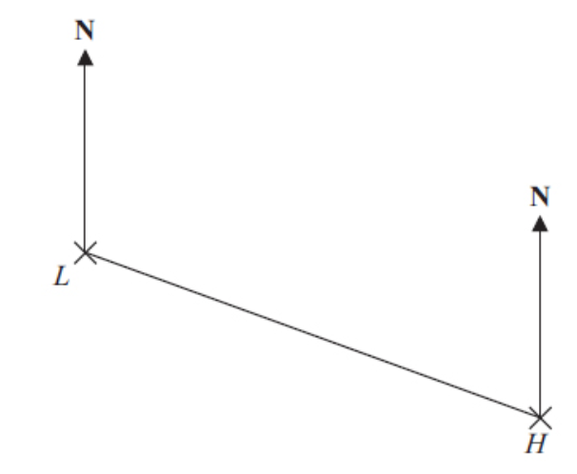

The scale of the diagram is 1 cm represents 5 km.

(a) Work out the real distance between L and H.

…………………………….. km

**(1)**

(b) Measure the bearing of H from L.

…………………………….. °

**(1)**

A boat B is 20 km from H on a bearing of 040°.

(c) On the diagram, mark the position of boat B with a cross (×).  
Label it B.

**(2)**

**(Total for Question 22 is 4 marks)**

**___________________________________________________________________________**

**23.** A mixture of sugar and salt is in the ratio 3 : 2

The weight of the mixture is 150 grams.

(a) Calculate the weight of sugar and the weight of salt in the mixture.

Sugar ……………g

Salt ……………….g

**(3)**

30 grams of sugar and 10 grams of salt are added to the mixture.

(b) Calculate the ratio of sugar to salt in the new mixture.

………………………………….

**(2)**

**(Total for Question 23 is 5 marks)**

**___________________________________________________________________________**

**24.** *A* = 22 × 3 × 52

*B* = 23 × 5

(a)  Find the Highest Common Factor (HCF) of *A* and *B*.

...........................................................

**(1)**

(b)  Find the Lowest Common Multiple (LCM) of *A* and *B*.

...........................................................

**(2)**

**(Total for Question 24 is 3 marks)**

**___________________________________________________________________________**

**25.** On a particular day, a scientist recorded the air temperature at 8 different heights above sea level. The scatter diagram shows the air temperature, *y* °C, at each of these heights, *x* km, above sea level.

(a) Using the scatter diagram, write down the air temperature recorded at a height of 2.5 km above sea level.

................................. °C

**(1)**

(b) Describe the correlation between the air temperature and the height above sea level.

........................................................

**(1)**

**Air temperature at different heights above sea level**



(c) On the scatter diagram, plot the point (1.5, 8) and draw a line of best fit through (1.5, 8).

**(2)**

(d) Using your line of best fit, find an estimate of the height above sea level when the air temperature is 0°C.

........................... km

**(1)**

**(Total for Question 25 is 5 marks)**

**___________________________________________________________________________**

**26.**



Enlarge shape **S** with scale factor  and centre (1, 3).

**(Total for Question 26 is 2 marks)**

**___________________________________________________________________________**

**27.** *ABC* is a right-angled triangle.

**

1.6 cm

3.2 cm

Work out the size of the angle marked *x*.

....................................................... °

**(Total for Question 27 is 2 marks)**

**TOTAL FOR PAPER: 80 MARKS**