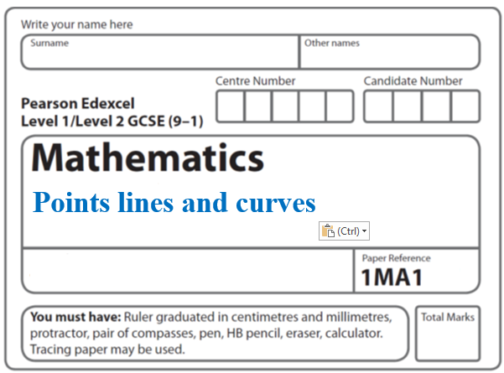**Instructions**

**Linear graphs**

* Use **black** ink or ball-point pen.
  + **Fill in the boxes** at the top of this page with your name,  
    centre number and candidate number.
* Answer **all** questions.
* Answer the questions in the spaces provided  
  *– there may be more space than you need.*
* You must **show all your working.**
* Diagrams are **NOT** accurately drawn, unless otherwise indicated.
* If your calculator does not have a *π* button, take the value of *π* to be3.142

unless the question instructs otherwise.

**Information**

* The total mark for this paper is **66**. There are **19** questions.
* Questions have been arranged in an ascending order of mean difficulty, as found by all students in the June 2017–November 2019 examinations.
* The marks for **each** question are shown in brackets  
  *– use this as a guide as to how much time to spend on each question.*

**Advice**

* Read each question carefully before you start to answer it.
* Keep an eye on the time.
* Try to answer every question.
* Check your answers if you have time at the end.

**1** On the grid below, draw the graph of *y* = 2*x* – 3 for values of *x* from –2 to 4

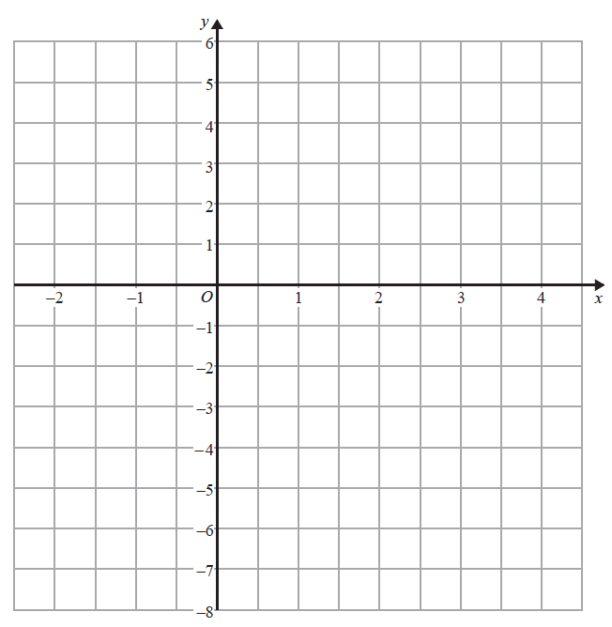

**(Total for Question 1 is 3 marks)**

**___________________________________________________________________________**

**2** The line **L** is shown on the grid.



Find an equation for **L**.

......................................................

(**Total for Question 2 is 3 marks)**

**___________________________________________________________________________**

**3** Line **L** is drawn on the grid below.



Find an equation for the straight line **L**.

Give your answer in the form *y = mx + c*.

......................................................

**(Total for Question 3 is 3 marks)**

**___________________________________________________________________________**

**4** Shona has to draw the line with equation *y* = 3*x* + 2

Here is her line.



(*c*)Explain why Shona’s line **cannot** be correct.

......................................................................................................................................................

......................................................................................................................................................

**(1)**

**(Total for Question 4 is 3 marks)**

**___________________________________________________________________________**

**5**

**

Phone calls cost £ *y* for *x* minutes.

The graph gives the values of *y* for values of *x* from 0 to 5.

(a)(i) Give an interpretation of the intercept of the graph on the *y*-axis.

......................................................................................................................................................

......................................................................................................................................................

(ii) Give an interpretation of the gradient of the graph.

......................................................................................................................................................

......................................................................................................................................................

**(2)**

(b)Find the equation of the straight line in the form *y* = *m x* + *c*

..................................................................................

**(3)**

**(Total for Question 5 is 5 marks)**

**___________________________________________________________________________**

**6** The graph shows the volume of liquid (*L* litres) in a container at time *t* seconds.



(*a*)Find the gradient of the graph.

.......................................................

(**2**)

(*b*)Explain what this gradient represents.

......................................................................................................................................................

......................................................................................................................................................

(**1**)

The graph intersects the volume axis at *L* = 4

(*c*)Explain what this intercept represents.

......................................................................................................................................................

......................................................................................................................................................

(**1**)

(**Total for Question 6 is 4 marks)**

**___________________________________________________________________________**

**7** The graph shows the depth, *d* cm, of water in a tank after *t* seconds.



(*a*)Find the gradient of this graph.

.......................................................

**(2)**

(*b*)Explain what this gradient represents.

......................................................................................................................................................

......................................................................................................................................................

**(1)**

**(Total for Question 7 is 3 marks)**

**___________________________________________________________________________**

**8** The equation of the line L1 is *y* = 3*x* – 2

The equation of the line L2 is 3*y* – 9*x* + 5 = 0

Show that these two lines are parallel.

**(Total for Question 8 is 2 marks)**

**___________________________________________________________________________**

**9** *A* is the point with coordinates (2, 10)

*B* is the point with coordinates (5, *d*)

The gradient of the line *AB* is 4

Work out the value of *d*.

*d* = .......................................................

**(Total for Question 9 is 3 marks) ___________________________________________________________________________**

**10** A pattern is made from four identical squares.

The sides of the squares are parallel to the axes.

**

Point *A* has coordinates (6, 7)

Point *B* has coordinates (38, 36)

Point *C* is marked on the diagram.

Work out the coordinates of *C*.

(................................ , ................................)

(**Total for Question 10 is 5 marks)**

**___________________________________________________________________________**

**11** The graphs with equations 3*y* + 2*x* =  and 2*y* – 3*x* =  have been drawn on the

grid below.

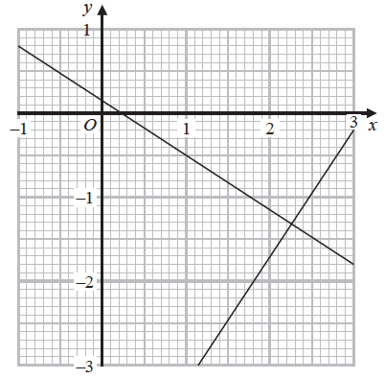

Using the graphs, find estimates of the solutions of the simultaneous equations

3*y* + 2*x* = 

2*y* − 3*x* = 

*x* = .......................................................

*y* = .......................................................

(**Total for Question 11 is 2 marks)**

**___________________________________________________________________________**

**12** The straight line **L** has the equation 3*y* = 4*x* + 7

The point *A* has coordinates (3, −5)

Find an equation of the straight line that is perpendicular to **L** and passes through *A*.

..................................................................................

**(Total for Question 12 is 3 marks)**

**___________________________________________________________________________**

**13**

**

*ABCD* is a rhombus.

The coordinates of *A* are (5,11)

The equation of the diagonal *DB* is **

Find an equation of the diagonal *AC*.

.......................................................

**(Total for Question 13 is 4 marks)**

**___________________________________________________________________________**

**14** *A* is the point with coordinates (5, 9)

*B* is the point with coordinates (*d*, 15)

The gradient of the line *AB* is 3

Work out the value of *d*.

.......................................................

**(Total for Question 14 is 3 marks)**

**___________________________________________________________________________**

**15** The point *P* has coordinates (3, 4)

The point *Q* has coordinates (*a*, *b*)

A line perpendicular to *PQ* is given by the equation 3*x* + 2*y* = 7

Find an expression for *b* in terms of *a*.

.......................................................

(**Total for Question 15 is 5 marks)**

**___________________________________________________________________________**

**16** The straight line **L**1 passes through the points with coordinates (4, 6) and (12, 2)

The straight line **L**2 passes through the origin and has gradient − 3

The lines **L**1 and **L**2 intersect at point *P*.

Find the coordinates of *P*.

(................................... , ...................................)

**(Total for Question 16 is 4 marks)**

**___________________________________________________________________________**

**17**



Find an equation of the line that passes through *C* and is perpendicular to *AB*.

..................................................................................

**(Total for Question 17 is 4 marks)**

**18**

**

*ABCD* is a rectangle.

*A*, *E* and *B* are points on the straight line **L** with equation *x* + 2*y* = 12

*A* and *D* are points on the straight line **M**.

*AE* = *EB*

Find an equation for **M**.

....................................................................

**(Total for Question 18 is 4 marks)**

**___________________________________________________________________________**

**19** *P* has coordinates (–9, 7)

*Q* has coordinates (11, 12)

*M* is the point on the line segment *PQ* such that *PM* : *MQ* = 2 : 3

Line **L** is perpendicular to the line segment *PQ*.

**L** passes through *M*.

Find an equation of **L**.

.......................................................

**(Total for Question 1 is 5 marks)**

**___________________________________________________________________________**

**TOTAL MARKS FOR PAPER: 66**