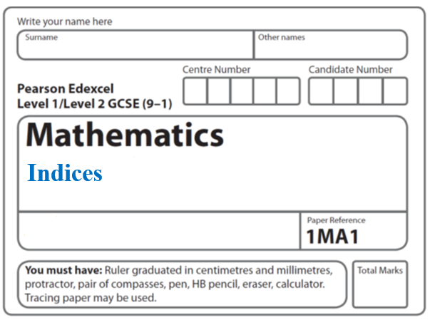**Instructions**

* Use **black** ink or ball-point pen.
  + **Fill in the boxes** at the top of this page with your name,  
    centre number and candidate number.
* Answer **all** questions.
* Answer the questions in the spaces provided  
  *– there may be more space than you need.*
* You must **show all your working.**
* Diagrams are **NOT** accurately drawn, unless otherwise indicated.
* If your calculator does not have a *π* button, take the value of *π* to be3.142

unless the question instructs otherwise.

**Information**

* The total mark for this paper is **43**. There are **14** questions.
* Questions have been arranged in an ascending order of mean difficulty, as found by all students in the June 2017–November 2019 examinations.
* The marks for **each** question are shown in brackets  
  *– use this as a guide as to how much time to spend on each question.*

**Advice**

* Read each question carefully before you start to answer it.
* Keep an eye on the time.
* Try to answer every question.
* Check your answers if you have time at the end.

**1** (*a*) Write  as a power of 3

.......................................................

**(2)**

(*b*) Write down the value of 120

.......................................................

**(1)**

(*c*)Write down the value of 3–2

.......................................................

**(1)**

**(Total for Question 1 is 4 marks)**

**___________________________________________________________________________**

**2** (*a*)Simplify (*p*2)5

.......................................................

**(1)**

(*b*)Simplify 12*x*7*y*3 ÷ 6*x*3*y*

.......................................................

**(2)**

**(Total for Question 2 is 3 marks)**

**___________________________________________________________________________**

**3** (*a*)Write down the value of 

.......................................................

(**1**)

(*b*)Write down the value of 230

.......................................................

(**1**)

(*c*)Work out the value of 

.......................................................

(**2**)

(**Total for Question 3 is 4 marks**)

**___________________________________________________________________________**

**4** (*a*)Find the value of 

.......................................................

**(2)**

(*b*)Find the value of 

.......................................................

**(2)**

**(Total for Question 4 is 4 marks)**

**___________________________________________________________________________**

**5** (*a*)Simplify *m*3 × *m*4

......................................................

(**1**)

(*b*)Simplify (5*np*3)3

......................................................

(**2**)

(*c*)Simplify 

......................................................

(**2**)

(**Total for Question 5 is 5 marks**)

**___________________________________________________________________________**

**6** Work out the value of 

......................................................

**(Total for Question 6 is 2 marks)**

**___________________________________________________________________________**

**7** Patrick has to work out the exact value of 

Patrick says,

“ of 64 is 16 so  = 16 ”

Explain what is wrong with what Patrick says.

......................................................................................................................................................

......................................................................................................................................................

......................................................................................................................................................

**(Total for Question 7 is 1 mark)**

**___________________________________________________________________________**

**8** (*a*)Write down the value of 

....................................................................

**(1)**

(*b*)Find the value of 

....................................................................

**(2)**

**(Total for Question 8 is 3 marks)**

**___________________________________________________________________________**

**9** (a) Write down the value of 250

.......................................................

**(1)**

(b) Find the value of 

.......................................................

**(2)**

(c) Find the value of 

.......................................................

**(2)**

**(Total for Question 9 is 5 marks)**

**___________________________________________________________________________**

**10** (a) Find the value of 

....................................................................

**(2)**

(b) Find the value of 

.........................................

**(2)**

**(Total for Question 10 is 4 marks)**

**___________________________________________________________________________**

**11** 

Work out the exact value of *x.*

......................................................

**(Total for Question 11 is 3 marks)**

**___________________________________________________________________________**

**12** Given that  =  ÷ 3*x*+1

find the exact value of *x*.

*x* = .......................................................

**(Total for Question 12 is 3 marks)**

**___________________________________________________________________________**

**13** (*a*)Work out the value of 

......................................................

**(2)**

3*a* =  3*b* =  3*c* = 

(*b*)Work out the value of *a* + *b* + *c*

......................................................

**(2)**

**(Total for Question 13 is 4 marks)**

**___________________________________________________________________________**

**14** Given that 3*–n* = 0.2

find the value of (34)*n*

.......................................................

**(Total for Question 14 is 2 marks)**

**___________________________________________________________________________**

**TOTAL MARKS FOR PAPER: 43**