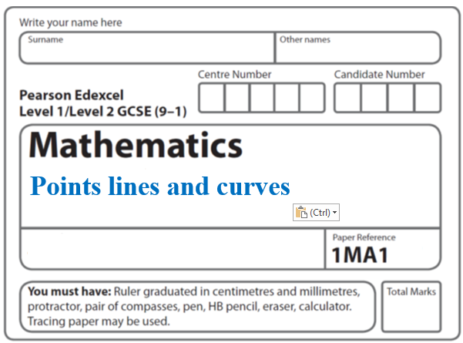**Instructions**

**Speed Distance Time**

* Use **black** ink or ball-point pen.
  + **Fill in the boxes** at the top of this page with your name,  
    centre number and candidate number.
* Answer **all** questions.
* Answer the questions in the spaces provided  
  *– there may be more space than you need.*
* You must **show all your working.**
* Diagrams are **NOT** accurately drawn, unless otherwise indicated.
* If your calculator does not have a *π* button, take the value of *π* to be3.142

unless the question instructs otherwise.

**Information**

* The total mark for this paper is **68**. There are **16** questions.
* Questions have been arranged in an ascending order of mean difficulty, as found by all students in the June 2017–November 2019 examinations.
* The marks for **each** question are shown in brackets  
  *– use this as a guide as to how much time to spend on each question.*

**Advice**

* Read each question carefully before you start to answer it.
* Keep an eye on the time.
* Try to answer every question.
* Check your answers if you have time at the end.

**1** In May 2019, the distance between Earth and Mars was 3.9 × 107 km.

In May 2019, a signal was sent from Earth to Mars.

Assuming that the signal sent from Earth to Mars travelled at a speed of 3 × 105 km per second,

(*a*)how long did the signal take to get to Mars?

....................................................... seconds

**(2)**

The speed of the signal sent from Earth to Mars in May 2019 was actually less than

3 × 105 km per second.

(*b*)How will this affect your answer to part (*a*)?

......................................................................................................................................................

......................................................................................................................................................

......................................................................................................................................................

**(1)**

**(Total for Question 1 is 3 marks)**

**___________________________________________________________________________**

**2** A cycle race across America is 3069.25 miles in length.

Juan knows his average speed for his previous races is 15.12 miles per hour.

For the next race across America he will cycle for 8 hours per day.

(*a*)Estimate how many days Juan will take to complete the race.

.......................................................

(**3**)

Juan trains for the race.

The average speed he can cycle at increases.

It is now 16.27 miles per hour.

(*b*)How does this affect your answer to part (*a*)?

......................................................................................................................................................

......................................................................................................................................................

(**1**)

**(Total for Question 2 is 5 marks)**

**3** Nimer was driving to a hotel.

He looked at his Sat Nav at 13 30

|  |  |
| --- | --- |
| Time | 13 30 |
| Distance to destination | 65 miles |

Nimer arrived at the hotel at 14 48

Work out the average speed of the car from 13 30 to 14 48

You must show all your working.

.......................................................mph

**(Total for Question 3 is 4 marks)**

**___________________________________________________________________________**

**4** A car moves from rest.

The graph gives information about the speed, *v* metres per second, of the car *t* seconds

after it starts to move.

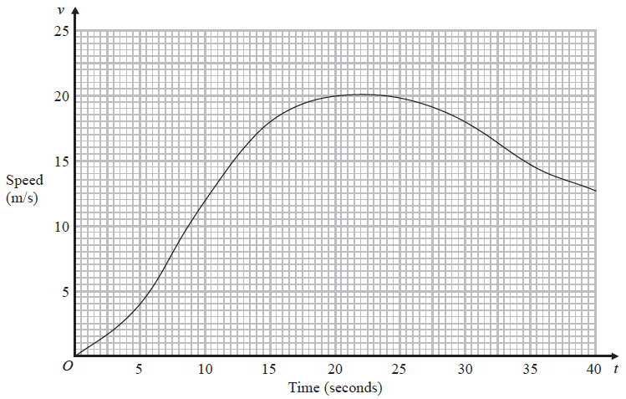

(*a*)(i) Calculate an estimate of the gradient of the graph at *t* = 15

.......................................................

**(3)**

(ii) Describe what your answer to part (i) represents.

......................................................................................................................................................

**(1)**

(*b*)Work out an estimate for the distance the car travels in the first 20 seconds of its journey.

Use 4 strips of equal width.

.......................................................m

**(3)**

**(Total for Question 4 is 7 marks)**

**___________________________________________________________________________**

**5** Olly drove 56 km from Liverpool to Manchester.

He then drove 61 km from Manchester to Sheffield.

Olly’s average speed from Liverpool to Manchester was 70 km/h.

Olly took 75 minutes to drive from Manchester to Sheffield.

(*a*)Work out Olly’s average speed for his total drive from Liverpool to Sheffield.

...................................................... km/h

**(4)**

Janie drove from Barnsley to York.

Janie’s average speed from Barnsley to Leeds was 80 km/h.

Her average speed from Leeds to York was 60 km/h.

Janie says that the average speed from Barnsley to York can be found by working out the

mean of 80 km/h and 60 km/h.

(*b*)If Janie is correct, what does this tell you about the two parts of Janie’s journey?

......................................................................................................................................................

......................................................................................................................................................

**(1)**

**(Total for Question 5 is 5 marks)**

**___________________________________________________________________________**

**6** The graph shows the speed of a car, in metres per second, during the first 20 seconds of

a journey.



(*a*)Work out an estimate for the distance the car travelled in the first 20 seconds.

Use 4 strips of equal width.

....................................................... metres

(**3**)

(*b*)Is your answer to part (*a*) an underestimate or an overestimate of the actual distance

the car travelled in the first 20 seconds?

Give a reason for your answer.

......................................................................................................................................................

......................................................................................................................................................

(**1**)

(**Total for Question 6 is 4 marks**)

**___________________________________________________________________________**

**7** Here is part of a distance-time graph for a car’s journey.



(*a*) Between which two times does the car travel at its greatest speed?

Give a reason for your answer.

......................................................................................................................................................

......................................................................................................................................................

**(2)**

(*b*) Work out this greatest speed.

.................................................... m/s

**(1)**

**(Total for Question 7 is 3 marks)**

**___________________________________________________________________________**

**8** A car travels for 18 minutes at an average speed of 72 km/h.

(*a*)How far will the car travel in these 18 minutes?

....................................................... km

**(2)**

David says,

“72 kilometres per hour is faster than 20 metres per second.”

(*b*)Is David correct?

You must show how you get your answer.

**(2)**

**(Total for Question 8 is 4 marks)**

**___________________________________________________________________________**

**9** A train travelled along a track in 110 minutes, correct to the nearest 5 minutes.

Jake finds out that the track is 270 km long.

He assumes that the track has been measured correct to the nearest 10 km.

(*a*)Could the average speed of the train have been greater than 160 km/h?

You must show how you get your answer.

**(4)**

Jake’s assumption was wrong.

The track was measured correct to the nearest 5 km.

(*b*)Explain how this could affect your decision in part (*a*).

......................................................................................................................................................

......................................................................................................................................................

......................................................................................................................................................

**(1)**

**(Total for Question 9 is 5 marks)**

**___________________________________________________________________________**

**10** A plane travels at a speed of 213 miles per hour.

(*a*)Work out an estimate for the number of seconds the plane takes to travel 1 mile.

...................................................... seconds

**(3)**

(*b*)Is your answer to part (*a*)an underestimate or an overestimate?

Give a reason for your answer.

......................................................................................................................................................

......................................................................................................................................................

**(1)**

**(Total for Question 10 is 4 marks)**

**___________________________________________________________________________**

**11** The distance-time graph shows information about part of a car journey.



Use the graph to estimate the speed of the car at time 5 seconds.

...................................................... m/s

(**Total for Question 11 is 3 marks**)

**___________________________________________________________________________**

**12** A high speed train travels a distance of 487 km in 3 hours.

The distance is measured correct to the nearest kilometre.

The time is measured correct to the nearest minute.

By considering bounds, work out the average speed, in km/minute, of the train to a

suitable degree of accuracy.

You must show all your working and give a reason for your answer.

.......................................................km/minute

**(Total for Question 12 is 5 marks)**

**__________________________________________________________________________**

**13** James and Peter cycled along the same 50 km route.

James took 2 hours to cycle the 50 km.

Peter started to cycle 5 minutes after James started to cycle.

Peter caught up with James when they had both cycled 15 km.

James and Peter both cycled at constant speeds.

Work out Peter’s speed.

....................................................... km/h

**(Total for Question 13 is 5 marks)**

**___________________________________________________________________________**

**14** The graph shows information about part of a cyclist’s journey.

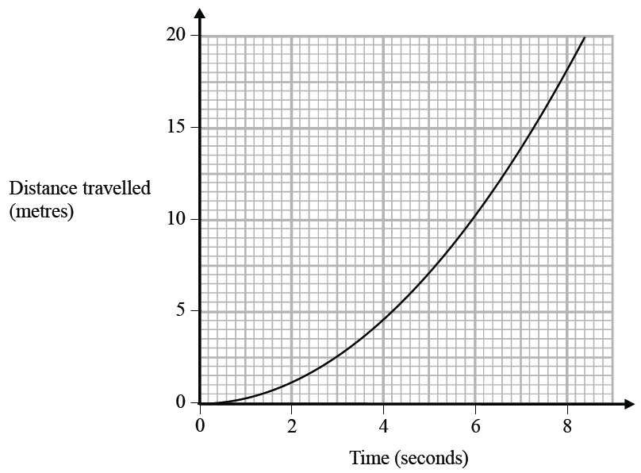

Work out an estimate of the speed, in m/s, of the cyclist at time 6 seconds.

.......................................................m/s

**(Total for Question 14 is 3 marks)**

**___________________________________________________________________________**

**15** On Monday Ria delivered a parcel to a hospital.

The travel graph represents Ria’s journey to the hospital.

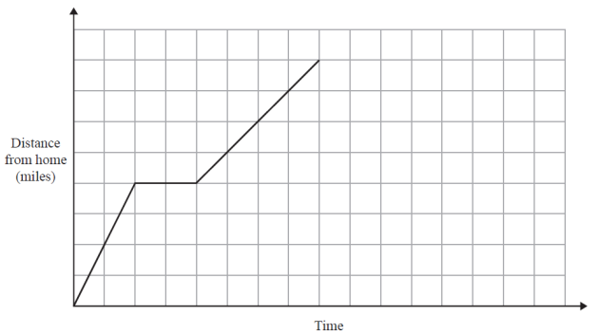

Ria left home at 13 00

She drove for 30 minutes at a constant speed of 40 mph.

She then stopped for a break.

Ria then drove to the hospital at a constant speed.

She was at the hospital for 30 minutes.

She then drove home at a constant speed of 32 mph.

Show that she does not arrive home before 16 30

**(Total for Question 15 is 4 marks)**

**___________________________________________________________________________**

**16** Here is a speed-time graph for a train.



(*a*)Work out an estimate for the distance the train travelled in the first 20 seconds.

Use 4 strips of equal width.

...................................................... m

**(3)**

(*b*)Is your answer to (*a*)an underestimate or an overestimate of the actual distance the

train travelled?

Give a reason for your answer.

......................................................................................................................................................

......................................................................................................................................................**(1)**

**(Total for Question 16 is 4 marks)**

**___________________________________________________________________________**

**TOTAL MARKS FOR PAPER: 68**