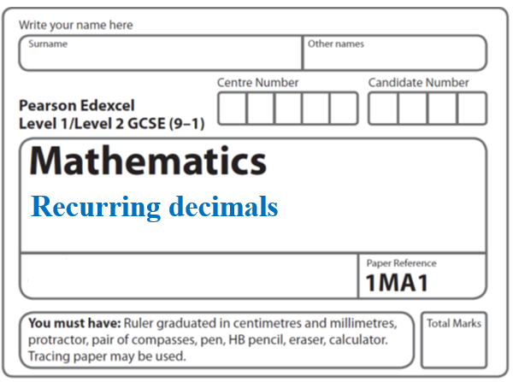**Instructions**

**Trigonometry 2D and Bearings**

* Use **black** ink or ball-point pen.
  + **Fill in the boxes** at the top of this page with your name,  
    centre number and candidate number.
* Answer **all** questions.
* Answer the questions in the spaces provided  
  *– there may be more space than you need.*
* You must **show all your working.**
* Diagrams are **NOT** accurately drawn, unless otherwise indicated.
* If your calculator does not have a *π* button, take the value of *π* to be3.142

unless the question instructs otherwise.

**Information**

* The total mark for this paper is **88.** There are **23** questions.
* Questions have been arranged in an ascending order of mean difficulty, as found by all students in the June 2017–November 2019 examinations.
* The marks for **each** question are shown in brackets  
  *– use this as a guide as to how much time to spend on each question.*

**Advice**

* Read each question carefully before you start to answer it.
* Keep an eye on the time.
* Try to answer every question.
* Check your answers if you have time at the end.

**1** *ABC* is a right-angled triangle.

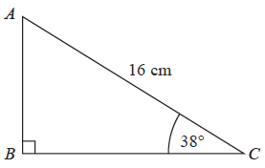

Calculate the length of *AB*.

Give your answer correct to 2 decimal places.

.......................................................cm

**(Total for Question 1 is 2 marks)**

**___________________________________________________________________________**

**2** *ABC* is a right-angled triangle.

**

Calculate the length of *AB*.

Give your answer correct to 3 significant figures.

.......................................................cm

**(Total for Question 2 is 2 marks)**

**___________________________________________________________________________**

**3** *ABC* is a right-angled triangle.

**

Calculate the length of *BC*.

Give your answer correct to 1 decimal place.

....................................................... cm

**(Total for Question 3 is 3 marks)**

**___________________________________________________________________________**

**4** *ABC* is a right-angled triangle.

**

(*a*)Work out the size of angle *ABC*.

Give your answer correct to 1 decimal place.

....................................................... °

(**2**)

The length of the side *AB* is reduced by 1 cm.

The length of the side *BC* is still 7 cm.

Angle *ACB* is still 90°

(*b*)Will the value of cos *ABC* increase or decrease?

You must give a reason for your answer.

......................................................................................................................................................

......................................................................................................................................................

(**1**)

(**Total for Question 4 is 3 marks**)

**___________________________________________________________________________**

**5**

**

Work out the value of *x*.

.......................................................

**(Total for Question 5 is 2 marks) ___________________________________________________________________________**

**6** Here is triangle *PQR*.

**

The length of *QR* is 60% of the length of *PR*.

Find the value of sin *QPR*.

Give your answer correct to 3 significant figures.

.......................................................

**(Total for Question 6 is 3 marks)**

**___________________________________________________________________________**

**7**

**

Work out the length of *AD*.

Give your answer correct to 3 significant figures.

....................................................... cm

(**Total for Question 7 is 5 marks**)

**___________________________________________________________________________**

**8** *ABC* is a right-angled triangle.

**

*AC* = 14 cm.

Angle *C* = 90°

size of angle *B* : size of angle *A* = 3 : 2

Work out the length of *AB*.

Give your answer correct to 3 significant figures.

.......................................................cm

**(Total for Question 8 is 4 marks)**

**__________________________________________________________________________**

**9** (*a*)Write down the exact value of tan 45°

......................................................

**(1)**

Here is a right-angled triangle.



cos 60° = 0.5

(*b*)Work out the value of *x*.

......................................................

**(2)**

**(Total for Question 9 is 3 marks)**

**___________________________________________________________________________**

**10**



The area of triangle *ABC* is  m2.

Calculate the value of *x*.

Give your answer correct to 3 significant figures.

.......................................................

**(Total for Question 10 is 5 marks)**

**___________________________________________________________________________**

**11** The diagram shows triangle *ABC*.

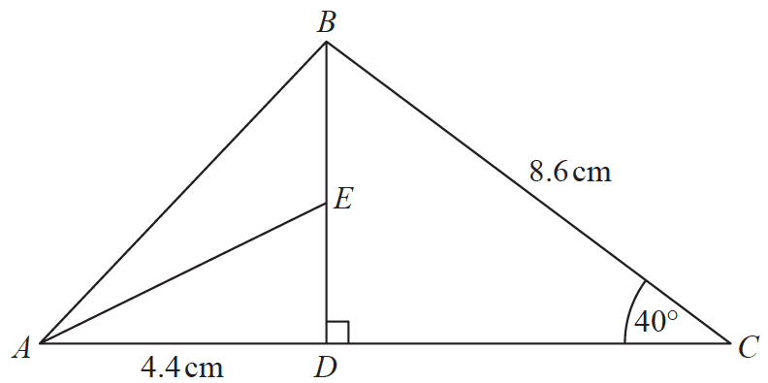

*ADC* and *DEB* are straight lines.

*AD* = 4.4 cm

*BC* = 8.6 cm

*E* is the midpoint of *DB*.

Angle *CDB* = 90°

Angle *DCB* = 40°

Work out the size of angle *EAD*.

Give your answer correct to 1 decimal place.

You must show all your working.

.......................................................°

**(Total for Question 11 is 4 marks)**

**___________________________________________________________________________**

**12** *ABCD* is a trapezium.



Work out the size of angle *CDA*.

Give your answer correct to 1 decimal place.

..................................................... °

**(Total for Question 12 is 5 marks)**

**___________________________________________________________________________**

**13** The diagram shows a quadrilateral *JKLM*.



Work out the size of angle *KLM*.

Give your answer correct to 3 significant figures.

.......................................................°

**(Total for Question 13 is 4 marks)**

**___________________________________________________________________________**

**14** Here are two right-angled triangles.



Given that

tan *e* = tan *f*

find the value of *x*.

You must show all your working.

.......................................................

(**Total for Question 14 is 5 marks**)

**___________________________________________________________________________**

**15** Here is trapezium *ABCD*.

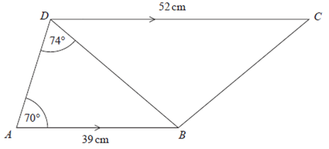

*AB* and *DC* are parallel.

Work out the area of triangle *BCD*.

Give your answer correct to 3 significant figures.

.......................................................cm2

**(Total for Question 15 is 5 marks)**

**___________________________________________________________________________**

**16**



*ABC* is a triangle.

*D* is a point on *AB*.

Work out the area of triangle *BCD*.

Give your answer correct to 3 significant figures.

....................................................... cm2

**(Total for Question 16 is 5 marks)**

**___________________________________________________________________________**

**17** *ABC* and *ADC* are triangles.

**

The area of triangle *ADC* is 56 m2

Work out the length of *AB*.

Give your answer correct to 1 decimal place.

...................................................... m

**(Total for Question 17 is 5 marks)**

**___________________________________________________________________________**

**18**

**

The area of triangle *AB*C is 42 cm2

Find the length of *AB*.

Give your answer correct to 3 significant figures.

....................................................... cm

**(Total for Question 18 is 5 marks)**

**___________________________________________________________________________**

**19** The diagram shows the positions of three points, *A*, *B* and *C*, on a map.



The bearing of *B* from *A* is 070°

Angle *ABC* is 50°

*AB* = *CB*

Work out the bearing of *C* from *A*.

....................................................... °

**(Total for Question 19 is 3 marks)**

**___________________________________________________________________________**

**20** The diagram shows the positions of three towns, Acton (*A*), Barston (*B*)and Chorlton (*C*).

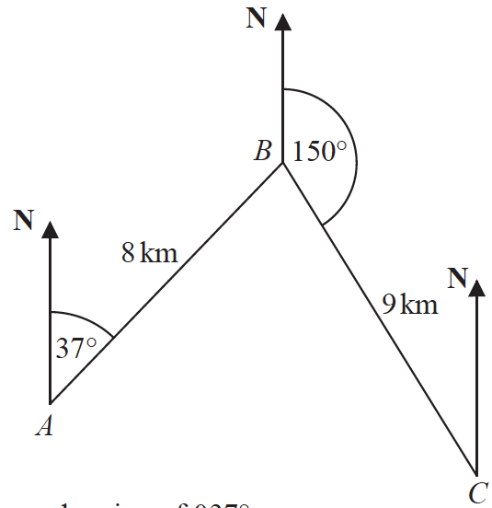

Barston is 8 km from Acton on a bearing of 037°

Chorlton is 9 km from Barston on a bearing of 150°

Find the bearing of Chorlton from Acton.

Give your answer correct to 1 decimal place.

You must show all your working.

.......................................................°

**(Total for Question 20 is 5 marks)**

**21** The diagram shows triangle *ABC*.

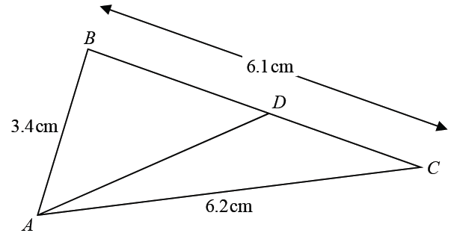

*AB* = 3.4 cm *AC* = 6.2 cm *BC* = 6.1 cm

*D* is the point on *BC* such that

size of angle *DAC* =  × size of angle *BCA*

Calculate the length *DC*.

Give your answer correct to 3 significant figures.

You must show all your working.

.......................................................cm

**(Total for Question 21 is 5 marks)**

**___________________________________________________________________________**

**22** The diagram shows a hexagon *ABCDEF*.

**

*ABEF* and *CBED* are congruent parallelograms where *AB* = *BC* = *x* cm.

*P* is the point on *AF* and *Q* is the point on *CD* such that *BP = BQ =* 10 cm.

Given that angle *ABC* = 30°,

prove that cos *PBQ* = 1 –  *x*2

**(Total for Question 22 is 5 marks)**

**23** The diagram shows an acute-angled triangle *ABC*.



Prove that area of triangle *ABC* = *ab* sin *C*

**(Total for Question 23 is 3 marks)**

**___________________________________________________________________________**

**TOTAL MARKS FOR PAPER: 88**