**Foundation Tier**

**Angles: Geometrical Reasoning**

**Instructions**

* Use **black** ink or ball-point pen.
  + **Fill in the boxes** at the top of this page with your name,  
    centre number and candidate number.
* Answer **all** questions.
* Answer the questions in the spaces provided  
  *– there may be more space than you need.*
* You must **show all your working.**
* Diagrams are **NOT** accurately drawn, unless otherwise indicated.
* If your calculator does not have a *π* button, take the value of *π* to be3.142

unless the question instructs otherwise.

**Information**

* The total mark for this paper is **30**. There are **8** questions.
* Questions have been arranged in an ascending order of mean difficulty, as found by all students in the June 2017–November 2019 examinations.
* The marks for **each** question are shown in brackets  
  *– use this as a guide as to how much time to spend on each question.*

**Advice**

* Read each question carefully before you start to answer it.
* Keep an eye on the time.
* Try to answer every question.
* Check your answers if you have time at the end.

**1**



*BCD* is a straight line.

*ABC* is a triangle.

Show that triangle *ABC* is an isosceles triangle.

Give a reason for each stage of your working.

**(Total for Question 1 is 4 marks)**

**___________________________________________________________________________**

**2** Mary needs to work out the size of angle *x* in this diagram.

**

She writes

*x* = 63° because base angles of an isosceles triangle are equal.

Mary is wrong.

(*a*)Explain why.

......................................................................................................................................................

......................................................................................................................................................

(**1**)

William needs to work out the size of angle *y* in this diagram.

**

William writes

|  |  |
| --- | --- |
| **Working** | **Reason** |
| angle *EGH* = 57° | because corresponding angles are equal |
| *y* = 180° – 57°  *y* = 123° | because angles on a straight line add up to 180° |

One of William’s reasons is wrong.

(*b*)Write down the correct reason.

......................................................................................................................................................

......................................................................................................................................................

(**1**)

(**Total for Question 2 is 2 marks**)

**___________________________________________________________________________**

**3** The diagram shows quadrilateral *ABCD* with each of its sides extended.

**

*AB* = *AD*

Show that *ABCD* is a kite.

Give a reason for each stage of your working.

**(Total for Question 3 is 4 marks)**

**___________________________________________________________________________**

**4**

**

*ABCD* is a parallelogram.

*EDC* is a straight line.

*F* is the point on *AD* so that *BFE* is a straight line.

Angle *EFD* = 35°

Angle *DCB* = 75°

Show that angle *ABF* = 70°

Give a reason for each stage of your working.

**(Total for Question 4 is 4 marks)**

**___________________________________________________________________________**

**5**

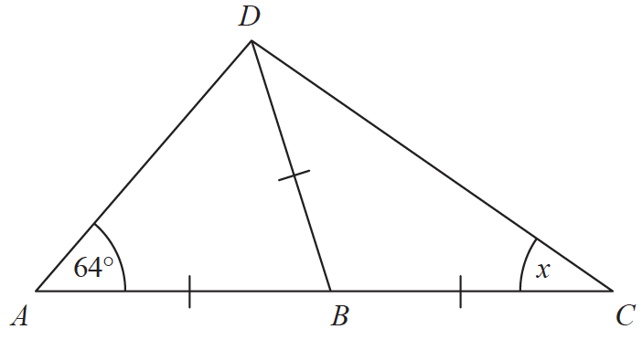

*ABC* is a straight line.

*AB* = *BC* = *BD*.

Angle *DAB* = 64°

Work out the size of the angle marked *x*.

Give a reason for each stage of your working.

**(Total for Question 5 is 4 marks)**

**___________________________________________________________________________**

**6** *BEG* is a triangle.



*ABC* and *DEF* are parallel lines.

Work out the size of angle *x*.

Give a reason for each stage of your working.

.......................................................°

**(Total for Question 6 is 4 marks)**

**_____________________________________________________________________________**

**7** The diagram shows triangle *ABD* and triangle *BCD*.

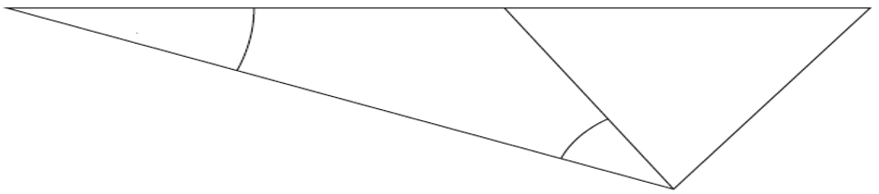

*A*

*B*

*C*

*D*

*x*

25°

*ABC* is a straight line.

*BCD* is an equilateral triangle.

Angle *DAB =* 25o

Work out the size of the angle marked *x*. Give a reason for each stage of your working.

…………………………… o

**(Total for Question 7 is 4 marks)**

**___________________________________________________________________________**

**8** In the diagram, *AB*, *BC* and *CD* are three sides of a regular polygon **P**.



Show that polygon **P** is a hexagon.

You must show your working.

**(Total for Question 8 is 4 marks)**

**___________________________________________________________________________**

**TOTAL MARKS FOR PAPER: 30**