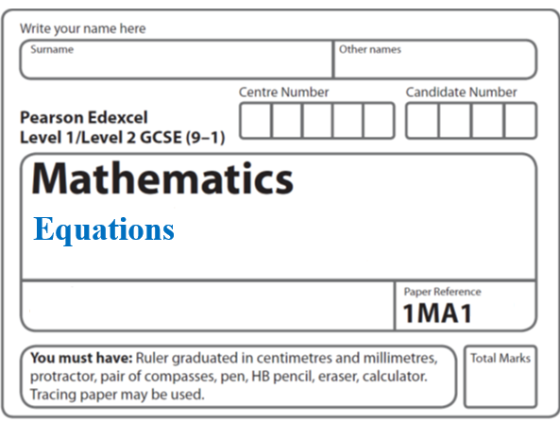**Instructions**

**Upper and Lower bounds**

* Use **black** ink or ball-point pen.
  + **Fill in the boxes** at the top of this page with your name,  
    centre number and candidate number.
* Answer **all** questions.
* Answer the questions in the spaces provided  
  *– there may be more space than you need.*
* You must **show all your working.**
* Diagrams are **NOT** accurately drawn, unless otherwise indicated.
* If your calculator does not have a *π* button, take the value of *π* to be3.142

unless the question instructs otherwise.

**Information**

* The total mark for this paper is **19**. There are **7** questions.
* Questions have been arranged in an ascending order of mean difficulty, as found by all students in the June 2017–November 2019 examinations.
* The marks for **each** question are shown in brackets  
  *– use this as a guide as to how much time to spend on each question.*

**Advice**

* Read each question carefully before you start to answer it.
* Keep an eye on the time.
* Try to answer every question.
* Check your answers if you have time at the end.

**1** A number, *n*, is rounded to 2 decimal places.

The result is 4.76.

Using inequalities, write down the error interval for *n*.

............................................................................................................

**(Total for Question 1 is 2 marks)**

**___________________________________________________________________________**

**2** Sally used her calculator to work out the value of a number *y*.

The answer on her calculator display began

8.3

Complete the error interval for *y*.

............................ ⩽ *y* < ............................

**(Total for Question 2 is 2 marks)**

**___________________________________________________________________________**

**3** (*a*)Find the value of the reciprocal of 1.6.

Give your answer as a decimal.

.......................................................

**(1)**

Jess rounds a number, *x*, to one decimal place.

The result is 9.8.

(*b*)Write down the error interval for *x*.

..................................................................................

**(2)**

**(Total for Question 3 is 3 marks)**

**___________________________________________________________________________**

**4** Kiera used her calculator to work out the value of a number *x*.

She wrote down the first two digits of the answer on her calculator.

She wrote down 7.3

Write down the error interval for *x*.

...............................................................................................

**(Total for Question 4 is 2 marks)**

**___________________________________________________________________________**

**5** Martin truncates the number *N* to 1 digit.

The result is 7

Write down the error interval for *N*.

..............................................................

**(Total for Question 5 is 2 marks)**

**___________________________________________________________________________**

**6** *m* = 

*p* = 5.37 correct to 2 decimal places.

*s* = 2.9 correct to 1 decimal place.

Calculate the upper bound for the value for *m*.

You must show your working.

...........................................................................

**(Total for Question 6 is 3 marks)**

**___________________________________________________________________________**

**7 **

*a* = 6.43 correct to 2 decimal places.

*b* = 5.514 correct to 3 decimal places.

By considering bounds, work out the value of *v* to a suitable degree of accuracy.

Give a reason for your answer.

.......................................................

**(Total for Question 7 is 5 marks)**

**___________________________________________________________________________**

**TOTAL MARKS FOR PAPER: 19**