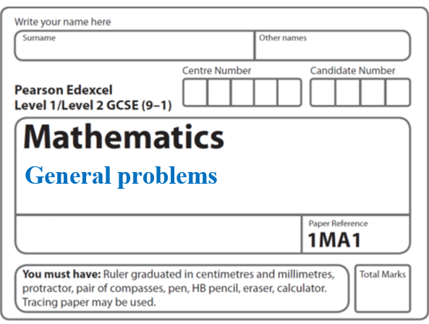**Instructions**

**Density problems**

* Use **black** ink or ball-point pen.
  + **Fill in the boxes** at the top of this page with your name,  
    centre number and candidate number.
* Answer **all** questions.
* Answer the questions in the spaces provided  
  *– there may be more space than you need.*
* You must **show all your working.**
* Diagrams are **NOT** accurately drawn, unless otherwise indicated.
* If your calculator does not have a *π* button, take the value of *π* to be3.142

unless the question instructs otherwise.

**Information**

* The total mark for this paper is **41**. There are **10** questions.
* Questions have been arranged in an ascending order of mean difficulty, as found by all students in the June 2017–November 2019 examinations.
* The marks for **each** question are shown in brackets  
  *– use this as a guide as to how much time to spend on each question.*

**Advice**

* Read each question carefully before you start to answer it.
* Keep an eye on the time.
* Try to answer every question.
* Check your answers if you have time at the end.

**1** The density of apple juice is 1.05 grams per cm3.

The density of fruit syrup is 1.4 grams per cm3.

The density of carbonated water is 0.99 grams per cm3.

25 cm3 of apple juice are mixed with 15 cm3 of fruit syrup and

280 cm3 of carbonated water to make a drink with a volume of 320 cm3.

Work out the density of the drink.

Give your answer correct to 2 decimal places.

.......................................................g/cm3

**(Total for Question 1 is 4 marks)**

**___________________________________________________________________________**

**2** The density of ethanol is 1.09 g/cm3

The density of propylene is 0.97 g/cm3

60 litres of ethanol are mixed with 128 litres of propylene to make 188 litres of antifreeze.

Work out the density of the antifreeze.

Give your answer correct to 2 decimal places.

....................................................... g/cm3

**(Total for Question 2 is 4 marks)**

**___________________________________________________________________________**

**3** Jackson is trying to find the density, in g/cm3, of a block of wood.

The block of wood is in the shape of a cuboid.

He measures

the length as 13.2 cm, correct to the nearest mm

the width as 16.0 cm, correct to the nearest mm

the height as 21.7 cm, correct to the nearest mm

He measures the mass as 1970 g, correct to the nearest 5 g.

By considering bounds, work out the density of the wood.

Give your answer to a suitable degree of accuracy.

You must show all your working and give a reason for your final answer.

(**Total for Question 3 is 5 marks**)

**___________________________________________________________________________**

**4** Liquid A and liquid B are mixed together in the ratio 2 : 13 by volume to make liquid C.

Liquid A has density 1.21 g/cm3

Liquid B has density 1.02 g/cm3

A cylindrical container is filled completely with liquid C.

The cylinder has radius 3 cm and height 25 cm.

Work out the mass of the liquid in the container.

Give your answer correct to 3 significant figures.

You must show all your working.

.......................................................g

**(Total for Question 4 is 4 marks)**

**___________________________________________________________________________**

**5** A gold bar has a mass of 12.5 kg.

The density of gold is 19.3 g/cm3

Work out the volume of the gold bar.

Give your answer correct to 3 significant figures.

....................................................... cm3

**(Total for Question 5 is 3 marks)**

**___________________________________________________________________________**

**6** Liquid **A** has a density of 1.42 g/cm3

7 cm3 of liquid **A** is mixed with 125 cm3 of liquid **B** to make liquid **C**.

Liquid **C** has a density of 1.05 g/cm3

Find the density of liquid **B**.

Give your answer correct to 2 decimal places.

.......................................................g/cm3

**(Total for Question 6 is 3 marks)**

**___________________________________________________________________________**

**7** Here is a frustum of a cone.



The diagram shows that the frustum is made by removing a cone with height 3.2 cm from

a solid cone with height 6.4 cm and base diameter 7.2 cm.

The frustum is joined to a solid hemisphere of diameter 7.2 cm to form the solid **S** shown

below.



The density of the frustum is 2.4 g/cm3

The density of the hemisphere is 4.8 g/cm3

Calculate the average density of solid **S**.

.......................................................g/cm3

**(Total for Question 20 is 5 marks)**

**___________________________________________________________________________**

**8** The diagram shows a piece of wood in the shape of a cuboid.



The piece of wood is 3 cm by 20 cm by 1.2 m.

The mass of the piece of wood is 8 kg.

The piece of wood will float in sea water if the density of the wood is less than the

density of the sea water.

In a large pool, 1 litre of sea water has a mass of 1030 g.

Will the piece of wood float in this pool?

You must show how you get your answer.

**(Total for Question 8 is 4 marks)**

**___________________________________________________________________________**

**9** Here are two solid spheres, **A** and **B**.



Sphere **A** is made of gold.

Sphere **B** is made of silver.

Sphere **A** has radius 2 cm.

Sphere **B** has radius 3 cm.

Gold has a density of 19 000 kg/m3

Silver has a density of 10 000 kg/m3

Which sphere has the greater mass?

You must show how you get your answer.

**(Total for Question 9 is 4 marks)**

**___________________________________________________________________________**

**10** Here are two solid prisms, prism **A** and prism **B**.



prism **A** prism **B**

The cross section of prism **A** is a sector, with angle 45°, of a circle of radius 10 cm.

The prism has a depth of 10 cm and a mass of 40*π* grams.

The cross section of prism **B** is a sector, with angle 60°, of a circle of radius 10 cm.

The prism has a depth of 5 cm and a mass of 50*π* grams.

Express the difference in the densities of the two prisms as a percentage of the density of prism **A**.

....................................................... %

**(Total for Question 10 is 5 marks)**

**___________________________________________________________________________**

**TOTAL MARKS FOR PAPER: 41**