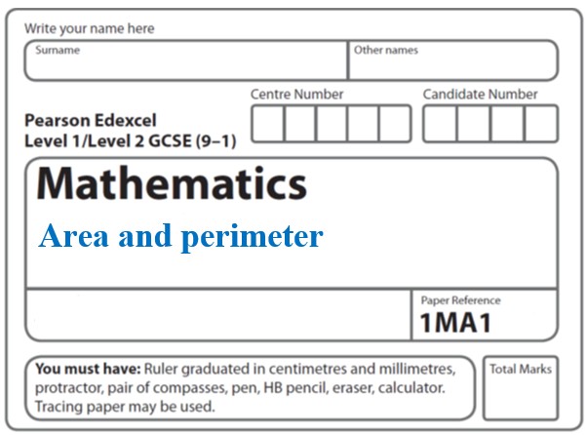

**Instructions**

* Use **black** ink or ball-point pen.
  + **Fill in the boxes** at the top of this page with your name,  
    centre number and candidate number.
* Answer **all** questions.
* Answer the questions in the spaces provided  
  *– there may be more space than you need.*
* You must **show all your working.**
* Diagrams are **NOT** accurately drawn, unless otherwise indicated.
* If your calculator does not have a *π* button, take the value of *π* to be3.142

unless the question instructs otherwise.

**Information**

* The total mark for this paper is **58**. There are **13** questions.
* Questions have been arranged in an ascending order of mean difficulty, as found by all students in the June 2017–November 2019 examinations.
* The marks for **each** question are shown in brackets  
  *– use this as a guide as to how much time to spend on each question.*

**Advice**

* Read each question carefully before you start to answer it.
* Keep an eye on the time.
* Try to answer every question.
* Check your answers if you have time at the end.

**1** Here are two rectangles.

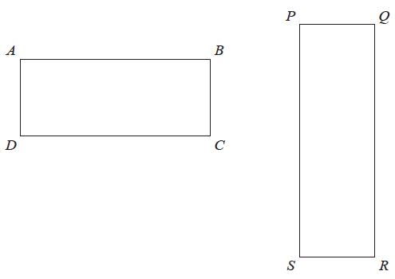

*QR* = 10 cm

*BC* = *PQ*

The perimeter of *ABCD* is 26 cm

The area of *PQRS* is 45 cm2

Find the length of *AB*.

....................................................... cm

**(Total for Question 1 is 4 marks)**

**___________________________________________________________________________**

**2** This rectangular frame is made from 5 straight pieces of metal.



The weight of the metal is 1.5 kg per metre.

Work out the total weight of the metal in the frame.

...................................................... kg

**(Total for Question 2 is 5 marks)**

**___________________________________________________________________________**

**3** Here is a trapezium drawn on a centimetre grid.



On the grid, draw a triangle equal in area to this trapezium.

(**Total for Question 3 is 2 marks**)

**___________________________________________________________________________**

**4** The diagram shows a shape *ABCDEF*.

**

All the corners of the shape are right angles.

The perimeter of the shape is 28 m.

Work out the area of *ABCE* shown shaded on the diagram.

.......................................................

**(Total for Question 4 is 5 marks)**

**___________________________________________________________________________**

**5** The diagram shows a floor in the shape of a trapezium.



John is going to paint the floor.

Each 5 litre tin of paint costs £16.99

1 litre of paint covers an area of 2m2

John has £160 to spend on paint.

Has John got enough money to buy all the paint he needs?

You must show how you get your answer.

**(Total for Question 5 is 5 marks)**

**___________________________________________________________________________**

**6** Jeremy has to cover 3 tanks completely with paint.

Each tank is in the shape of a cylinder with a top and a bottom.

The tank has a diameter of 1.6 m and a height of 1.8 m.

Jeremy has 7 tins of paint.

Each tin of paint covers 5 m2

Has Jeremy got enough paint to cover completely the 3 tanks?

You must show how you get your answer.

**(Total for Question 6 is 5 marks)**

**___________________________________________________________________________**

**7** Here are two rectangles.



All measurements are in centimetres.

The area of rectangle **A** isequal to the area of rectangle **B**.

Work out the perimeter of rectangle **B**.

.......................................................cm

**(Total for Question 7 is 5 marks)**

**___________________________________________________________________________**

**8** The perimeter of a square has the same length as the perimeter of this triangle.



All measurements are in centimetres.

Find an expression, in terms of *x*, for the length of a side of the square.

Give your answer in its simplest form.

....................................................................

**(Total for Question 8 is 3 marks)**

**___________________________________________________________________________**

**9** Here is a rectangle.



All measurements are in centimetres.

The area of the rectangle is 48 cm2.

Show that *y* = 3

**(Total for Question 9 is 4 marks)**

**___________________________________________________________________________**

**10** Here is a rectangle.



The length of the rectangle is 7 cm longer than the width of the rectangle.

4 of these rectangles are used to make this 8-sided shape.



The perimeter of the 8-sided shape is 70 cm.

Work out the area of the 8-sided shape.

...................................................... cm2

**(Total for Question 10 is 5 marks)**

**___________________________________________________________________________**

**11** The diagram shows a rectangle, *ABDE*, and two congruent triangles, *AFE* and *BCD*.

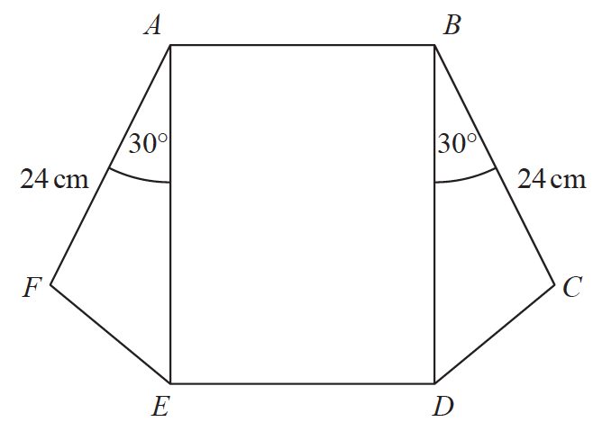

area of rectangle *ABDE* = area of triangle *AFE* + area of triangle *BCD*

*AB* : *AE* = 1 : 3

Work out the length of *AE*.

....................................................... cm

**(Total for Question 11 is 4 marks)**

**___________________________________________________________________________**

**12** Here is a rectangle and a right-angled triangle.



All measurements are in centimetres.

The area of the rectangle is greater than the area of the triangle.

Find the set of possible values of *x*.

.......................................................

**(Total for Question 12 is 5 marks)**

**___________________________________________________________________________**

**13** The length of a rectangle is the same as the length of each side of a square.

The length of the rectangle is 4 cm more than 3 times the width of the rectangle.

The area of the square is 66 cm2 more than the area of the rectangle.

Find the length and the width of the rectangle.

You must show all your working.

..........................................................................................................................

**(Total for Question 13 is 6 marks)**

**___________________________________________________________________________**

**TOTAL MARKS FOR PAPER: 58**