**EDEXCEL A Level MATHEMATICS**

**At LPGS**

**MCj04041550000[1]**

**MCj02506590000[1]**

**Introductory Handbook**

**2021-2023**

**Contents**

**Introduction page 3**

**Course Overview page 4**

**Module Content page 4**

**Resources provided page 5**

**Resources needed page 5**

**Useful websites page 6**

**Introduction**

Welcome to A Level mathematics at LPGS where we follow the Edexcel course studying 4 modules over the two years.

The A level Maths team at LPGS are

**Ms. Hine** Head of Maths

**Miss Lonergan**  Assistant Head of Maths

**Mr. Frost** Head of KS5 Maths

**Mrs. Leake**

**Ms Gough**

**Mr. Lennon**

**Mrs. Sedghi**

**Mrs. Polson**

If you have been accepted onto this course, it is because you have shown at GCSE that you have the potential and desire to study mathematics at a higher level. The necessary qualities for a student who is successful at A Level Maths are;

* Enjoys maths
* Works hard throughout the course (not just at the last minute)
* Discusses their maths with their teacher and fellow students
* Shows perseverance and determination when the going gets tough

As teachers we will do all that we can to help you achieve your potential. In return we expect you, as students, to work hard and be committed to the course. You are expected to put in around **4 hours of work** outside of lesson time **every week**. Studying A Level maths is like training for a marathon; practise over a long period of time building on the work already put in.

**Need extra help?**

**There will be A level maths teachers available to help every Monday from 3.20 – 4.30 pm in Room M002**

**Course Overview**

You will have twelve 50-minute lessons over 2 weeks. Some of these will be double lessons. You will be taught by two teachers, one who will cover pure mathematics and the other statistics and mechanics.

You will be required to sit 3 exams in May/June 2023. Each exam is 2 hours long and worth 100 marks. There is **no coursework** component in Edexcel A level Maths.

The exam papers are:

* Pure Mathematics 1 (9MA0/01)
* Pure Mathematics 2 (9MA0/02)
* Statistics and Mechanics (9MA0/03)

**Content**

Pure 1 and Pure 2

* Proof
* Algebra and Functions
* Coordinate geometry in the (x,y) plane
* Sequences and series
* Trigonometry
* Exponentials and Logarithms
* Differentiation
* Integration
* Vectors

Statistics

* Statistical sampling
* Data presentation and interpretation
* Probability
* Statistical distributions
* Statistical hypothesis testing

Mechanics

* Quantities and units in mechanics
* Kinematics
* Forces and Newton’s Law
* Moments

**Resources provided**

You will be issued with

* a textbook for each module
* a copy of the formulae book.
* An exercise book for notes and examples
* past exam papers to use as revision material (as your exam approaches)
* a log in to Pearson Active Learn
* access to resources on firefly
* a log in to Maths Watch

**These are the books you will be issued with**

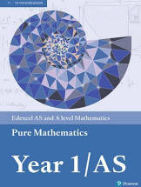 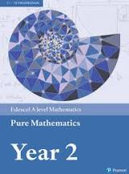

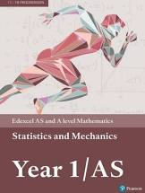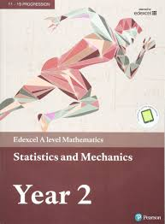

**Resources needed**

You are required to have

* a scientific calculator **Casio fx-991ex CLASSWIZ**
* ring binders to keep your work in
* file paper

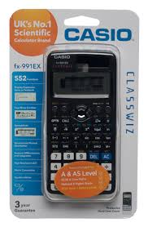

You may also find this useful to work through before the course starts in September.

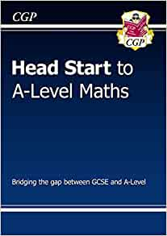

Useful Websites

* <https://qualifications.pearson.com/en/home.html>
* <https://www.physicsandmathstutor.com/>

We are looking forward to meeting you all in September!