*Maths Emporium Recipe Booklet*

[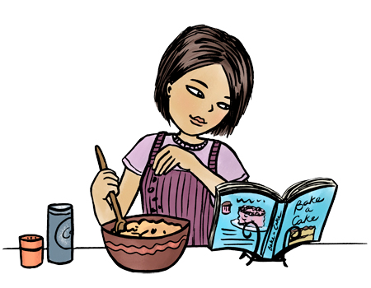](http://www.google.co.uk/url?sa=i&rct=j&q=&esrc=s&source=images&cd=&cad=rja&uact=8&ved=0ahUKEwie7siQ_sTJAhXC_Q4KHVlBDGwQjRwIBw&url=http%3A%2F%2Fcliparts.co%2Ffree-cookbook-clipart&bvm=bv.108538919,d.ZWU&psig=AFQjCNGourHrItnZvCvB8WF5OlVUMDN50A&ust=1449414007540430)

**Introduction**

Past papers aren’t just for practising your mathematics skills – they also include a number of delicious recipes for you to try in your own homes. You can calculate the correct proportions to be used for any size of gathering, and they’re all suitable for vegetarians. For those with an electronic version of this booklet, chef’s comments can be found [here](https://soundcloud.com/user-768186181).

Thanks are due to our examiners for coming up with all these mouth-watering confections which both Foundation tier and Higher tier students will enjoy while enhancing their understanding of ratio and proportion.

**Information**

The marks for individual recipes are shown in round brackets: e.g. **(2)**.

There are 17 recipes in this booklet. The total mark is **64**.

Recipes marked with a * sign will require some explanation before serving.

**Calculators must not be used for questions marked with a # sign, though Kenwood mixers can be used as and when they are required.**

**Advice**

Show all stages in any calculations.

Work steadily through the paper. Do not spend too long on one recipe.

If you cannot answer a question, leave it and attempt the next one.

Return at the end to those you have left out.

**1.** Here are the ingredients needed to make 10 pancakes.

|  |
| --- |
| **Pancakes**  Ingredients to make **10** pancakes  300 m*l* of milk  120 g of flour  2 eggs |

Matthew makes 30 pancakes.

(a) Work out how much flour he uses.

.............................................. g

**(2)**

Tara makes some pancakes.

She uses 750 m*l* of milk.

(b) Work out how many pancakes she makes.

..............................................

**(2)**

**(Total for recipe 1 is 4 marks)**

**#2.** This is a list of ingredients for making macaroni cheese for 4 people.

|  |
| --- |
| Ingredients for **4** people  100m*l* milk  200g cheese  175g dried macaroni  40g butter  50g plain flour |

Work out the amount of each ingredient needed to make macaroni cheese for **10** people.

..............................................m*l* milk

..............................................g cheese

..............................................g dried macaroni

..............................................g butter

..............................................g plain flour

**(Total for recipe 2 is 3 marks)**

**3.** Here is a list of ingredients for making a trifle for 4 people.

|  |
| --- |
| **Trifle for 4 people**  120 g of raspberry jelly  8 sponge fingers  420 m*l* of custard  180 g of tinned fruit |

Rob is going to make a trifle for **6** people.

Work out the amount of each ingredient he needs.

.......................... g of raspberry jelly

.......................... sponge fingers

.......................... m*l* of custard

.......................... g of tinned fruit

**(Total for recipe 3 is 3 marks)**

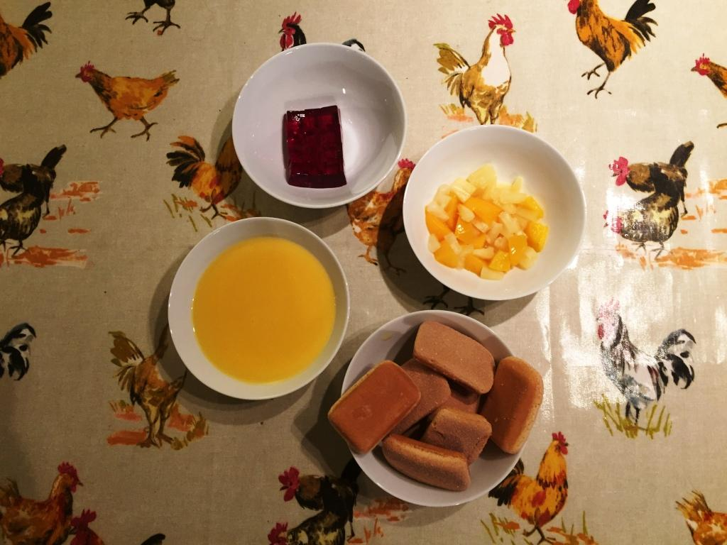

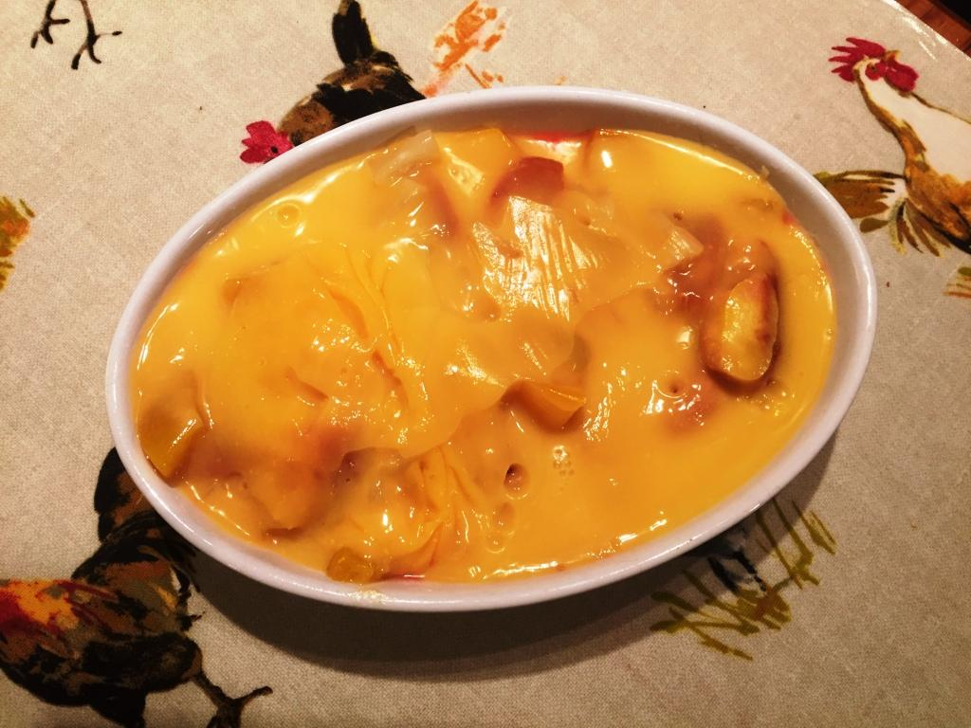

**4.** Here are the ingredients for making cheese pie for 6 people.

|  |
| --- |
| Cheese pie for **6** people  180 g flour  240 g cheese  80 g butter  4 eggs  160 m*l* milk |

Bill makes a cheese pie for **3** people.

(a) Work out how much flour he needs.

...................................... g

**(2)**

Jenny makes a cheese pie for 15 people.

(b) Work out how much milk she needs.

...................................... m*l*

**(2)**

**(Total for recipe 4 is 4 marks)**

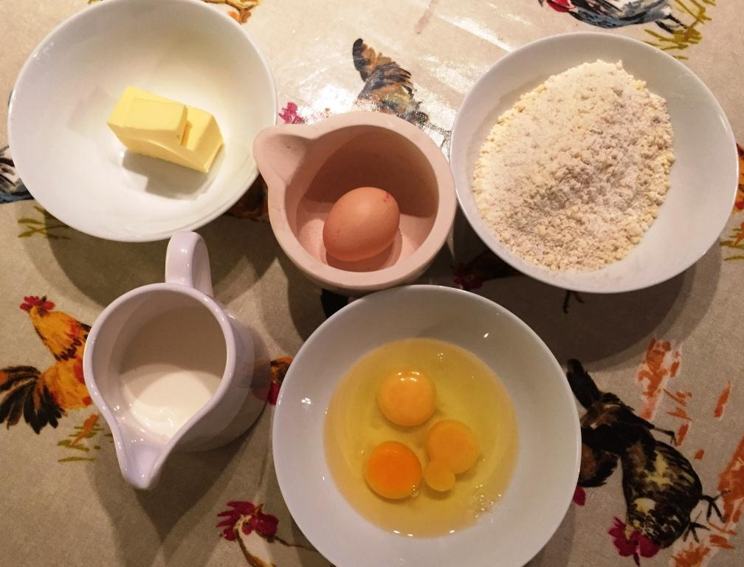 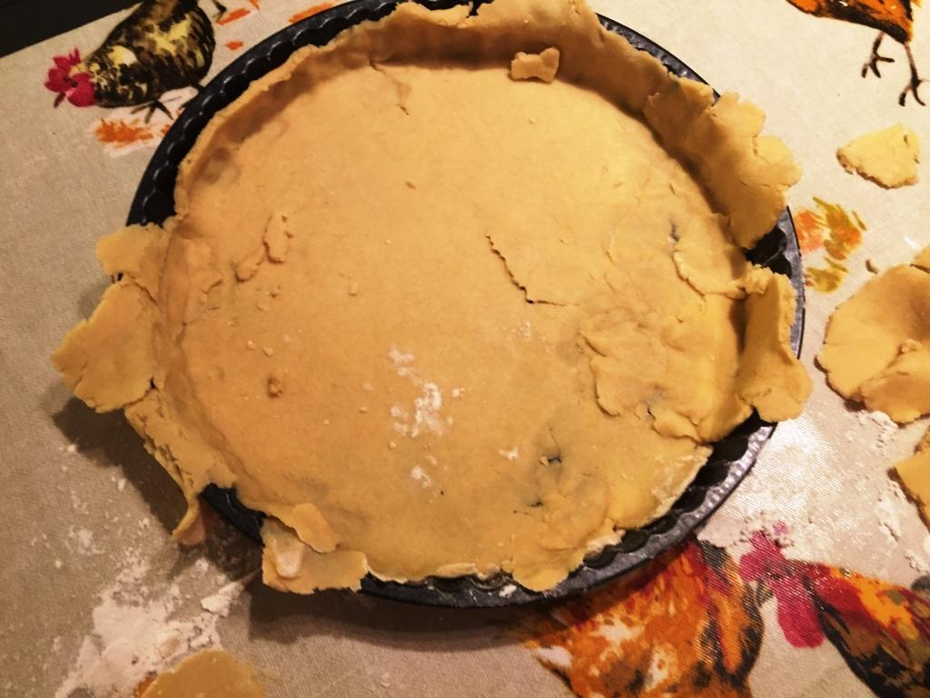

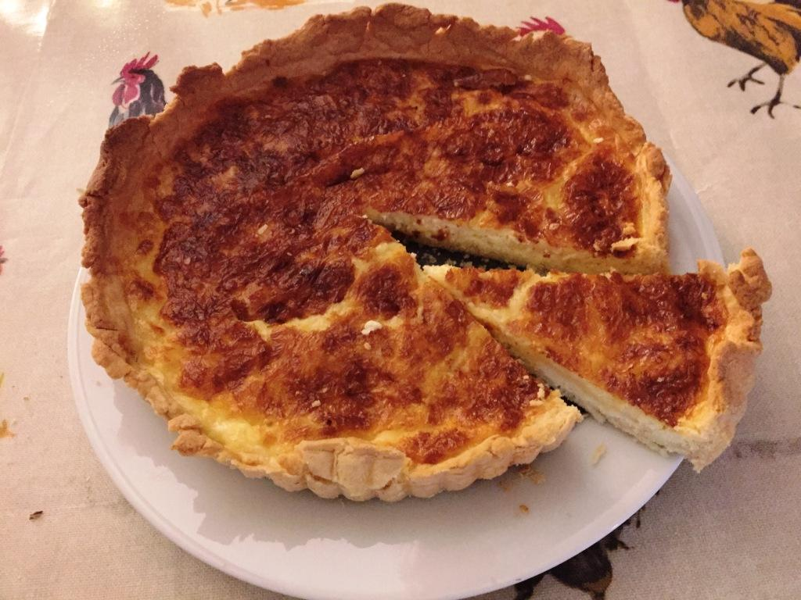

**#5.** Here is a list of ingredients for making **10** Flapjacks.

|  |
| --- |
| **Ingredients for 10 Flapjacks**  80 g rolled oats  60 g butter  30 m*l* golden syrup  36 g light brown sugar |

Work out the amount of each ingredient needed to make **15** Flapjacks.

..................... g rolled oats

..................... g butter

..................... m*l* golden syrup

..................... g light brown sugar

**(Total for recipe 5 is 3 marks)**

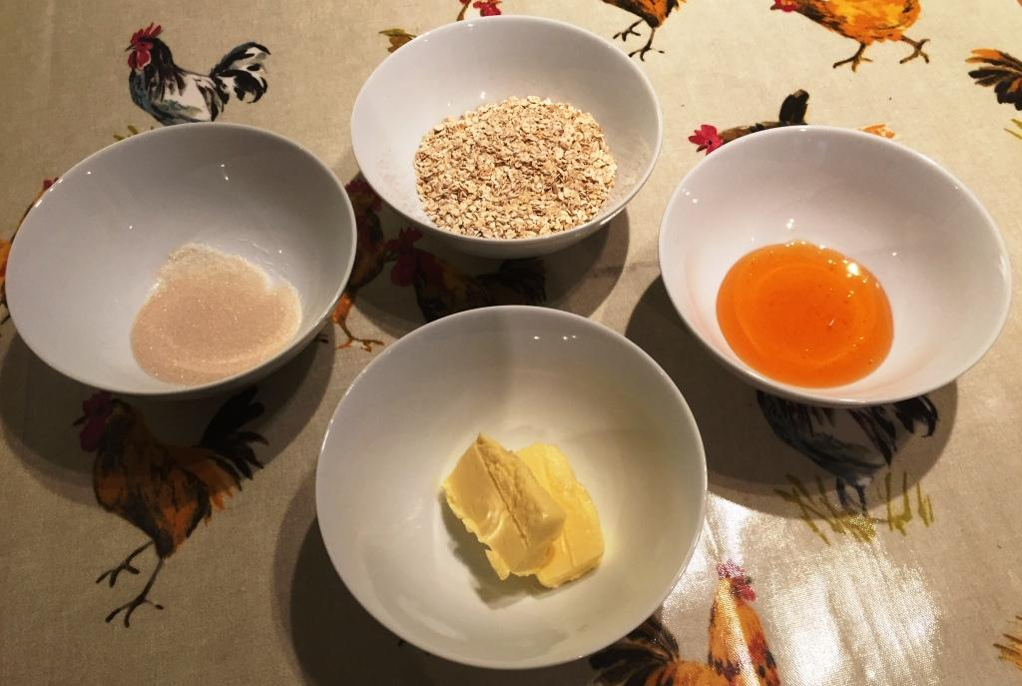 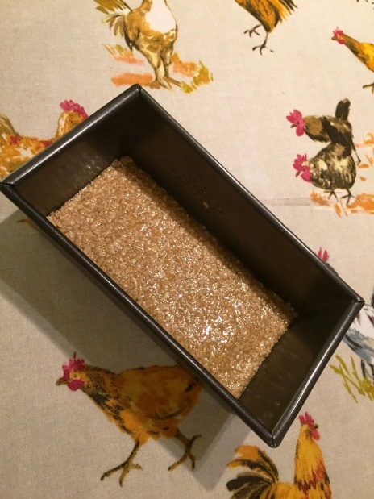

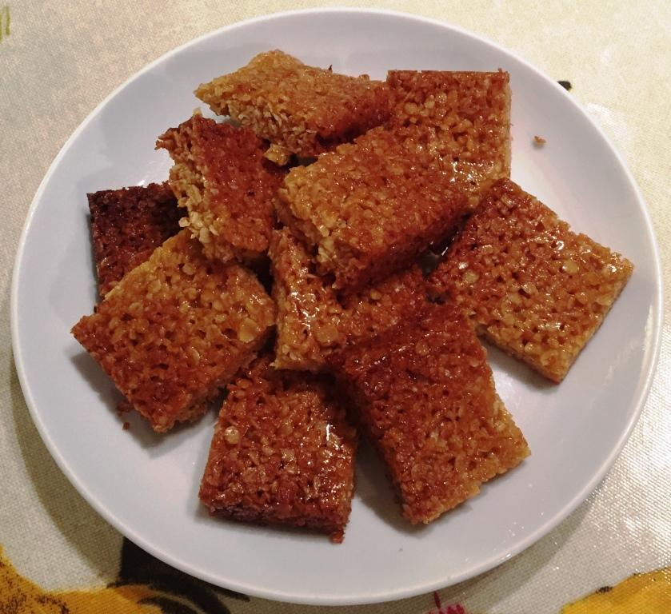

**6.** Here is a list of ingredients to make melon sorbet for **6** people.

|  |
| --- |
| **Melon Sorbet**  for 6 people  800 g melon  4 egg whites  lime  100 g caster sugar |

Terry makes melon sorbet for **18** people.

(a) Work out how much caster sugar he uses.

.................................. g

**(2)**

Hedley makes melon sorbet.

He uses 2 limes.

(b) Work out how many people he makes melon sorbet for.

.....................................

**(2)**

**(Total for recipe 6 is 4 marks)**

**#7.** This is a list of ingredients for making chicken soup for 4 people.

|  |
| --- |
| Ingredients for **4** people  60 g butter  300 g chicken  150 m*l* cream  1 onion  640 m*l* chicken stock |

Bill is going to make chicken soup for **6** people.

Work out the amount of each ingredient he needs.

.......................................... g butter

.......................................... g chicken

.......................................... m*l* cream

.......................................... onion

.......................................... m*l* chicken stock

**(Total for recipe 7 is 3 marks)**

#**8.** Here are the ingredients needed to make 8 pancakes.

|  |
| --- |
| **Pancakes**  Ingredients to make **8** pancakes  300 m*l* milk  1 egg  120 g flour  5 g butter |

Jacob makes 24 pancakes.

(a) Work out how much milk he needs.

................................................. m*l*

**(2)**

Cathie makes 12 pancakes.

(b) Work out how much flour she needs.

.................................................... g

**(2)**

**(Total for recipe 8 is 4 marks)**

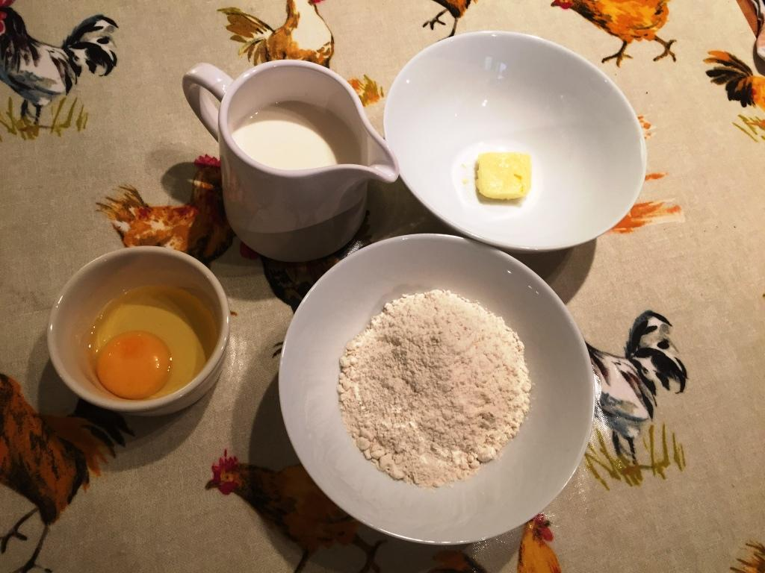

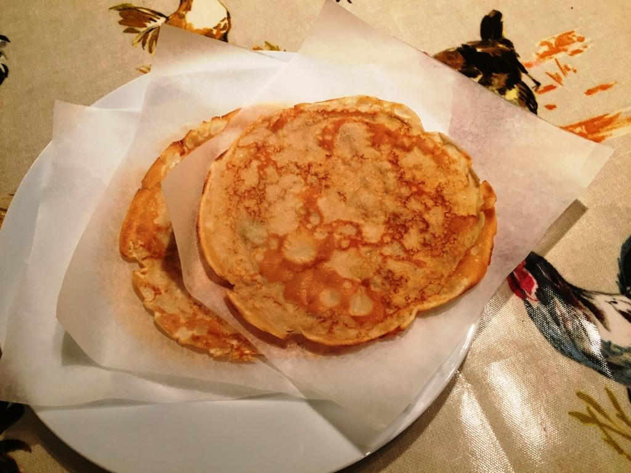

**9.** Here is a list of ingredients for making small cakes.

|  |
| --- |
| **Small cakes**  400 g flour  200 g butter  200 g sugar  2 eggs  **Makes 15 small cakes** |

Rosie has

2 kg of flour

800 g of butter

1.5 kg of sugar

12 eggs

What is the greatest number of small cakes Rosie can make?

You must show all your working.

..............................................

**(Total for recipe 9 is 4 marks)**

**\*10.** Here are the ingredients to make 12 cupcakes.

|  |
| --- |
| For **12** cupcakes  200 g butter  200 g caster sugar  4 eggs  240 g flour |

Martin is making cupcakes to sell at his school play.

Martin wants to make 1 cupcake for each adult and 2 cupcakes for each child.

There will be 90 children and 120 adults at the school play.

Martin can get these ingredients from the school kitchen.

5 kg butter

5 kg caster sugar

90 eggs

5 kg flour

Make a shopping list of any ingredients Martin still needs, showing the amount of each ingredient. You must show all your working.

..............................................

**(Total for recipe 10 is 5 marks)**

**#11.** Here is a list of ingredients for making a Cheese Soufflé.

|  |  |  |
| --- | --- | --- |
| Cheese Soufflé  3 eggs  1 oz butter  oz flour  pint milk  3 oz grated cheese |  | Imperial Units Metric Units  1 oz = 28 g    1 pint = 568 m*l* |
|  |

(a) Complete the list of ingredients using metric units.

Cheese Soufflé

..……………………………….. eggs

…………………………….. g butter

.…………………………….. g flour

.…………………………….. m*l* milk

…………………….. g grated cheese

**(2)**

Jemma wants to make 12 Cheese Soufflés.

(b) Work out how much milk she will need.

Give your answer in litres.

………………………………………………….. litres

**(2)**

**(Total for recipe 11 is 4 marks)**

**#12.** Here are the ingredients needed to make 16 gingerbread men.

|  |
| --- |
| Ingredients  to make **16** gingerbread men  180 g flour  40 g ginger  110 g butter  30 g sugar |

Hamish wants to make **24** gingerbread men.

Work out how much of each of the ingredients he needs.

..........................................................g flour

.......................................................g ginger

........................................................g butter

.........................................................g sugar

**(Total for recipe 12 is 3 marks)**

**13.** Here is a list of ingredients for making fruit buns.

|  |
| --- |
| **Fruit buns**  Flour 300 g  Butter 150 g  Sugar 150 g  Mixed fruit 100 g  Eggs 1  **Makes 12 fruit buns** |

Rosie has

3 kg of flour

900 g of butter

1 kg of sugar

800 g of mixed fruit

12 eggs

What is the greatest number of fruit buns Rosie can make?

You must show your working.

..............................................

**(Total for recipe 13 is 4 marks)**

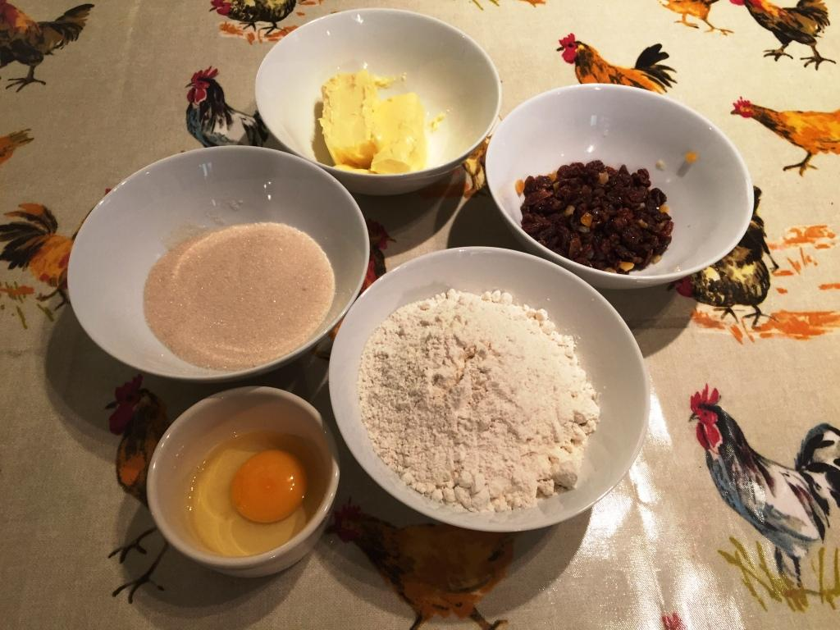

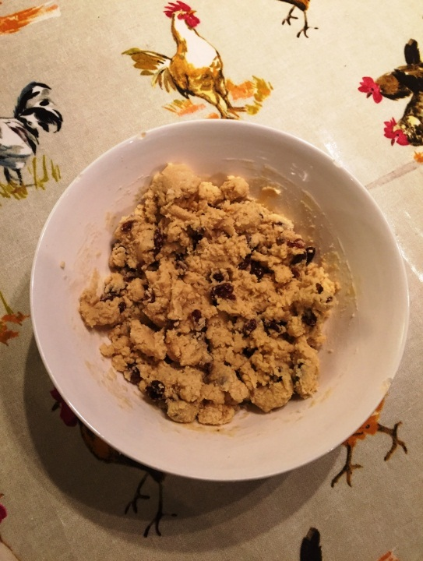 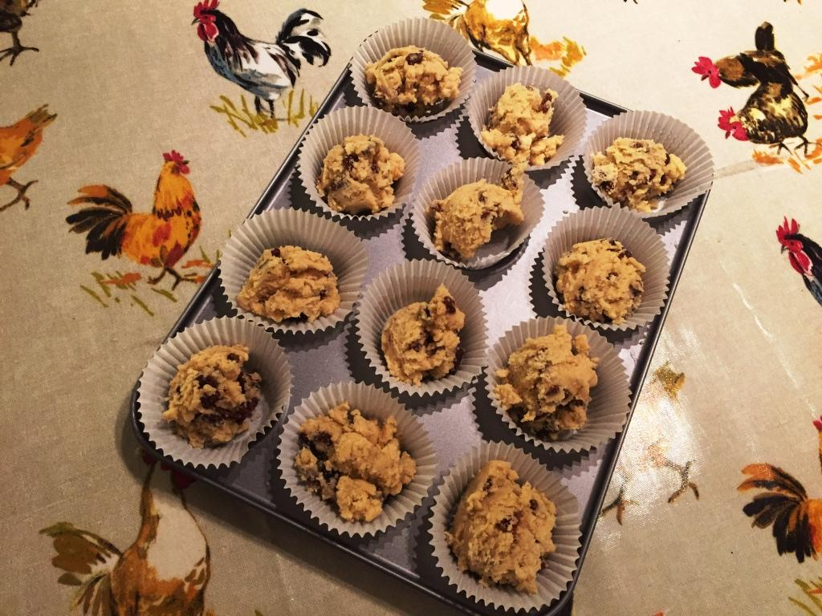

**\*14.** Here are the ingredients needed to make 20 cookies.

|  |
| --- |
| **Cookies**  Ingredients to make **20** cookies  225 g of butter  120 g of caster sugar  275 g of flour |

Liz is going to make some cookies for a party.

There will be 4 adults and 14 children at the party.

Liz wants to make 2 cookies for each adult and 3 cookies for each child.

Liz has

500 g of butter

300 g of caster sugar

1 kg of flour

Does Liz have enough butter, enough caster sugar and enough flour to make all the cookies for the party?

You must show all your working.

**(Total for recipe 14 is 5 marks)**

**15.** Here are the ingredients needed to make 12 shortcakes.

|  |
| --- |
| **Shortcakes**  Makes **12** shortcakes  50 g of sugar  200 g of butter  200 g of flour  10 m*l* of milk |

Liz makes some shortcakes.

She uses 25 m*l* of milk.

(a) How many shortcakes does Liz make?

..............................................

**(2)**

Robert has 500 g of sugar

1000 g of butter

1000 g of flour

500 m*l* of milk

(b) Work out the greatest number of shortcakes Robert can make.

..............................................

**(2)**

**(Total for recipe 15 is 4 marks)**

**\*16.** Here is a list of ingredients for making 18 mince pies.

|  |
| --- |
| **Ingredients for 18 mince pies**  225 g of butter  350 g of flour  100 g of sugar  280 g of mincemeat  1 egg |

Elaine wants to make **45** mince pies.

Elaine has

1 kg of butter

1 kg of flour

500 g of sugar

600 g of mincemeat

6 eggs

Does Elaine have enough of each ingredient to make 45 mince pies?

You must show clearly how you got your answer.

**(Total for recipe 16 is 4 marks)**

**#17.** Here are the ingredients needed to make **8** shortbread biscuits.

|  |
| --- |
| Shortbread biscuits |
| makes **8** biscuits |
| 120 g butter |
| 60 g caster sugar |
| 180 g flour |

Tariq is going to make some shortbread biscuits.

He has the following ingredients

330 g butter 200 g caster sugar 450 g flour

Work out the greatest number of shortbread biscuits that Tariq can make with his ingredients.

You must show all your working.

......................................... biscuits

**(Total for recipe 17 is 3 marks)**

**TOTAL = 64 MARKS**

**BLANK PAGE**

| **Edexcel Recipe Book – Mark Scheme** | | | | | |
| --- | --- | --- | --- | --- | --- |
| **Question** | | **Working** | **Answer** | **Mark** | **Notes** |
| 1 | (a) |  | 360 | 2 | M1 30 ÷ 10 (= 3) or 120 ÷ 10 (=12) or 120 + 120 + 120 oe  A1 cao |
|  | (b) |  | 25 | 2 | M1 for (=2.5) oe  A1 cao |
| 2 |  |  | 250  500  437.5  100  125 | 3 | M1 for identifying the scale factor  e.g. 10 ÷ 4 can be implied by one correct answer  A1 for three correct; A1 for all correct |
| 3 |  | 120×1.5  8×1.5  420×1.5  180×1.5 | 180  12  630  270 | 3 | M1 for × 6 ÷ 4 or 4/6  or ÷4 × 6 oe (120 + 60) or 1.5 seen or sight of any one of the four correct answers  A1 for 2 or more correct answers  A1 for 4 correct answers |
| 4 | (a) | 180 ÷ 2 | 90 g | 2 | M1 180 ÷ 2 **OR** 180 ÷ 6 × 3 oe  A1 cao |
|  | (b) | 160 × 2.5 | 400 m*l* | 2 | M1 160 × 2.5 **OR** 160 ÷ 6 × 15 **OR** 160 ÷ 2 × 5 oe  A1 cao |
| 6 | (a) | 3 × 100 | 300 | 2 | M1 for 3 × 100 or 100 ÷ 6 × 18 oe  A1 cao |
|  | (b) | 2 ÷ ½ × 6 | 24 | 2 | M1 for 2 ÷ ½ × 6 oe  A1 cao |
| 7 |  |  | 90  450  225  1.5  960 | 3 | M1 for 6 ÷ 4 (= 1.5) or 4 ÷ 6 (= 0.66..) or ÷4 × 6 oe or sight of any one of the correct answers  A1 for three correct  A1 for all correct |
| 8 | (a) |  | 900 | 2 | M1 for  oe or oe or 300 + 300 + 300  A1 for 900 |
|  | (b) |  | 180 | 2 | M1 for use of or 1.5 or 120 + 60 or “1208”  12  A1 for 180 |
| 9 |  | **Number of batches**  Flour 2000 ÷ 400 = 5  Butter 800 ÷ 200 = 4  Sugar 1500 ÷ 200 = 7.5  Eggs 12 ÷ 2 = 6  15 × 4 =  **Number of cakes**  Flour 400 ÷ 15 = 26.67 g  2000 ÷ 26.67 = 75 cakes  Butter 200 ÷ 15 = 13.33 g  800 ÷ 13.3 = 60 cakes  Sugar 200 ÷ 15 = 13.33 g  1500 ÷ 13.33 = 112 to 113 cakes  Eggs 2 ÷ 15 = 0.133  12 ÷ 0.133 = 90 cakes | 60 | 4 | M1 for appropriate method to find how many batches of cakes using one ingredient or the number of cakes one of the ingredients available can make  M1 for appropriate method to find how many batches of cakes using at least 3 ingredients **or** the number of cakes at least 3 of the available ingredients can make  M1 for 15 × “4” or identifying their smallest number of cakes  A1 for 60 cao with supported working for all ingredients |
| *10 |  |  | Needed:  10 eggs  1 kg flour | 5 | M1 number of cupcakes is 90×2 + 120 (=300)  M1 scaling “300”÷12 (=25)  M1 needed 200 × “25” or 4 × “25” or 240 × “25”  or 5000 or 100 or 6000  A1 5000 (g) and 100 (eggs) and 6000 (g)  C1 (dep on at least M1) correct statement of which items are needed with quantities and units  OR  M1 number of cupcakes is 90×2 + 120 (=300)  M1 scaling “300”÷12 (=25)  M1 no. cupcakes 5 ÷ “25” or 90 ÷ “25”  A1 0.2, 3.6, 0.2 f  C1 (dep on at least M1) correct statement of which items are needed with quantities and units.  OR  M1 number of cupcakes is 90×2 + 120 (=300)  M1 200 ÷ 12(=16.6..), 4 ÷ 12(= 0.33..), 240 ÷ 12 (=20)  M1 “300” × “16.6” and “300” × “0.33” and “300” × “16.6”  A1 5000 (g) and 100 (eggs) and 6000 g)  C1 (dep on at least M1) correct statement of which items are needed with quantities and units |
| 11 | (a) |  | 28g butter 14g flour 142m*l* milk 84g cheese | 2 | M1 for use of 1 ounce = 28g or 1 pint= 568m*l* (may be implied by at least 2 correct quantities)  A1 cao |
|  | (b) | 12 × 142 | 1.704 | 2 | M1 for 12 × “142” or sight of figures 1704  A1 ft (accept 1.7, 1.70) |
| 12 |  | 180 × 1.5  40 × 1.5  110 × 1.5  30 × 1.5 | Flour = 270  Ginger = 60  Butter = 165  Sugar = 45 | 3 | M1 for × 24 ÷ 16 oe or 24/16 or 1.5 seen or 180 + 90 (= 270) or 40 + 20 (= 60) or 110 + 55 (=165) or 30 + 15 (=4 5) or sight of any one of the correct answers  A2 for all 4 correct answers (A1 for 2 or 3 correct answers) |
| 13 |  | Flour: 300 ÷ 12 = 25  3000 ÷ 25 = 120  Butter 150 ÷ 12 = 12.5  900 ÷ 12.5 = 72  Sugar 150 ÷ 12 = 12.5  1000 ÷ 12.5 = 80  Fruit 100 ÷ 12 = 8.3(33..)  800 ÷ 8.3(33..) = 96  Eggs 1÷ 12 = 0.08(33..)  12 ÷ 0.08(33..) = 144  Flour: 3000 ÷ 300 = 10  12 × 10 = 120  Butter 900 ÷ 150 = 6  12 × 6 = 72  Sugar 1000 ÷ 150 = 6.6(66..)  12 × 6.6(66..) = 80  Fruit 800 ÷ 100 = 8  12 × 8 = 96  Eggs 12÷ 1 = 12  12 × 12 = 144 | 72 | 4 | M1 for a correct method to either find the amount of one ingredient required for one bun, eg. 300 ÷ 12 (= 25 g), 150 ÷ 12 (= 12.5 g), etc.  or for a correct method to find the number of groups of 12 buns that are possible with the amount of one ingredient available, eg. 3000 ÷ 300 (= 10), 900 ÷ 150 (= 6), etc.  M1 (dep) for a correct method for considering all ingredients in this way  M1 for a fully complete and correct method leading to the number of buns that can be made from each ingredient.  A1for 72 cao |
| *14 |  |  | Not enough butter,  enough sugar  and enough flour | 5 | M1 for a correct method to find the total number of cookies required (= 50)  M1 (dep) for “50” ÷ 20 (= 2.5)  M1 (dep on M2) for 2.5 used as a factor  A1 for two of: 562.5, 300, 687.5  or two of: 2.22… , 2.5, 3.636…  or two of: 200, 120, 400  C1 (dep on M2) for 562.5g and 300g and 687.5g  or for 2.22… and 2.5 and 3.636…  or for 200g and 120g and 400g  AND a correct decision for all three ingredients  **OR**  M1 for a correct method to find the total number of cookies required (= 50)  M1 for a correct method to find the number of cookies  one ingredient could produce  M1 for correct method to find the number of cookies  that ALL ingredients could produce  A1 for two of: 44. … , 50 and 72. …  C1 (dep on at least M2) for 44. .. cookies  and 50 cookies and 72. … cookies  AND a correct decision for all three ingredients |
| 15 | (a) |  | 30 | 2 | M1 for 25 ÷ 10 or 2.5 seen or 10 ÷ 25 or 0.4 seen or  12 + 12 + 6 oe or a complete method eg. 25 × 12 ÷ 10 oe  A1 cao |
|  | (b) | 1000 ÷ 200 × 12 | 60 | 2 | M1 for 500÷50 or 1000÷200 or 500÷10  OR  correct scale factor clearly linked with one ingredient  eg. 10 with sugar or 5 with butter or flour or 50 with milk  OR  answer of 120 or 600  A1 cao |
| *16 |  |  | Not enough mincemeat since 600 < 700  OR  Only able to make 38 mince pies since insufficient mincemeat | 4 | M1 for 45 ÷ 18 (= 2.5)  M1 for 2.5 used as factor or divisor  A1 for ingredients as 562.5 and 875 and 250 and 700 and 2.5 (accept 2 or 3) OR for availables as 400, 400, 200 240, 2.4 (accept 2 or 3)  C1 ft (dep on at least M1) for identifying and stating which ingredient is insufficient for the recipe (with some supportive evidence)  OR  M1 for a correct method to determine the number of pies one ingredient could produce  M1 for a correct method to determine the number of pies **all** ingredient could produce  A1 for 80 and 51 and 90 and 38 and 108  C1 ft (dep on at least M1) for identifying and stating which ingredient is insufficient for the recipe. (with some supportive evidence) |
| 17 |  |  | 20 | 3 | M1 for 330 ÷ 120 (= 2.75) or 200 ÷ 60 (=3 1/3) or 450 ÷180 (= 2.5)  M1 for 450 ÷ 180 (= 2.5) AND 8 × “2.5” (= 20)  A1 cao  **OR**  M1 for 120 ÷ 8 (= 15) or 60 ÷ 8 (= 7.5) or 180 ÷ 8 (= 22.5)  M1 for 330 ÷ (120 ÷ 8) (= 22) or 200 ÷ (60 ÷ 8) (= 26.6...) or 450 ÷ (180 ÷ 8) (= 20)  A1 cao  **OR**  M1 for multiples of 120:60:180, e.g. 240:120:360  M1 for multiples linked to 450 and 8 + 8 + 4 or scaling 2.5, oe  A1 cao |

Questions were taken from the following past linear (2540, 130 and 1MA0) and linked pair pilot (5AM1 and 5AM2) papers. The average score for students achieving each of the grades A*–G are shown in the table below. Students on average achieved over 50% in all but six of the recipe questions.

|  |  |  |  |  |  |  |  |  |  |  |  |  |  |  |  |  |  |
| --- | --- | --- | --- | --- | --- | --- | --- | --- | --- | --- | --- | --- | --- | --- | --- | --- | --- |
| **Spec** | **Paper** | **Year-Month** | **Orig**  **Qn** | **Qn** | **Recipe** | **Mean score** | **Max score** | **Mean %** | **ALL** | **A\*** | **A** | **B** | **C** | **D** | **E** | **F** | **G** |
| 1MA0 | 2F | 14-11 | Q20 | 1 | 10 Pancakes | 3.31 | 4 | 83 | 3.31 |  |  |  | 3.82 | 3.59 | 3.25 | 2.76 | 2.11 |
| 1MA0 | 2H | 14-11 | Q01 | 1 | 10 Pancakes | 3.43 | 4 | 86 | 3.43 | 3.96 | 3.94 | 3.86 | 3.64 | 3.26 | 2.62 |  |  |
| 5AM1 | 1H | 12-06 | Q05 | 2 | Macaroni cheese | 2.88 | 3 | 96 | 2.88 | 2.99 | 2.97 | 2.93 | 2.86 | 2.65 | 1.00 |  |  |
| 1380 | 2H | 10-06 | Q01 | 3 | Trifle | 2.85 | 3 | 95 | 2.85 | 2.99 | 2.95 | 2.90 | 2.79 | 2.52 | 2.03 |  |  |
| 2540 | 2F | 08-11 | Q22 | 4 | Cheese pie | 2.86 | 4 | 72 | 2.86 |  |  |  | 3.64 | 3.19 | 2.45 | 1.61 | 0.92 |
| 2540 | 2H | 08-11 | Q01 | 4 | Cheese pie | 3.56 | 4 | 89 | 3.56 | 3.95 | 3.90 | 3.77 | 3.55 | 3.07 | 2.75 |  |  |
| 1380 | 1H | 11-06 | Q01 | 5 | Flapjacks | 2.75 | 3 | 92 | 2.75 | 2.96 | 2.91 | 2.84 | 2.68 | 2.36 | 1.91 |  |  |
| 1380 | 2H | 10-11 | Q04 | 6 | Melon Sorbet | 3.51 | 4 | 88 | 3.51 | 3.82 | 3.73 | 3.67 | 3.53 | 3.18 | 2.66 |  |  |
| 1MA0 | 1H | 13-11 | Q01 | 7 | Chicken soup | 2.55 | 3 | 85 | 2.55 | 2.95 | 2.89 | 2.81 | 2.63 | 2.17 | 1.32 |  |  |
| 2540 | 3H | 08-06 | Q01 | 8 | 8 Pancakes | 3.66 | 4 | 92 | 3.66 | 3.93 | 3.83 | 3.70 | 3.50 | 3.14 | 2.81 |  |  |
| 5AM2 | 2F | 15-06 | Q26 | 9 | Small cakes | 2.02 | 4 | 51 | 2.02 |  |  |  | 3.35 | 2.42 | 1.43 | 0.48 | 0.16 |
| 5AM2 | 2H | 15-06 | Q10 | 9 | Small cakes | 3.54 | 4 | 89 | 3.54 | 3.89 | 3.81 | 3.61 | 3.38 | 2.69 | 1.46 |  |  |
| 5AM2 | 2F | 14-11 | Q20 | 10 | Cupcakes | 2.04 | 5 | 41 | 2.04 |  |  |  | 4.00 | 2.53 | 1.24 | 0.20 | 0.25 |
| 5AM2 | 2H | 14-11 | Q06 | 10 | Cupcakes | 3.90 | 5 | 78 | 3.90 | 5.00 | 5.00 | 3.88 | 4.04 | 3.07 | 0.33 |  |  |
| 5AM1 | 1F | 11-11 | Q20 | 11 | Cheese souffle | 2.20 | 4 | 55 | 2.20 |  |  |  | 3.04 | 2.87 | 2.11 | 1.45 | 0.84 |
| 5AM1 | 1H | 11-11 | Q02 | 11 | Cheese souffle | 3.44 | 4 | 86 | 3.44 | 3.83 | 3.71 | 3.60 | 3.45 | 2.71 | 2.00 |  |  |
| 1MA0 | 1F | 12-11 | Q23 | 12 | Gingerbread men | 1.34 | 3 | 45 | 1.34 |  |  |  | 2.36 | 1.75 | 1.11 | 0.58 | 0.29 |
| 1MA0 | 1H | 12-11 | Q01 | 12 | Gingerbread men | 2.23 | 3 | 74 | 2.23 | 2.93 | 2.83 | 2.66 | 2.33 | 1.71 | 0.95 |  |  |
| 5AM2 | 2F | 14-06 | Q19 | 13 | Fruit Buns | 1.78 | 4 | 45 | 1.78 |  |  |  | 3.09 | 2.17 | 1.04 | 0.38 | 0.23 |
| 5AM2 | 2H | 14-06 | Q04 | 13 | Fruit Buns | 3.28 | 4 | 82 | 3.28 | 3.78 | 3.52 | 3.40 | 3.15 | 2.40 | 1.08 |  |  |
| 5AM2 | 2F | 13-06 | Q18 | 14 | Cookies | 2.50 | 5 | 50 | 2.50 |  |  |  | 3.85 | 2.95 | 1.42 | 0.76 | 0.45 |
| 5AM2 | 2H | 13-06 | Q02 | 14 | Cookies | 4.04 | 5 | 81 | 4.04 | 4.60 | 4.45 | 4.14 | 3.68 | 2.98 | 1.11 |  |  |
| 1MA0 | 1H | 12-06 | Q06 | 15 | Shortcakes | 3.05 | 4 | 76 | 3.05 | 3.79 | 3.58 | 3.33 | 2.91 | 2.07 | 1.30 |  |  |
| 1MA0 | 2F | 13-06 | Q22 | 16 | Mince pies | 1.12 | 4 | 28 | 1.12 |  |  |  | 2.84 | 1.78 | 0.80 | 0.23 | 0.06 |
| 1MA0 | 2H | 13-06 | Q02 | 16 | Mince pies | 2.81 | 4 | 70 | 2.81 | 3.77 | 3.59 | 3.31 | 2.76 | 1.75 | 0.61 |  |  |
| 1MA0 | 1F | 12-06 | Q23 | 15 | Shortcakes | 1.67 | 4 | 42 | 1.67 |  |  |  | 2.79 | 2.05 | 1.48 | 0.86 | 0.40 |
| 1MA0 | 1F | 15-11 | Q19 | 17 | Shortbread biscuits |  | 3 | Data not yet available | | | | |  |  |  |  |  |
| 1MA0 | 1H | 15-11 | Q05 | 17 | Shortbread biscuits |  | 3 |  |  |  |  |  |