LPGS AQA A Level Law
Student handbook

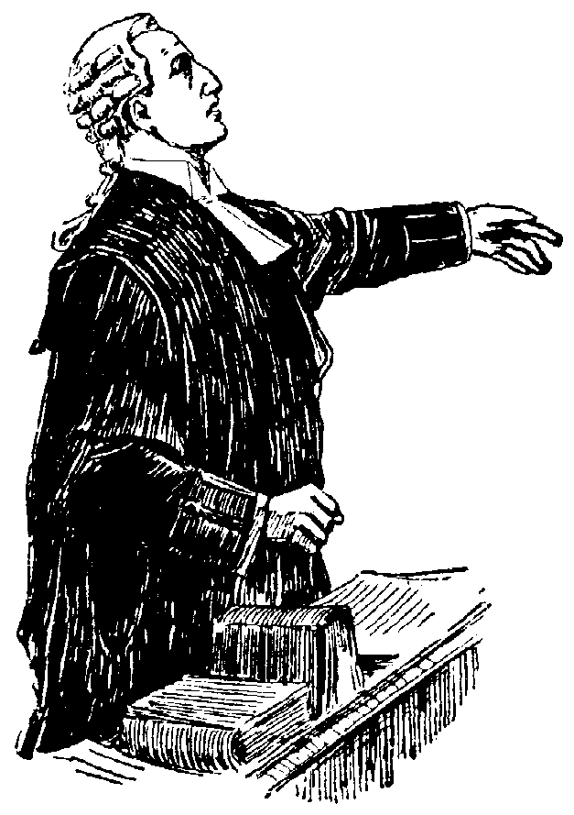

- The plan for the two years (provided at the start of the course)
- Frequently asked questions and everything you need to know
- Specification
- Summary sheets for substantive law ( to be provided once course starts)

Curriculum Intent:
Philosophy of the department
Everyone is affected by the law. Knowledge of the law can give people more control over their lives and more confidence in their dealings with others. People should be aware of their rights under the law and, equally, of their legal duty to respect the rights of others. Law is not a dry and dusty subject. The cases we study involve real people and decisions about what is fair, just and morally right.
The course encourages you to develop the skills necessary to analyse and solve problems. The main way that you are assessed in the exam is in being given problem scenarios where you are expected to explain how the law applies to that situation. In legal writing, we value an ability to write precisely and concisely.
These are skills which will complement virtually any other subject and which will be valued by employers and universities. Many students combine law with business, geography, psychology, politics or the sciences.
What do we expect from our students? Learning in law is not a passive activity. We expect that you will take an active part in all class activities. We hope that you will have a genuine interest in law and will enjoy developing your own understanding. During the course you will attend criminal trials, visit Parliament and listen to visiting speakers. The expectation is that you will enjoy and engage with these to enhance your own learning.
We expect you to do your best at all times and we will help you to achieve your best.
How do we make the curriculum more representative of diverse women?
When we visit courts and Parliament you will see women in power (MPs, judges/barristers and solicitors) and see women from BAME backgrounds
How is the course designed?
We start with where you are at: interest/knowledge (crime)
We try to make what you are learning accessible and tangible e.g. by acting out or watching trials. And by taking you out of the classroom.
We start by teaching you some skills and legal language.

Paper 1 Criminal Law

Paper 2 Tort

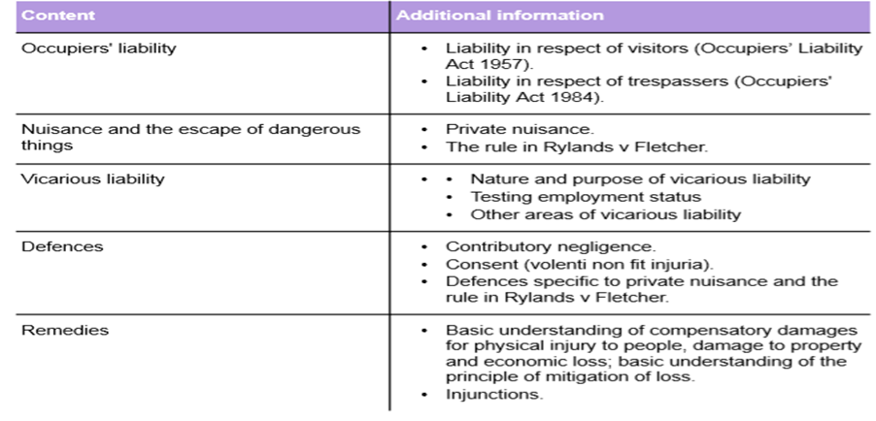

Paper 3

The English Legal System: distribution of topics

Who teaches us?
Mrs Murray-Smith BA and Mr Saunders-Griffin
cms@lpgs.bromley.sch.uk

How many lessons do we have?
Three double lessons per week
What resources are there?
You need to buy a copy of My Revision Notes AQA A Level Law by Claire Wilson and Craig Beauman published by Hodder Education
We subscribe to Flipped Law and to the Law Review magazine
There is a selection of law textbooks and books for wider reading in the class room

Do we go on any trips?
During the course you can expect to visit the Houses of Parliament and The Old Bailey. We may also visit the Royal Courts of Justice and the Middle Temple.
How are we assessed?
During the course
You will complete guided learning work (supervised private study). This will be a mixture of your own research and of completing exam questions. The research booklets will be checked.
Exam questions will be marked and graded:
Excellent- comprehensive answer, law accurately defined and applied (A*)
Good-answer is broadly accurate but there may be some omissions/errors (A/B)
Satisfactory- you have shown a reasonable understanding but have significant errors/omissions (C/D)
Limited- some of the answer is accurate (E)
Minimal- there is not much in your answer which is relevant (U)
You will complete exam questions in and out of class.
When you are studying substantive law (actual law) you will have weekly case tests.

At the end of the course
There are three two hour exams. Each of the papers follows the same format.

