**What’s wrong with the diagram?**

**Instructions**

* Use **black** ink or ball-point pen.
  + **Fill in the boxes** at the top of this page with your name,  
    centre number and candidate number.
* Answer **all** questions.
* Answer the questions in the spaces provided  
  *– there may be more space than you need.*
* You must **show all your working.**
* Diagrams are **NOT** accurately drawn, unless otherwise indicated.
* If your calculator does not have a *π* button, take the value of *π* to be3.142

unless the question instructs otherwise.

**Information**

* The total mark for this paper is **16**. There are **8** questions.
* Questions have been arranged in an ascending order of mean difficulty, as found by all students in the June 2017–November 2019 examinations.
* The marks for **each** question are shown in brackets  
  *– use this as a guide as to how much time to spend on each question.*

**Advice**

1. Read each question carefully before you start to answer it.
2. Keep an eye on the time.
3. Try to answer every question.
4. Check your answers if you have time at the end.

**1** David sells CDs in a shop.

The tally chart shows information about the number of CDs David sold

on Monday, on Tuesday and on Wednesday.

|  |  |  |
| --- | --- | --- |
|  | **Tally** | **Frequency** |
| **Monday** |  | 12 |
| **Tuesday** |  | 18 |
| **Wednesday** |  | 8 |

(*a*)Write down **one** thing that is wrong with the tally chart.

......................................................................................................................................................

......................................................................................................................................................

**(1)**

David drew this pictogram to show the information for Tuesday and Wednesday.



(*b*)Write down **one** thing that is wrong with this pictogram.

......................................................................................................................................................

......................................................................................................................................................

**(1)**

**(Total for Question 1 is 2 marks)**

**___________________________________________________________________________**

**2** The table shows the number of TVs sold in a shop on each of five days.

|  |  |  |  |  |  |
| --- | --- | --- | --- | --- | --- |
| **Day** | Mon | Tue | Wed | Thu | Fri |
| **Number of TVs sold** | 8 | 12 | 9 | 6 | 8 |

David uses this information to draw the graph below.



Number of TVs sold

TVs sold

Write down **three** things wrong with this graph.

1 ...................................................................................................................................................

2 ...................................................................................................................................................

3 ...................................................................................................................................................

**(Total for Question 2 is 3 marks)**

**___________________________________________________________________________**

**3** Here are the ages, in years, of 20 footballers.

|  |  |  |  |  |  |  |  |  |  |
| --- | --- | --- | --- | --- | --- | --- | --- | --- | --- |
| 17 | 32 | 25 | 41 | 23 | 26 | 29 | 29 | 32 | 30 |
| 21 | 17 | 40 | 35 | 34 | 28 | 32 | 19 | 27 | 31 |

Wayne drew this stem and leaf diagram to show this information.

|  |  |  |  |  |  |  |  |  |  |  |
| --- | --- | --- | --- | --- | --- | --- | --- | --- | --- | --- |
| 1 | 7 | 7 | 9 |  | | | | Key: 1|7 represents 17 footballers | | |
| 2 | 1 | 3 | 5 | 6 | 7 | 8 | 9 |  |  |  | |
| 3 | 0 | 1 | 2 | 2 | 2 | 4 | 5 |  |  |  | |
| 4 | 1 | 0 |  |  |  |  |  |  |  |  | |

Write down two things that are wrong with the stem and leaf diagram.

**1** ...................................................................................................................................................

**2** ...................................................................................................................................................

**(Total for Question 3 is 2 marks)**

**4** Sean has information about the height, in cm, and the weight, in kg, of each of ten rugby players.

He is asked to draw a scatter graph and a line of best fit for this information.

Here is his answer.



Sean has plotted the points accurately.

Write down two things that are wrong with his answer.

1..........................................................................................................................................................................................................................................................................................................

......................................................................................................................................................

2....................................................................................................................................................

......................................................................................................................................................

......................................................................................................................................................

**(Total for Question 4 is 2 marks)**

**___________________________________________________________________________**

**5** The table shows some information about the weights of 50 potatoes.

|  |  |
| --- | --- |
| **Weight (*w* grams)** | **Frequency** |
| 10 < *w* ⩽ 20 | 6 |
| 20 < *w* ⩽ 30 | 21 |
| 30 < *w* ⩽ 40 | 13 |
| 40 < *w* ⩽ 50 | 7 |
| 50 < *w* ⩽ 60 | 3 |

Iveta drew this frequency polygon for the information in the table.

The frequency polygon is **not** fully correct.

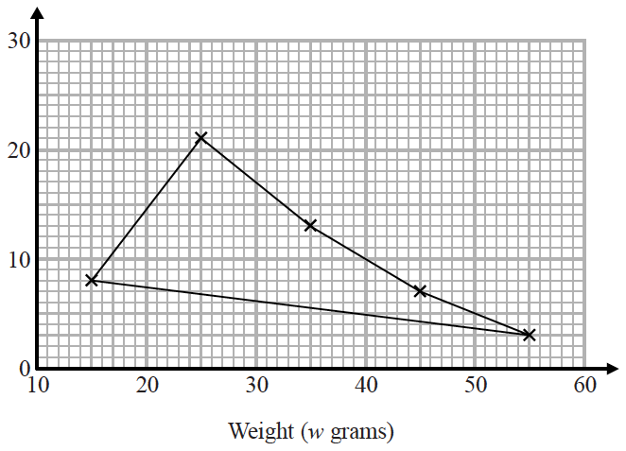

Write down **two** things that are wrong with the frequency polygon.

1..........................................................................................................................................................................................................................................................................................................2..........................................................................................................................................................................................................................................................................................................**(Total for Question 5 is 2 marks**

**6** When a biased 6-sided dice is thrown once, the probability that it will land on 4 is 0.65

The biased dice is thrown twice.

Amir draws this probability tree diagram.

The diagram is **not** correct.



Write down **two** things that are wrong with the probability tree diagram.

1....................................................................................................................................................

......................................................................................................................................................

2 ......................................................................................................................................................

......................................................................................................................................................

(**Total for Question 6 is 2 marks**)

**___________________________________________________________________________**

**7** Sean has drawn a time series graph to show the numbers, in thousands, of visitors to a

fun park.

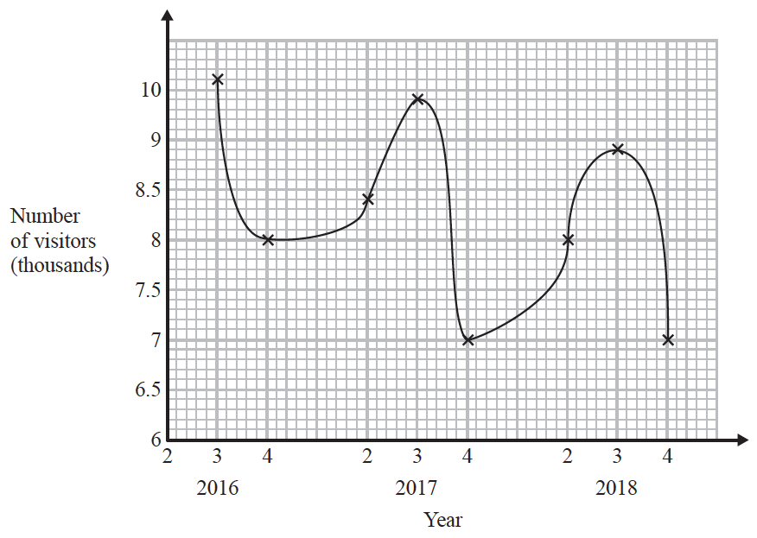

Write down two things that are wrong or could be misleading with this graph.

1 ...................................................................................................................................................

......................................................................................................................................................

......................................................................................................................................................

2 ...................................................................................................................................................

......................................................................................................................................................

......................................................................................................................................................

**(Total for Question 7 is 2 marks)**

**___________________________________________________________________________**

**8** Brogan needs to draw the graph of *y* = *x*2 + 1

Here is her graph.

**

Write down one thing that is wrong with Brogan’s graph.

......................................................................................................................................................

......................................................................................................................................................

**(Total for Question 8 is 1 mark)**

**TOTAL MARKS FOR PAPER: 16**