**Statistical diagrams: Scatter graphs**

**Instructions**

* Use **black** ink or ball-point pen.
  + **Fill in the boxes** at the top of this page with your name,  
    centre number and candidate number.
* Answer **all** questions.
* Answer the questions in the spaces provided  
  *– there may be more space than you need.*
* You must **show all your working.**
* Diagrams are **NOT** accurately drawn, unless otherwise indicated.
* If your calculator does not have a *π* button, take the value of *π* to be3.142

unless the question instructs otherwise.

**Information**

* The total mark for this paper is **22**. There are **6** questions.
* Questions have been arranged in an ascending order of mean difficulty, as found by all students in the June 2017–November 2019 examinations.
* The marks for **each** question are shown in brackets  
  *– use this as a guide as to how much time to spend on each question.*

**Advice**

1. Read each question carefully before you start to answer it.
2. Keep an eye on the time.
3. Try to answer every question.
4. Check your answers if you have time at the end.

**1** The scatter graph shows information about the marks a group of students got in a Science

test and in a Maths test.

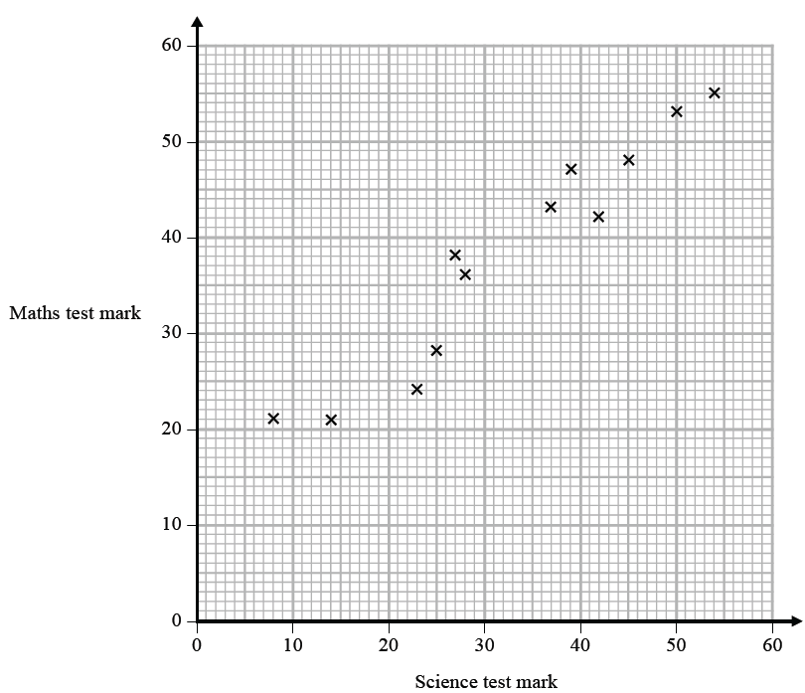

Jamie got a mark of 34 in the Science test.

Using the scatter graph, find an estimate for Jamie’s mark in the Maths test.

.......................................................

**(Total for Question 1 is 2 marks)**

**___________________________________________________________________________**

**2** The scatter graph shows the maximum temperature and the number of hours of sunshine

in fourteen British towns on one day.



One of the points is an outlier.

(*a*)Write down the coordinates of this point.

( .......................... , ..........................)

**(1)**

(*b*)For all the other points write down the type of correlation.

.......................................................

**(1)**

On the same day, in another British town, the maximum temperature was 16.4 °C.

(*c*)Estimate the number of hours of sunshine in this town on this day.

...................................................... hours

**(2)**

A weatherman says,

“Temperatures are higher on days when there is more sunshine.”

(*d*)Does the scatter graph support what the weatherman says?

Give a reason for your answer.

......................................................................................................................................................

......................................................................................................................................................

**(1)**

**(Total for Question 2 is 5 marks)**

**_________________________________________________________________________**

**3** Sean has information about the height, in cm, and the weight, in kg, of each of ten rugby players.

He is asked to draw a scatter graph and a line of best fit for this information.

Here is his answer.



Sean has plotted the points accurately.

Write down two things that are wrong with his answer.

1..........................................................................................................................................................................................................................................................................................................

2....................................................................................................................................................

......................................................................................................................................................

**(Total for Question 3 is 2 marks)**

**___________________________________________________________________________**

**4** The scatter diagram shows information about 12 girls.

It shows the age of each girl and the best time she takes to run 100 metres.



(*a*)Write down the type of correlation.

..............................................................................................................

(**1**)

Kristina is 11 years old.

Her best time to run 100 metres is 12 seconds.

The point representing this information would be an outlier on the scatter diagram.

(*b*)Explain why.

......................................................................................................................................................

......................................................................................................................................................

(**1**)

Debbie is 15 years old.

Debbie says,

“The scatter diagram shows I should take less than 12 seconds to run 100 metres.”

(*c*)Comment on what Debbie says.

......................................................................................................................................................

......................................................................................................................................................

(**1**)

(**Total for Question 4 is 3 marks**)

**___________________________________________________________________________**

**5** Oliver records the distance from London to each of eight cities in the USA.

He also records the time taken to fly from London to each of these cities.

The scatter graph shows this information.



Chicago is a city in the USA.

Chicago is 4000 miles from London.

(*a*) (i) By drawing a line of best fit, find an estimate for the time taken to fly from

London to Chicago.

.......................................................minutes

**(2)**

(ii) Why is your answer to part (i) only an estimate?

......................................................................................................................................................

......................................................................................................................................................

**(1)**

(*b*) (i) Calculate the gradient of your line of best fit.

.......................................................

**(2)**

(ii) Give an interpretation of the gradient of your line of best fit.

......................................................................................................................................................

......................................................................................................................................................

**(1)**

**(Total for Question 5 is 6 marks)**

**___________________________________________________________________________**

**6** Jean records the maximum daily temperature each day for 10 days.

She also records the number of children going to a paddling pool for each of these days.

She draws this scatter graph for her information.



Jean’s information for one of these days is an outlier on the scatter graph.

(a) Give a possible reason for this.

......................................................................................................................................................

......................................................................................................................................................

**(1)**

(b) What type of correlation does the scatter graph show?

.......................................................

**(1)**

On the 11th day, the maximum daily temperature was 19 °C.

(c) Write down an estimate for the number of children going to the paddling pool on

the 11th day.

.......................................................

**(1)**

It would not be sensible to use the scatter graph to predict the number of children going

to the paddling pool on a day when the maximum daily temperature was 13 °C.

(d)Give a reason why.

......................................................................................................................................................

......................................................................................................................................................

**(1)**

**(Total for Question 6 is 4 marks)**

**___________________________________________________________________________**

**TOTAL** **FOR** **PAPER** **IS** **22** **MARKS**