An introduction to macroeconomics: Venezuela

We will spend a lot of time in lessons discussing examples from around the world. We will try to apply economic theory to explain and analyse what we see in both the UK and internationally.

Macroeconomics is the study of the economy as a whole and covers many of the concepts you might hear regularly on the news such as unemployment, inflation, trade and recessions.

For this session, I would like you to consider the economy of Venezuela – it is a truly fascinating example of a country that should be far richer than it actually is.
I think it’s a great case study to get you started on the wide range of topics we cover in economics – I hope you find it interesting too.

Most of the questions relate to the BBC video in the link below. You do not need to print the worksheet out. You can type your answers directly underneath each question or you could handwrite if you prefer.

Remember you are just starting out on your Economics journey: I am not expecting you to know the answers to everything, approach the questions with an inquiring mind and see where you it takes you!

You will need to watch from 22min 40 – 41minutes and you are likely to need to pause, rewind and perhaps watch some parts more than once.
BBC Caribbean with Simon Reeve episode 2

- Identify 2 reasons why Venezuela should be ‘one of the world’s richest countries’?

- Extension: Which other countries have large oil reserves? Think before you click!
map countries most oil reserves
How does each country’s GDP compare?
How to economists make use of GDP data? Watch this video Changing world economy - use of GDP data
Where does Venezuela rank in GDP/capita data? Do any countries have higher or lower GDP/capita than you were expecting?
https://www.usatoday.com/story/money/2019/05/22/largest-oil-reserves-in-world-15-countries-that-control-the-worlds-oil/39497945/
- Before you continue watching the BBC video, think of reasons WHY Venezuela’s GDP per capita might not be as high as expected (given the oil reserves)? You will find out some possible answers as you watch the video.

- Throughout the video, there are lots of examples of Venezuela’s worsening living standards. You can come back to this question as you go along. Applying your knowledge is a key skill for economics students.
- 1 in 3 Venezuelans are poor

- Simon comments that ‘wealth is in the hands of the few in Venezuela’. Watch how economists measure inequality using Lorenz curves/Gini coefficient’
Lorenz curve and Gini coefficient tutorial

Think about what it means for a country to have high levels of inequality and the impact it has on society. Is inequality inevitable in (free market) economies?

- Year 13 question: Simon visits a hospital and is shocked by the shortages of essential medicine such as paracetamol. Use a supply and demand diagram to explain how a shortage might exist in this market. You should refer to the functions of the price mechanism

- 32min20 Some of the reasons given for Venezuela’s economic decline are given as ‘restrictions on foreign currency meaning that businesses don’t want to import and ‘Soviet-style’ controls on prices meaning that shops don’t want to sell.

Extension question: objectives of producers/functions of the price mechanism
Read/watch the explanations about the objectives of producers / functions of the price mechanism. Explain why Venezuelan shops might be behaving rationally if prices are set below the free market equilibrium.
- 33min 20 How much does it cost to fill a tank of petrol? How does this compare to your local petrol station?
What reasons are given for why petrol is so cheap?
Year 13 question: Draw a supply/demand to support your answer

- How does this government policy (in question 8) lead to a more unequal distribution of income in Venezuela?

- 34 min 45. Simon visits a family living with an oil pump outside their house. What problems have the family suffered/witnessed as a result?
Year 13 question: Use a relevant diagram to explain the market failure arising from this situation.
- 36min 15. Petrol in Columbia costs 100 times the price in Venezuela and large numbers of people illegally smuggle petrol at the border.
Explain the impact of this smuggling on the Venezuelan economy. Consider the impact of the lost tax revenue? How does it change the incentives for the taxi driver to seek work?

- What is the recent situation in Venezuela? Watch these 4 videos.

In particular, focus on the impact of inflation. What does inflation mean? inflation definition What impact does it have on day to day living and working in Venezuela?
https://www.tutor2u.net/economics/reference/economic-crisis-in-venezuela
What is inflation?
https://www.tutor2u.net/economics/reference/why-is-high-inflation-a-problem
The story of Venezuela's collapse

Year 13 question: Use relevant macroeconomic diagrams to explain the possible causes of inflation in Venezuela.
- Go back through the questions. Did you find answers to questions 1, 3 and 4?

Finding out more/further investigation

- Look at the 2 charts below. What impact might the current oil price of $25 per barrel have on the Venezuelan economy?
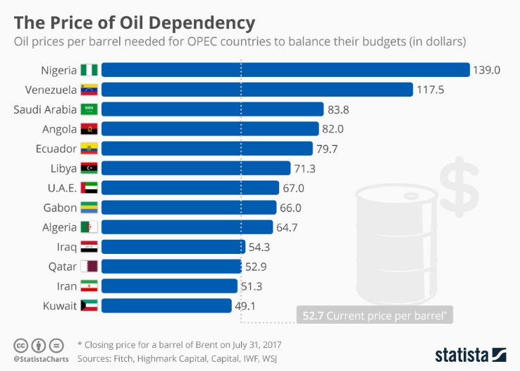
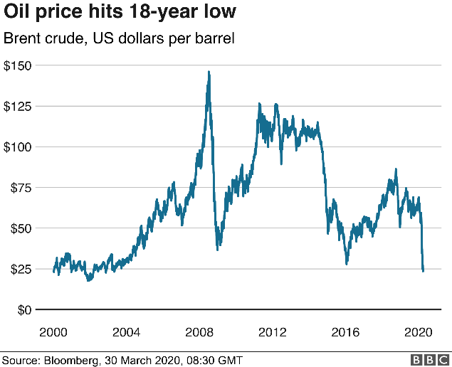

- Resource Curses.
A key (economic) question is why some countries are richer than others. Watch the videos about natural resource curses which offer a potential explanation

Is there a natural resource curse?

Innovating your way out of the resource curse An interesting article about the impact of natural resources on Qatar and Norway and policies to diversify away from sole reliance on a primary product.

