**Sketching quadratic graphs**

Key points

* 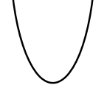The graph of the quadratic function   
  *y* = *ax*2 + *bx* + *c*, where *a* ≠ 0, is a curve   
  called a parabola.

for *a* < 0

for *a* > 0

* Parabolas have a line of symmetry and   
  a shape as shown.
* To sketch the graph of a function, find the points where the graph intersects the axes.
* To find where the curve intersects the *y*-axis substitute *x* = 0 into the function.
* To find where the curve intersects the *x*-axis substitute *y* = 0 into the function.
* At the turning points of a graph the gradient of the curve is 0 and any tangents to the curve at these points are horizontal.
* To find the coordinates of the maximum or minimum point (turning points) of a quadratic curve (parabola) you can use the completed square form of the function.

Examples

**Example 1** Sketch the graph of *y* = *x*2.

|  |  |
| --- | --- |
|  | The graph of *y* = *x*2 is a parabola.  When *x* = 0, *y* = 0.  *a* = 1 which is greater than zero, so the graph has the shape: |

**Example 2** Sketch the graph of *y* = *x*2 − *x* − 6.

|  |  |
| --- | --- |
| When *x* = 0, *y* = 02 − 0 − 6 = −6  So the graph intersects the *y*-axis at  (0, −6)  When *y* = 0, *x*2 − *x* − 6 = 0  (*x* + 2)(*x* − 3) = 0  *x* = −2 or *x* = 3  So,  the graph intersects the *x*-axis at (−2, 0) and (3, 0)  *x*2 − *x* − 6 =  =  When ,  and , so the turning point is at the point | **1** Find where the graph intersects the *y*-axis by substituting *x* = 0.  **2** Find where the graph intersects the *x*-axis by substituting *y* = 0.  **3** Solve the equation by factorising.  **4** Solve (*x* + 2) = 0 and (*x* − 3) = 0.  **5** *a* = 1 which is greater than zero, so the graph has the shape:  *(continued on next page)*  **6** To find the turning point, complete the square.  **7** The turning point is the minimum value for this expression and occurs when the term in the bracket is equal to zero. |

Practice

**1** Sketch the graph of *y* = −*x*2.

**2** Sketch each graph, labelling where the curve crosses the axes.

**a** *y* = (*x* + 2)(*x* − 1) **b** *y* = *x*(*x* − 3) **c** *y* = (*x* + 1)(*x* + 5)

**3** Sketch each graph, labelling where the curve crosses the axes.

**a** *y* = *x*2 − *x* − 6 **b** *y* = *x*2 − 5*x* + 4 **c** *y* = *x*2 – 4

**d** *y* = *x*2 + 4*x* **e** *y* = 9 − *x*2 **f** *y* = *x*2 + 2*x* − 3

**4** Sketch the graph of *y* = 2*x*2 + 5*x* − 3, labelling where the curve crosses the axes.

Extend

**5** Sketch each graph. Label where the curve crosses the axes and write down the coordinates of the turning point.

**a** *y* = *x*2 − 5*x* + 6 **b** *y* = −*x*2 + 7*x* − 12 **c** *y* = −*x*2 + 4*x*

**6** Sketch the graph of *y* = *x*2 + 2*x* + 1. Label where the curve crosses the axes and write down the equation of the line of symmetry.

Answers

**1**

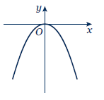

**2 a b c**

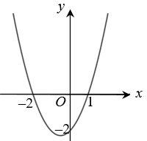 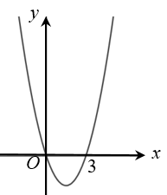 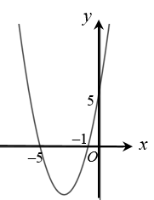

**3 a b c**

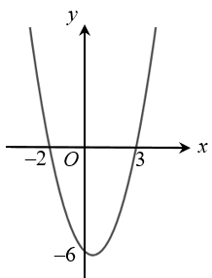 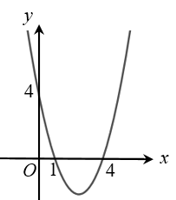 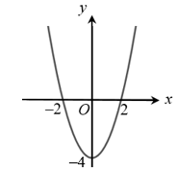

**d e f**

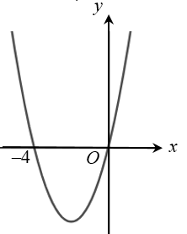 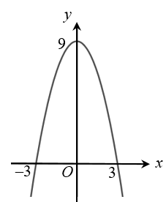 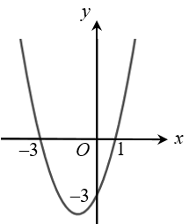

**4**

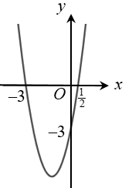

**5 a b c**

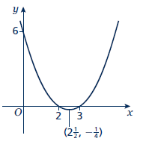 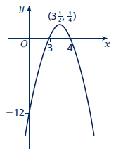 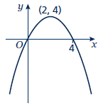

**6**

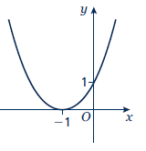

Line of symmetry at *x* = −1.