**Sketching cubic and reciprocal graphs**

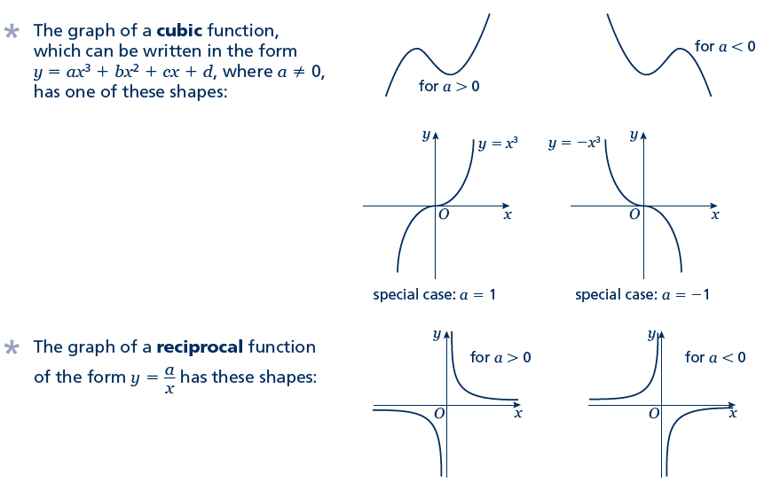Key points

* The graph of a cubic function, which can be written in the form *y* = *ax*3 + *bx*2 + *cx* + *d*, where *a* ≠ 0, has one of the shapes shown here.



* The graph of a reciprocal function of the form  has one of the shapes shown here.
* To sketch the graph of a function, find the points where the graph intersects the axes.
* To find where the curve intersects the *y*-axis substitute *x* = 0 into the function.
* To find where the curve intersects the *x*-axis substitute *y* = 0 into the function.
* Where appropriate, mark and label the asymptotes on the graph.
* Asymptotes are lines (usually horizontal or vertical) which the curve gets closer to but never touches or crosses. Asymptotes usually occur with reciprocal functions. For example, the asymptotes for the graph of  are the two axes (the lines *y* = 0 and *x* = 0).
* At the turning points of a graph the gradient of the curve is 0 and any tangents to the curve at these points are horizontal.
* A double root is when two of the solutions are equal. For example (*x* – 3)2(*x* + 2) has a double root at *x* = 3.
* When there is a double root, this is one of the turning points of a cubic function.

Examples

**Example 1** Sketch the graph of *y* = (*x* − 3)(*x* − 1)(*x* + 2)

|  |  |
| --- | --- |
| To sketch a cubic curve find intersects with both axes and use the key points above for the correct shape. | |
| When *x* = 0, *y* = (0 − 3)(0 − 1)(0 + 2)  = (−3) × (−1) × 2 = 6  The graph intersects the *y*-axis at (0, 6)  When *y* = 0, (*x* − 3)(*x* − 1)(*x* + 2) = 0  So *x* = 3, *x* = 1 or *x* = −2  The graph intersects the *x*-axis at   (−2, 0), (1, 0) and (3, 0) | **1** Find where the graph intersects the axes by substituting *x* = 0 and *y* = 0.  Make sure you get the coordinates the right way around, (*x*, *y*).  **2** Solve the equation by solving  *x* − 3 = 0, *x* − 1 = 0 and *x* + 2 = 0  **3** Sketch the graph.  *a* = 1 > 0 so the graph has the shape: |

**Example 2** Sketch the graph of *y* = (*x* + 2)2(*x* − 1)

|  |  |
| --- | --- |
| To sketch a cubic curve find intersects with both axes and use the key points above for the correct shape. | |
| When *x* = 0, *y* = (0 + 2)2(0 − 1)  = 22 × (−1) = −4  The graph intersects the *y*-axis at (0, −4)  When *y* = 0, (*x* + 2)2(*x* − 1) = 0  So *x* = −2 or *x* =1  (−2, 0) is a turning point as *x* = −2 is a double root. The graph crosses the *x*-axis at (1, 0) | **1** Find where the graph intersects the axes by substituting *x* = 0 and *y* = 0.  **2** Solve the equation by solving  *x* + 2 = 0 and *x* − 1 = 0  **3** *a* = 1 > 0 so the graph has the shape: |

Practice

**1** Here are six equations.

**Hint**

Find where each of the cubic equations cross the *y*-axis.

**A**  **B** *y* = *x*2 + 3*x* – 10 **C** *y* = *x*3 + 3*x*2

**D** *y* = 1 – 3*x*2 – *x*3 **E** *y* = *x*3 – 3*x*2 – 1 **F** *x* + *y* = 5

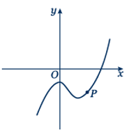 Here are six graphs.

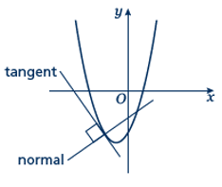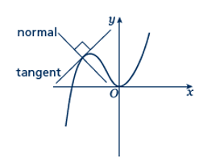 **i ii iii**

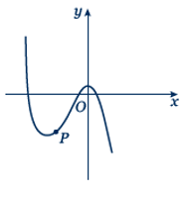

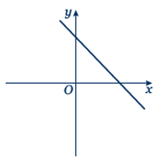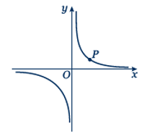 **iv v vi**

**a** Match each graph to its equation.

**b** Copy the graphs ii, iv and vi and draw the tangent and normal each at point *P*.

Sketch the following graphs

**2**  *y* = 2*x*3 **3** *y* = *x*(*x* – 2)(*x* + 2)

**4** *y* = (*x* + 1)(*x* + 4)(*x* – 3) **5** *y* = (*x* + 1)(*x* – 2)(1 – *x*)

**6** *y* = (*x* – 3)2(*x* + 1) **7** *y* = (*x* – 1)2(*x* – 2)

**8** *y* =  **9** *y* = 

**Hint:** Look at the shape of *y* =  in the second key point.

Extend

**10** Sketch the graph of  **11** Sketch the graph of 

Answers

**1****a** i – C

ii – E

iii – B

iv – A

v – F

vi – D

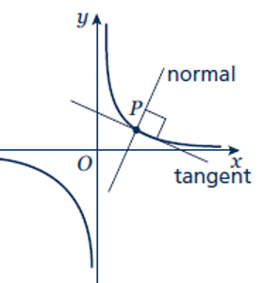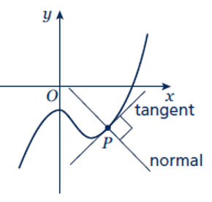 **b ii iv**

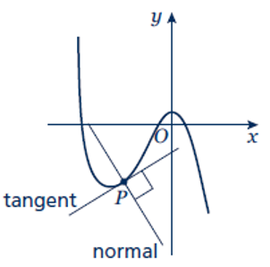

**vi**

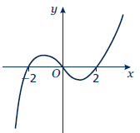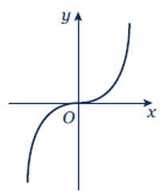**2 3**

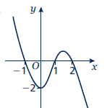

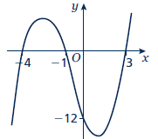**4 5**

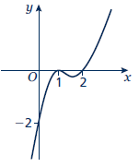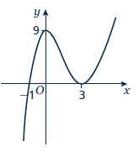**6 7**

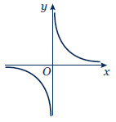**8 9**

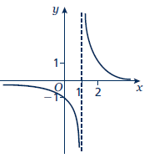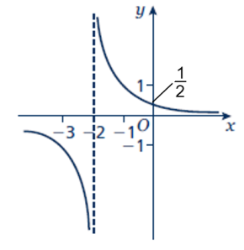**10 11**