**LPGS A Level Physics Student Course Guide**

**You’re studying AS or A-level Physics, congratulations!**

Studying physics after your GCSEs really develops your practical and mathematical skills.

At first, you may find the jump in demand from GCSE a little daunting, but if you follow the tips and advice in this guide, you’ll soon adapt. We recommend you keep this somewhere safe, as you may like to refer to the information inside throughout your studies.

**Why study A-level Physics?**

Physicists explore the fundamental nature of almost everything we know of. They study everything from the fundamental particles that build matter, to the galaxies that make up the universe itself. Join them to enter a world deep beneath the surface of normal human experience.

Even if you don’t decide to work in physics, studying it still develops useful and transferable skills for other careers. You’ll develop research, problem solving and analytical skills, alongside teamwork and communication. Universities and business regard all of these very highly.

**Possible degree options:**

According to bestcourse4me.com the top seven degree courses taken by students who have A-level Physics are:

* Mathematics
* physics
* mechanical engineering
* computer science
* civil engineering
* economics
* business.

Other course options include: medicine, electronic engineering, computer engineering, materials science, meteorology, astrophysics, particles physics, geophysics, medical physics, radiotherapy, finance, accountancy.

For more details, go to bestcourse4me.com or UCAS.

Other Useful Website

The institute of Physics: https://www.iop.org/tailored/students/

**Course Layout**

**Edexel A level Physics:**

|  |  |
| --- | --- |
| **Year 12** | **Year 13** |
| * Working as a Physicist * Mechanics * Electric Circuits * Materials * Waves * The Particle Nature of Light | * Working as a Physicist * Further Mechanics * Electric and Magnetic Fields * Nuclear and Particle Physics * Thermodynamics * Space * Nuclear Radiation * Gravitational Fields * Oscillations |

In addition to this there will be 16 course practicals. Students’ skills and technical competency when completing practical work will be assessed by teachers. This will form the basis for the award of a Practical Endorsement at A level. This is separate to the A level grade and, if awarded, will be reported as a ‘Pass’ on A level certificates for students who achieve it.

**Examinations**

We do not sit the AS exams at the end of year 12. We set the full A level at the end of year 13. We follow the content led approach.

|  |
| --- |
| **A level Paper 1 – Advanced Physics I** |
| 90 marks 30% weighting 1 hour 45 minutes |
| • Working as a Physicist  • Mechanics  • Electric Circuits  • Further Mechanics  • Electric and Magnetic Fields  • Nuclear and Particle Physics |

|  |
| --- |
| **A level Paper 2 – Advanced Physics II** |
| 90 marks 30% weighting 1 hour 45 minutes |
| • Working as a Physicist  • Materials  • Waves and the Particle Nature of Light  • Thermodynamics  • Space  • Nuclear Radiation  • Gravitational Fields  • Oscillations |

|  |
| --- |
| **A level Paper 3 – General and Practical Principles in Physics** |
| 120 marks 40% weighting 2 hours 30 minutes |
| * All topics across the full A level specification.   • Half of the paper will also focus on testing students’ knowledge and understanding of practical skills and techniques. |

Exam papers will feature questions allowing students to demonstrate investigative skills in the context of the core practicals.

Questions assessing students’ use of mathematical skills will make up 40% of the exam papers. The questions will test a wide range of maths skills, and to a slightly greater depth than the old A level syllabus.

Algebra is vital and being able to rearrange formulae with confidence is crucial. A sound knowledge of trigonometry is required as is the ability to differentiate.

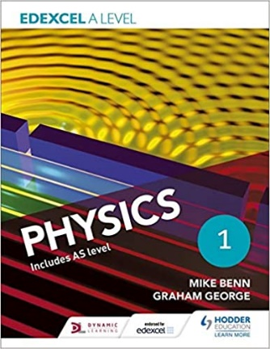**Course Books:**

**We recommend:**

**Edexcel A Level Physics Student Book 1** by Mike Benn , Graham George

And

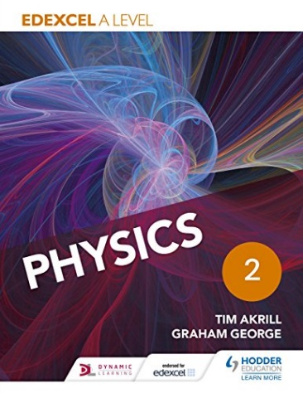

**Edexcel A Level Physics Student Book 2** by Tim Akrill and Graham George

Pearson also produce their own course book.

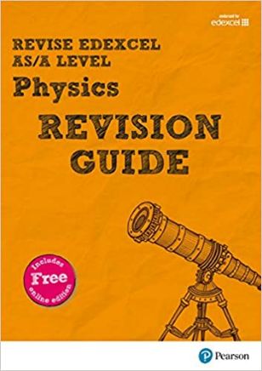Revision Guides:

**Revise Edexcel AS/A Level Physics Revision Guide** by Mr Steve Adams and Steve Woolley

There is also a practice workbook.

CPG also produces a good revision guide.

**Command Words**

|  |  |
| --- | --- |
| **Command Word** | **Definition** |
| Add/Label | Requires the addition or labelling to a stimulus material given in the question, for example labelling a diagram or adding units to a table. |
| Assess | Give careful consideration to all the factors or events that apply and identify which are the most important or relevant. Make a judgement on the importance of something, and come to a conclusion where needed. |
| Calculate | Obtain a numerical answer, showing relevant working. If the answer has a unit, this must be included. |
| Comment on | Requires the synthesis of a number of variables from data/information to form a judgement. |
| Compare and contrast | Looking for the similarities and differences of two (or more) things. Should not require the drawing of a conclusion. Answer must relate to both (or all) things mentioned in the question. The answer must include at least one similarity and one difference. |
| Complete | Requires the completion of a table/diagram. |
| Criticise | Inspect a set of data, an experimental plan or a scientific statement and consider the elements. Look at the merits and/or faults of the information presented, and back judgements made. |
| Deduce | Draw/reach conclusion(s) from the information provided. |
| Derive | Combine two or more equations or principles to develop a new equation. |
| Describe | To give an account of something. Statements in the response need to be developed as they are often linked but do not need to include a justification or reason. |
| Determine | The answer must have an element which is quantitative from the stimulus provided, or must show how the answer can be reached quantitatively. |
| Devise | Plan or invent a procedure from existing principles/ideas |
|  |  |
| Discuss | ● Identify the issue/situation/problem/argument that is being assessed within the question.  ● Explore all aspects of an issue/situation/problem/argument.  ● Investigate the issue/situation etc by reasoning or argument. |
| Draw | Produce a diagram either using a ruler or using freehand. |
| Evaluate | Review information then bring it together to form a conclusion, drawing on evidence including strengths, weaknesses, alternative actions, relevant data or information. Come to a supported judgement of a subject’s qualities and relation to its context. |
| Explain | An explanation requires a justification/exemplification of a point. The answer must contain some element of reasoning/justification, this can include mathematical explanations. |
| Give/state/name | All of these command words are really synonyms. They generally all require recall of one or more pieces of information. |
| Give a reason/ reasons | When a statement has been made and the requirement is only to give the reasons why. |
| Identify | Usually requires some key information to be selected from a given stimulus/resource. |
| Justify | Give evidence to support (either the statement given in the question or an earlier answer). |
| Plot | Produce a graph by marking points accurately on a grid from data that is provided and then drawing a line of best fit through these points. A suitable scale and appropriately labelled axes must be included if these are not provided in the question. |
| Predict | Give an expected result. |
| Show that | Prove that a numerical figure is as stated in the question. The answer must be to at least 1 more significant figure than the numerical figure in the question. |
| Sketch | Produce a freehand drawing. For a graph, this would require a line and labelled axis with important features indicated, the axes are not scaled. |
| State what is meant by | When the meaning of a term is expected but there are different ways of how these can be described. |
| Write | When the questions ask for an equation. |

**SI Units**

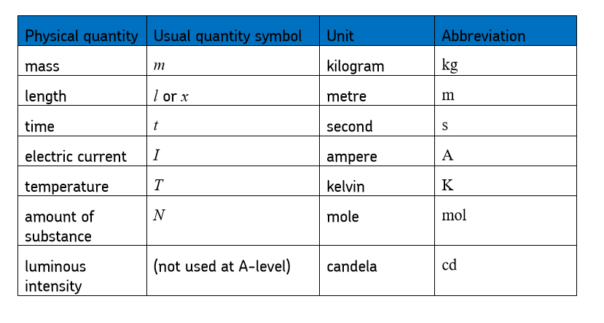

**Suggested Reading.**

We strongly recommend reading the “**New Scientist**” magazine. It is published weekly.

|  |  |  |
| --- | --- | --- |
| **The World According to Physics** | Jim Al-Khalili | A round up of modern Physics. Good reviews. |
| **The Electric Universe: How Electricity Switched on the Modern World.** | David Bodanis | Much better than it sounds. |
| **Quantum Theory Cannot Hurt You** | Marcus Chown | Popular author: has written many books. |
| **We Need to Talk About Kelvin** | Marcus Chown | All about the physics of heat, temperature and energy. |
| **Engineering: A Beginners Guide** | Natasha McCarthy | Has good reviews. |
| **The Particle Zoo** | Gavin Hesketh | A modern summary of particle physics. |
| **Why the Universe Exists.** | A New Scientist Instant Expert book. | A popular account of particle physics. Edited articles from the New Scientist. |
| **The Quantum World.** | A New Scientist Instant Expert book. | A popular account of quantum physics. Edited articles from the New Scientist. |
| **Astrophysics for People in a Hurry** | Neil de Grasse Tyson | Brief, but not dumbed down, summary of astrophysics. |
| **Beyond Infinity** | Eugenia Cheng | Wonderful explanation of the concept of infinity. |
| **Why does E = mc2** | Brian Cox | A good intro into relativity. |
| **13.8** | John Gribbin | A historical account of what we know about the big bang and stars. |

**Six Successful Study Techniques**

**Spaced Practice**

You should review your work a **day**, a **week** and a **month** after you first learn it. The idea is to do consistent, short, study sessions over time. Use the other techniques in this document to review your learning. Start your revision early: don’t cram!

**Switching**

Don’t spend too long studying one subject. In a revision session don’t just revise one topic. Switch topics so you study 3 or 4 things in one session. The next time you study change the order of topics. You will find this harder, BUT it will make you remember and understand more. This is all about being successful, not about being easy.

**Elaboration**

Make a list of things you need to learn. Then go down the list and ask a series of **how** and **why** questions. Then try to answer these. After this go through you class materials (your notes/ text books/ revision guides/ kerboodle) and mark your answers. Make a list of the answers to questions you got wrong or couldn’t do.

**Words & Visuals/Dual Coding**

When you look at two ways of remembering something you will find it easier to recall that information. Find diagrams/pictures in your notes/ revision guides/ kerboodle etc. Make notes on how the words describe the image. Then make notes on how the image describes the words. After this try drawing your own diagrams from memory and writing a text to go with it. Then use your class material to review what you have done, noting any mistakes or things you have left out.

**RETRIEVAL PRACTICE (Most important)**

If you want to be good at recalling things in exams, you have got to practice recalling things.

1. Without using your notes/books, write down on a sheet of paper everything you know about a topic. Wait a while then use your notes/books to correct mistakes and list/ highlight what you forgot.
2. Take as many practice tests as you can. Make questions up with a friend if you have to. Wait a while (few hours?) and use the mark scheme/notes/books to mark your work. Take notes on what you got wrong or forgot. This is the single most effective thing you can do for a test.

**Remember, learning is not an event, it is a process.**

**We make our luck by working hard.**

**Good luck.**