**GCSE Mathematics**

**Practice Tests: Set 13**

**Paper 1H (Non-calculator)**

**Time: 1 hour 30 minutes**

You should have: Ruler graduated in centimetres and millimetres, protractor, pair of compasses, pen, HB pencil, eraser, calculator. Tracing paper may be used.

**Instructions**



* Use **black** ink or ball-point pen.
* **Fill in the boxes** at the top of this page with your name,  
  centre number and candidate number.
* Answer **all** questions.
* Answer the questions in the spaces provided

– *there may be more space than you need*.

* **Calculators may be used.**
* Diagrams are NOT accurately drawn, unless otherwise indicated.
* You must **show all your working out.**

**Information**

* The total mark for this paper is 80
* The marks for **each** question are shown in brackets  
  – *use this as a guide as to how much time to spend on each question*.

**Advice**

* Read each question carefully before you start to answer it.
* Keep an eye on the time.
* Try to answer every question.
* Check your answers if you have time at the end.

**Answer all questions.**

**Write your answers in the spaces provided.**

**You must write down all the stages in your working.**

**1** (*a*)Make *a* the subject of *d* = *g* + 2*ac*

......................................................

**(2)**

(*b*)Factorise fully 9*e f* − 12 *f*

......................................................

**(2)**

(*c*)Expand and simplify (*x* + 2)(*x* − 5)

......................................................

**(2)**

(*d*)Simplify fully **

......................................................

**(2)**

**(Total for Question 1 is 8 marks)**

**___________________________________________________________________________**

**2** Solve the simultaneous equations

3*x* + 5*y* = 6

7*x* – 5*y* = –11

Show clear algebraic working.

*x* = .......................................................

*y* = .......................................................

**(Total for Question 2 is 3 marks)**

**___________________________________________________________________________**

**3** Solve *x*2 − 5*x* − 36 = 0

Show clear algebraic working.

......................................................

**(Total for Question 3 is 3 marks)**

**___________________________________________________________________________**

**4** (*a*)Write 517 × 52 as a single power of 5

.......................................................

**(1)**

(*b*)Write 800 as a product of its prime factors.

Show your working clearly.

.................................................................................

**(2)**

**(Total for Question 4 is 3 marks)**

**___________________________________________________________________________**

**5** Three tins, *A*, *B* and *C*, each contain buttons.

Tin *A* contains *x* buttons.

Tin *B* contains 4 times the number of buttons that tin *A* contains.

Tin *C* contains 7 fewer buttons than tin *A*.

The total number of buttons in the three tins is 137

Work out the number of buttons in tin *C*.

.......................................................

**(Total for Question 5 is 4 marks)**

**___________________________________________________________________________**

**6** (*a*)Complete the table of values for *y* = *x*2 − ** − 3

|  |  |  |  |  |  |  |  |
| --- | --- | --- | --- | --- | --- | --- | --- |
| *x* | –3 | –2 | –1 | 0 | 1 | 2 | 3 |
| *y* | 7.5 |  |  |  | –2.5 |  | 4.5 |

**(2)**

(*b*)On the grid, draw the graph of *y* = *x*2 − – 3 for values of *x* from –3 to 3

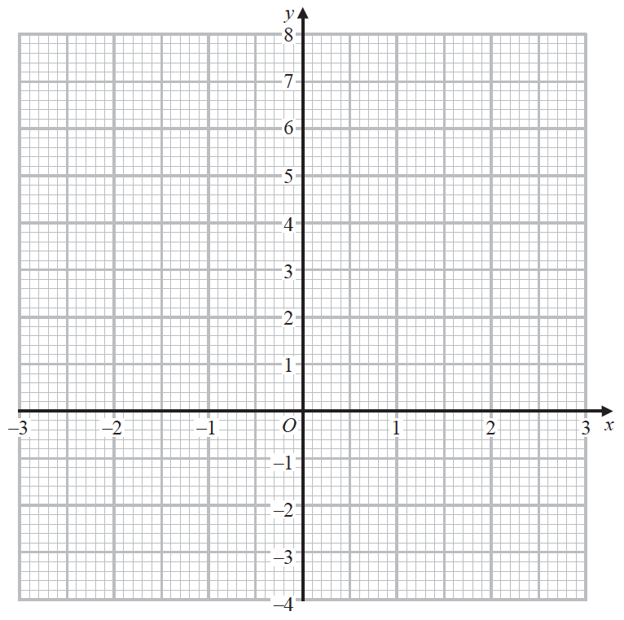

**(2)**

**(Total for Question 6 is 4 marks)**

**___________________________________________________________________________**

**7** Write down the integer values of *x* that satisfy the inequality –2 < *x* ≤ 4

..................................................................................

**(Total for Question 7 is 2 marks)**

**___________________________________________________________________________**

**8** The function f is such that f (*x*) = (*x* − 4)2 for all values of *x*.

(*a*)Find f (1)

......................................................

**(1)**

The function g is such that g (*x*) =  **

(*b*)Work out fg (2)

......................................................

**(2)**

**(Total for Question 8 is 3 marks)**

**___________________________________________________________________________**

**9** The diagram shows a regular hexagon, *ABCDEF*, and an isosceles triangle, *GHJ*.

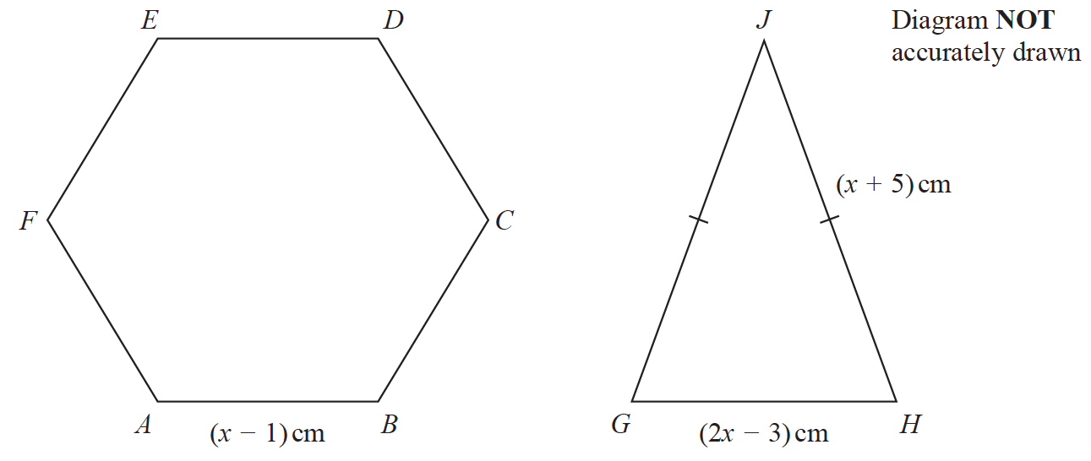

The perimeter of the hexagon is equal to the perimeter of the triangle.

Find the length of each side of the hexagon.

Show clear algebraic working.

...................................................... cm

**(Total for Question 9 is 5 marks)**

**___________________________________________________________________________**

**10** Brendon, Asha and Julie share some money in the ratios 3 : 2 : 6

The **total** amount of money that Asha and Julie receive is £36

Work out the amount of money that Brendon receives.

£......................................................

**(Total for Question 10 is 3 marks)**

**___________________________________________________________________________**

**11** Show that 

**(Total for Question 11 is 3 marks)**

**___________________________________________________________________________**

**12** Use ruler and compasses only to construct the perpendicular bisector of the line *AB*.

You must show all your construction lines.



**(Total for Question 12 is 2 marks)**

**___________________________________________________________________________**

**13** The cumulative frequency graph gives information about the waiting times, in minutes,

of people with appointments at Hospital A.

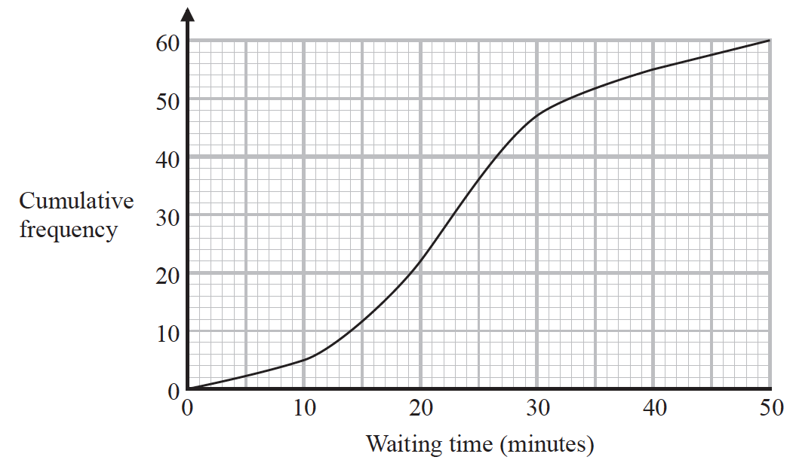

(*a*)Use the graph to find an estimate of the median waiting time at Hospital A.

...................................................... minutes

**(1)**

(*b*)Use the graph to find an estimate of the interquartile range of the waiting times at

Hospital A.

...................................................... minutes

**(2)**

At a different hospital, Hospital B, the median waiting time is 28 minutes and the

interquartile range of the waiting times is 19 minutes.

(*c*)Compare the waiting times at Hospital A with the waiting times at Hospital B.

......................................................................................................................................................

......................................................................................................................................................

......................................................................................................................................................

......................................................................................................................................................

**(2)**

**(Total for Question 13 is 5 marks)**

**___________________________________________________________________________**

**14** Max kept a record of the marks he scored in each of the 11 spelling tests he took one term.

Here are his marks.

|  |  |  |  |  |  |  |  |  |  |  |
| --- | --- | --- | --- | --- | --- | --- | --- | --- | --- | --- |
| 18 | 5 | 7 | 12 | 11 | 18 | 15 | 16 | 17 | 13 | 14 |

Find the interquartile range of the marks.

.......................................................

**(Total for Question 14 is 3 marks)**

**___________________________________________________________________________**

**15**

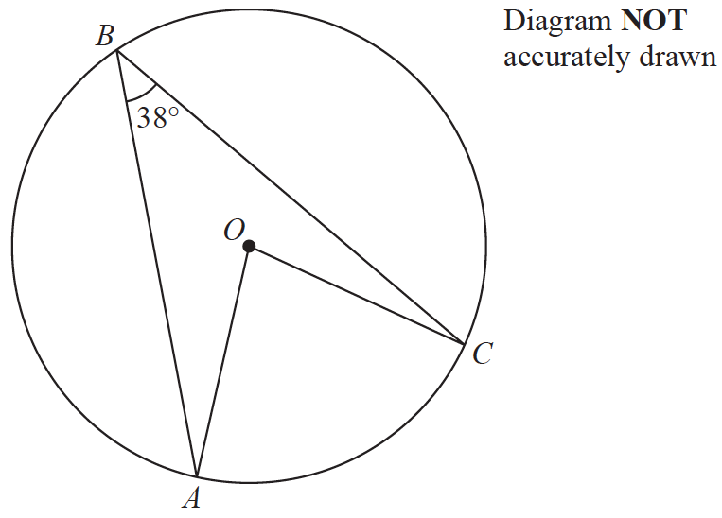

*A*, *B* and *C* are points on a circle, centre *O*.

Angle *ABC* = 38°

Work out the size of angle *OAC*.

Give a reason for each stage of your working.

......................................................°

**(Total for Question 15 is 4 marks)**

**___________________________________________________________________________**

**16** Given that *y* is a prime number,

express  in the form ** where *a*, *b* and *c* are integers.

......................................................

**(Total for Question 16 is 2 marks)**

**___________________________________________________________________________**

**17** Some students in a school were asked the following question.

“ Do you have a dog (*D*), a cat (*C*)or a rabbit (*R*)?”

Of these students

28 have a dog

18 have a cat

20 have a rabbit

8 have both a cat and a rabbit

9 have both a dog and a rabbit

*x* have both a dog and a cat

6 have a dog, a cat and a rabbit

5 have not got a dog or a cat or a rabbit

(*a*)Using this information, complete the Venn diagram to show the number of students in

each appropriate subset.

Give the numbers in terms of *x* where necessary.

|  |  |
| --- | --- |
| E |  |
|  |  |

**(3)**

Given that a total of 50 students answered the question,

(*b*)work out the value of *x*.

*x* = .......................................................

**(2)**

**(Total for Question 17 is 5 marks)**

**___________________________________________________________________________**

**18** (*a*)Simplify fully 

.......................................................

**(3)**

22*y* × 23*y* + 2 = 

(*b*)Find an expression for *n* in terms of *y*.

Show clear algebraic working and simplify your expression.

.......................................................

**(4)**

**(Total for Question 18 is 7 marks)**

**___________________________________________________________________________**

**19** *N* is a multiple of 5

*A* = *N* + 1

*B* = *N* – 1

Prove, using algebra, that *A*2 – *B*2 is always a multiple of 20

**(Total for Question 19 is 3 marks)**

**___________________________________________________________________________**

**20** Express 7 – 12*x* – 2*x*2 in the form *a* + *b*(*x* + *c*)2 where *a*, *b* and *c* are integers.

.......................................................

**(Total for Question 20 is 3 marks)**

**___________________________________________________________________________**

**21** The diagram shows trapezium *OACB*.

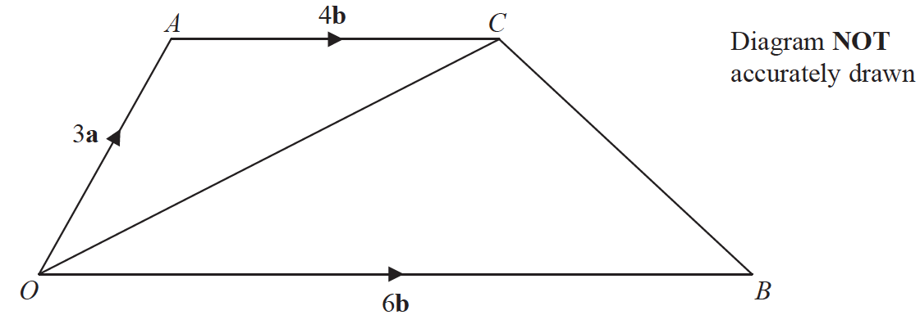

 = 3**a ** = 6**b ** = 4**b**

*N* is the point on *OC* such that *ANB* is a straight line.

Find as a simplified expression in terms of **a** and **b**.

.......................................................

**(Total for Question 21 is 5 marks)**

**TOTAL FOR PAPER IS 80 MARKS**

**BLANK PAGE**