**GCSE Mathematics**

**Practice Tests: Set 12**

**Paper 2H/3H (Calculator)**

**Time: 1 hour 30 minutes**

You should have: Ruler graduated in centimetres and millimetres, protractor, pair of compasses, pen, HB pencil, eraser, calculator. Tracing paper may be used.

**Instructions**

* Use **black** ink or ball-point pen.
* **Fill in the boxes** at the top of this page with your name,  
  centre number and candidate number.
* Answer **all** questions.
* Answer the questions in the spaces provided

– *there may be more space than you need*.

* **Calculators may be used.**
* Diagrams are NOT accurately drawn, unless otherwise indicated.
* You must **show all your working out.**

**Information**

* The total mark for this paper is 80
* The marks for **each** question are shown in brackets  
  – *use this as a guide as to how much time to spend on each question*.

**Advice**

* Read each question carefully before you start to answer it.
* Keep an eye on the time.
* Try to answer every question.
* Check your answers if you have time at the end.

**Answer ALL questions.**

**Write your answers in the spaces provided.**

**You must write down all the stages in your working.**

**1** The density of gold is 19.3 g/cm3

A gold bar has volume 150 cm3

Work out the mass of the gold bar.

....................................................... g

**(Total for Question 1 is 2 marks)**

**___________________________________________________________________________**

**2** The table shows information about the weights, in kilograms, of 40 babies.

|  |  |
| --- | --- |
| **Weight (*w* kg)** | **Frequency** |
| 2 < *w* ⩽ 3 | 12 |
| 3 < *w* ⩽ 4 | 16 |
| 4 < *w* ⩽ 5 | 9 |
| 5 < *w* ⩽ 6 | 2 |
| 6 < *w* ⩽ 7 | 1 |

(*a*)Write down the modal class.

.......................................................

**(1)**

(*b*)Work out an estimate for the mean weight of the 40 babies.

....................................................... kg

**(4)**

One of the 40 babies is going to be chosen at random.

(*c*)Find the probability that this baby has a weight of more than 5 kg.

.......................................................

**(2)**

**(Total for Question 2 is 7 marks)**

**___________________________________________________________________________**

**3** A bag contains only red beads, blue beads, green beads and yellow beads.

The table gives the probabilities that, when a bead is taken at random from the bag,

the bead will be blue or the bead will be yellow.

|  |  |  |  |  |
| --- | --- | --- | --- | --- |
| **Colour** | **red** | **blue** | **green** | **yellow** |
| **Probability** |  | 0.24 |  | 0.31 |

The probability that the bead will be green is twice the probability that the bead will be red.

Sofia takes at random a bead from the bag.

She writes down the colour of the bead and puts the bead back into the bag.

She does this 180 times.

Work out an estimate for the number of times she takes a red bead from the bag.

.......................................................

**(Total for Question 3 is 4 marks)**

**___________________________________________________________________________**

**4** (*a*)Write 7.8 × 10−4 as an ordinary number.

..................................................................................

**(1)**

(*b*)Work out 

Give your answer in standard form.

..................................................................................

**(2)**

**(Total for Question 4 is 3 marks)**

**___________________________________________________________________________**

**5** Here is a right-angled triangle.

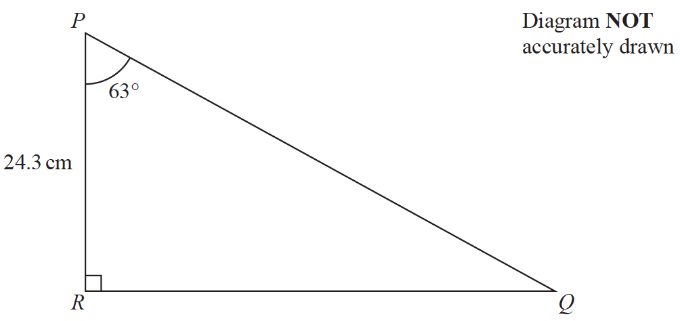

Calculate the length of *PQ*.

Give your answer correct to 3 significant figures.

....................................................... cm

**(Total for Question 5 is 3 marks)**

**___________________________________________________________________________**

**6** There are 20 glasses in a cupboard.

13 of the glasses are large

7 of the glasses are small

Roberto takes at random two glasses from the cupboard.

(*a*)Complete the probability tree diagram.



**(2)**

(*b*)Work out the probability that Roberto takes two small glasses.

.......................................................

**(2)**

**(Total for Question 6 is 4 marks)**

**___________________________________________________________________________**

**7** 120 children go on an activity holiday.

The ratio of the number of girls to the number of boys is 3 : 5

On Sunday, all the children either go sailing or go climbing.

 of the boys go climbing.

Twice as many girls go sailing as go climbing.

Work out how many children go sailing on Sunday.

.......................................................

**(Total for Question 7 is 6 marks)**

**___________________________________________________________________________**

**8** The table shows the cost, in euros, of Brigitte’s car insurance in each of the years 2016,

2017 and 2018

|  |  |  |  |
| --- | --- | --- | --- |
| **Year** | **2016** | **2017** | **2018** |
| **Cost of insurance (euros)** | 500 | 545 | 592 |

Brigitte says,

“The percentage increase in the cost of my car insurance from 2017 to 2018 is more than

the percentage increase in the cost of my car insurance from 2016 to 2017”

(*a*)Is Brigitte correct?

You must show how you get your answer.

**(4)**

Henri wants to insure his car.

He gets a discount of 15% off the normal price.

Henri pays 952 euros for his car insurance after the discount.

(*b*)Work out the discount that Henri gets.

....................................................... euros

**(3)**

**(Total for Question 8 is 7 marks)**

**___________________________________________________________________________**

**9** Astrid wants to buy some oil.

She can buy the oil from either Dane Oil or Arctic Oil.

Here is information about the price that each company will charge Astrid.

|  |  |
| --- | --- |
| **Dane Oil** | **Arctic Oil** |
| (4.2 × 105) litres  for  2 500 000 Krone | (8.6 × 105) litres  for  770 000 Dollars |

Astrid wants to get the better value for money for the oil.

1 Dollar = 6.57 Krone

From which company should she buy her oil, Dane Oil or Arctic Oil?

You must show your working.

**(Total for Question 9 is 4 marks)**

**___________________________________________________________________________**

**10** Change a speed of 50 metres per second to a speed in kilometres per hour.

....................................................... kilometres per hour

**(Total for Question 10 is 3 marks)**

**___________________________________________________________________________**

**11** The point *A* has coordinates (5, −4)

The point *B* has coordinates (13, 1)

(*a*)Work out the coordinates of the midpoint of *AB*.

(............................ , ............................)

**(2)**

Line **L** has equation *y* = 2 − 3*x*

(*b*)Write down the gradient of line **L**.

.......................................................

**(1)**

Line **L** has equation *y* = 2 − 3*x*

(*c*)Does the point with coordinates (100, −302) lie on line **L**?

You must give a reason for your answer.

......................................................................................................................................................

......................................................................................................................................................

......................................................................................................................................................

**(1)**

**(Total for Question 11 is 4 marks)**

**___________________________________________________________________________**

**12** Max invests $6000 in a savings account for 3 years.

The account pays compound interest at a rate of 1.5% per year for the first 2 years.

The compound interest rate changes for the third year.

At the end of 3 years, there is a total of $6311.16 in the account.

Work out the compound interest rate for the third year.

Give your answer correct to 1 decimal place.

....................................................... %

**(Total for Question 12 is 3 marks)**

**___________________________________________________________________________**

**13** The diagram shows a solid cube.

The cube is placed on a table so that the whole of one face of the cube is in contact with

the table.

**

The cube exerts a force of 56 newtons on the table.

The pressure on the table due to the cube is 0.14 newtons/cm2



Work out the volume of the cube.

....................................................... cm3

**(Total for Question 13 is 4 marks)**

**___________________________________________________________________________**

**14** The diagram shows a cuboid *ABCDEFGH*.

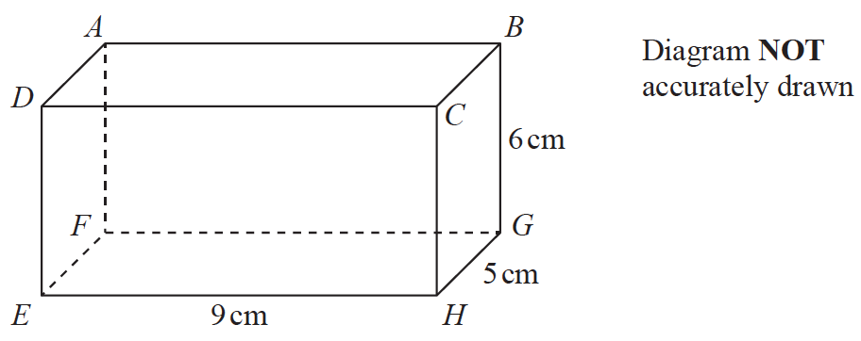

*EH* = 9 cm, *HG* = 5 cm and *GB* = 6 cm.

Work out the size of the angle between *AH* and the plane *EFGH*.

Give your answer correct to 3 significant figures.

.......................................................°

**(Total for Question 14 is 4 marks)**

**___________________________________________________________________________**

**15** The diagram shows parallelogram *EFGH*.

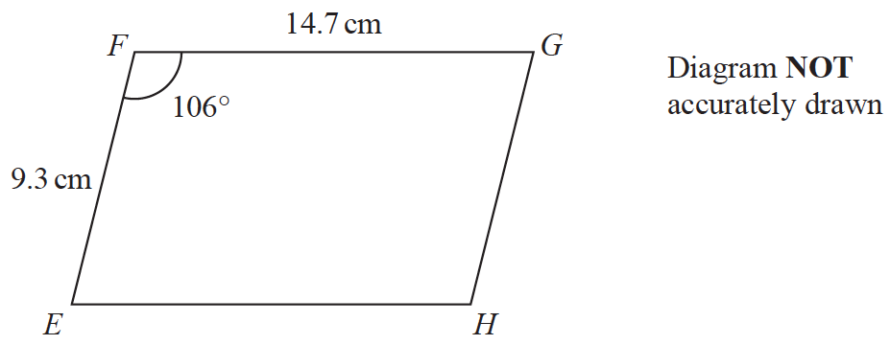

*EF* = 9.3 cm

*FG* = 14.7 cm

Angle *EFG* = 106°

(*a*)Work out the area of the parallelogram.

Give your answer correct to 3 significant figures.

....................................................... cm2

**(2)**

(*b*)Work out the length of the diagonal *EG* of the parallelogram.

Give your answer correct to 3 significant figures.

....................................................... cm

**(3)**

**(Total for Question 15 is 5 marks)**

**___________________________________________________________________________**

**16** *P* = 

*a* = 58.4 correct to 3 significant figures.

*c* = 20 correct to 2 significant figures.

*d* = 3.6 correct to 2 significant figures.

Work out the upper bound for the value of *P*.

Show your working clearly.

Give your answer correct to 2 decimal places.

.......................................................

**(Total for Question 16 is 3 marks)**

**___________________________________________________________________________**

**17**

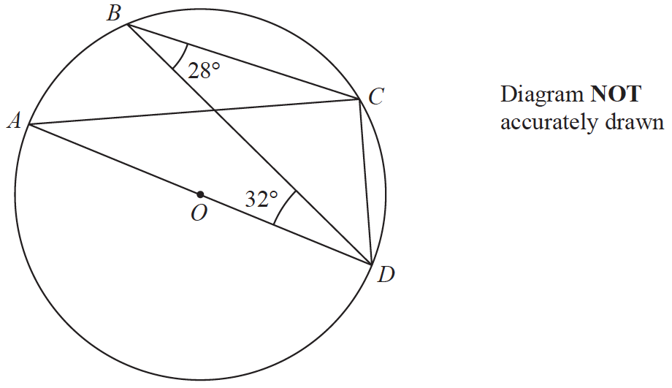

*A*, *B*, *C* and *D* are points on a circle, centre *O*.

*AOD* is a diameter of the circle.

Angle *CBD* = 28°

Angle *BDA* = 32°

Find the size of angle *BDC*.

Give a reason for each stage of your working.

....................................................... °

**(Total for Question 17 is 4 marks)**

**___________________________________________________________________________**

**TURN OVER FOR QUESTION 18**

**18** Here is a sector, *AOB*, of a circle with centre *O* and angle *AOB* = *x*°

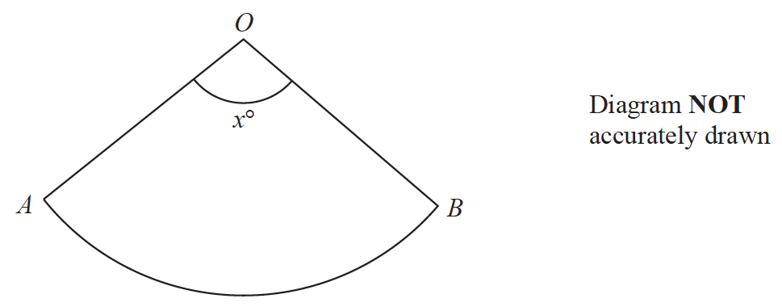

The sector can form the curved surface of a cone by joining *OA* to *OB*.

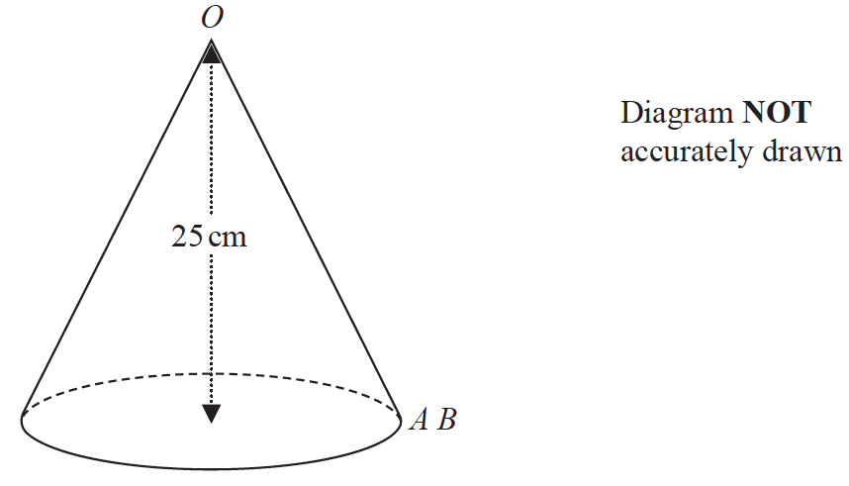

The height of the cone is 25 cm.

The volume of the cone is 1600 cm3

Work out the value of *x*.

Give your answer correct to the nearest whole number.

*x* = .......................................................

**(Total for Question 18 is 6 marks)**

**___________________________________________________________________________**

**19** There are 16 sweets in a bowl.

4 of the sweets are blackcurrant.

5 of the sweets are lemon.

7 of the sweets are orange.

Anna, Ravi and Sam each take at random one sweet from the bowl.

Work out the probability that the 5 lemon sweets are still in the bowl.

.......................................................

**(Total for Question 19 is 4 marks)**

**TOTAL FOR PAPER IS 80 MARKS**