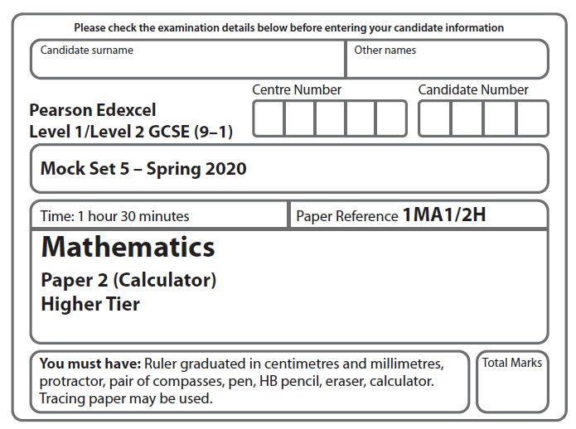

LPGS Autumn Mock Exam 2020

**Instructions**

* Use **black** ink or ball-point pen.
* **Fill in the boxes** at the top of this page with your name, centre number   
  and candidate number.
* Answer **all** questions.
* Answer the questions in the spaces provided.

*– there may be more space than you need.*

* You must **show all your working.**
* Diagrams are **NOT** accurately drawn, unless otherwise indicated.
* **Calculators may be used.**

**Information**

* The total mark for this paper is 80
* The marks for **each** question are shown in brackets

*– use this as a guide as to how much time to spend on each question.*

**Advice**

* Read each question carefully before you start to answer it.
* Try to answer every question.
* Check your answers if you have time at the end.

**S66511A**

**Answer ALL questions.**

**Write your answers in the spaces provided.**

**You must write down all the stages in your working.**

**1** Find the highest common factor (HCF) of 90 and 126

…………………………

**(Total for Question 1 is 3 marks)**

**2** (a) Simplify 2*a* 3 × *a* 4

…………………………………..

**(1)**

(b) Simplify 12*x* 5 *y* 2 ÷ 3*x* 2 *y*

…………………………………..

**(2)**

**(Total for Question 2 is 3 marks)**

**3** Joe went on holiday to Spain.

His flights cost a total of £320

Joe stayed in an apartment for 3 weeks.

The apartment cost 560 euros each week.

Joe hired a car for 15 days.

The car hire cost 20.16 euros each day.

The exchange rate was £1 = 1.12 euros.

1. Work out the total cost, in pounds, of the flights, the apartment and the car hire.

£……………………

**(4)**

(b) If there had been more than 1.12 euros to £1, how would this affect your answer

to part (a)?

…………………………………………………………………………………………………..

…………………………………………………………………………………………………..

…………………………………………………………………………………………………..

**(1)**

**(Total for Question 3 is 5 marks)**

**4**

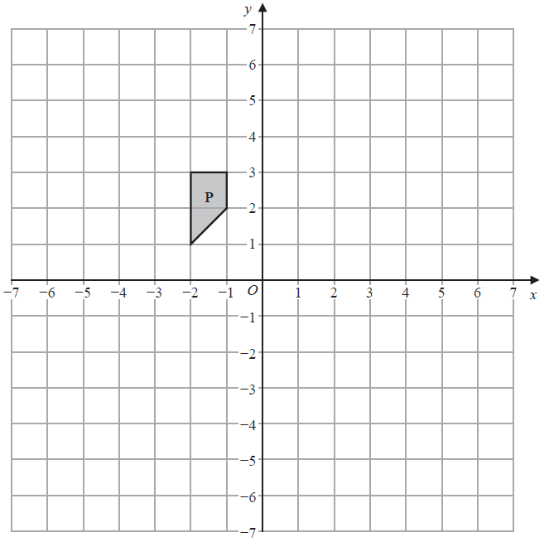

1. Translate shape **P** by the vector 

**(2)**

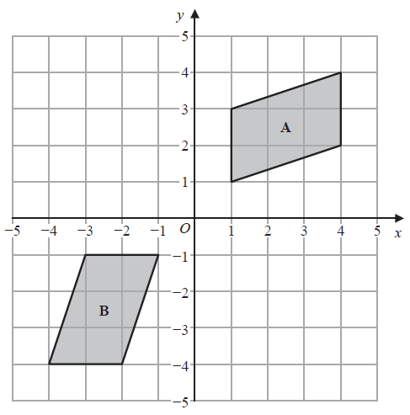

(b) Describe fully the single transformation that maps shape **A** onto shape **B**.

…………………………………………………………………………………………………...

…………………………………………………………………………………………………...

…………………………………………………………………………………………………...

**(2)**

**(Total for Question 4 is 4 marks)**

**5** The table gives information about the length of each of 90 sticks.

|  |  |
| --- | --- |
| **Length (*b* cm)** | **Frequency** |
| 0 < *b* ⩽ 8 | 5 |
| 8 < *b* ⩽ 16 | 20 |
| 16 < *b* ⩽ 24 | 45 |
| 24 < *b* ⩽ 32 | 20 |

Jenny drew the frequency polygon below for the information in the table. The frequency polygon is **not** correct.

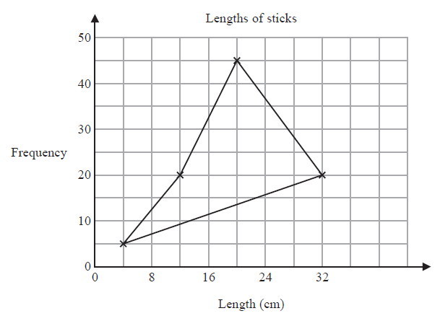

Write down **two** things that are wrong with the frequency polygon.

1 …………………………………………………………………………………………………...

…………………………………………………………………………………………………...

2 …………………………………………………………………………………………………...

…………………………………………………………………………………………………...

**(Total for Question 5 is 2 marks)**

**6** A rectangle has length 8 cm

The rectangle has area 20 cm2

The length of the rectangle is increased by 2 cm

The area of the rectangle is increased by 4 cm2

Noah says,

“The width of the rectangle decreases by less than 5%”

Is Noah correct?

You must show how you get your answer.

**(Total for Question 6 is 3 marks)**

**7**  *a* : *b* = 2 : 3

*b* : *c* = 5 : 6

Show that *a* : *c* = 5 : 9

**(Total for Question 7 is 2 marks)**

**8** *A*, *B* and *C* are points on a circle with diameter *AB*.

*ABC* is a right-angled triangle.

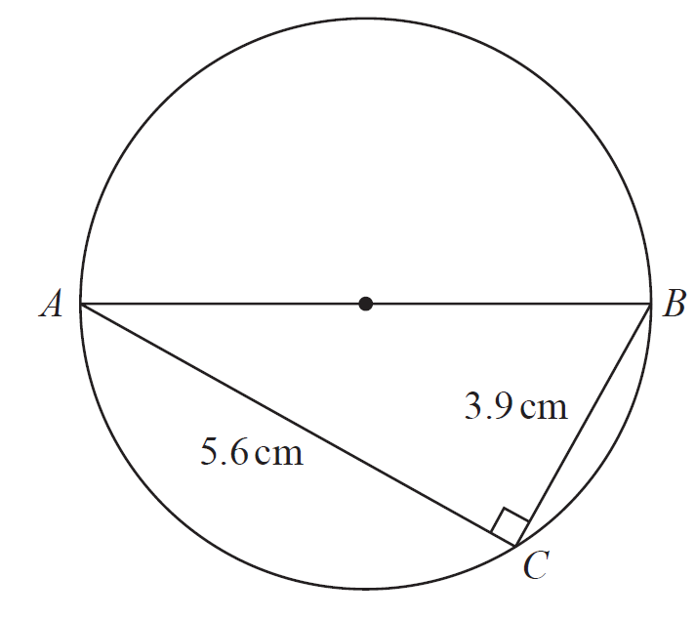

Calculate the area of the circle.

Give your answer correct to 3 significant figures.

……………………………….. cm2

**(Total for Question 8 is 4 marks)**

**9** This graph can be used to convert between kilograms and pounds.

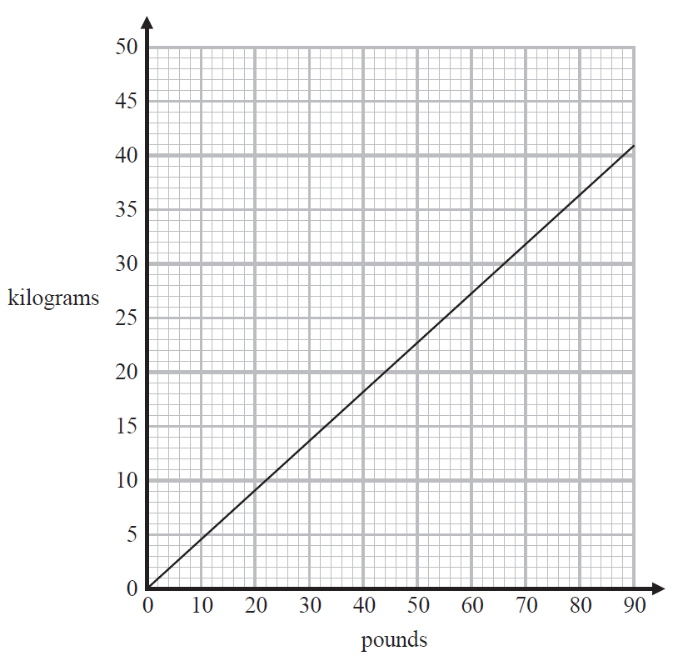

1. Work out the gradient of the straight line.

………………………

**(2)**

(b) What does the gradient of this line represent?

…………………………………………………………………………………………………...

…………………………………………………………………………………………………...

…………………………………………………………………………………………………...

**(1)**

**(Total for Question 9 is 3 marks)**

**10** The table gives some information about the times taken by 80 students to complete a test.

|  |  |
| --- | --- |
| **Time (*t* minutes)** | **Frequency** |
| 20 < *t* ⩽ 25 | 4 |
| 25 < *t* ⩽ 30 | 16 |
| 30 < *t* ⩽ 35 | 30 |
| 35 < *t* ⩽ 40 | 18 |
| 40 < *t* ⩽ 45 | 12 |

1. Complete the cumulative frequency table for this information.

|  |  |
| --- | --- |
| **Time (*t* minutes)** | **Cumulative frequency** |
| 20 < *t* ⩽ 25 |  |
| 20 < *t* ⩽ 30 |  |
| 20 < *t* ⩽ 35 |  |
| 20 < *t* ⩽ 40 |  |
| 20 < *t* ⩽ 45 |  |

**(1)**

1. On the grid opposite, draw a cumulative frequency graph for your table.

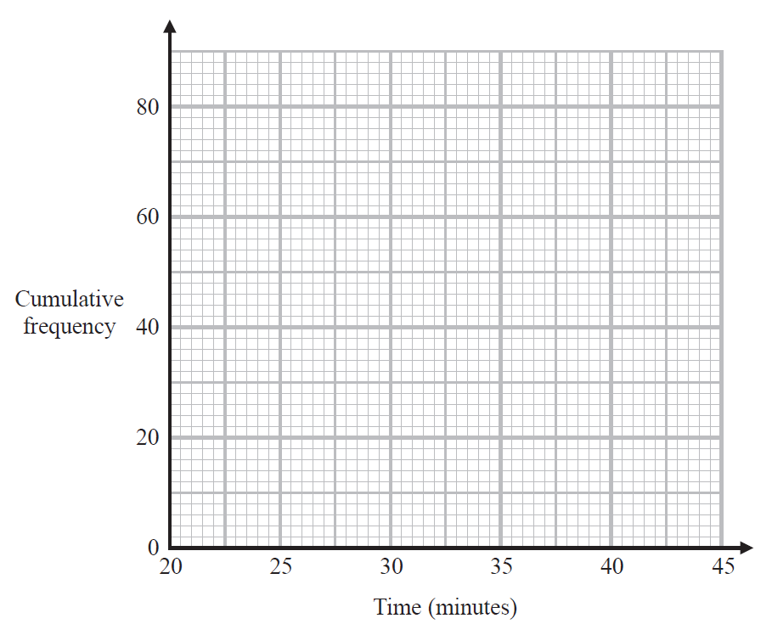

**(2)**

(c) Use your graph to find an estimate for the median.

……………………… minutes

**(1)**

One of the students is chosen at random.

(d) Use your graph to find an estimate for the probability that this student took longer than 38 minutes to complete the test.

………………………….

**(2)**

**(Total for Question 10 is 6 marks)**

**11** Lisa bought a house.

The value of the house increased by 1.5% each year for 2 years.

At the end of 2 years, the value of the house was £123 627

Work out the value of the house when Lisa bought it.

£……………………

**(Total for Question 11 is 2 marks)**

**12** Expand and simplify (*x* + 5)(*x* – 3)(*x* + 4)

……………………………………………………….

**(Total for Question 12 is 3 marks)**

**13** Here are nine graphs.

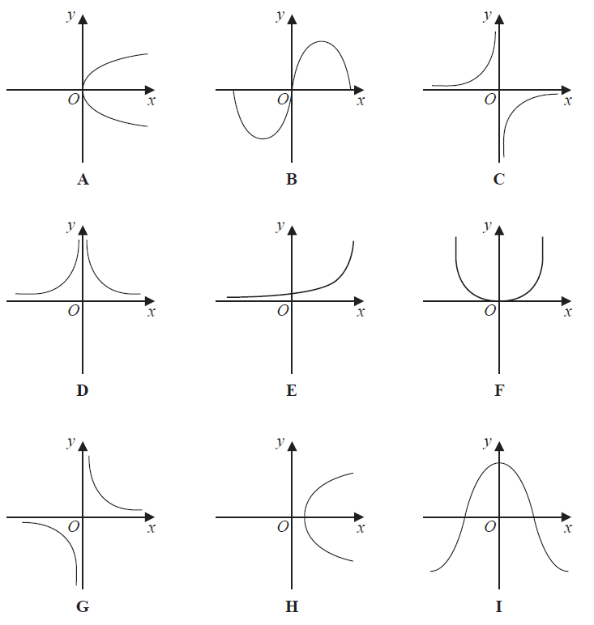

1. Write down the letter of the graph that could have the equation *y* = cos *x*°

…………….

**(1)**

1. Write down the letter of the graph that could have the equation

…………….

**(1)**

1. Write down the letter of the graph that could have the equation *y* 2 = 4*x*

…………….

**(1)**

**(Total for Question 13 is 3 marks)**

**14** The diagram shows an isosceles triangle *ABC* with *AB = AC*.

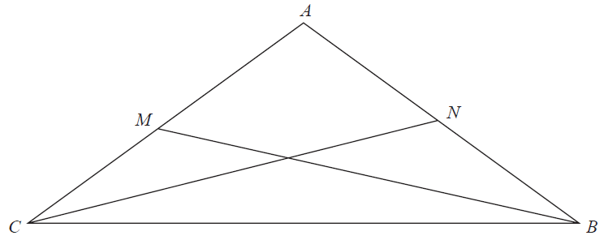

*M* is the midpoint of *AC.*

*N* is the midpoint of *AB*.

Prove that triangle *MBC* is congruent to triangle *NCB.*

**(Total for Question 14 is 3 marks)**

**15** g is a function such that

g(*x*) = *x* 3 + 1

1. Find g(–3)

……………………………..

**(1)**

(b) Find )

…………………………….

**(2)**

**(Total for Question 15 is 3 marks)**

**16** The probability that Saira walks to school is 0.8

If Saira walks to school, the probability that she will be late is 0.3

If Saira does **not** walk to school, the probability that she will be late is 0.05

Work out an estimate for the number of days that Saira will be late on the next 20 school days.

…………………………….

**(Total for Question 16 is 3 marks)**

**17** Here are two right-angled triangles.

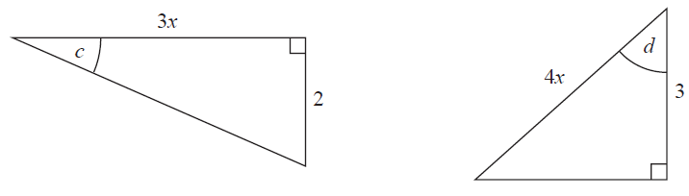

The lengths of the sides are given in centimetres.

Given thattan *c* + cos *d* = 1.5 find the size of angle *c*.

Give your answer correct to the nearest degree.

…………………………………o

**(Total for Question 17 is 4 marks)**

**18**  Here are the first five terms of a quadratic sequence.

1 8 21 40 65

The *n*th term of this sequence can be written in the form *an* 2 + *bn*,

where *a* and *b* are integers.

Work out the value of *a* and the value of *b*.

*a* = …………….

*b* = …………….

**(Total for Question 18 is 3 marks)**

**19** *T* =

*m* = 120 correct to 3 significant figures

*f*  = 25.6 correct to 1 decimal place

By considering bounds, work out the value of *T* to a suitable degree of accuracy. Give a reason for your answer.

You must show all your working.

……………………………

**(Total for Question 19 is 4 marks)**

**20** *OABC* is a sector of a circle with centre *O*.

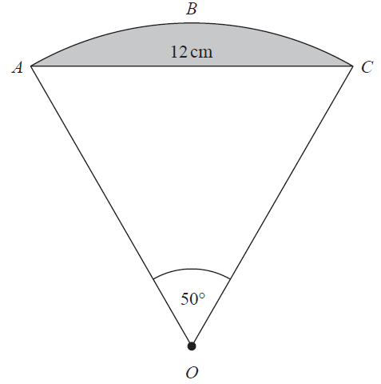

Angle *AOC* = 50o

*AC* = 12 cm

Work out the area of the shaded segment of the circle.

Give your answer correct to 3 significant figures.

………………………………. cm2

**(Total for Question 20 is 5 marks)**

**21** The diagram shows a sketch of the graph with equation

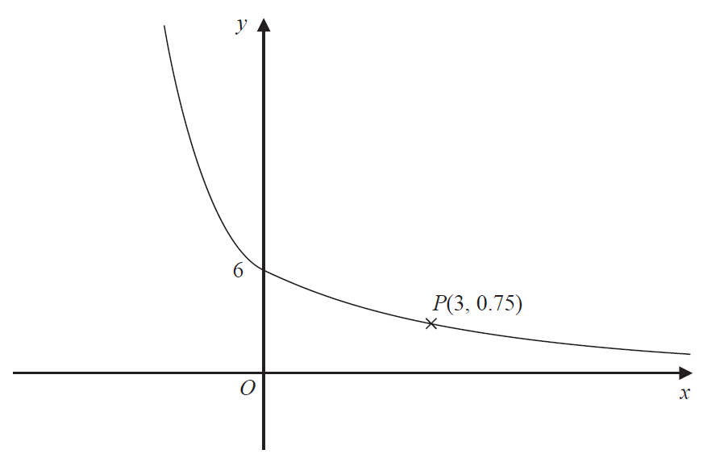

*P* is a point on the graph with coordinates (3, 0.75)

Work out the value of *a* and the value of *b*.

*a* = …………….

*b* = …………….

**(Total for Question 21 is 3 marks)**

**22 A**, **B** and **C** are three similar solids.

The surface area of **A** is 24 cm2

The surface area of **B** is 54 cm2

The height of **B** : the height of **C** = 3 : 7

The volume of **A** is 72 cm3

**C** is made of wood with density 0.14 g/cm3

Work out the mass of **C**.

………………………….. g

**(Total for Question 22 is 5 marks)**

**23** Solve 5 < (*x* – 2)(*x* + 2) < 12

You must show all your working.

…………………………………………………………………………………...

**(Total for Question 23 is 4 marks)**

**TOTAL FOR PAPER IS 80 MARKS**