**A Level Geography**

**Course Guide**

|  |  |  |
| --- | --- | --- |
| **UNIT** | **Exam Length** | **EXAM DETAILS (Examination board = Edexcel)** |
| Paper 1 30% of the Course | 2 Hours 15min | You must answer a series of short and extended answer question on:   * **Tectonics** * **Coasts** * **Water** * **Carbon** |
| Paper 2   30% of the Course | 2 hours 15 mins | You must answer a series of short and longer answer questions on:   * **Globalisation** * **Regeneration** * **Health and Human Rights** * **Superpowers** |
| Paper 3 20% of the course | 2 hours 15min | This paper is synoptic, just like paper 3 at GCSE. You are provided with a resource booklet and a question paper. The paper ties together all the knowledge you have learnt across the exam into three themes:   * Players * Actions * Futures and uncertainties. |
| NEA   20% of the course | Non examined | In this investigation, you chose the title of your NEA and create an investigation. You will collect and present this data. This year we are undertaking a residential to Dorset where students will be investigating coasts and regeneration. |

**Get to know the Exam Board’s website from Day 1:**

[**https://qualifications.pearson.com/en/qualifications/edexcel-a-levels/geography-2016.html**](https://qualifications.pearson.com/en/qualifications/edexcel-a-levels/geography-2016.html)

**Teaching staff: Miss Sutherland, Miss Hudson and Mr Maisey**

**Geography Learning Journey at LPGS**

**Yr. 1:**

|  |  |  |
| --- | --- | --- |
|  | **Teacher 1 Miss Sutherland** | **Teacher 2 Miss Hudson** |
| **Autumn Term** | **Globalisation** | **Tectonics** |
| **Spring Term** | **Regeneration** | **Coasts** |
| **Summer Term** | **NEA** | **Water** |

**Yr. 2:**

|  |  |  |
| --- | --- | --- |
|  | **Teacher 1** | **Teacher 2** |
| **Autumn Term** | **Carbon** | **Health and Human Rights** |
| **Spring Term** | **Superpowers** | **Revision** |
| **Summer Term** | **Revision** | **Revision** |

**Key expectations:**

* Keep your work organised. We expect all students to have Folders and to organise their notes appropriately.
* Students will complete assessed work in a class books that will be kept in their folders.
* Complete all classwork and homework to the best of your ability
* Begin revision work independently under guidance of your teachers from day one of the course (retrieval practice is crucial for your exam success!)

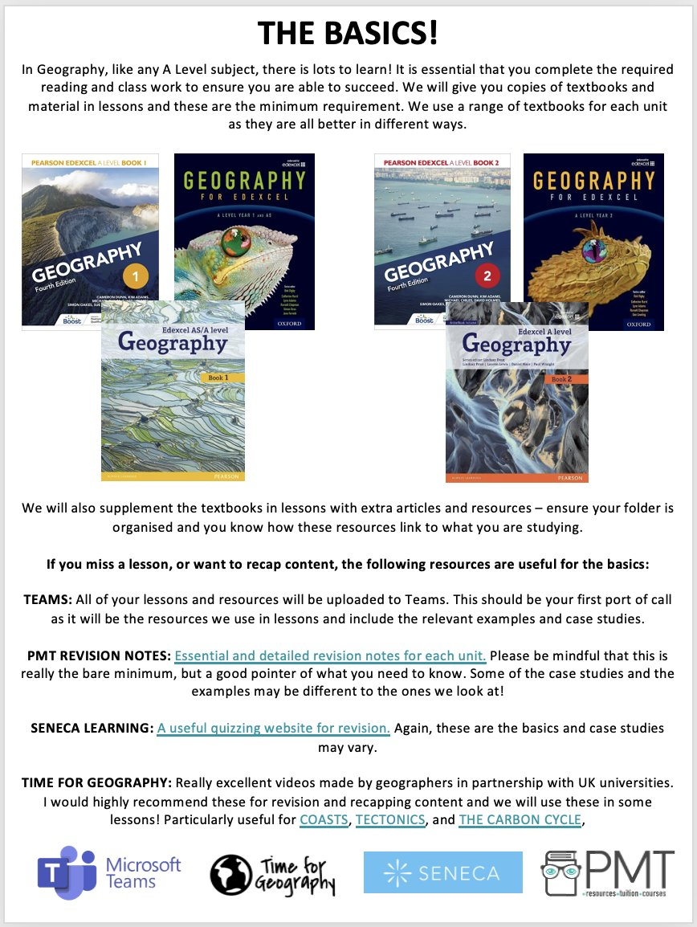

**Firefly**: All of your lessons will be uploaded to Firefly. This should be your first port of call as it will be the resources we will have used in the lessons including the relevant examples and case studies.

**Suggested textbooks:**

The textbooks we use in class are the following (we do not expect you to purchase these – we will provide copies in class when they are needed)

* Geography for Edexcel A Level Year 1 and AS Student Book
* Geography for Edexcel A Level Year 2 Student Book
* Pearson Edexcel A Level Geography Book 1 Fourth Edition Paperback
* Pearson Edexcel A Level Geography Book 2 Fourth Edition Paperback

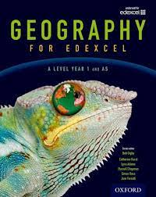

**Recommended Revision guides:**

* Pearson Edexcel A-level Geography Student Guide 1: Physical Geography
* Pearson Edexcel A-level Geography Student Guide 2: Human Geography Paperback
* Pearson Edexcel A-level Geography Workbook 2: Human Geography
* Pearson Edexcel A-level Geography Workbook 1: Physical Geography

Additional Revision Guides.:

* Pearson REVISE Edexcel AS/A Level Geography Revision Guide & Workbook: for home learning, 2022 and 2023 assessments and exams
* Geography for Edexcel A Level Year 1 and AS Level Revision Guide
* Edexcel A Level Geography Exam Practice (Digby)

Tips for success on this course:

1. **Read beyond the class notes and textbook.** There are a variety of Geography textbooks and magazines in the library and classrooms. Reading about the same topic/ content in a different book is a great way to consolidate your learning and helps you to better understand concepts we study.
2. **Make sure you know the specification** – We provide you with Personal Learning Checklists for every topic, tick off/ highlight each section covered, be familiar with the wording (as this is the basis of exam questions).
3. **Exam practice** – use practice papers from the Edexcel website.
4. **Start revision early:** The most successful students are those that start their revision early. The best way is to revise as you go. Regular retrieval practice is crucial to success.
5. **Do not plagiarise** (i.e. copying other people’s work and passing it off as your own, or simply copy from your textbook when completing assignments). Firstly, this is cheating (if you do this at University you will be expelled), secondly it stops you learning (it may get you a good homework grade but when in the exam you will suddenly find yourself without a clue) and thirdly you will get caught (your teachers are savvy and can usually spot plagiarised work instantly).
6. **Read questions analytically** – the wording of exam questions is not insignificant! Work out exactly what you are being asked to do and circle key words.This will help you to **answer the question** – refer back to it throughout the essay and at the end when you conclude.
7. **Make your answers Geographical** – try to use as many examples as possible – Geograohy is all aboi=ut the world and how it works, therefore we need to talk about it!!
8. **Quality not quantity –** it is not about how much, it is about what you write! Tailoring what you write to the question being asked is crucial to success in the tight time constraints of the exam!
9. **Good time management –** Spend a proportionate amount of time on each question, depending on how many marks it is worth.



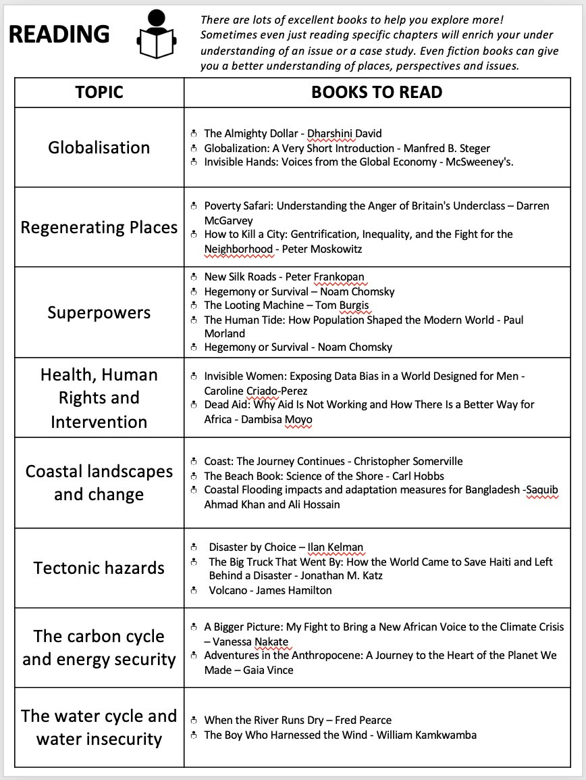

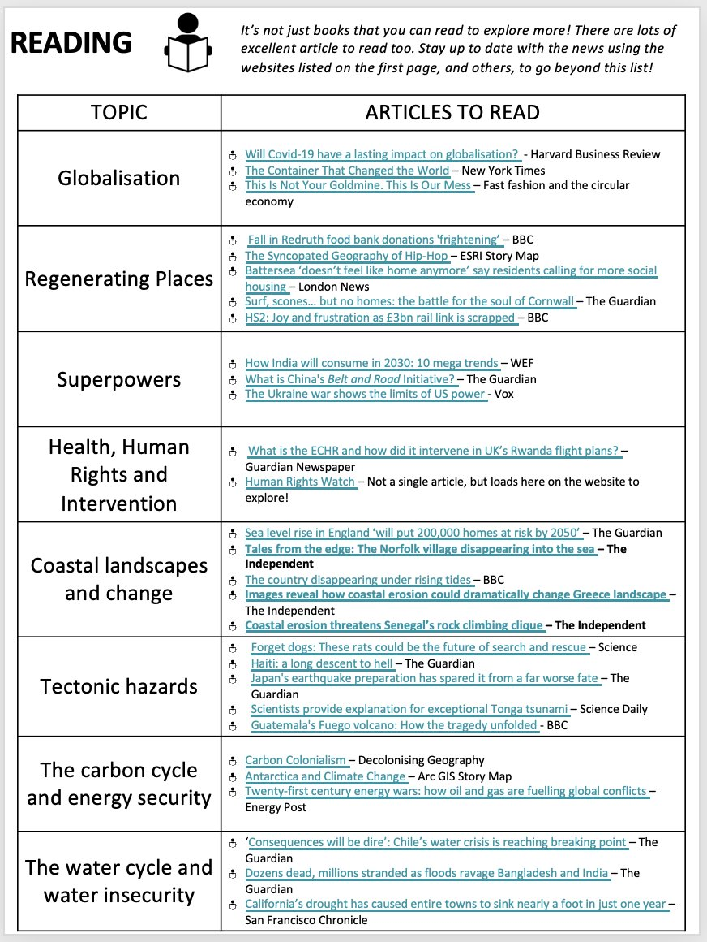

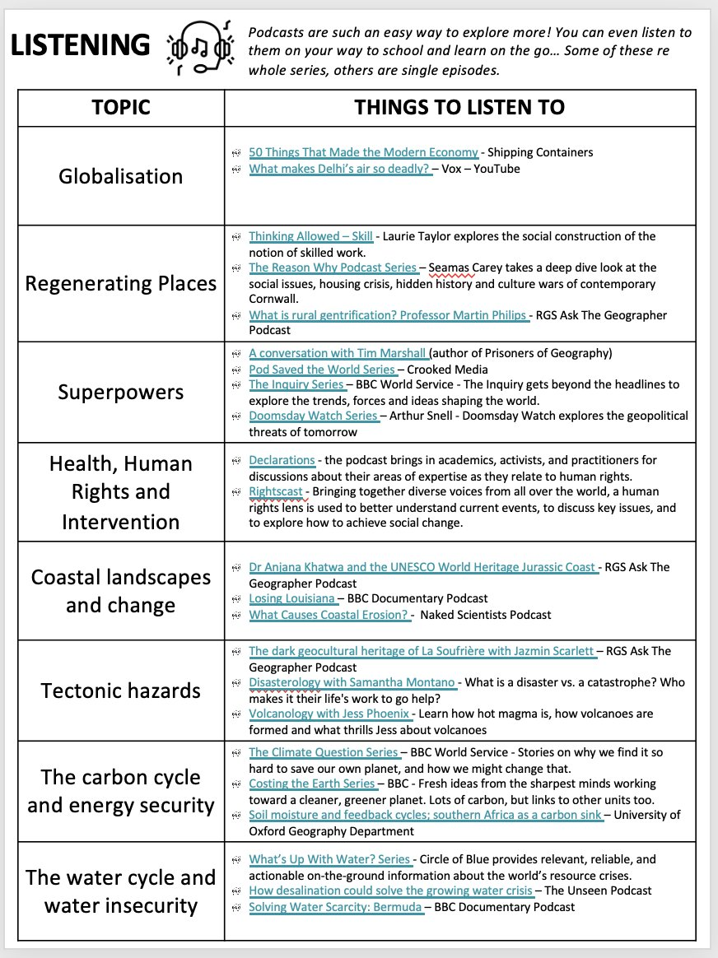

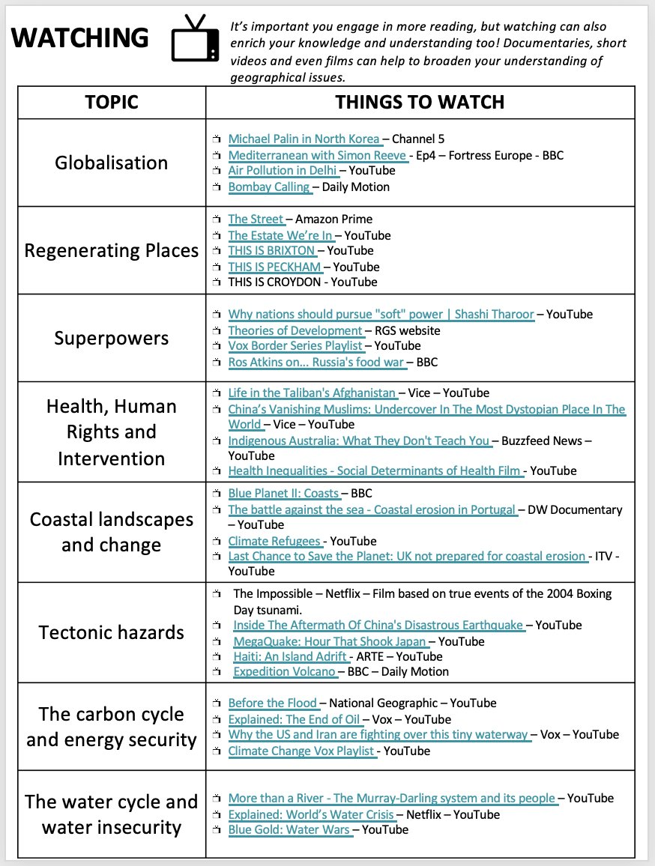

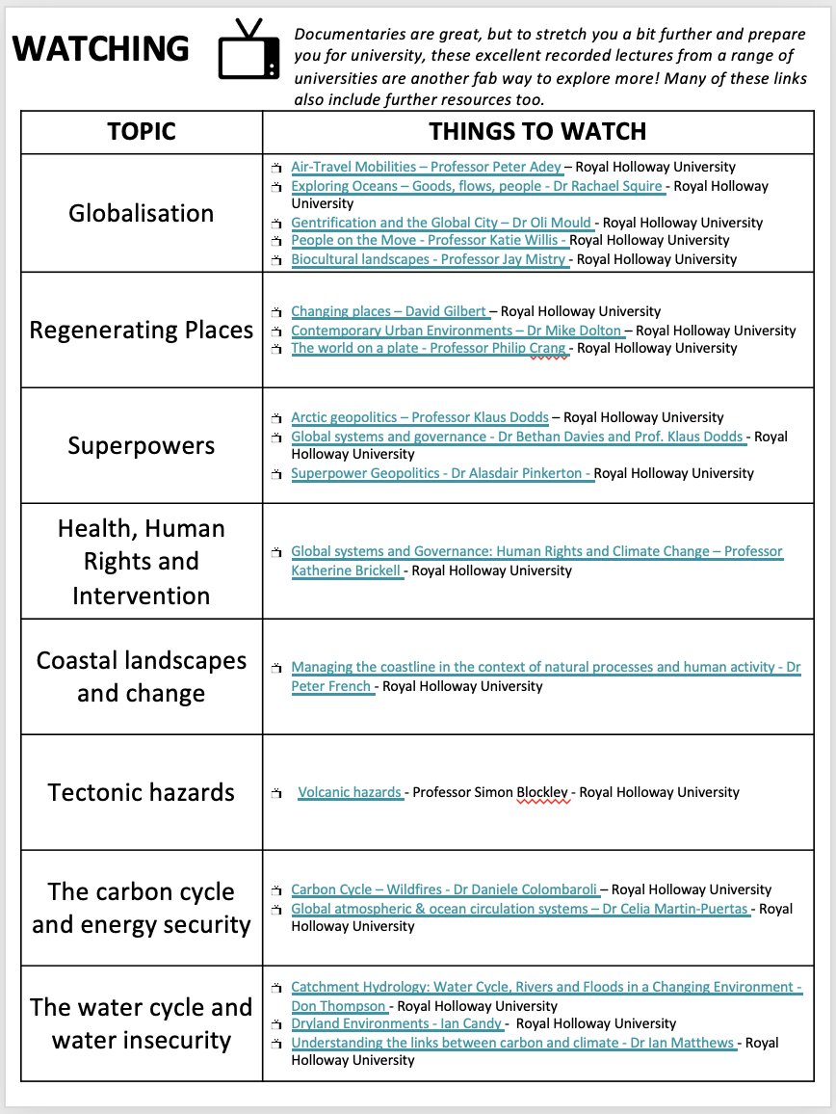

PREPARING YOU FOR THE FUTURE ...

Each year, many students go on to study Geography or Geography related courses at university. These could include Architecture, International Development, Quantity Surveying, Town Planning, Disaster Risk management ect…

Staff in the department have lots of experience with helping students make excellent applications for some of the best psychology courses in the country!

The guardian website ranks Geography courses and may be a useful place to start. In 2021, these were the rankings:

Depending on what is important to you, you can filter the course accordingly.

COMMITMENT TO LEARNING

* **Attend** **all lessons.** Should you miss any lessons it is **your responsibility to catch up** on both the missed lesson work and homework set before your next lesson. Ensure you contact someone in your class to ask them to collect sheets for you and make sure you copy up before the next lesson. You also need to make sure you are prepared to hand in any work that is expected next lesson or sit any tests that will be sat (not being in the previous lesson is not an excuse!).
* **Lessons will be uploaded onto firefly but this may not be done straight away.**
* You are expected to **be on time** for lessons, if you are late it is courteous to apologise to your teacher and you may be kept behind after the lesson to catch up on the work missed.
* Once your assessment tasks have been marked and handed back – (Teachers have two weeks to do this) you will be expected to **respond to the teacher’s feedback** – completing corrections and demonstrating where you have acted upon advice.
* Make sure that you **arrive at lessons ready to learn, be prepared by always bring your exercise books and appropriate stationary/ equipment. It is your responsibility to keep your exercise book well organised.**
* In class, you will both enhance your skills and enjoy the course more if you **participate fully** in group activities (listening and contributing), complete the individual tasks, challenge yourself to undertake extension activities and contribute to discussion.
* Outside of class you should **consolidate your learning** e.g. test your recall of key information (retrieval practice is crucial to success), look up key terms/ studies/ theories on the internet. You should also aim to do some wider reading to deepen your subject knowledge and enhance your literacy skills.

**If you fail to make the expected progress on this course or fail to demonstrate the behaviours for learning we expect, you will be placed on Geogragy subject report for two weeks. It is expected that after two weeks, you will know and be well practiced in what is expected.**

**EXAM TERMS**

AO1 - Knowledge and Understanding of places environments, concepts, processes, interactions and change at a variety of scales

AO2 – Apply knowledge and understanding in n different contexts to interpret, analyse and evaluate geographical information and issues.

AO3 – Use a variety of relevant quantitative, qualitative and fieldwork skills to

• investigate geographical questions and issues

• interpret, analyse and evaluate data and evidence

• construct arguments and draw conclusions