

LPGS

Cambridge Technical in

Business

Student Handbook

LEVEL 3

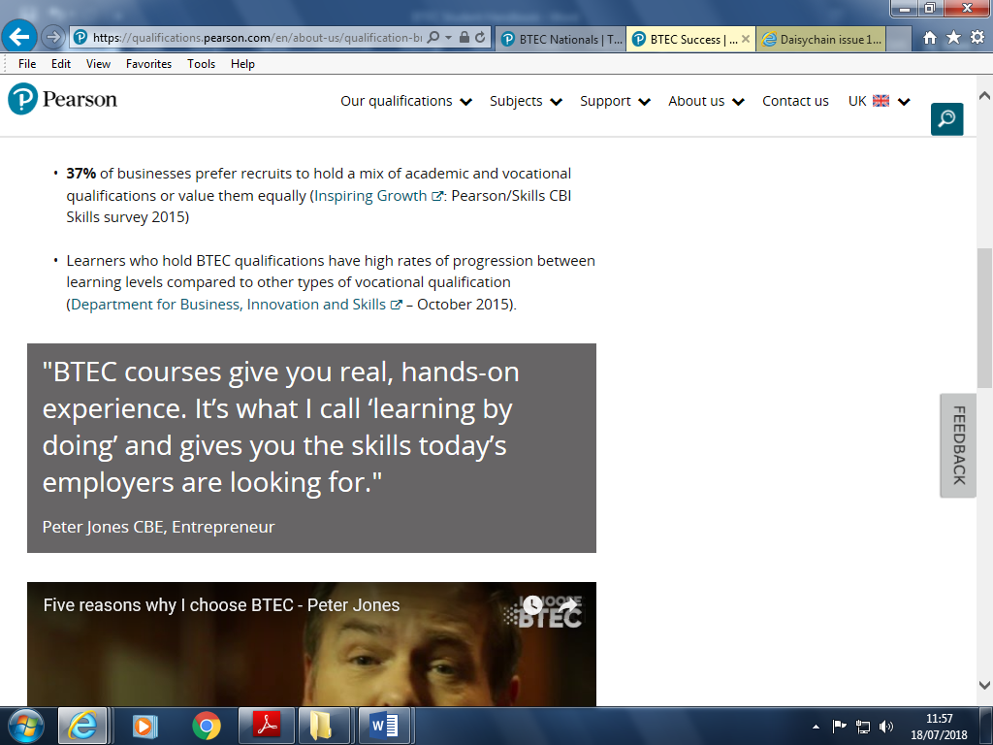

## give you real, hands-on ece. It’s what I call ‘learning by doing’ and gives you the skills today’s employers are looking for."Petones CBE,

* **1 in 4** students who got into university in the UK did so with a Vocational qualification ([UCAS](https://www.ucas.com/) report – Progression Pathways January 2016)

**4 out of 5** of Vocational students go on to receive a First or Second class degree (The outcomes associated with the BTEC route of degree level acquisition, [London Economics](https://londoneconomics.co.uk/) 2013)

|  |
| --- |
| Learner name: |
| ULN: |
| Course start:  Course finish: |

**Welcome to LPGS OCR Cambridge Technical in Business Level 3 courses**

The Vocational Team welcome you and we are pleased to have you here as our student. Whether you are new to Langley or have been here some time you are going to be our most important and valuable assets.

What makes vocational qualifications different?

* Students develop skills, knowledge and understanding in the vocational area they are studying.
* Each vocational course is made up of a number of units, allowing students to build up their qualification in stages.
* Students are assessed through assignments/coursework, controlled assessments and exams
* Students take responsibility for their own learning by planning their work, doing research and regularly reviewing progress.

We hope that you will have success and will enjoy your time here at Langley. The BTEC courses are different to A Levels and you will be expected to work hard throughout your time here and to meet deadlines.

Your teachers are here to help you and we will present you with many opportunities to broaden your vocational learning.

Mrs Boulton, Head of Business [LBO@lpgs.bromley.sch.uk](mailto:LBO@lpgs.bromley.sch.uk)

Staffing structure

Mrs Ashman-Clarke, Deputy Head

Overall responsibility for vocational courses and sixth form

Mrs Boulton

Head of Business

Internal verifier, Course Leader

**What advice do our current students give you?**

Make the most of the January exams and be prepared so you have less resits as this is time consuming as you will have CW to do as well!

Revise Early! Create your flash cards as you go along – don’t leave until the end just before the exam!

Learn the structures for the 12 and 16 mark essay questions and do these first in the exam!

Always aim for the Distinction!

Stay on top of the coursework as you could have several pieces of work to do at once!

Make mini deadlines and write these down!

Year 12 Units count! Make it count!

**How will you be assessed?**

You will have some exams.

You will have some controlled assessments.

You will complete some assignments/coursework.

**Rules for exams and controlled assessments**

There are two resits opportunities. This means that if you fail the exams three times then you fail the course. All exams in business are traditional paper exams – Unit 1 and Unit 3, sat in Year 12 have a pre-release in which some of the exam is based on that you will have access to at least eight weeks before the examination to help with your preparation and revision. Unit 1 pre -release relates to the content covered in Section B of the exam and Unit 3 is the context for the whole exam paper - although you are not allowed to take notes into the exam with you – the pre-release allows you to be extra prepared. Units 2 and 15, sat in Year 13 have no pre-release and are traditional exams including 12 and 16 mark essay questions.

**Assignment rules**

**What are assignments?**

Assignment briefs are issued once the content has been taught/delivered. You need to keep them close to you while you are working on the assignment as they keep you on track.

**Preparing for assessment**

Your teacher will teach you the content (stuff you need to know).

Your teacher will check that you understand what to do and how to do it. Your teacher will ensure that you are aware of the deadlines and have been given sufficient time to complete the work.

**Submitting evidence for assessment**

You have one chance to submit work.

You hand in a declaration and submission form with every assignment and you declare that it is your own work.

All work must be your own. It should not be copied from another student or copied and pasted from the Internet. This is regarded as plagiarism and is extremely serious. It is cheating and jeopardises your chances of getting the qualification.

Teachers/assessors mark your work and complete an Assessment Record Form which says whether you have met the assessment criteria or not.

Work is usually word processed and you must keep a copy for your own reference.

it must be evident that you have genuinely attempted the whole task in your initial submission. It is not enough to hand in half completed work on time simply to try to secure a resubmission.

**Deadlines**

These are fixed. If you do not meet the deadline then you are NOT entitled to resubmit the work. Missing a deadline means not achieving the qualification. No one in school is authorised to allow a resubmission. The exception would be if something serious has happened and the school has been formally notified e.g. you have been in hospital and we have a note from the hospital.

*We are not allowed to give individual students an advantage by allowing them more time than other students to complete work.*

**Assessment**

We will give you feedback which makes it clear if you have achieved the criteria with comments on how you achieved or did not achieve the criteria. You will also get overall comments. The assessor signs this form and you sign to show that you have read the comments and you add a comment of your own.

**Re-submission**

Every assignment counts towards your final grade.

The rules from OCR are clear:

* You are able to have one final resubmission of the coursework task addressing the areas you have missed out based on the feedback
* You need to ensure the work is handed in by the final deadline instructed to you

**Marking and moderation**

Work is marked by your teachers and is then second-marked by an internal verifier.

Samples of work are sent to the exam board to check that we are marking correctly.

**Business Units/Qualifications**

|  |  |  |  |  |
| --- | --- | --- | --- | --- |
| **Award** | **Level** | **Duration** | **Number of Units** | **Equivalent** |
| OCR Level 3 Cambridge Technical Diploma in Business | 3 | 2 years | 10 | 2 x A Level |
| OCR Level 3 Cambridge Technical Extended Certificate in Business | 3 | 2 years | 5 | 1 x A Level |

**OCR Cambridge Technical in Business Units and Assessments**

|  |  |  |  |  |
| --- | --- | --- | --- | --- |
| **Unit Number** | **Unit Title** | **Method of Assessment** | **Extended Certificate** | **Diploma** |
| 1 | The Business Environment | 2 hour exam | Yes | Yes |
| 2 | Working in Business | 1 hour 30 minutes exam | Yes | Yes |
| 3 | Business Decisions | 1 hour 30 minutes Exam | No | Yes |
| 4 | Customers and Communication | Coursework | Yes | Yes |
| 5 | Marketing and Market Research | Coursework | Yes | Yes |
| 6 | Marketing Strategy | Coursework | No | Yes |
| 7 | Marketing Campaign | Coursework | No | Yes |
| 15 | Change Management | 1 hour 30 minutes exam | No | Yes |
| 16 | Principles of Project management | Coursework | Yes | Yes |
| 22 | Delivering a Business Project | Coursework | No | Yes |

**OCR Level 3 Diploma in Business 2022-2024**

|  |  |
| --- | --- |
| **Year 12** | **Year 13** |
| Unit 1 January 2023 Exam  Unit 3 January 2023 Exam  Unit 4 Coursework  Unit 6 Coursework  Unit 7 Coursework  Unit 16 Coursework | Unit 2 January 2024 exam  Unit 15 Jan 2024 Exam  Unit 5 Coursework  Unit 22 Coursework |

**OCR Level 3 Extended Certificate in Business 2022-2024**

|  |  |
| --- | --- |
| **Year 12** | **Year 13** |
| Unit 1 2023 January Exam  Unit 4 Coursework  Unit 16 coursework | Unit 2 January 2024 exam  Unit 5 coursework |

**Unit Assessment Points**

**Points are added together to give the final grade**

Your record of your grades/points

|  |  |  |
| --- | --- | --- |
| Unit number | Final grade | Points |
|  |  |  |
|  |  |  |
|  |  |  |
|  |  |  |
|  |  |  |
|  |  |  |
|  |  |  |
|  |  |  |
| TOTAL POINTS |  |  |

|  |
| --- |
| Plan to make sure I get the result I want: |