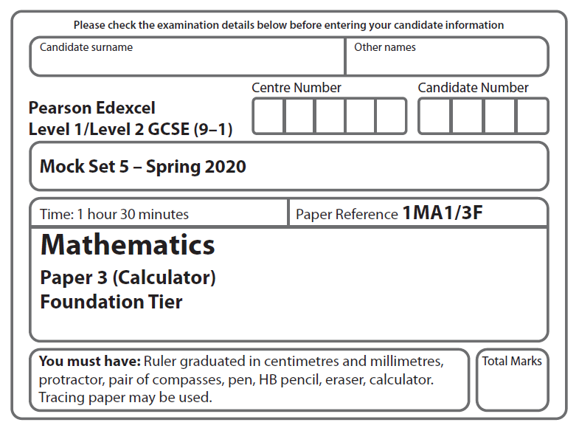

LPGS Autumn Mock Exam 2020

**Instructions**

* Use **black** ink or ball-point pen.
* 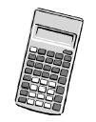**Fill in the boxes** at the top of this page with your name, centre number   
  and candidate number.
* Answer **all** questions.
* Answer the questions in the spaces provided.

*– there may be more space than you need.*

* You must **show all your working.**
* Diagrams are **NOT** accurately drawn, unless otherwise indicated.
* **Calculators may be used.**

**Information**

* The total mark for this paper is 80
* The marks for **each** question are shown in brackets

*– use this as a guide as to how much time to spend on each question.*

**Advice**

* Read each question carefully before you start to answer it.
* Try to answer every question.
* Check your answers if you have time at the end.

**S66512A**

**Answer ALL questions.**

**Write your answers in the spaces provided.**

**You must write down all the stages in your working.**

1. Write 0.9 as a fraction.

……………………

(Total for Question 1 is 1 mark)

**2** Change 4000 millilitres into litres.

litres

**(Total for Question 2 is 1 mark)**

**3** Work out the value of

(Total for Question 3 is 1 mark)

**4** Simplify 6*k* × 2*t*

(Total for Question 4 is 1 mark)

**5** Work out the value of 13 2

(Total for Question 5 is 1 mark)

**6** Mehvish buys kg carrots, 3 kg potatoes, 2 kg onions and 1 kg of chicken.

|  |  |
| --- | --- |
| **Price list** | |
| carrots | 50p per kg |
| potatoes | 64p per kg |
| onions | 42p per kg |
| chicken | £6 per kg |

She pays with a £20 note.

Work out the change that Mehvish should get.

£

(Total for Question 6 is 5 marks)

**7** Here are three symbols.

= ˂ ˃

Write one of these symbols on each dotted line to make four true statements.

(–8)2 –16

20 – 5 × 2 30

20

*y* × *y* *y* 2

(Total for Question 7 is 3 marks)

**8** Here is a solid 3-D shape.

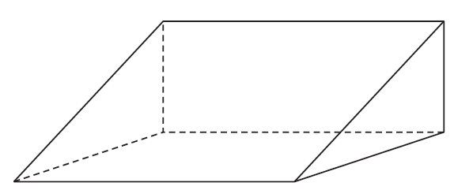

(a) Write down the name of this 3-D shape.

**(1)**

(b) Write down the number of faces of this 3-D shape.

**(1)**

(Total for Question 8 is 2 marks)

**9** (a) Simplify 4*m* – *m* + 3*m*

**(1)**

(b) Simplify 5*n* – 4 + 2*n* + 3

**(2)**

(Total for Question 9 is 3 marks)

**10** Here are four fractions.

|  |  |  |  |
| --- | --- | --- | --- |
|  |  |  |  |

Write the fractions in order of size.

Start with the smallest fraction.

(Total for Question 10 is 2 marks)

**11** The table gives the monthly rainfall in Manchester for four months.

|  |  |  |  |  |
| --- | --- | --- | --- | --- |
| **Month** | Jan | Feb | Mar | Apr |
| **Rainfall (mm)** | 84 | 58 | 66 | 56 |

(a) On the grid below, draw a bar chart for this information.

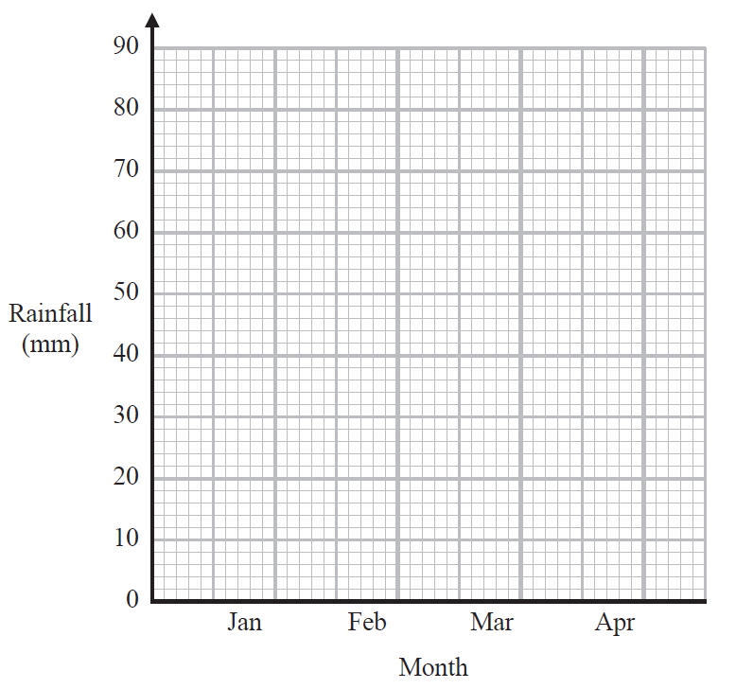

**(2)**

The table below gives the monthly rainfall in Birmingham for the same four months.

|  |  |  |  |  |
| --- | --- | --- | --- | --- |
| **Month** | Jan | Feb | Mar | Apr |
| **Rainfall (mm)** | 58 | 48 | 52 | 48 |

(b) (i) Work out the mean monthly rainfall for Birmingham.

mm

**(2)**

(ii) Work out the range for Birmingham.

mm

**(1)**

The mean monthly rainfall for Manchester is 66 mm.

The range for Manchester is 28 mm.

Neil says that the amount of rain in Manchester varies more than the amount of rain in Birmingham.

(c) Is Neil correct?

You must give a reason for your answer.

**(1)**

(Total for Question 11 is 6 marks)

**12** Here is a fair 4-sided spinner and a fair coin.

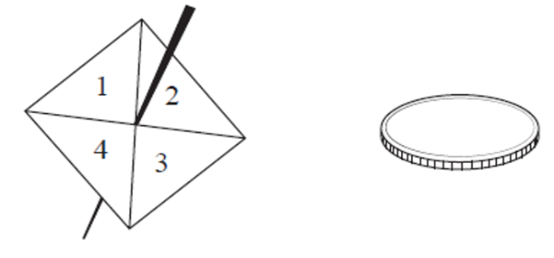

Sophie spins the spinner once and throws the coin once.

(a) List all the possible outcomes.

The first one has been done for you.

(1, H)

**(2)**

(b) Find the probability that Sophie will get an even number and a head.

**(2)**

(Total for Question 12 is 4 marks)

**13** The point *P* has coordinates (–2, 6)

The point *M* has coordinates (5, 6)

*M* is the midpoint of *PQ*.

Find the coordinates of the point *Q*.

(……….. , ..………)

(Total for Question 13 is 2 marks)

**14** 150 people live in a village.

Some of these people are pet owners.

45 of the people live alone.

30 of the pet owners do **not** live alone.

50 of the people are pet owners.

(a) Use this information to complete the frequency tree.

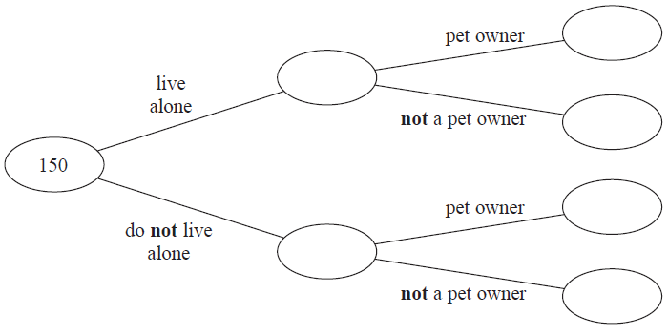

**(3)**

(b) Write down the number of pet owners who live alone as a fraction of the total

number of people who live alone.

Give your fraction in its simplest form.

**(2)**

(Total for Question 14 is 5 marks)

**15** (a) Factorise *w* 2 *+* 4*w*

**(1)**

(b) Solve 5(2*p* – 3) = 30

*p* =

**(3)**

(c) Show the inequality ⩽ *x* < 4 on the number line below.

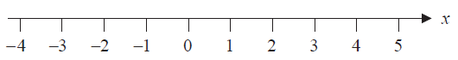

**(2)**

(Total for Question 15 is 6 marks)

**16** The diagram shows a kitchen floor in the shape of a rectangle.

300 cm

540 cm

Lynn is going to cover the floor with tiles.

Each tile is a rectangle of side 60 cm by 30 cm.

Each tile costs £4.25

Lynn has £400 to spend on tiles.

Show that she has enough money to buy all the tiles she needs.

(Total for Question 16 is 5 marks)

**17** The real distance between two towns is 75 km.

On a map, the distance between the two towns is 3 cm.

(a) Complete the following statement.

1 cm on the map represents a real distance of ................ km.

**(1)**

The diagram shows the position of two castles, *P* and *Q*.

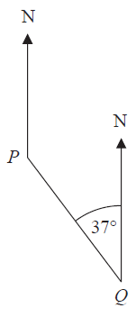

Mike has to work out the bearing of *P* from *Q*.

Here is Mike’s working.

180 – 37 = 143

The bearing of *P* from *Q* = 143°

Mike’s answer is wrong.

(b) What mistake has Mike made?

**(1)**

(Total for Question 17 is 2 marks)

**18** Give an example to show that when two prime numbers are added, the result

may be an odd number.

(Total for Question 18 is 2 marks)

**19** Calculate

Give your answer correct to 3 significant figures.

(Total for Question 19 is 2 marks)

**20** *ABC* and *PQR* are similar triangles.

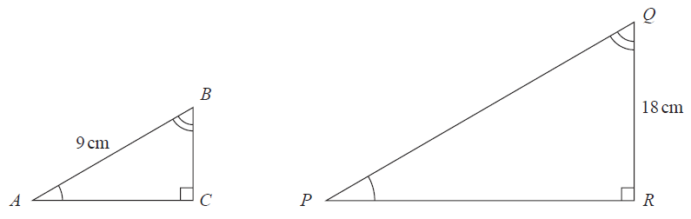

*AB* : *PQ* = 2 : 5

(i) Work out the length of *PQ.*

cm

**(2)**

(ii) Work out the length of *BC.*

cm

**(2)**

(Total for Question 20 is 4 marks)

**21** The table shows information about the distances travelled by 50 new cars before a tyre was changed.

|  |  |
| --- | --- |
| **Distance (*d* km)** | **Number of cars** |
| 5000 ⩽ *d* ˂ 25 000 | 9 |
| 25 000 ⩽ *d* ˂ 45 000 | 25 |
| 45 000 ⩽ *d* ˂ 65 000 | 16 |

Calculate an estimate for the mean distance.

km

(Total for Question 27 is 3 marks)

**22** The diagram shows a cylinder with diameter 10 cm and height 12 cm.

10 cm

12 cm

Calculate the volume of this cylinder.

Give your answer correct to 3 significant figures.

cm³

(Total for Question 22 is 2 marks)

**23** Luke invested £4000 in a savings account for 3 years.

Compound interest was paid at a rate of 1.8% each year.

Alexa also invested £4000 in a savings account for 3 years.

Simple interest was paid at a rate of 1.8% each year.

Luke got more interest than Alexa in total over the 3 years.

How much more?

You must show all your working.

£

(Total for Question 23 is 4 marks)

**24** The height, *h* metres, of a tall building is 184 metres correct to the nearest metre.

Complete the following statement to show the range of possible values of *h*.

⩽ *h* <

(Total for Question 24 is 2 marks)

**25** Here is a rectangle *ABCD*.

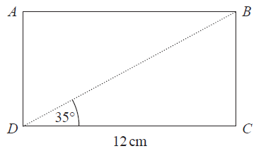

Work out the perimeter of the rectangle.

Give your answer correct to 3 significant figures.

cm

(Total for Question 25 is 4 marks)

**26** (a) Complete the table of values for *y* = *x*3 + 2

|  |  |  |  |  |  |  |  |
| --- | --- | --- | --- | --- | --- | --- | --- |
| *x* | −3 | −2 | −1 | 0 | 1 | 2 | 3 |
| *y* |  | −6 |  |  | 3 |  |  |

**(2)**

(b) On the grid below, draw the graph of *y* = *x* 3 + 2 for values of *x* from −3 to 3

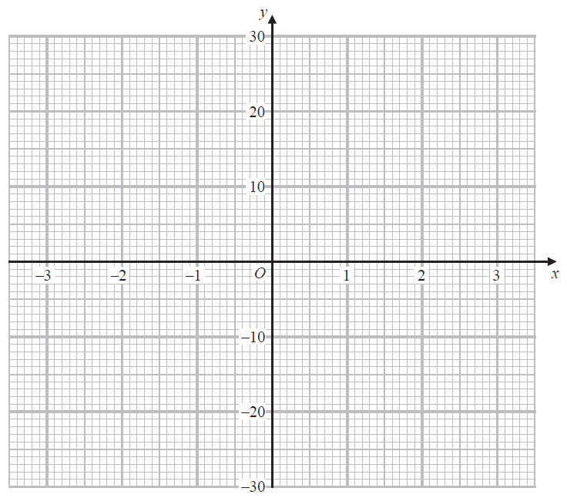

(2)

(c) Use your graph to find the value of *x* when *y* = 6

**(1)**

(Total for Question 26 is 5 marks)

**27** There are some counters in a box.

Each counter is blue or green or red.

There are

twice as many blue counters as red counters

and three times as many green counters as blue counters.

One counter is picked at random from the box.

Work out the probability that this counter is green.

(Total for Question 27 is 3 marks)

**TOTAL FOR PAPER IS 80 MARKS**