**GCSE Mathematics**

**Practice Tests: Set 12**

**Paper 1H (Non-calculator)**

**Time: 1 hour 30 minutes**

You should have: Ruler graduated in centimetres and millimetres, protractor, pair of compasses, pen, HB pencil, eraser, calculator. Tracing paper may be used.

**Instructions**



* Use **black** ink or ball-point pen.
* **Fill in the boxes** at the top of this page with your name,  
  centre number and candidate number.
* Answer **all** questions.
* Answer the questions in the spaces provided

– *there may be more space than you need*.

* **Calculators may not be used.**
* Diagrams are NOT accurately drawn, unless otherwise indicated.
* You must **show all your working out.**

**Information**

* The total mark for this paper is 80
* The marks for **each** question are shown in brackets  
  – *use this as a guide as to how much time to spend on each question*.

**Advice**

* Read each question carefully before you start to answer it.
* Keep an eye on the time.
* Try to answer every question.
* Check your answers if you have time at the end.

**Answer all questions.**

**Write your answers in the spaces provided.**

**You must write down all the stages in your working.**

**1** The diagram shows a triangle.

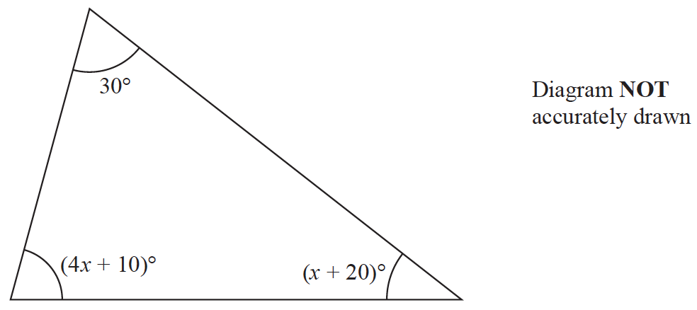

Work out the value of *x*.

*x* = .......................................................

**(Total for Question 1 is 4 marks)**

**___________________________________________________________________________**

**2** (*a*)Simplify **

.......................................................

**(1)**

(*b*)Write  as a single power of 7

.......................................................

**(2)**

**(Total for Question 2 is 3 marks)**

**___________________________________________________________________________**

**3** Expand and simplify (*m* − 8)(*m* + 5)

.......................................................

**(Total for Question 3 is 2 marks)**

**___________________________________________________________________________**

**4** The diagram shows a shape.

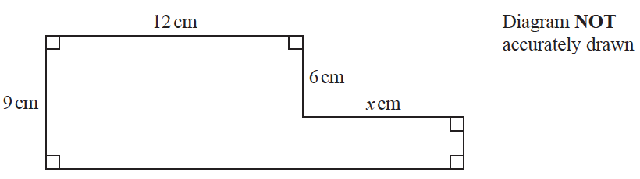

The shape has area 129 cm2

Work out the value of *x*.

*x* = .......................................................

**(Total for Question 4 is 4 marks)**

**___________________________________________________________________________**

**5** Show that 

**(Total for Question 5 is 3 marks)**

**___________________________________________________________________________**

**6** Solve 3(2*x* − 5) = 

Show clear algebraic working.

*x* = .......................................................

**(Total for Question 6 is 4 marks)**

**___________________________________________________________________________**

**7** Factorise fully 5*y* + 20*y*2

.......................................................

**(Total for Question 7 is 2 marks)**

**___________________________________________________________________________**

**8** Solve the inequality 2*x* + 7 > 4

.......................................................

**(Total for Question 8 is 2 marks)**

**___________________________________________________________________________**

**9** Solve *x*2 – 3*x* – 40 = 0

Show clear algebraic working.

.......................................................

**(Total for Question 9 is 3 marks)**

**___________________________________________________________________________**

**10**

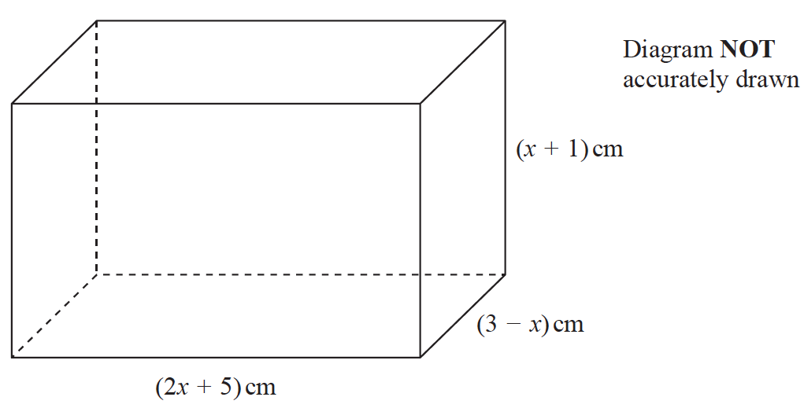

The diagram shows a cuboid of volume *V* cm3

Show that *V* = 15 + 16*x* − *x*2 − 2*x*3

**(Total for Question 10 is 3 marks)**

**___________________________________________________________________________**

**11** Find the lowest common multiple (LCM) of 28 and 105

.......................................................

**(Total for Question 11 is 2 marks)**

**___________________________________________________________________________**

**12** The weight of a cat is 4.3 kg correct to 2 significant figures.

(*a*)Write down the upper bound of the weight of the cat.

...................................................... kg

**(1)**

(*b*)Write down the lower bound of the weight of the cat.

...................................................... kg

**(1)**

**(Total for Question 11 is 2 marks)**

**___________________________________________________________________________**

**13**

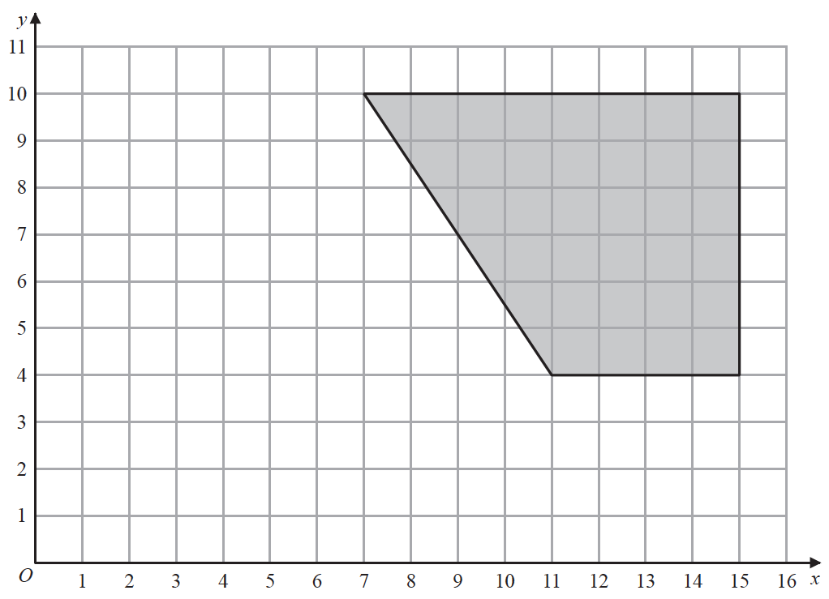

On the grid, enlarge the shaded shape with scale factor  and centre (1, 2)

**(Total for Question 13 is 2 marks)**

**___________________________________________________________________________**

**14** Use ruler and compasses to construct the bisector of angle *BAC*.

You must show all your construction lines.



**(Total for Question 14 is 2 marks)**

**___________________________________________________________________________**

**15** A total of 80 men and women took part in a race.

The cumulative frequency graph gives information about the times, in minutes, they took

for the race.

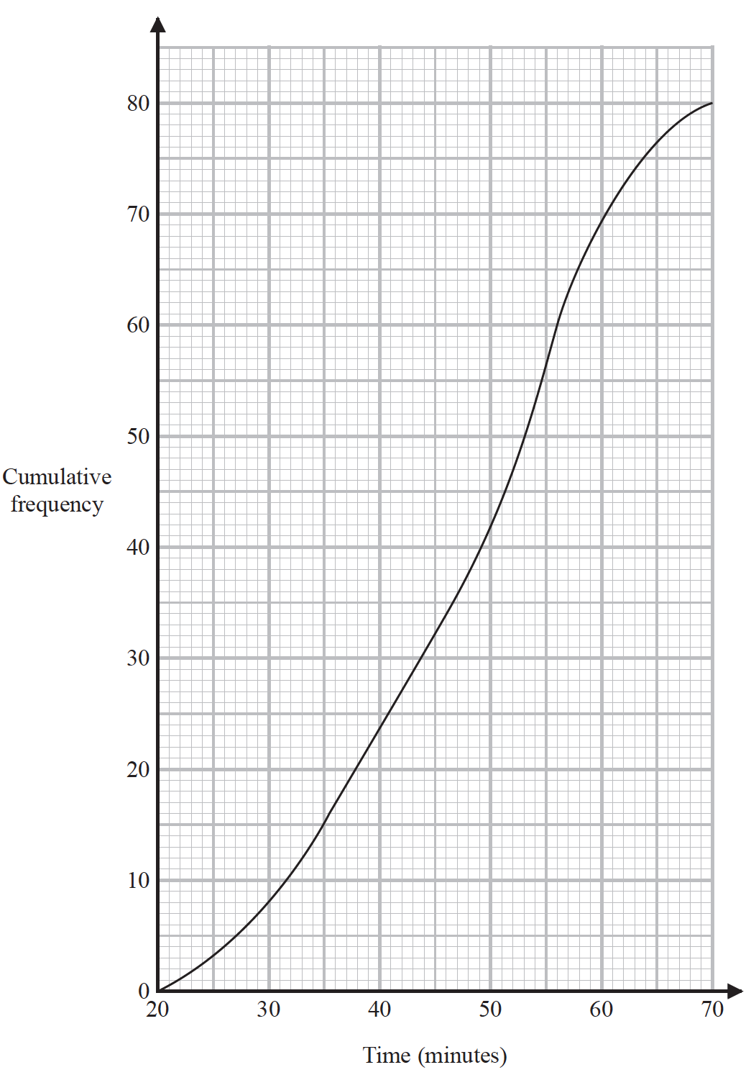

(*a*)Use the graph to find an estimate for the interquartile range.

....................................................... minutes

**(2)**

60% of the men took 50 minutes or less for the race.

No women took 50 minutes or less for the race.

(*b*)Work out an estimate for the number of men who took part in the race.

.......................................................

**(3)**

**(Total for Question 15 is 5 marks)**

**___________________________________________________________________________**

**16** Simplify (*p*2 + 3)0

.......................................................

**(Total for Question 16 is 1 mark)**

**___________________________________________________________________________**

**17** Make *x* the subject of *y* = **

.......................................................

**(Total for Question 17 is 4 marks)**

**___________________________________________________________________________**

**18** Show that 

Show each stage of your working.

**(Total for Question 18 is 3 marks)**

**___________________________________________________________________________**

**19** Here are six graphs.



Complete the table below with the letter of the graph that could represent each given

equation.

Write your answers on the dotted lines.

|  |  |
| --- | --- |
| **Equation** | **Graph** |
| *y* = | ............................ |
| *y* = | ............................ |
| *y* = | ............................ |

**(Total for Question 19 is 3 marks)**

**___________________________________________________________________________**

**20** Simplify fully 

**(Total for Question 20 is 3 marks)**

**___________________________________________________________________________**

**21** The shaded region in the diagram is bounded by three lines.

The equation of one of the lines is given.

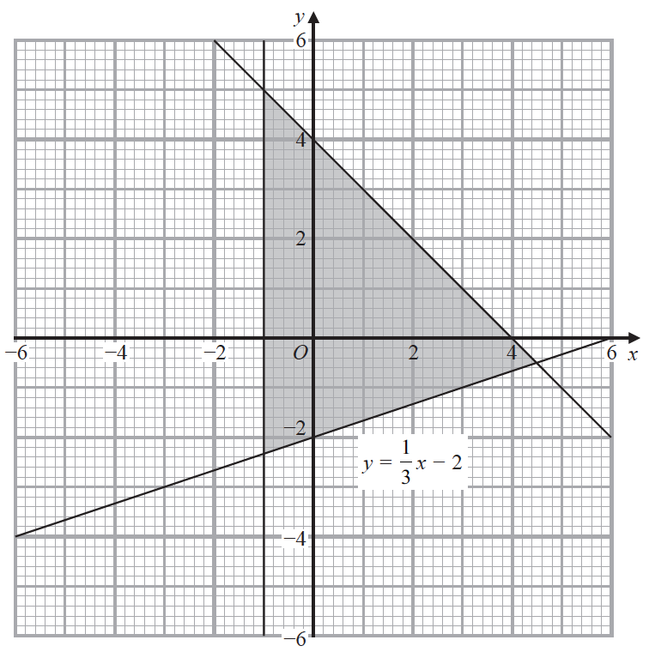

Write down the three inequalities that define the shaded region.

.......................................................

.......................................................

.......................................................

**(Total for Question 21 is 3 marks)**

**___________________________________________________________________________**

**22** Change 32.4 m3 into cm3

....................................................... cm3

**(Total for Question 22 is 2 marks)**

**___________________________________________________________________________**

**23** The line with equation *y* = *x* + 2 intersects the curve with equation *x*2 + *y*2 – 2*y* = 24 at

the points *A* and *B*.

Find the coordinates of *A* and *B*.

Show clear algebraic working.

(............................. , .............................)

(............................. , .............................)

**(Total for Question 23 is 5 marks)**

**___________________________________________________________________________**

**24**

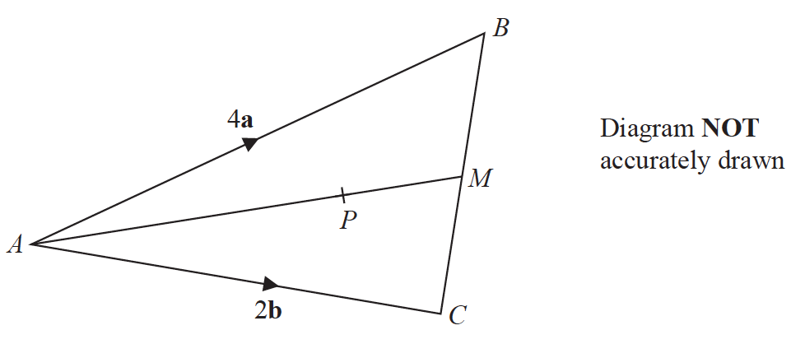

*ABC* is a triangle.

The midpoint of *BC* is *M*.

*P* is a point on *AM*.

 = 4**a**

 = 2**b**

 = **a** + **b**

Find the ratio *AP* : *PM*

.......................................................

**(Total for Question 24 is 3 marks)**

**___________________________________________________________________________**

**25** Express



as a single fraction in its simplest form.

.......................................................

**(Total for Question 25 is 4 marks)**

**___________________________________________________________________________**

**26** The area of a rectangle is 18 cm2

The length of the rectangle is ( + 1) cm.

Without using a calculator and showing each stage of your working,

find the width of the rectangle.

Give your answer in the form *a* + *c* where *a*, *b* and *c* are integers.

....................................................... cm

**(Total for Question 26 is 3 marks)**

**___________________________________________________________________________**

**27** Prove that the difference between two consecutive square numbers is always an odd number.

Show clear algebraic working.

**(Total for Question 27 is 3 marks)**

**TOTAL FOR PAPER IS 80 MARKS**

**BLANK PAGE**