**Statistical diagrams: Pie charts**

**Instructions**

* Use **black** ink or ball-point pen.
  + **Fill in the boxes** at the top of this page with your name,  
    centre number and candidate number.
* Answer **all** questions.
* Answer the questions in the spaces provided  
  *– there may be more space than you need.*
* You must **show all your working.**
* Diagrams are **NOT** accurately drawn, unless otherwise indicated.
* If your calculator does not have a *π* button, take the value of *π* to be3.142

unless the question instructs otherwise.

**Information**

* The total mark for this paper is **22**. There are **6** questions.
* Questions have been arranged in an ascending order of mean difficulty, as found by all students in the June 2017–November 2019 examinations.
* The marks for **each** question are shown in brackets  
  *– use this as a guide as to how much time to spend on each question.*

**Advice**

1. Read each question carefully before you start to answer it.
2. Keep an eye on the time.
3. Try to answer every question.
4. Check your answers if you have time at the end.

**1** 60 students were asked how they get to school.

The table shows the results.

|  |  |  |  |  |
| --- | --- | --- | --- | --- |
|  | **Bus** | **Walk** | **Car** | **Bicycle** |
| **Number of students** | 15 | 27 | 12 | 6 |

(*a*)What fraction of the 60 students did **not** walk to school?

......................................................

**(2)**

(*b*)Complete the pie chart for the information in the table.



**(4)**

**(Total for Question 1 is 6 marks)**

**___________________________________________________________________________**

**2** A group of football fans were asked what their half time snack was.

The table below gives information about their answers.

|  |  |
| --- | --- |
| **Snack** | **Number of fans** |
| burger | 11 |
| pie | 17 |
| hot dog | 8 |

Draw an accurate pie chart for this information.



(**Total for Question 2 is 3 marks**)

**___________________________________________________________________________**

**3** Year 9 students from Halle School were asked to choose one language to study.

The table shows information about their choices.

|  |  |  |
| --- | --- | --- |
| **Language** | **Number of students** |  |
| French | 56 |  |
| Spanish | 40 |  |
| German | 24 |  |

(*a*)Draw an accurate pie chart to show this information.



**(3)**

Year 9 students from Lowry School were also asked to choose one language to study.

This accurate pie chart shows information about their choices.



Shameena says,

“The pie chart shows that French was chosen by more Year 9 students at

Lowry School than at Halle School.”

(*b*)Is Shameena right?

You must explain your answer.

......................................................................................................................................................

......................................................................................................................................................

......................................................................................................................................................

**(1)**

**(Total for Question 3 is 4 marks)**

**___________________________________________________________________________**

**4** The pie charts show information about the favourite animal of each student at school **A**

and of each student at school **B**.

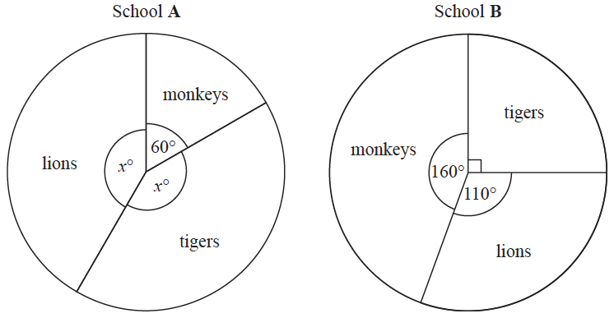

There are 480 students at school **A**. There are 760 students at school **B**.

Henry says,

“The same number of students at each school have tigers as their favourite animal.”

Is Henry correct?

You must show how you get your answer.

**(Total for Question 4 is 4 marks)**

**___________________________________________________________________________**

**5** There are 240 students in Year 7 at a school.

The pie chart shows the proportion of boys and the proportion of girls in Year 7.



There are 8 more girls in Year 8 than in Year 7.

There are 32 fewer boys in Year 8 than in Year 7.

Andy draws a pie chart to show the proportion of boys and the proportion of girls in Year 8

Work out the angle of the sector in Andy’s pie chart that represents girls.

.......................................................°

**(Total for Question 5 is 4 marks)**

**___________________________________________________________________________**

**6** Sharon asked each of her friends to name their favourite Olympic sport.

The table below shows information about their answers.

|  |  |
| --- | --- |
| **Sport** | **Frequency** |
| athletics | 13 |
| cycling | 17 |
| swimming | 8 |
| gymnastics | 7 |

Draw an accurate pie chart for this information.



**(Total for Question 6 is 3 marks)**

**___________________________________________________________________________**

**TOTAL** **FOR** **PAPER** **IS** **22** **MARKS**