**GCSE Mathematics**

**Practice Tests: Set 13**

**Paper 2F/3F (Calculator)**

**Time: 1 hour 30 minutes**

You should have: Ruler graduated in centimetres and millimetres, protractor, pair of compasses, pen, HB pencil, eraser, calculator. Tracing paper may be used.

**Instructions**



* Use **black** ink or ball-point pen.
* **Fill in the boxes** at the top of this page with your name,  
  centre number and candidate number.
* Answer **all** questions.
* Answer the questions in the spaces provided

– *there may be more space than you need*.

* **Calculators may be used.**
* Diagrams are NOT accurately drawn, unless otherwise indicated.
* You must **show all your working out.**

**Information**

* The total mark for this paper is 80
* The marks for **each** question are shown in brackets  
  – *use this as a guide as to how much time to spend on each question*.

**Advice**

* Read each question carefully before you start to answer it.
* Keep an eye on the time.
* Try to answer every question.
* Check your answers if you have time at the end.

**Answer ALL questions.**

**Write your answers in the spaces provided.**

**You must write down all the stages in your working.**

**1** Lin has 60 bricks.

He puts his 60 bricks into a bag.

Some information about the 60 bricks is shown in the two-way table.

|  |  |  |  |  |
| --- | --- | --- | --- | --- |
|  | **orange** | **blue** | **yellow** | **Total** |
| **small** |  | 7 | 14 |  |
| **large** | 13 |  |  | 33 |
| **Total** |  | 23 |  | 60 |

(*a*)Complete the two-way table.

**(3)**

One of the bricks is taken at random from the bag.

(*b*)Write down the probability that this brick is blue.

.......................................................

**(1)**

Lin now puts all his large bricks into a sack.

He takes at random a large brick from the sack.

(*c*)Write down the probability that this large brick is orange.

.......................................................

**(2)**

**(Total for Question 1 is 6 marks)**

**___________________________________________________________________________**

**2** (*a*)Write 24.8635 correct to 3 significant figures.

......................................................

**(1)**

(*b*)Find the value of 

......................................................

**(1)**

(*c*)Change  to a percentage.

...................................................... %

**(2)**

**(Total for Question 2 is 4 marks)**

**___________________________________________________________________________**

**3** Mike is going to buy

1 hammer at £6

2 boxes of nails at £3.50 for each box

4 pieces of wood at £4.20 for each piece

some pairs of gloves at £1.80 for each pair

Mike has £40 to spend in total on these items.

He wants to buy as many pairs of gloves as he can.

Work out the greatest number of pairs of gloves that Mike can buy.

......................................................

**(Total for Question 3 is 4 marks)**

**___________________________________________________________________________**

**4** The table gives information about the amount of money, in £, that Fiona spent in a

grocery store each week during 2019

|  |  |
| --- | --- |
| **Amount spent (£*x*)** | **Frequency** |
| 0 ≤ *x* < 20 | 5 |
| 20 ≤ *x* < 40 | 11 |
| 40 ≤ *x* < 60 | 8 |
| 60 ≤ *x* < 80 | 19 |
| 80 ≤ *x* < 100 | 9 |

Work out an estimate for the total amount of money that Fiona spent in the grocery store

during 2019

£.......................................................

**(Total for Question 4 is 3 marks)**

**___________________________________________________________________________**

**5** The table shows information about the surface area of each of the world’s oceans.

|  |  |
| --- | --- |
| **Ocean** | **Surface area in**  **square kilometres** |
| Pacific | 1.56 × 108 |
| Indian | 6.86 × 107 |
| Southern | 2.03 × 107 |
| Arctic | 1.41 × 107 |
| Atlantic | 1.06 × 108 |

(*a*)Write 1.56 × 108 as an ordinary number.

.......................................................

**(1)**

(*b*)Which ocean has the least surface area?

.......................................................

**(1)**

(*c*)Work out the difference, in square kilometres, between the surface area of the

Atlantic Ocean and the surface area of the Indian Ocean.

Give your answer in standard form.

....................................................... square kilometres

**(2)**

**(Total for Question 5 is 4 marks)**

**___________________________________________________________________________**

**6** Diego left home on Tuesday at 07 50

He arrived home on the same Tuesday at 17 35

Work out the length of time that Diego was away from home on Tuesday.

Give your answer in hours and minutes.

........................... hours ........................... minutes

**(Total for Question 6 is 2 marks)**

**___________________________________________________________________________**

**7** The diagram shows a rectangle and a diagonal of the rectangle.



Work out the length of the diagonal of the rectangle.

Give your answer correct to 1 decimal place.

....................................................... cm

**(Total for Question 7 is 3 marks)**

**___________________________________________________________________________**

**8** Here is a sequence of patterns made from circles.



(*a*)In the space below, draw Pattern number 5

**(1)**

(*b*)Complete the table.

|  |  |  |  |  |  |  |
| --- | --- | --- | --- | --- | --- | --- |
| **Pattern number** | 1 | 2 | 3 | 4 | 5 | 6 |
| **Number of circles** | 1 | 4 | 7 | 10 |  |  |

**(1)**

(*c*)Work out the number of circles in Pattern number 8

.......................................................

**(1)**

*C* is the number of circles in Pattern number *P*

(*d*)Write down a formula for *C* in terms of *P*

.......................................................

**(2)**

A different sequence of patterns is made from triangles.

The rule to find the number of triangles in each pattern is

|  |
| --- |
| multiply the Pattern number by 5 and subtract 4 |

(*e*)Is there a pattern in this sequence that is made from exactly 136 triangles?

You must give a reason for your answer.

**(1)**

**(Total for Question 8 is 6 marks)**

**___________________________________________________________________________**

**9** Here are four different numbers written in order of size.

|  |  |  |  |
| --- | --- | --- | --- |
| 3 | 6 | *m* | *n* |

The range of the four numbers is 13

The median of the four numbers is 8.5

Find the value of *m* and the value of *n*.

*m* = .......................................................

*n* = .......................................................

**(Total for Question 9 is 2 marks)**

**___________________________________________________________________________**

**10**



In the diagram, *A*, *B*, *C* and *D* are points on a straight line.

*AB* = 30 cm *AC* = 96 cm *BC* = 3*CD*

Work out the length of *AD*.

....................................................... cm

**(Total for Question 10 is 3 marks)**

**___________________________________________________________________________**

**11** Here is a rectangle.



The area of the rectangle is 28 cm2

Three of these rectangles are used to make the shape below.



Work out the perimeter of the shape.

...................................................... cm

**(Total for Question 11 is 4 marks)**

**___________________________________________________________________________**

**12** Three tins, *A*, *B* and *C*, each contain buttons.

Tin *A* contains *x* buttons.

Tin *B* contains 4 times the number of buttons that tin *A* contains.

Tin *C* contains 7 fewer buttons than tin *A*.

The total number of buttons in the three tins is 137

Work out the number of buttons in tin *C*.

.......................................................

**(Total for Question 12 is 4 marks)**

**___________________________________________________________________________**

**13** Iona buys a box of cereal.

The cereal in the box weighs 0.75 kg.

Each helping of the cereal eaten by Iona has a weight of 40 g.

(*a*)Write 40 g as a fraction of 0.75 kg.

Give your answer in its simplest form.

.......................................................

**(2)**

The cereal in the box contains 6.8 g of protein for each 100 g of cereal.

(*b*)Work out the amount of protein in each of Iona’s helpings of cereal.

....................................................... g

**(2)**

3 g of every 40 g helping of cereal is fat.

(*c*)Write 3 g as a percentage of 40 g.

.......................................................%

**(2)**

**(Total for Question 13 is 6 marks)**

**___________________________________________________________________________**

**14**

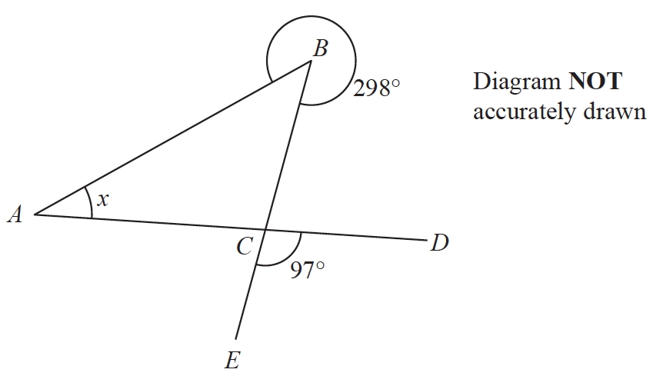

*ABC* is a triangle.

*D* and *E* are points such that *ACD* and *BCE* are straight lines.

reflex angle *ABC* = 298°

angle *ECD* = 97°

Work out the size of angle *x*.

Give a reason for each stage of your working.

*x* = ......................................................°

**(Total for Question 14 is 4 marks)**

**___________________________________________________________________________**

**15** A plane takes 3 hours 36 minutes to fly from the Cayman Islands to New York.

The plane flies a distance of 2470 km.

Work out the average speed of the plane in km/h.

Give your answer correct to the nearest whole number.

....................................................... km/h

**(Total for Question 15 is 3 marks)**

**___________________________________________________________________________**

**16** Hamish buys a new car for £20 000

The car depreciates in value by 19% each year.

Work out the value of the car at the end of 3 years.

Give your answer to the nearest £.

£.......................................................

**(Total for Question 16 is 3 marks)**

**___________________________________________________________________________**

**17** The accurate scale drawing shows the positions of two mobile phone masts, *A* and *B*.



The scale is 1 cm to 2.5 km.

(*a*)Find the bearing of *A* from *B*.

......................................................°

**(1)**

(*b*)Work out the actual distance, in km, between *A* and *B*.

...................................................... km

**(2)**

A third mobile phone mast, *C*, is put up.

*C* will be on a bearing of 115° from *A*.

*C* will be 20 km from *B*.

(*c*)Find the position of *C*.

Mark this point with a cross (×) and label it *C*.

**(3)**

**(Total for Question 17 is 6 marks)**

**___________________________________________________________________________**

**18** Pablo made a solid gold statue.

He melted down some gold blocks and used the gold to make the statue.

Each block of gold was a cuboid, as shown below.

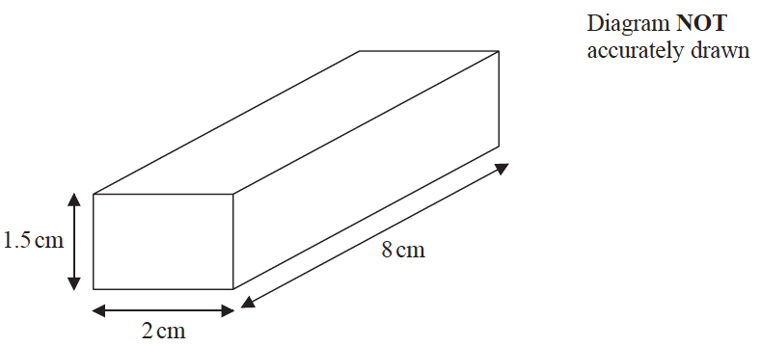

The mass of the statue is 5.73 kg.

The density of gold is 19.32 g/cm3

Work out the least number of gold blocks Pablo melted down in order to make the statue.

Show your working clearly.

......................................................

**(Total for Question 18 is 5 marks)**

**___________________________________________________________________________**

**19** The weight of a cat is 4.3 kg correct to 2 significant figures.

(*a*)Write down the upper bound of the weight of the cat.

...................................................... kg

**(1)**

(*b*)Write down the lower bound of the weight of the cat.

...................................................... kg

**(1)**

**(Total for Question 19 is 2 marks)**

**___________________________________________________________________________**

**20** 5 children are playing on a trampoline.

The mean weight of the 5 children is 28 kg.

2 of the children get off the trampoline.

The mean weight of these 2 children is 26.5 kg.

Work out the mean weight of the 3 children who remain on the trampoline.

...................................................... kg

**(Total for Question 20 is 3 marks)**

**___________________________________________________________________________**

**21** In a sale, the normal price of a hat is reduced by 15%

The sale price of the hat is 20.40 euros.

Work out the normal price of the hat.

...................................................... euros

**(Total for Question 21 is 3 marks)**

**TOTAL FOR PAPER IS 100 MARKS**