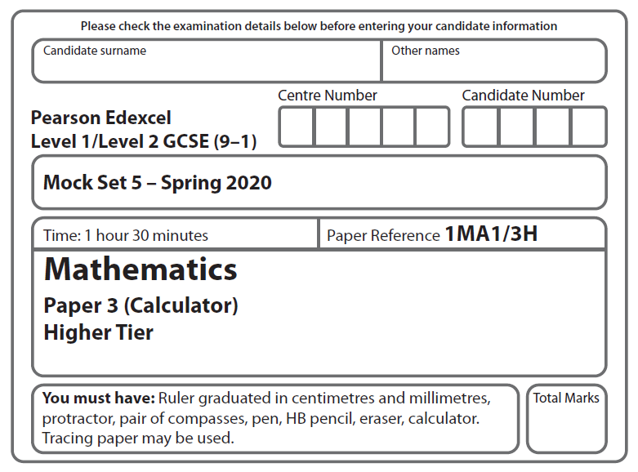

LPGS Autumn Mock Exam 2020

**Instructions**

* Use **black** ink or ball-point pen.
* 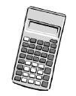**Fill in the boxes** at the top of this page with your name, centre number   
  and candidate number.
* Answer **all** questions.
* Answer the questions in the spaces provided.

*– there may be more space than you need.*

* You must **show all your working.**
* Diagrams are **NOT** accurately drawn, unless otherwise indicated.
* **Calculators may be used.**

**Information**

* The total mark for this paper is 80
* The marks for **each** question are shown in brackets

*– use this as a guide as to how much time to spend on each question.*

**Advice**

* Read each question carefully before you start to answer it.
* Try to answer every question.
* Check your answers if you have time at the end.

**S66513A**

**Answer ALL questions.**

**Write your answers in the spaces provided.**

**You must write down all the stages in your working.**

**1** Calculate

Give your answer correct to 3 significant figures.

**(Total for Question 1 is 2 marks)**

**2** *ABC* and *PQR* are similar triangles.

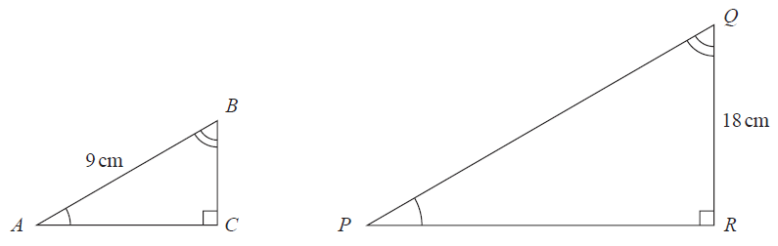

*AB* : *PQ* = 2 : 5

(i) Work out the length of *PQ.*

cm

**(2)**

(ii) Work out the length of *BC.*

cm

**(2)**

**(Total for Question 2 is 4 marks)**

**3** The table shows information about the distances travelled by 50 new cars before a tyre was changed.

|  |  |
| --- | --- |
| **Distance (*d* km)** | **Number of cars** |
| 5000 ⩽ *d* ˂ 25 000 | 9 |
| 25 000 ⩽ *d* ˂ 45 000 | 25 |
| 45 000 ⩽ *d* ˂ 65 000 | 16 |

Calculate an estimate for the mean distance.

km

**(Total for Question 3 is 3 marks)**

**4** The diagram shows a cylinder with diameter 10 cm and height 12 cm.

10 cm

12 cm

Calculate the volume of this cylinder.

Give your answer correct to 3 significant figures.

cm³

**(Total for Question 4 is 2 marks)**

**5** Luke invested £4000 in a savings account for 3 years.

Compound interest was paid at a rate of 1.8% each year.

Alexa also invested £4000 in a savings account for 3 years.

Simple interest was paid at a rate of 1.8% each year.

Luke got more interest than Alexa in total over the 3 years.

How much more?

You must show all your working.

£

**(Total for Question 5 is 4 marks)**

**6** The height, *h* metres, of a tall building is 184 metres correct to the nearest metre.

Complete the following statement to show the range of possible values of *h*.

⩽ *h* <

**(Total for Question 6 is 2 marks)**

**7** Here is a rectangle *ABCD*.

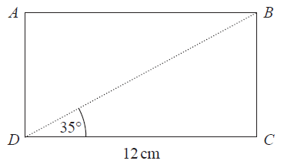

Work out the perimeter of the rectangle.

Give your answer correct to 3 significant figures.

cm

**(Total for Question 7 is 4 marks)**

**8** (a) Complete the table of values for *y* = *x*3 + 2

|  |  |  |  |  |  |  |  |
| --- | --- | --- | --- | --- | --- | --- | --- |
| *x* | −3 | −2 | −1 | 0 | 1 | 2 | 3 |
| *y* |  | −6 |  |  | 3 |  |  |

**(2)**

(b) On the grid, draw the graph of *y* = *x*3 + 2 for values of *x* from −3 to 3

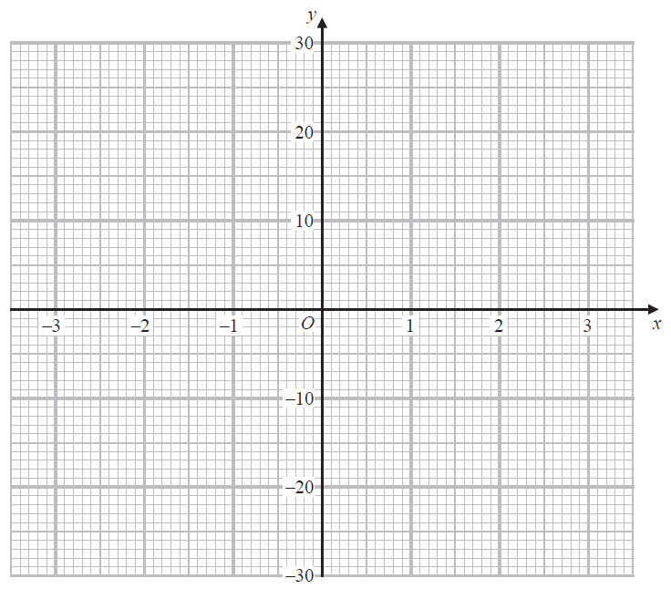

**(2)**

(c) Use your graph to find the value of *x* when *y* = 6

**(1)**

**(Total for Question 8 is 5 marks)**

**9** Here is some information about the population and the land area of England, Scotland and Wales in 2016

|  |  |  |
| --- | --- | --- |
|  | **Population** | **Land area (km2)** |
| **England** | 5.5 ×107 | 1.3 ×105 |
| **Scotland** | 5.4 ×106 | 8.0 ×104 |
| **Wales** | 1.9 ×106 | 2.1 ×104 |

(a) Calculate the total population of England, Scotland and Wales in 2016

**(1)**

(b) Calculate the average number of people per km2 in England, Scotland and Wales in 2016

Give your answer correct to the nearest whole number.

**(3)**

**(Total for Question 9 is 4 marks)**

**10** There are *n* adults in a club.

54 of the adults are over 30 years of age.

20 of the adults in the club are chosen at random.

8 of these 20 adults are over 30 years of age.

Work out an estimate for the value of *n*.

……………………………………

**(Total for Question 10 is 2 marks)**

**11** Solve = 8 – 2*x*

*x* =……………………..

(Total for Question 11 is 3 marks)

**12** Mrs Atkins is going to choose two students from her class to take part in a competition.

She can choose from 16 girls and 14 boys.

(a) Work out the number of different ways of choosing one girl and one boy.

(1)

(b) Work out the number of different ways of choosing two boys.

(2)

(Total for Question 12 is 3 marks)

**13** (a)Show that the equation *x*4 – 3*x* – 1 = 0 has a solution between *x* = 1 and *x* = 2

(2)

(b) Show that for *x* ˃ 0 the equation *x*4 – 3*x* – 1 = 0 can be arranged to give *x* =

(1)

(c) Starting with *x*0 = 1, use the iteration formula *xn* + 1 = once to find

an estimate for a solution of *x*4 – 3*x* – 1 = 0

(1)

(Total for Question 13 is 4 marks)

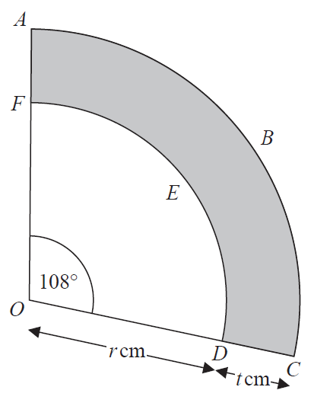**14**

*ABC* and *DEF* are two arcs of circles, centre *O*.

*OFA* and *ODC* arestraight lines.

(a) Show that the perimeter of the shaded region is given by cm

(5)

(b)(i) Find the exact value of when *r* = 0 and *t* = 10

Give your answer in its simplest form.

(1)

(ii) Explain what your value in part (b)(i) represents.

(1)

(Total for Question 14 is 7 marks)

**15** *c* is inversely proportional to *d.*

*c* = 0.5 when *d* = 6

Find a formula for *c* in terms of *d.*

……………………..……………………..

(Total for Question 15 is 3 marks)

**16** There are some counters in a box.

Each counter is blue or green or red or yellow.

The total number of blue and green counters is twice the total number of red and yellow counters.

The number of green counters is of the number of blue counters.

Show that, to the nearest percent, the percentage of blue counters in the box is 57 %

(Total for Question 16 is 4 marks)

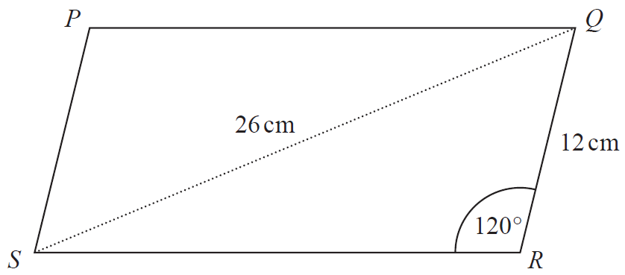**17**

Calculate the area of the parallelogram *PQRS*.

Give your answer correct to 3 significant figures.

You must show all your working.

cm²

(Total for Question 17 is 5 marks)

**18** Frank invested an amount of money for 12 years.

The graph shows the value of Frank’s investment over the 12 year period.

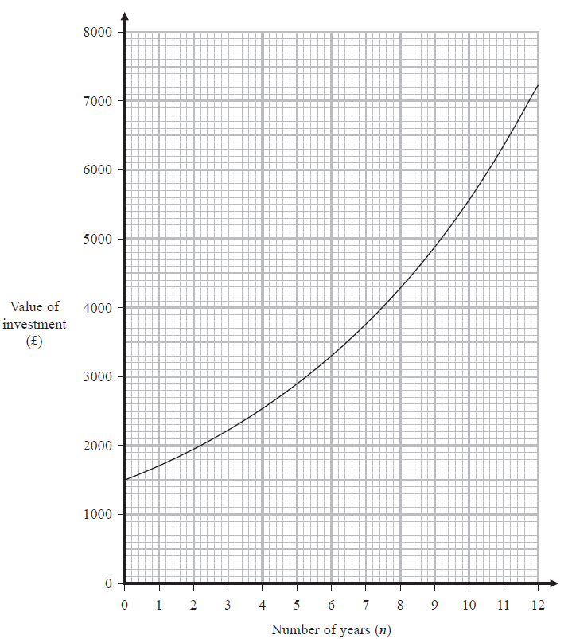

1. (i) Write down the amount of money that Frank invested.

£

(1)

Frank said that 12 years after he had made his investment, it was worth more than five times its original value.

(ii) Was Frank correct?

Give a reason for your answer.

(1)

1. (i) Find an estimate for the gradient of the curve at *n* = 7

(3)

(ii) Explain what this gradient represents.

(1)

(Total for Question 18 is 6 marks)

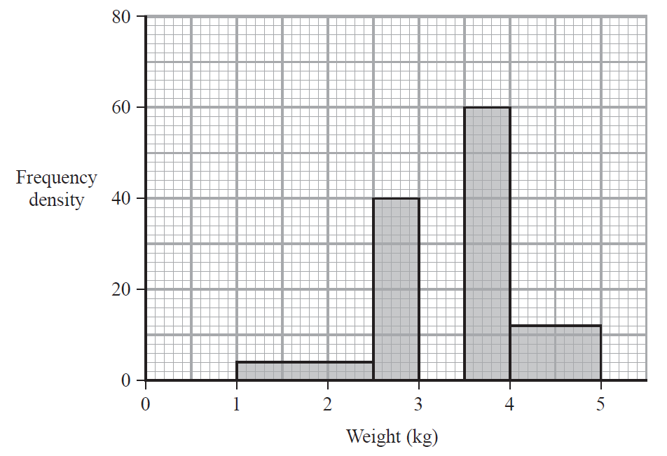**19**

The incomplete histogram shows information about the weights of 100 babies.

All 100 babies have a weight between 1 kg and 5 kg.

6 of the babies have a weight between 1 kg and 2.5 kg.

Complete the histogram.

You must show all your working.

(Total for Question 19 is 4 marks)

**20** Two bags, **A** and **B**, each contain only green marbles and red marbles.

There are 6 green marbles and 4 red marbles in bag **A**.

There are 8 green marbles and 2 red marbles in bag **B**.

One marble is going to be taken at random from bag **A** and placed in bag **B**.

A marble is then going to be taken at random from bag **B**.

Work out the probability that this marble will be a green marble.

(Total for Question 20 is 4 marks)

**21** Here is a solid cuboid.

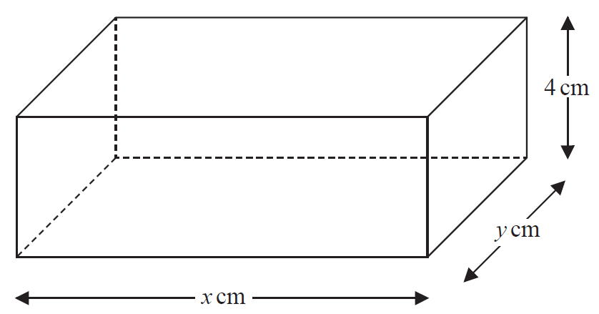

The volume of the cuboid is 119 cm³

The total surface area of the cuboid is 155.5 cm²

Given that *x* > *y*, work out the value of *x* and the value of *y*.

You must show all your working.

*x* =

*y* =

(Total for Question 21 is 5 marks)

**TOTAL FOR PAPER IS 80 MARKS**