**GCSE Mathematics**

**Practice Tests: Set 14**

**Paper 1H (Non-calculator)**

**Time: 1 hour 30 minutes**

You should have: Ruler graduated in centimetres and millimetres, protractor, pair of compasses, pen, HB pencil, eraser, calculator. Tracing paper may be used.

**Instructions**



* Use **black** ink or ball-point pen.
* **Fill in the boxes** at the top of this page with your name,  
  centre number and candidate number.
* Answer **all** questions.
* Answer the questions in the spaces provided

– *there may be more space than you need*.

* **Calculators may be used.**
* Diagrams are NOT accurately drawn, unless otherwise indicated.
* You must **show all your working out.**

**Information**

* The total mark for this paper is 80
* The marks for **each** question are shown in brackets  
  – *use this as a guide as to how much time to spend on each question*.

**Advice**

* Read each question carefully before you start to answer it.
* Keep an eye on the time.
* Try to answer every question.
* Check your answers if you have time at the end.

**Answer all questions.**

**Write your answers in the spaces provided.**

**You must write down all the stages in your working.**

**1** Solve 5(4 – *x*) = 7 – 3*x*

Show clear algebraic working.

*x* = .......................................................

**(Total for Question 1 is 1 mark)**

**___________________________________________________________________________**

**2** On the grid, draw the graph of *y* = 7 – 4*x* for values of *x* from −2 to 3

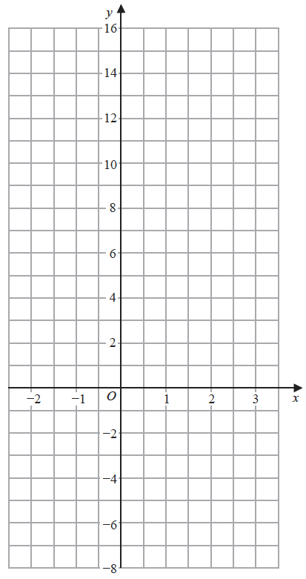

**(Total for Question 2 is 3 marks)**

**___________________________________________________________________________**

**3**(*a*)Simplify *g*6 × *g*4

.......................................................

**(1)**

(*b*)Simplify *k*10 ÷ *k*3

.......................................................

**(1)**

(*c*)Simplify (3*cd*4)2

.......................................................

**(2)**

**(Total for Question 3 is 4 marks)**

**___________________________________________________________________________**

**4** Solve the simultaneous equations

7*x* – 2*y* = 34

3*x* + 5*y* = −3

Show clear algebraic working.

*x* = .......................................................

*y* = .......................................................

**(Total for Question 4 is 4 marks)**

**___________________________________________________________________________**

**5** Solve the inequality 4*x* + 7 > 2

.......................................................

**(Total for Question 5 is 2 marks)**

**___________________________________________________________________________**

**6**The line **L**is shown on the grid.

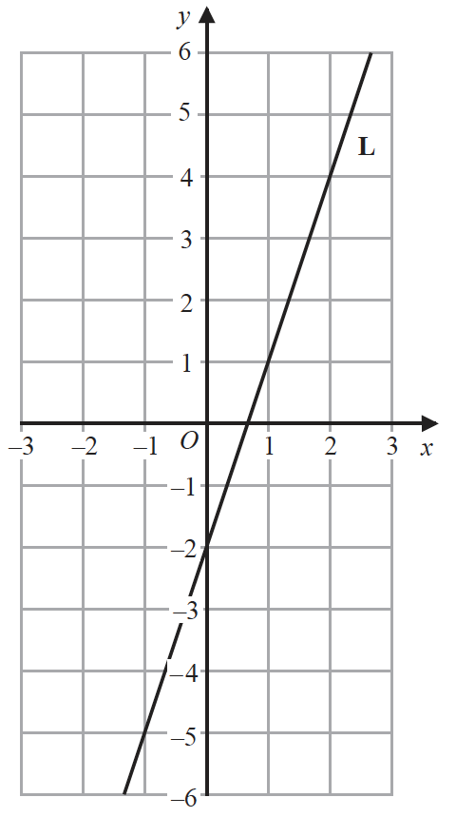

Find an equation for **L**.

.......................................................

**(Total for Question 6 is 2 marks)**

**___________________________________________________________________________**

**7** The numbers from 1 to 14 are shown in the Venn diagram.



(*a*)List the members of the set *A* *B*

............................................................................................................

**(1)**

A number is picked at random from the numbers in the Venn diagram.

(*b*)Find the probability that this number is in set *A* but is **not** in set *B*.

.......................................................

**(2)**

**(Total for Question 7 is 3 marks)**

**___________________________________________________________________________**

**8** Harry has two fair 5-sided spinners.



Harry is going to spin each spinner once.

(*a*) Complete the probability tree diagram.



**(2)**

(*b*)Work out the probability that at least one of the spinners will land on green.

.......................................................

**(3)**

**(Total for Question 8 is 5 marks)**

**___________________________________________________________________________**

**9** Solve 

Show clear algebraic working.

*x* = .......................................................

**(Total for Question 9 is 4 marks)**

**___________________________________________________________________________**

**10** Factorise fully 16*m*3*g*3 + 24*m*2*g*5

.......................................................

**(Total for Question 10 is 2 marks)**

**___________________________________________________________________________**

**11**Make *x* the subject of 

.......................................................

**(Total for Question 11 is 4 marks)**

**___________________________________________________________________________**

**12** *F* is inversely proportional to the square of *v*.

Given that *F* = 6.5 when *v* = 4, find a formula for *F* in terms of *v*.

.......................................................

**(Total for Question 12 is 3 marks)**

**___________________________________________________________________________**

**13**(*a*)Simplify fully 

.......................................................

**(2)**

(*b*)Express  in the form *ayn* where *a* and *n* are integers.

.......................................................

**(2)**

**(Total for Question 13 is 4 marks)**

**___________________________________________________________________________**

**14**Use algebra to show that 

**(Total for Question 14 is 2 marks)**

**___________________________________________________________________________**

**15**

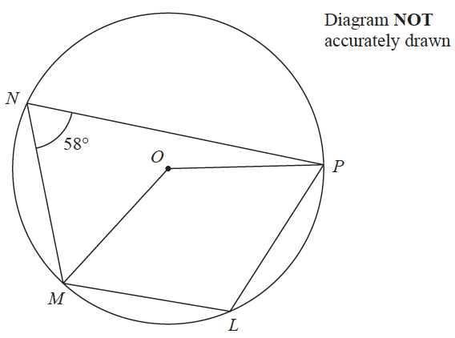

*L*, *M*, *N* and *P* are points on a circle, centre *O*

Angle *MNP* = 58°

(*a*)(i) Find the size of angle *MLP*

.......................................................°

(ii) Give a reason for your answer.

................................................................................................................................................

................................................................................................................................................

**(2)**

(*b*)Find the size of the reflex angle *MOP*

.......................................................°

**(2)**

**(Total for Question 15 is 4 marks)**

**___________________________________________________________________________**

**16** Rationalise the denominator of 

Simplify your answer.

You must show each stage of your working.

.......................................................

**(Total for Question 16 is 3 marks)**

**___________________________________________________________________________**

**17**Solve the simultaneous equations

3*xy* – *y*2 = 8

*x* – 2*y* = 1

Show clear algebraic working.

..............................................................................................................

**(Total for Question 17 is 5 marks)**

**___________________________________________________________________________**

**18**Given that  = 81, find the value of *x*.

Show clear algebraic working.

*x* = .......................................................

**(Total for Question 18 is 3 marks)**

**___________________________________________________________________________**

**19***OAB* is a triangle.

 = **a ** = **b**

The point *C* lies on *OA* such that *OC* : *CA* = 1 : 2

The point *D* lies on *OB* such that *OD* : *DB* = 1 : 2

Using a vector method, prove that *ABDC* is a trapezium.

**(Total for Question 19 is 3 marks)**

**___________________________________________________________________________**

**20**The diagram shows a rectangle.



The area of the rectangle is *A* cm2

Given that *A* < 3*x* + 27

find the range of possible values for *x*.

.......................................................

**(Total for Question 20 is 5 marks)**

**___________________________________________________________________________**

**21** Express

 ×  – 

as a single fraction in its simplest form.

..................................................................................

**(Total for Question 21 is 5 marks)**

**___________________________________________________________________________**

**22**The function f is such that f(*x*) = 5 + 6*x* – *x*2 for *x* ≤ 3

(*a*) Express 5 + 6*x* – *x*2 in the form *p* – (*x* – *q*)2 where *p* and *q* are constants.

.......................................................

**(2)**

(*b*)Using your answer to part (*a*), find the range of values of *x* for which f –1(*x*) is positive.

.......................................................

**(5)**

**(Total for Question 22 is 7 marks)**

**TOTAL FOR PAPER IS 80 MARKS**