**Foundation Tier**

**Angles**

**Instructions**

* Use **black** ink or ball-point pen.
  + **Fill in the boxes** at the top of this page with your name,  
    centre number and candidate number.
* Answer **all** questions.
* Answer the questions in the spaces provided  
  *– there may be more space than you need.*
* You must **show all your working.**
* Diagrams are **NOT** accurately drawn, unless otherwise indicated.
* If your calculator does not have a *π* button, take the value of *π* to be3.142

unless the question instructs otherwise.

**Information**

* The total mark for this paper is **40**. There are **11** questions.
* Questions have been arranged in an ascending order of mean difficulty, as found by all students in the June 2017–November 2019 examinations.
* The marks for **each** question are shown in brackets  
  *– use this as a guide as to how much time to spend on each question.*

**Advice**

* Read each question carefully before you start to answer it.
* Keep an eye on the time.
* Try to answer every question.
* Check your answers if you have time at the end.

**1** *PQR* is a straight line.

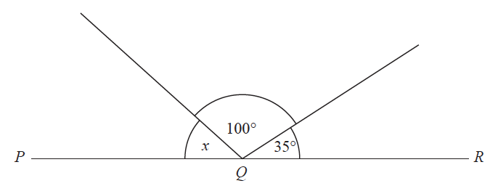

Work out the size of angle *x*.

....................................................... °

**(Total for Question 1 is 2 marks)**

**___________________________________________________________________________**

**2** *AB* and *BC* are perpendicular lines.

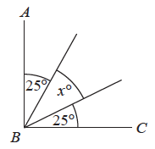

(*a*)Find the value of *x*.

*x* = .......................................................

**(2)**

*RS* and *TU* are parallel lines.

*PQ* is a straight line.

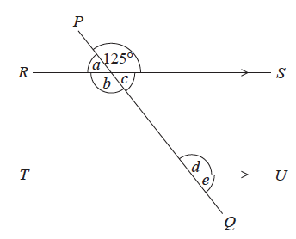

An angle of size 125° is shown on the diagram.

(*b*)(i) Write down the letter of one other angle of size 125°

Give a reason for your answer.

......................................................................................................................................................

......................................................................................................................................................

**(2)**

(ii) Explain why *a* + *b* + *c* = 235°

......................................................................................................................................................

......................................................................................................................................................

......................................................................................................................................................

**(1)**

**(Total for Question 2 is 5 marks)**

**___________________________________________________________________________**

**3**



Find the value of *x*.

......................................................

**(Total for Question 3 is 3 marks)**

**___________________________________________________________________________**

**4** The diagram shows a square *ABDE* and an equilateral triangle *BCD*.

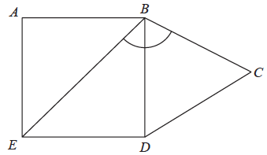

Work out the size of angle *EBC*.

.......................................................°

**(Total for Question 4 is 2 marks)**

**___________________________________________________________________________**

**5** The size of the largest angle in a triangle is 4 times the size of the smallest angle.

The other angle is 27° less than the largest angle.

Work out, in degrees, the size of each angle in the triangle.

You must show your working.

............................. ° , ............................. ° , ............................. °

**(Total for Question 5 is 5 marks)**

**______________________________________________________________________________________________________________________________________________________**

**6** The diagram shows a regular pentagon and a parallelogram.

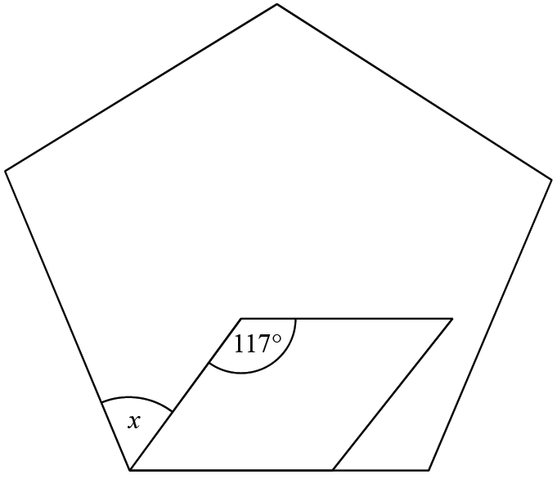

Work out the size of the angle marked *x*.

You must show all your working.

**(Total for Question 6 is 4 marks)**

**___________________________________________________________________________**

**7** *ABCDE* is a pentagon.

**

Angle *BCD* = 2 × angle *ABC*

Work out the size of angle *BCD*.

You must show all your working.

**(Total for Question 7 is 5 marks)**

**___________________________________________________________________________**

**8** The diagram shows triangle *ABC*.

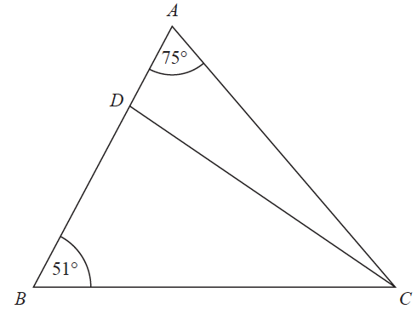

*ADB* is a straight line.

the size of angle *DCB* : the size of angle *ACD* = 2 : 1

Work out the size of angle *BDC*.

**(Total for Question 8 is 4 marks)**

**___________________________________________________________________________**

**9** The diagram shows a hexagon.

The hexagon has one line of symmetry.

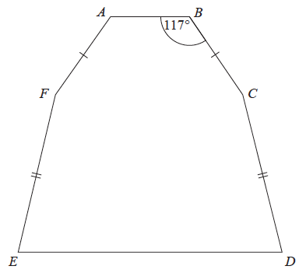

*FA* = *BC*

*EF* = *CD*

Angle *ABC* = 117°

Angle *BCD* = 2 × angle *CDE*

Work out the size of angle *AFE*.

You must show all your working.

.......................................................°

**(Total for Question 9 is 4 marks)**

**___________________________________________________________________________**

**10** The diagram shows triangle *AOB*.

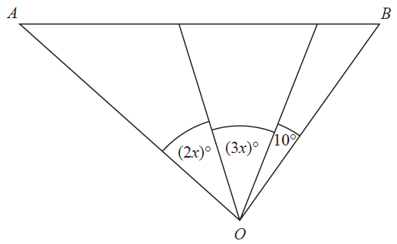

Angle *AOB* is **not** an obtuse angle.

Find the greatest value of *x*.

You must show all your working.

.......................................................

**(Total for Question 10 is 3 marks)**

**11** The size of each interior angle of a regular polygon is 11 times the size of each exterior angle.

Work out how many sides the polygon has.

......................................................

**(Total for Question 11 is 3 marks)**

**_________________________________________________________________________**

**TOTAL MARKS FOR PAPER: 40**