**GCSE Mathematics**

**Practice Tests: Set 12**

**Paper 1F (Non-calculator)**

**Time: 1 hour 30 minutes**

You should have: Ruler graduated in centimetres and millimetres, protractor, pair of compasses, pen, HB pencil, eraser, calculator. Tracing paper may be used.

**Instructions**

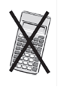

* Use **black** ink or ball-point pen.
* **Fill in the boxes** at the top of this page with your name,  
  centre number and candidate number.
* Answer **all** questions.
* Answer the questions in the spaces provided

– *there may be more space than you need*.

* **Calculators may not be used.**
* Diagrams are NOT accurately drawn, unless otherwise indicated.
* You must **show all your working out.**

**Information**

* The total mark for this paper is 80
* The marks for **each** question are shown in brackets  
  – *use this as a guide as to how much time to spend on each question*.

**Advice**

* Read each question carefully before you start to answer it.
* Keep an eye on the time.
* Try to answer every question.
* Check your answers if you have time at the end.

**Answer all questions.**

**Write your answers in the spaces provided.**

**You must write down all the stages in your working.**

**1** Write  as a decimal.

.......................................................

**(Total for Question 1 is 1 mark)**

**___________________________________________________________________________**

**2** Here is a list of numbers

|  |  |  |  |  |  |
| --- | --- | --- | --- | --- | --- |
| 13 | 14 | 18 | 23 | 30 | 36 |

From the numbers in the list, write down

(i) an odd number

.......................................................

**(1)**

(ii) the multiple of 4

.......................................................

**(1)**

(iii) the factor of 28

.......................................................

**(1)**

**(Total for Question 2 is 3 marks)**

**___________________________________________________________________________**

**3** (*a*)Simplify 10*a* × *b*

.......................................................

**(1)**

(*b*)Solve *n* + 3 = 7

*n* = .......................................................

**(1)**

**(Total for Question 3 is 2 marks)**

**___________________________________________________________________________**

**4** (*a*)Complete the table of values for *y* = 3*x* – 1

|  |  |  |  |  |  |  |  |  |  |
| --- | --- | --- | --- | --- | --- | --- | --- | --- | --- |
| *x* | –1 | 0 | 1 | 2 |  | 3 | 4 | 5 | 6 |
| *y* |  | –1 |  | 5 |  |  |  | 14 |  |

**(2)**

(*b*)On the grid, draw the graph of *y* = 3*x* – 1 for values of *x* from –1 to 6

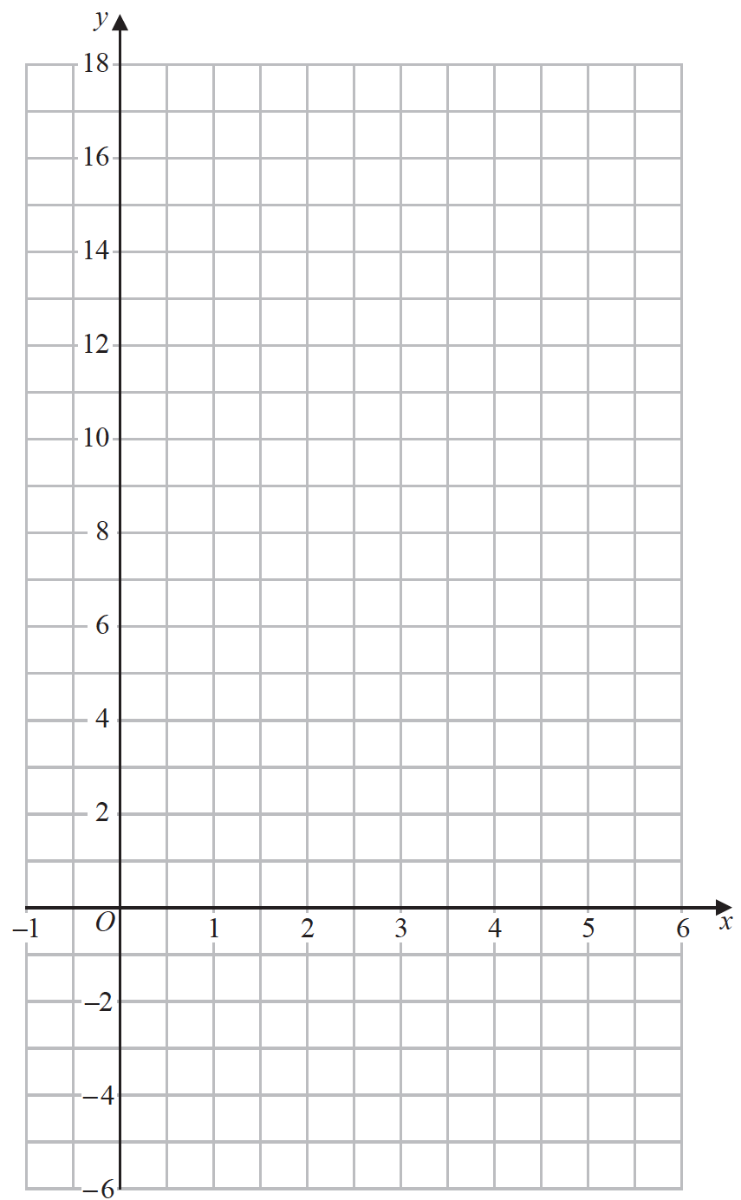

**(2)**

**(Total for Question 4 is 4 marks)**

**___________________________________________________________________________**

**5** The diagram shows a line *AB*.



(*a*)At the point *A* draw an acute angle.

Label your acute angle *a*.

**(1)**

The diagram shows a circle with centre *O*.



(*b*)Draw a diameter of the circle.

**(1)**

**(Total for Question 5 is 2 marks)**

**___________________________________________________________________________**

**6** Mohsen is going to a party.

He will choose at random one shirt from the three shirts and one pair of trousers from the

three pairs of trousers in the list below.

|  |  |
| --- | --- |
| **Shirts** | **Trousers** |
|  |  |
| Blue (B) | Green (G) |
| Red (R) | Orange (O) |
| Yellow (Y) | Purple (P) |

(*a*)Write down all the possible combinations that Mohsen can choose.

......................................................................................................................................................

......................................................................................................................................................

......................................................................................................................................................

**(2)**

(*b*)Find the probability that Mohsen chooses the red shirt to wear to the party.

......................................................

**(1)**

There are 20 counters in a bag.

4 of the counters are pink.

9 of the counters are white.

The rest of the counters are black.

Jean takes at random one counter from the bag.

(*c*)Work out the probability that Jean takes a black counter.

......................................................

**(2)**

**(Total for Question 6 is 5 marks)**

**___________________________________________________________________________**

**7** The bar chart shows information about the weight, in millions of tonnes, of bananas

produced by each of four countries in 2016

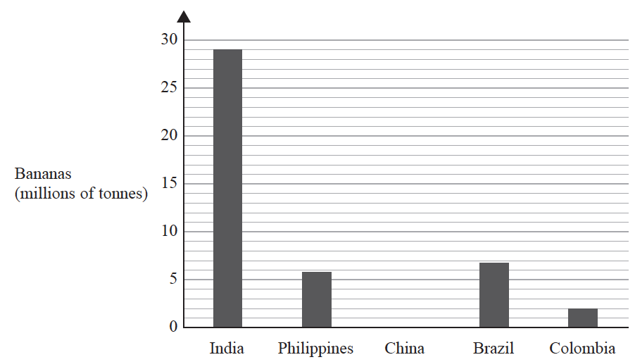

In 2016, China produced 13 million tonnes of bananas.

(*a*)Draw a bar on the bar chart to show this information.

**(1)**

One of these countries produced 6.8 million tonnes of bananas in 2016

(*b*)Which country?

.......................................................

**(1)**

In 2016, a total of 113 million tonnes of bananas was produced worldwide.

(*c*)What fraction of the 113 million tonnes of bananas was produced in India in 2016?

.......................................................

**(2)**

**(Total for Question 7 is 4 marks)**

**___________________________________________________________________________**

**8** Here are five mathematical signs



(*a*)Write one of these five signs in each box so that each of these statements is true.

(i)

|  |  |  |  |  |
| --- | --- | --- | --- | --- |
| 4 °C |  |  |  | 9 °C |

**(1)**

(ii)

|  |  |  |  |  |
| --- | --- | --- | --- | --- |
| –3 °C |  |  |  | –8 °C |

**(1)**

The table gives information about the boiling points and the freezing points of some

elements.

|  |  |  |  |  |
| --- | --- | --- | --- | --- |
| **Element** | **Chlorine** | **Mercury** | **Neon** | **Oxygen** |
| **Boiling point (°C)** | –35 | 357 | –246 | –183 |
| **Freezing point (°C)** | –101 | –39 | –249 | –218 |

(*b*)Which of these elements has the lowest boiling point?

.......................................................

**(1)**

(*c*)Which of these elements has the largest difference in temperature between its boiling

point and its freezing point?

.......................................................

**(1)**

**(Total for Question 8 is 4 marks)**

**___________________________________________________________________________**

**9** E= {10, 11, 12, 13, 14, 15, 16, 17, 18, 19, 20}

*A* = {multiples of 5}

*B* = {even numbers}

Complete the Venn diagram for this information.

|  |  |
| --- | --- |
| E |  |
|  |  |

**(Total for Question 9 is 3 marks)**

**___________________________________________________________________________**

**10** (*a*)Write these decimals in order of size.

Start with the smallest decimal.

|  |  |  |  |
| --- | --- | --- | --- |
| 0.501 | 0.51 | 0.5 | 0.55 |

......................................................................................................................................................

**(1)**

(*b*)Write 0.3 as a fraction.

.......................................................

**(1)**

(*c*)Write 0.46832 correct to 2 decimal places.

.......................................................

**(1)**

**(Total for Question 10 is 3 marks)**

**___________________________________________________________________________**

**11** (*a*)Simplify 6*m* − 2*k* + 5*m* − *k*

.......................................................

**(2)**

*P* = 2*a* + 3*b*

(*b*)Work out the value of *P* when *a* = 5 and *b* = 8

*P* = .......................................................

**(2)**

*P* = 2*a* + 3*b*

(*c*)Work out the value of *a* when *P* = 16 and *b* = 20

*a* = .......................................................

**(3)**

**(Total for Question 11 is 7 marks)**

**___________________________________________________________________________**

**12** Sergio buys *m* boxes of seeds and *n* packets of seeds.

Each box contains 10 seeds.

Each packet contains 6 seeds.

The total number of seeds that Sergio buys is *T*.

Write down a formula for *T* in terms of *m* and *n*.

...........................................................................

**(Total for Question 12 is 3 marks)**

**___________________________________________________________________________**

**13** (*a*)Simplify **

.......................................................

**(1)**

(*b*)Write  as a single power of 7

.......................................................

**(2)**

**(Total for Question 13 is 3 marks)**

**___________________________________________________________________________**

**14** Complete the following sentences by writing a sensible metric unit on each of the

dotted lines.

(i) The distance from Cairo to Nairobi is 5211 .......................................................

(ii) The weight of an egg is 20 .......................................................

(iii) The area of the floor of a classroom is 260 .......................................................

**(Total for Question 14 is 3 marks)**

**___________________________________________________________________________**

**15** Write  as a mixed number in its simplest form.

.......................................................

**(Total for Question 15 is 2 marks)**

**___________________________________________________________________________**

**16** (*a*)Expand *x*(5 – *x*)

.......................................................

**(1)**

(*b*)Factorise 3*y* – 21

.......................................................

**(1)**

(*c*)Make *p* the subject of the formula *f* = 3*p* – *d*

.......................................................

**(2)**

**(Total for Question 16 is 4 marks)**

**___________________________________________________________________________**

**17** Show that 

**(Total for Question 17 is 3 marks)**

**___________________________________________________________________________**

**18** Expand and simplify (*m* − 8)(*m* + 5)

.......................................................

**(Total for Question 18 is 2 marks)**

**___________________________________________________________________________**

**19**

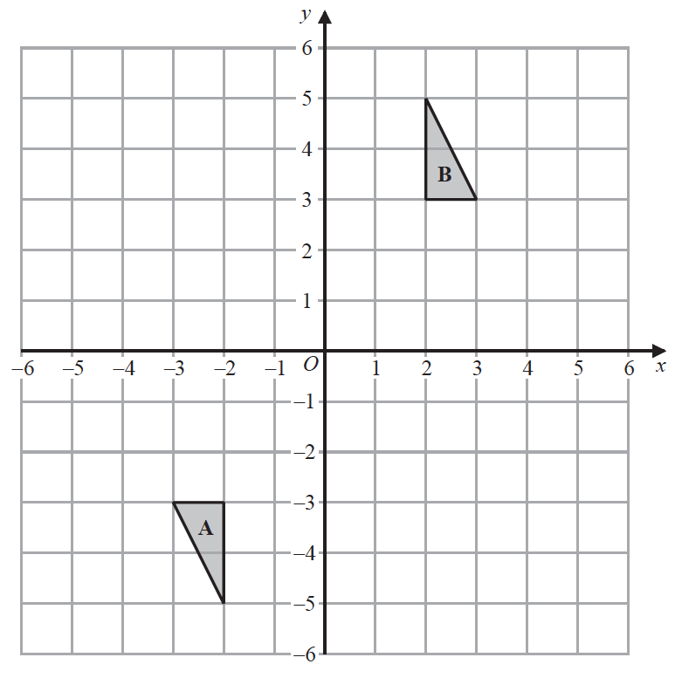

Describe fully the single transformation that maps triangle **A** onto triangle **B**.

......................................................................................................................................................

......................................................................................................................................................

......................................................................................................................................................

**(Total for Question 19 is 2 marks)**

**___________________________________________________________________________**

**20** Show that 

**(Total for Question 20 is 2 marks)**

**___________________________________________________________________________**

**21** Solve the inequality 2*x* + 7 > 4

.......................................................

**(Total for Question 21 is 2 marks)**

**___________________________________________________________________________**

**22** Factorise fully 5*y* + 20*y*2

.......................................................

**(Total for Question 22 is 2 marks)**

**___________________________________________________________________________**

**23** Use ruler and compasses to construct the bisector of angle *BAC*.

You must show all your construction lines.



**(Total for Question 23 is 2 marks)**

**___________________________________________________________________________**

**24**

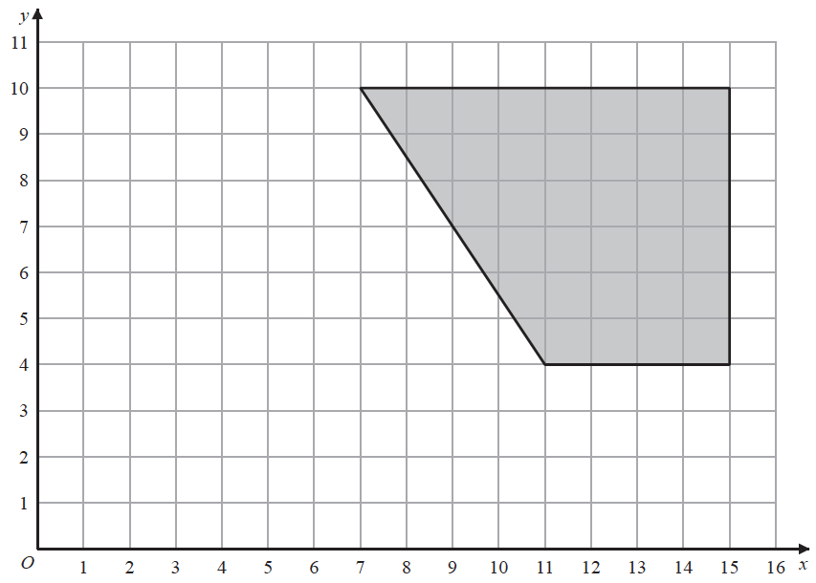

On the grid, enlarge the shaded shape with scale factor  and centre (1, 2)

**(Total for Question 24 is 2 marks)**

**___________________________________________________________________________**

**25** Solve 3(2*x* − 5) = 

Show clear algebraic working.

*x* = .......................................................

**(Total for Question 25 is 4 marks)**

**___________________________________________________________________________**

**26**Simplify ( *p*2 + 3)0

.......................................................

**(Total for Question 26 is 1 mark)**

**___________________________________________________________________________**

**27**Solve *x*2 – 3*x* – 40 = 0

Show clear algebraic working.

.......................................................

**(Total for Question 27 is 3 marks)**

**___________________________________________________________________________**

**28** Change 32.4 m3 into cm3

....................................................... cm3

**(Total for Question 28 is 2 marks)**

**TOTAL FOR PAPER IS 80 MARKS**