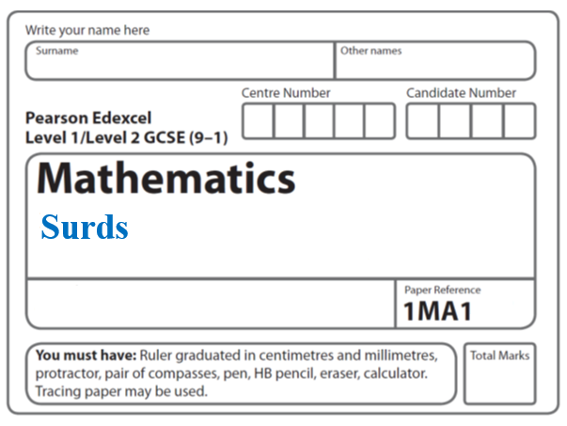

**Spheres and Cones**

**Instructions**

* Use **black** ink or ball-point pen.
  + **Fill in the boxes** at the top of this page with your name,  
    centre number and candidate number.
* Answer **all** questions.
* Answer the questions in the spaces provided  
  *– there may be more space than you need.*
* You must **show all your working.**
* Diagrams are **NOT** accurately drawn, unless otherwise indicated.
* If your calculator does not have a *π* button, take the value of *π* to be3.142

unless the question instructs otherwise.

**Information**

* The total mark for this paper is **47**. There are **12** questions.
* Questions have been arranged in an ascending order of mean difficulty, as found by all students in the June 2017–November 2019 examinations.
* The marks for **each** question are shown in brackets  
  *– use this as a guide as to how much time to spend on each question.*

**Advice**

* Read each question carefully before you start to answer it.
* Keep an eye on the time.
* Try to answer every question.
* Check your answers if you have time at the end.

**1** A hollow cylinder has radius *r* cm and height 6*r* cm.

3 spheres, also of radius *r* cm, are put into the cylinder.

**

(a) Work out the proportion of the cylinder that is **not** filled by the spheres.

.......................................................

**(3)**

The height of the cylinder is increased by 2*r* cm.

Another sphere of radius *r* cm is put into the cylinder.

Malcolm says,

“There is no change in the proportion of the cylinder **not** filled by the spheres.”

(b) Is Malcolm correct?

Justify your answer.

..........................................................................................................................................

..........................................................................................................................................

**(1)**

**(Total for Question 1 is 4 marks) _____________________________________________________________________**

**2** Jan has some metal that she is going to make

into solid metal spheres.

Each sphere will have a radius of 2.15 cm.

Jan has 1490 cm3 of metal.

(a) Work out an estimate for the number of spheres that Jan can make.

.........................................

**(3)**

(b) If you calculate the number of spheres accurately, how do you think your answer to part (a) will change?

Give a reason for your answer.

..........................................................................................................................................

..........................................................................................................................................

..........................................................................................................................................

**(1)**

**(Total for Question 2 is 4 marks)**

**_____________________________________________________________________**

**3** The diagram shows a solid shape.

The shape is a cone on top of a hemisphere.



The height of the cone is 10 cm.

The base of the cone has a diameter of 6 cm.

The hemisphere has a diameter of 6 cm.

The total volume of the shape is *k π* cm3, where *k* is an integer.

Work out the value of *k*.

*k* = .......................................................

**(Total for Question 3 is 4 marks)**

**_____________________________________________________________________**

**4** A cone has a volume of 98 cm3.

The radius of the cone is 5.13 cm.

(*a*)Work out an estimate for the height of the cone.

......................................................cm

**(3)**

John uses a calculator to work out the height of the cone to 2 decimal places.

(*b*)Will your estimate be more than John’s answer or less than John’s answer?

Give reasons for your answer.

..........................................................................................................................................

..........................................................................................................................................

..........................................................................................................................................

**(1)**

**(Total for Question 4 is 4 marks)**

**_____________________________________________________________________**

**5** Here are two solid spheres, **A** and **B**.



Sphere **A** is made of gold.

Sphere **B** is made of silver.

Sphere **A** has radius 2 cm.

Sphere **B** has radius 3 cm.

Gold has a density of 19 000 kg/m3

Silver has a density of 10 000 kg/m3

Which sphere has the greater mass?

You must show how you get your answer.

**(Total for Question 5 is 4 marks)**

**_____________________________________________________________________**

**6** Shape **S** is one quarter of a solid sphere, centre *O*.



The volume of **S** is 576 *π* cm3

Find the surface area of **S**.

Give your answer correct to 3 significant figures.

You must show your working.

...................................................... cm2

(**Total for Question 6 is 5 marks**)

**_____________________________________________________________________**

**7** The diagram shows a hemisphere with diameter 8.4 cm.

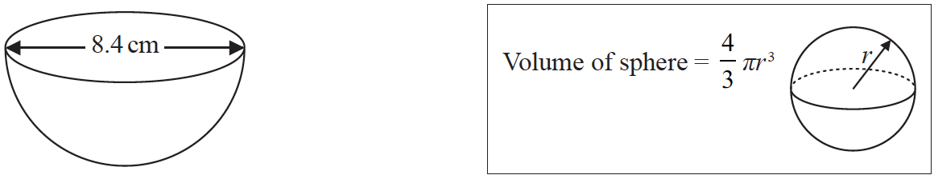

Work out the volume of the hemisphere.

Give your answer correct to 3 significant figures.

....................................................... cm3

**(Total for Question 7 is 2 marks)**

**8** The diagram shows a solid metal cylinder.

**

The cylinder has base radius 3*x* cm and height *h* cm.

The metal cylinder is melted.

All the metal is then used to make 270 spheres.

Each sphere has a radius of  cm.

Find an expression, in its simplest form, for *h* in terms of *x*.

.......................................................

**(Total for Question 8 is 3 marks)**

**_____________________________________________________________________**

**9** A factory makes ice cream tubs in two sizes, small and large.



The tubs are similar in shape.

The height of the small tub is 5 cm.

The volume of the small tub is 150 cm3.

The volume of the large tub is 500 cm3.

Work out the height of the large tub.

Give your answer correct to 3 significant figures.

.......................................................cm

**(Total for Question 9 is 2 marks)**

**_____________________________________________________________________**

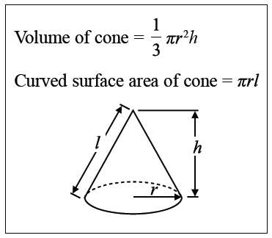**10** The diagram shows a sector *OACB* of a circle with centre *O*.

The point *C* is the midpoint of the arc *AB*.

The diagram also shows a hollow cone with vertex *O*.

The cone is formed by joining *OA* and *OB*.

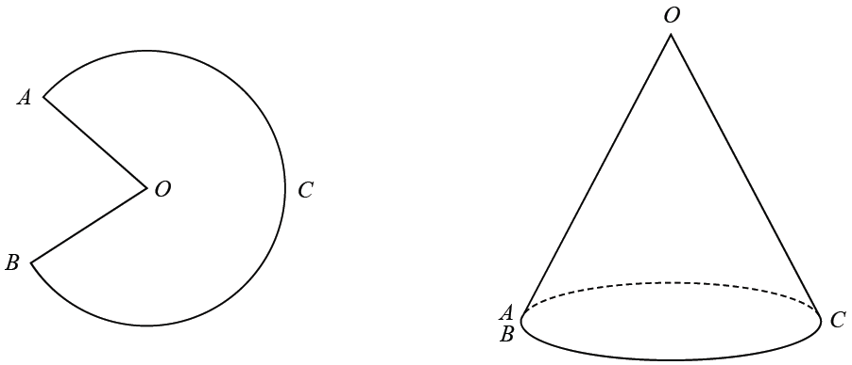

The cone has volume 56.8 cm3 and height 3.6 cm.

Calculate the size of angle *AOB* of sector *OACB*.

Give your answer correct to 3 significant figures.

You must show all your working.

....................................................... °

**(Total for Question 10 is 5 marks)**

**_____________________________________________________________________**

**11** The diagram shows a solid made by joining a solid hemisphere to a solid circular cone.

The centre of the plane face of the cone coincides with the centre of the plane face of the hemisphere.

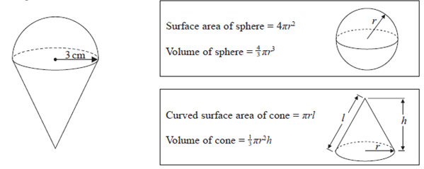

The radius of the hemisphere is 3 cm.

The radius of the base of the cone is 3 cm.

The volume of the solid is 30 *π* cm3

Work out the total surface area of the solid.

Give your answer as a multiple of *π*.

.......................................................cm2

**(Total for Question 11 is 5 marks)**

**_____________________________________________________________________**

**12** Here is a frustum of a cone.



The diagram shows that the frustum is made by removing a cone with height 3.2 cm from

a solid cone with height 6.4 cm and base diameter 7.2 cm.

The frustum is joined to a solid hemisphere of diameter 7.2 cm to form the solid **S** shown

below.



The density of the frustum is 2.4 g/cm3

The density of the hemisphere is 4.8 g/cm3

Calculate the average density of solid **S**.

.......................................................g/cm3

**(Total for Question 12 is 5 marks)**

**TOTAL MARKS FOR PAPER: 47**