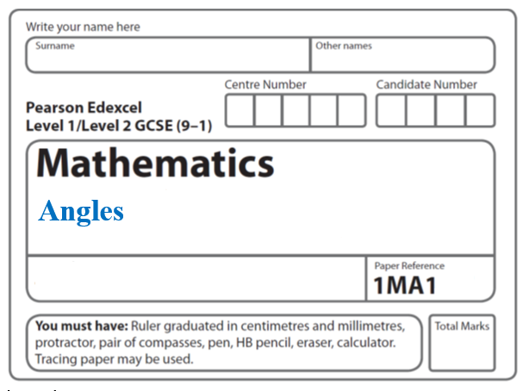

**Angles – Regular polygons**

**Instructions**

* Use **black** ink or ball-point pen.
  + **Fill in the boxes** at the top of this page with your name,  
    centre number and candidate number.
* Answer **all** questions.
* Answer the questions in the spaces provided  
  *– there may be more space than you need.*
* You must **show all your working.**
* Diagrams are **NOT** accurately drawn, unless otherwise indicated.
* If your calculator does not have a *π* button, take the value of *π* to be3.142

unless the question instructs otherwise.

**Information**

* The total mark for this paper is **18**. There are **5** questions.
* Questions have been arranged in an ascending order of mean difficulty, as found by all students in the June 2017–November 2019 examinations.
* The marks for **each** question are shown in brackets  
  *– use this as a guide as to how much time to spend on each question.*

**Advice**

* Read each question carefully before you start to answer it.
* Keep an eye on the time.
* Try to answer every question.
* Check your answers if you have time at the end.

**1** In the diagram, *AB*, *BC* and *CD* are three sides of a regular polygon **P**.



Show that polygon **P** is a hexagon.

You must show your working.

**(Total for Question 1 is 4 marks)**

**___________________________________________________________________________**

**2** The diagram shows a regular pentagon and a parallelogram.

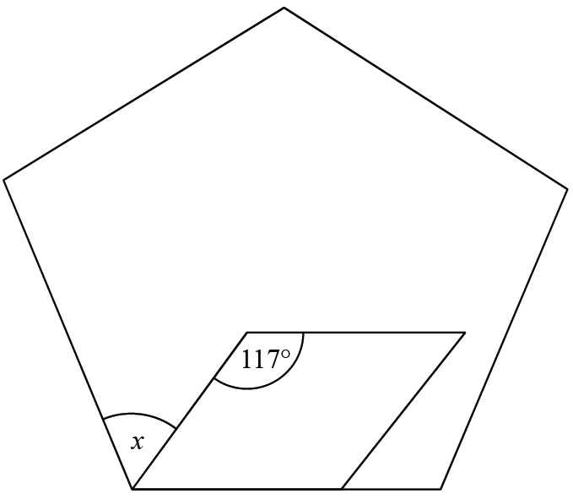

Work out the size of the angle marked *x*.

You must show all your working.

.......................................................°

**(Total for Question 2 is 4 marks)**

**3**



*RS* and *ST* are 2 sides of a regular 12-sided polygon.

*RT* is a diagonal of the polygon.

Work out the size of angle *STR*.

You must show your working.

..................................................... °

**(Total for Question 3 is 3 marks)**

**___________________________________________________________________________**

**4**

**1H**

*ABCDEFGH* is a regular octagon.

*ADJ* is a straight line.

angle *BAD* = angle *CDA*

Show that angle *CDJ* = 135°

**(Total for Question 4 is 4 marks)**

**___________________________________________________________________________**

**5**

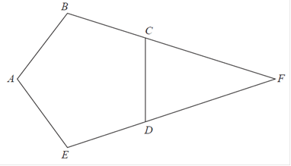

*ABCDE* is a regular pentagon.

*BCF* and *EDF* are straight lines.

Work out the size of angle *CFD*.

You must show how you get your answer.

....................................................... °

**(Total for Question 5 is 3 marks)**

**___________________________________________________________________________**

**TOTAL MARKS FOR PAPER: 18**