**Circle Theorems A**

**Instructions**

* Use **black** ink or ball-point pen.
  + **Fill in the boxes** at the top of this page with your name,  
    centre number and candidate number.
* Answer **all** questions.
* Answer the questions in the spaces provided  
  *– there may be more space than you need.*
* You must **show all your working.**
* Diagrams are **NOT** accurately drawn, unless otherwise indicated.
* If your calculator does not have a *π* button, take the value of *π* to be3.142

unless the question instructs otherwise.

**Information**

* The total mark for this paper is **28**. There are **7** questions.
* Questions have been arranged in an ascending order of mean difficulty, as found by all students in the June 2017–November 2019 examinations.
* The marks for **each** question are shown in brackets  
  *– use this as a guide as to how much time to spend on each question.*

**Advice**

* Read each question carefully before you start to answer it.
* Keep an eye on the time.
* Try to answer every question.
* Check your answers if you have time at the end.

**1** The points *A*, *B*, *C* and *D* lie on a circle.

*CDE* is a straight line.

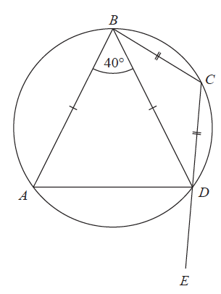

*BA* = *BD*

*CB* = *CD*

Angle *ABD* = 40°

Work out the size of angle *ADE*.

You must give a reason for each stage of your working.

**(Total for Question 1 is 5 marks)**

**___________________________________________________________________________**

**2**

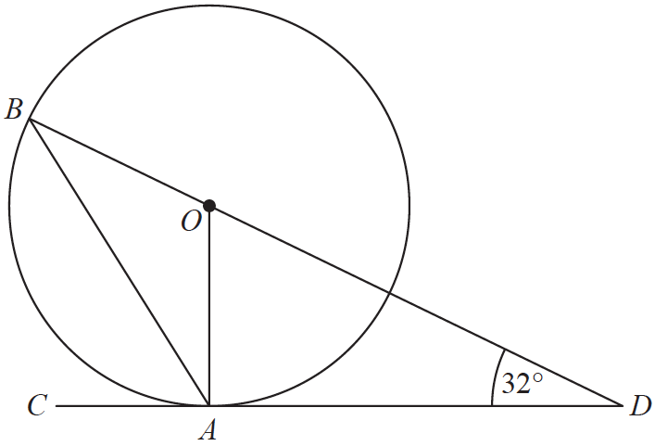

*A* and *B* are points on a circle with centre *O*.

*CAD* is the tangent to the circle at *A*.

*BOD* is a straight line.

Angle *ODA* = 32°

Work out the size of angle *CAB*.

You must show all your working.

.......................................................°

**(Total for Question 2 is 3 marks)**

**___________________________________________________________________________**

**3**

**

*A* and *B* are points on a circle, centre *O*.

*BC* is a tangent to the circle.

*AOC* is a straight line.

Angle *ABO* = *x*°.

Find the size of angle *ACB*, in terms of *x*.

Give your answer in its simplest form.

Give reasons for each stage of your working.

(**Total for Question 3 is 5 marks**)

**4**

**

*A*, *B*, *C* and *D* are points on the circumference of a circle, centre *O*.

*FDE* is a tangent to the circle.

(*a*)Show that *y* – *x* = 90

You must give a reason for each stage of your working.

(**3**)

Dylan was asked to give some possible values for *x* and *y*.

He said,

“*y* could be 200 and *x* could be 110, because 200 – 110 = 90”

(*b*)Is Dylan correct?

You must give a reason for your answer.

......................................................................................................................................................

......................................................................................................................................................

(**1**)

(**Total for Question 4 is 4 marks**)

**___________________________________________________________________________**

**5**



*A*, *B* and *C* are points on the circumference of a circle, centre *O*.

*DAE* is the tangent to the circle at *A*.

Angle *BAE* = 56°

Angle *CBO* = 35°

Work out the size of angle *CAO*.

You must show all your working.

......................................................°

**(Total for Question 5 is 3 marks)**

**___________________________________________________________________________**

**6**



*A*, *B* and *D* are points on the circumference of a circle centre *O*.

*EDC* is a tangent to the circle.

Angle *BDC* = 57°

Find the size of angle *AOB*.

You must give a reason for each stage of your working.

**(Total for Question 6 is 4 marks)**

**___________________________________________________________________________**

**7**

**

*A*, *B*, *C* and *D* are points on a circle.

*EDF* is the tangent to the circle at *D*.

Angle *ADE* = 54°

Angle *ABC* = 114°

Work out the size of angle *CAD*.

You must give a reason for each stage of your working.

.......................................................°

**(Total for Question 7 is 4 marks)**

**___________________________________________________________________________**

**TOTAL MARKS FOR PAPER: 28**