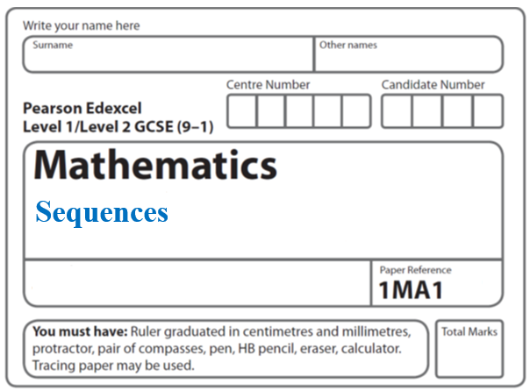**Instructions**

**Quadratic sequences**

* Use **black** ink or ball-point pen.
  + **Fill in the boxes** at the top of this page with your name,  
    centre number and candidate number.
* Answer **all** questions.
* Answer the questions in the spaces provided  
  *– there may be more space than you need.*
* You must **show all your working.**
* Diagrams are **NOT** accurately drawn, unless otherwise indicated.
* If your calculator does not have a *π* button, take the value of *π* to be3.142

unless the question instructs otherwise.

**Information**

* The total mark for this paper is **32**. There are **11** questions.
* Questions have been arranged in an ascending order of mean difficulty, as found by all students in the June 2017–November 2019 examinations.
* The marks for **each** question are shown in brackets  
  *– use this as a guide as to how much time to spend on each question.*

**Advice**

* Read each question carefully before you start to answer it.
* Keep an eye on the time.
* Try to answer every question.
* Check your answers if you have time at the end.

**1** The *n*th term of a sequence is *n*2 + 5

(a) (i) Find the first two terms of this sequence.

............................ ...........................

**(1)**

(ii) Is 126 a term of this sequence?

You must show how you get your answer.

..........................................................................................................................................

..........................................................................................................................................

..........................................................................................................................................

**(1)**

Here are the first five terms of an arithmetic sequence.

26 19 12 5 –2

(b) Find an expression, in terms of *n*, for the *n*th term of this sequence.

.......................................................

**(2)**

**(Total for Question 1 is 4 marks)**

**___________________________________________________________________________**

**2** Here are the first 7 terms of a quadratic sequence.

3 6 11 18 27 38 51

(a) Find an expression, in terms of *n*, for the *n*th term in this sequence.

.........................................

**(2)**

(b) Find the 50th term of this sequence.

.........................................

**(1)**

**(Total for Question 2 is 3 marks)**

**___________________________________________________________________________**

**3** Here are the first six terms of a quadratic sequence.

|  |  |  |  |  |  |
| --- | --- | --- | --- | --- | --- |
| −1 | 5 | 15 | 29 | 47 | 69 |

Find an expression, in terms of *n*, for the *n*th term of this sequence.

.......................................................

**(Total for Question 3 is 3 marks)**

**___________________________________________________________________________**

**4** Here are the first five terms of a sequence.

|  |  |  |  |  |
| --- | --- | --- | --- | --- |
| 4 | 11 | 22 | 37 | 56 |

Find an expression, in terms of *n*, for the *n*th term of this sequence.

............................................................................................................

**(Total for Question 4 is 3 marks)**

**___________________________________________________________________________**

**5** Here are the first four terms of a quadratic sequence.

|  |  |  |  |
| --- | --- | --- | --- |
| 3 | 8 | 15 | 24 |

(a)Find an expression, in terms of *n*, for the *n*th term of this sequence.

.......................................................

**(3)**

The *n*th term of a different sequence is 2*n* + 5

(b)Show that 36 is **not** a term of this sequence.

......................................................................................................................................................

......................................................................................................................................................

**(1)**

**(Total for Question 5 is 4 marks)**

**___________________________________________________________________________**

**6** The *n*th term of a sequence is given by *an*2 + *bn* where *a* and *b* are integers.

The 2nd term of the sequence is –2.

The 4th term of the sequence is 12.

(*a*)Find the 6th term of the sequence.

.......................................................

(**4**)

Here are the first five terms of a different quadratic sequence.

|  |  |  |  |  |
| --- | --- | --- | --- | --- |
| 0 | 2 | 6 | 12 | 20 |

(*b*)Find an expression, in terms of *n*, for the *n*th term of this sequence.

.......................................................

(**2**)

(**Total for Question 6 is 6 marks**)

**___________________________________________________________________________**

**7** Here are the first five terms of a sequence.

|  |  |  |  |  |
| --- | --- | --- | --- | --- |
| −1 | 0 | 3 | 8 | 15 |

Find an expression, in terms of *n*, for the *n*th term of this sequence.

.......................................................

**(Total for Question 7 is 2 marks)**

**___________________________________________________________________________**

**8** The *n*th term of a sequence is 2*n*2 − 1

The *n*th term of a different sequence is 40 − *n*2

Show that there is only one number that is in both of these sequences.

**(Total for Question 8 is 3 marks)**

**___________________________________________________________________________**

**9** S is a geometric sequence.

(*a*) Given that  1 and  are the first three terms of S, find the value of *x*.

You must show all your working.

......................................................

**(3)**

(*b*) Show that the 5th term of S is 7 + 

**(2)**

**(Total for Question 9 is 5 marks)**

**10** The diagram shows the first 10 sides of a spiral pattern.

It also gives the lengths, in cm, of the first 5 sides.

7



The lengths, in cm, of the sides of the spiral form a sequence.

Find an expression in terms of *n* for the length, in cm, of the *n*th side.

.........................................

**(Total for Question 10 is 3 marks)**

**___________________________________________________________________________**

**11** Here are the first 5 terms of a quadratic sequence.

1 3 7 13 21

Find an expression, in terms of *n*, for the *n*th term of this quadratic sequence.

.......................................................

**(Total for Question 11 is 3 marks)**

**___________________________________________________________________________**

**TOTAL MARKS FOR PAPER: 32**