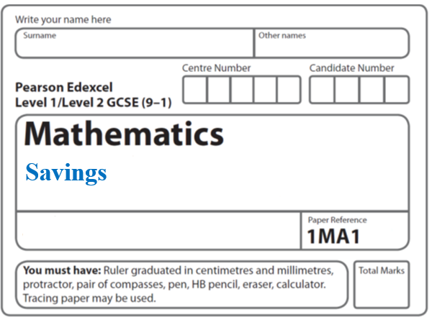**Instructions**

**Percentages**

* Use **black** ink or ball-point pen.
  + **Fill in the boxes** at the top of this page with your name,  
    centre number and candidate number.
* Answer **all** questions.
* Answer the questions in the spaces provided  
  *– there may be more space than you need.*
* You must **show all your working.**
* Diagrams are **NOT** accurately drawn, unless otherwise indicated.
* If your calculator does not have a *π* button, take the value of *π* to be3.142

unless the question instructs otherwise.

**Information**

* The total mark for this paper is **41**. There are **12** questions.
* Questions have been arranged in an ascending order of mean difficulty, as found by all students in the June 2017–November 2019 examinations.
* The marks for **each** question are shown in brackets  
  *– use this as a guide as to how much time to spend on each question.*

**Advice**

* Read each question carefully before you start to answer it.
* Keep an eye on the time.
* Try to answer every question.
* Check your answers if you have time at the end.

**1** Raya buys a van for £8500 plus VAT at 20%

Raya pays a deposit for the van.

She then pays the rest of the cost in 12 equal payments of £531.25 each month.

Find the ratio of the deposit Raya pays to the total of the 12 equal payments.

Give your answer in its simplest form.

......................................................

(**Total for Question 1 is 5 marks**)

**___________________________________________________________________________**

**2** Jules buys a washing machine.

20% VAT is added to the price of the washing machine.

Jules then has to pay a total of £600.

What is the price of the washing machine with **no** VAT added?

£.......................................................

**(Total for Question 2 is 2 marks)**

**___________________________________________________________________________**

**3** Adam buys a computer.

20% VAT is added to the price of the computer.

Adam has to pay a total of £900

Work out the price of the computer before VAT is added.

£.......................................................

**(Total for Question 3 is 2 marks)**

**4** Marie invests £8000 in an account for one year.

At the end of the year, interest is added to her account.

Marie pays tax on this interest at a rate of 20%

She pays £28.80 tax.

Work out the percentage interest rate for the account.

....................................................... %

**(Total for Question 4 is 3 marks)**

**___________________________________________________________________________**

**5** Kim, Laura and Molly share £385

The ratio of the amount of money Kim gets to the amount of money Molly gets is 2 : 5

Kim gets £105 less than Molly gets.

What percentage of the £385 does Laura get?

....................................................... %

**(Total for Question 5 is 4 marks)**

**___________________________________________________________________________**

**6** Sophia pays £222 for a plane ticket.

She also pays 100 euros airport tax.

The exchange rate is £1 = 1.38 euros.

What percentage of the total cost of the ticket and the airport tax does Sophia pay for the airport tax?

Give your answer correct to 1 decimal place.

.......................................................%

**(Total for Question 6 is 3 marks) ___________________________________________________________________________**

**7** A bonus of £2100 is shared by 10 people who work for a company.

40% of the bonus is shared equally between 3 managers.

The rest of the bonus is shared equally between 7 salesmen.

One of the salesmen says,

“If the bonus is shared equally between all 10 people I will get 25% more money.”

Is the salesman correct?

You must show how you get your answer.

**(Total for Question 7 is 5 marks)**

**___________________________________________________________________________**

**8** In 2003, Jerry bought a house.

In 2007, Jerry sold the house to Mia.

He made a profit of 20%

In 2012, Mia sold the house for £162 000.

She made a loss of 10%

Work out how much Jerry paid for the house in 2003.

£.......................................................

(**Total for Question 8 is 3 marks**)

**___________________________________________________________________________**

**9** Here are three rectangles.



The area of rectangle **B** is 10% greater than the area of rectangle **A**.

The area of rectangle **C** is 10% greater than the area of rectangle **B**.

By what percentage is the area of rectangle **C** greater than the area of rectangle **A**?

......................................... %

**(Total for Question 9 is 3 marks)**

**___________________________________________________________________________**

**10** Here are three spheres.



The volume of sphere **Q** is 50% more than the volume of sphere **P**.

The volume of sphere **R** is 50% more than the volume of sphere **Q**.

Find the volume of sphere **P** as a fraction of the volume of sphere **R**.

.......................................................

**(Total for Question 10 is 3 marks)**

**___________________________________________________________________________**

**11** Emily buys a pack of 12 bottles of water.

The pack costs £5.64.

Emily sells all 12 bottles for 50p each.

Work out Emily’s percentage profit.

Give your answer correct to 1 decimal place.

......................................................%

**(Total for Question 11 is 3 marks)**

**___________________________________________________________________________**

**12** Robert makes 50 litres of green paint by mixing litres of yellow paint and litres of

blue paint in the ratio 2 : 3

Yellow paint is sold in 5 litre tins.

Each tin of yellow paint costs £26

Blue paint is sold in 10 litre tins.

Each tin of blue paint costs £48

Robert sells all the green paint he makes in 10 litre tins.

He sells each tin of green paint for £66.96

Work out Robert’s percentage profit on each tin of green paint he sells.

.......................................................%

**(Total for Question 12 is 5 marks)**

**___________________________________________________________________________**

**TOTAL MARKS FOR PAPER: 41**