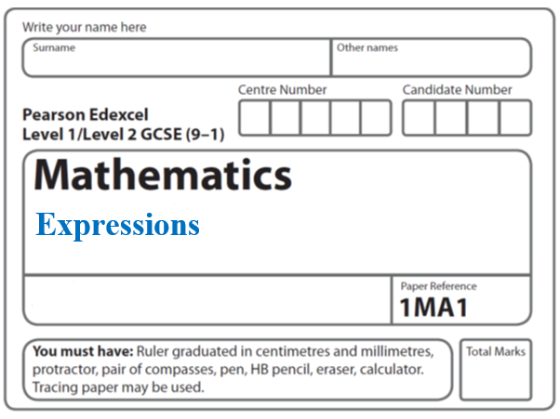Instructions
Expand and Factorise

- Use black ink or ball-point pen.
  - Fill in the boxes at the top of this page with your name,
centre number and candidate number.
- Answer all questions.
- Answer the questions in the spaces provided
– there may be more space than you need.
- You must show all your working.
- Diagrams are NOT accurately drawn, unless otherwise indicated.
- If your calculator does not have a π button, take the value of π to be 3.142
unless the question instructs otherwise.

Information
- The total mark for this paper is 58. There are 20 questions.
- Questions have been arranged in an ascending order of mean difficulty, as found by all students in the June 2017–November 2019 examinations.
- The marks for each question are shown in brackets
– use this as a guide as to how much time to spend on each question.

Advice
- Read each question carefully before you start to answer it.
- Keep an eye on the time.
- Try to answer every question.
- Check your answers if you have time at the end.

1 Expand and simplify 5( p + 3) – 2(1 – 2p)

....................................................
(Total for Question 1 is 2 marks)
___________________________________________________________________________

2 (a) Expand and simplify (x + 5)(x – 9)

.......................................................
(2)
(b) Factorise fully 9x² + 6x

.......................................................
(2)
(Total for Question 2 is 4 marks)
___________________________________________________________________________

3 Factorise x² + 3x – 4

......................................................
(Total for Question 3 is 2 marks)
___________________________________________________________________________

4 Factorise x² − 2x − 35

.......................................................

(Total for Question 4 is 2 marks)
___________________________________________________________________________

5 Show that (2x + 1)(x + 3)(3x + 7) can be written in the form ax³ + bx² + cx + d,
where a, b, c and d are integers.

(Total for Question 5 is 3 marks)
___________________________________________________________________________

6 Show that (x + 1)(x + 2)(x + 3) can be written in the form ax³ + bx² + cx + d
where a, b, c and d are positive integers.

(Total for Question 6 is 3 marks)
___________________________________________________________________________
7 can be written in the form where a is an integer.
Find the value of a.

a = .......................................................
(Total for Question 7 is 3 marks)

8 Expand and simplify (3x + 2)(2x + 1)(x − 5)

..............................................................................................................
(Total for Question 8 is 3 marks)
___________________________________________________________________________

9 Expand and simplify (x + 2)(x + 8)(x – 4)

.................................................................................
(Total for Question 9 is 3 marks)
___________________________________________________________________________

10 Simplify

.......................................................

(Total for Question 10 is 3 marks)
___________________________________________________________________________

11 Simplify fully

.......................................................
(Total for Question 11 is 3 marks)
___________________________________________________________________________

12 (a) Factorise a² − b²

.......................................................
(1)
(b) Hence, or otherwise, simplify fully (x² + 4)² – (x² – 2)²

.......................................................
(3)
(Total for Question 12 is 4 marks)
___________________________________________________________________________

13 (a) Expand and simplify (x – 2)(2x + 3)(x + 1)

.......................................................
(3)

(b) Find the value of n.

.......................................................
(2)
(c) Solve 5x² – 4x – 3 = 0
Give your solutions correct to 3 significant figures.

.......................................................
(3)
(Total for Question 13 is 8 marks)
___________________________________________________________________________

14 Factorise (x + y)² + 3(x + y)

..............................................................................................................
(1)
(Total for Question 14 is 3 marks)
___________________________________________________________________________

15 Show that

(3x – 1)(x + 5)(4x – 3) = 12x³ + 47x² – 62x + 15

for all values of x.

(Total of Question 15 is 3 marks)
___________________________________________________________________________

16 Martin expands (2x + 1)(2x − 3)(3x + 2)

He gets 12x³ − 4x² − 17x + 6

(b) Explain why Martin’s solution cannot be correct.

......................................................................................................................................................

......................................................................................................................................................
(1)
(Total for Question 16 is 2 marks)
___________________________________________________________________________

17 Expand and simplify (x + 2)(2x – 3)(3x + 1)

..............................................................................................................
(3)

(Total for Question 17 is 4 marks) ___________________________________________________________________________

18 Factorise 3(x − y)² − 2(x − y)

....................................................................
(2)
(Total for Question 18 is 2 marks)
___________________________________________________________________________

19 (a) Simplify

......................................................
(1)
(b) Factorise fully 50 – 2y²

........................................................................................
(2)
(Total for Question 19 is 3 marks)
___________________________________________________________________________

20 Maryam is trying to expand and simplify (n – 2)²
Here is her working.

(n – 2)² | = (n – 2)(n – 2)
 | = n² – 2n – 2n – 4
 | = n² – 4n – 4

Maryam’s answer is wrong.
(a) Find Maryam’s mistake.
......................................................................................................................................................
......................................................................................................................................................
(1)

Josh is trying to factorise x² – 6x + 8
His reasoning is,
because 4 × 2 = 8
and 4 + 2 = 6
then x² – 6x + 8 = (x + 4)(x + 2)
(b) Explain what is wrong with Josh’s reasoning.
......................................................................................................................................................
......................................................................................................................................................
......................................................................................................................................................
(1)
(Total for Question 20 is 4 marks) ___________________________________________________________________________

TOTAL MARKS FOR PAPER: 58

