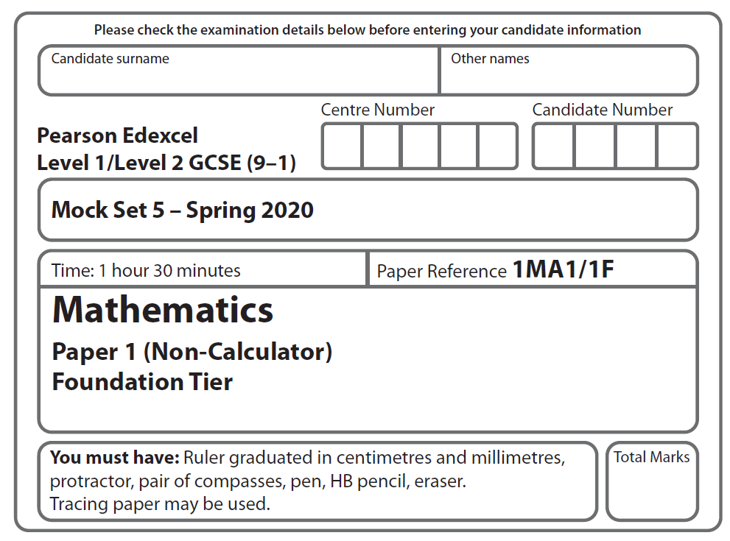

LPGS Autumn Mock Exam 2020

**Instructions**

* Use **black** ink or ball-point pen.
* **Fill in the boxes** at the top of this page with your name, centre number   
  and candidate number.
* Answer **all** questions.
* Answer the questions in the spaces provided.

*– there may be more space than you need.*

* You must **show all your working.**
* Diagrams are **NOT** accurately drawn, unless otherwise indicated.
* **Calculators may not be used.**

**Information**

* The total mark for this paper is 80
* The marks for **each** question are shown in brackets

*– use this as a guide as to how much time to spend on each question.*

**Advice**

* Read each question carefully before you start to answer it.
* Try to answer every question.
* Check your answers if you have time at the end.

**S66508A**

**Answer ALL questions.**

**Write your answers in the spaces provided.**

**You must write down all the stages in your working.**

**1** Write 40 673 to the nearest thousand.

..............................

**(Total for Question 1 is 1 mark)**

**2** Change 8 kilometres into metres.

……………………. metres

**(Total for Question 2 is 1 mark)**

**3** Write the following numbers in order of size.

Start with the smallest number.

0.5 0.577 0.507 0.57 0.05

.....………………………………………..............

**(Total for Question 3 is 1 mark)**

**4** Write 150 minutes in hours and minutes.

............ hours ............ minutes

**(Total for Question 4 is 1 mark)**

**5** Sam has a fair spinner.

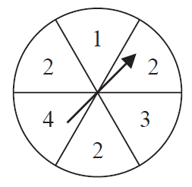

Sam is going to spin the arrow on the spinner once.

1. From the list below, choose the word that best describes the likelihood that the arrow

will land on 3

impossible unlikely evens likely certain

…………………………

**(1)**

1. From the list below, choose the word that best describes the likelihood that the arrow

will land on 2

impossible unlikely evens likely certain

…………………………

**(1)**

**(Total for Question 5 is 2 marks)**

**6** This notice is inside a bus.

**Maximum number of passengers**

Sitting 62

Standing 18

On the bus

54 passengers are sitting

and 7 passengers are standing.

The bus stops at a bus stop.

No-one gets off the bus.

17 people want to get on the bus.

Can all 17 people get on the bus?

You must show how you get your answer.

**(Total for Question 6 is 3 marks)**

**7** Fiona recorded the temperature, in °C, at 9 am on seven different days in December.

Here are her results.

|  |  |  |  |  |  |  |  |
| --- | --- | --- | --- | --- | --- | --- | --- |
| **Day** | Mon | Tue | Wed | Thu | Fri | Sat | Sun |
| **Temperature (°C)** | 5 | 4 | 1 | – 4 | – 6 | –2 | 2 |

(a) Work out the difference between the temperature at 9 am on Monday and

the temperature at 9 am on Friday.

………………..°C

**(1)**

(b) Find the median temperature.

………………..°C

**(2)**

**(Total for Question 7 is 3 marks)**

**8** Which is larger, 25% or ?

You must show how you get your answer.

…………………

**(Total for Question 8 is 2 marks)**

**9**

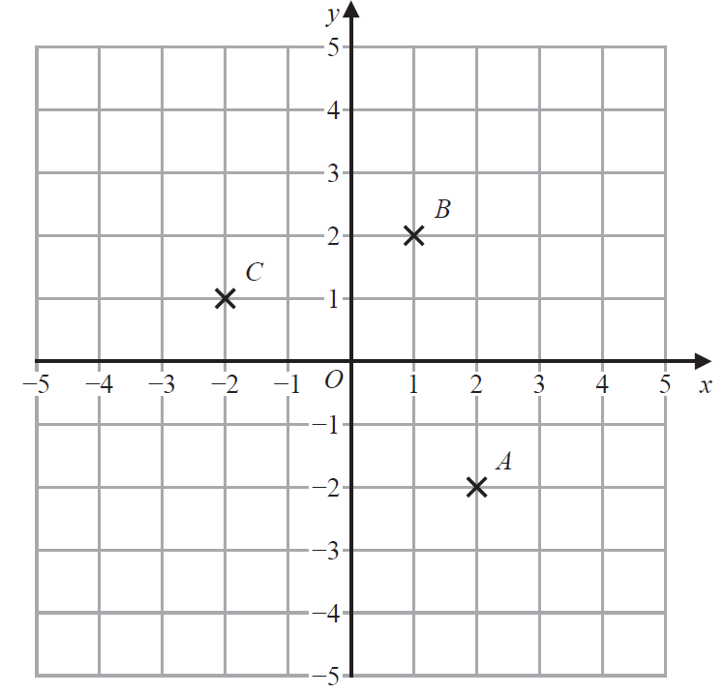

1. Write down the coordinates of the point *B*.

(………. , ……….)

**(1)**

1. On the grid, mark with a cross (×) the point *D* so that *ABCD* is a parallelogram.

Label this point *D*.

**(1)**

1. On the grid, mark with a cross (×) the point *E* so that *B* is the midpoint of *CE*.

Label this point *E*.

**(1)**

**(Total for Question 9 is 3 marks)**

**10** A ticket for a seat at a concert costs £8.75

There are 19 rows of seats.  
There are 28 seats in each row.

The tickets for 100 of the seats have **not** been sold.

(a) Work out an estimate for the total cost of the tickets that have been sold.

£…………………….

**(3)**

(b) Is your answer to part (a) an underestimate or an overestimate?

Give a reason for your answer.

......................................................................................................................................................

......................................................................................................................................................

**(1)**

**(Total for Question 10 is 4 marks)**

**11** You can use this graph to change between ounces and grams.

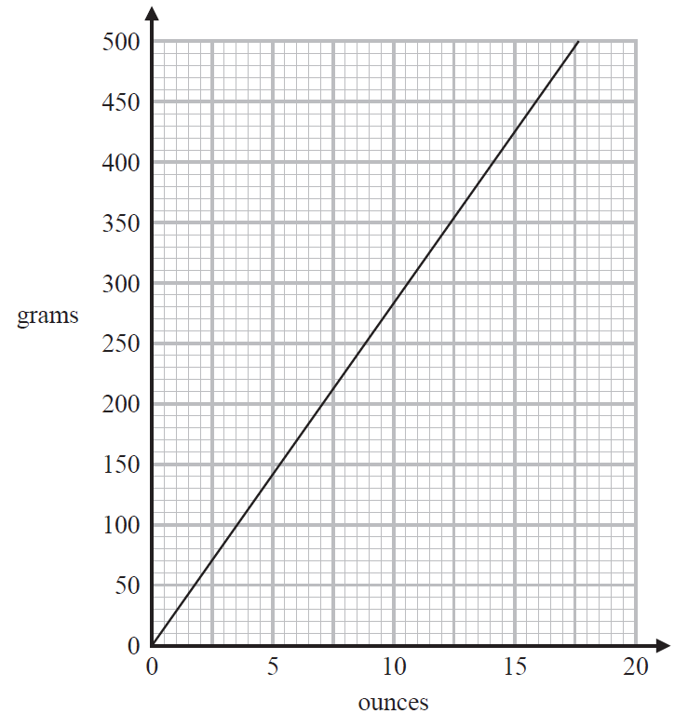

(a) Change 11 ounces to grams.

.……………….. grams

**(1)**

Dave is making a cake.

He needs 800 grams of sugar.

Dave thinks that 800 grams is the same as 30 ounces.

(b) Is Dave correct?

You must show how you get your answer.

**(3)**

**(Total for Question 11 is 4 marks)**

**12** Solve 4*y* – 7 = 29

*y* = ………………..

**(Total for Question 12 is 2 marks)**

**13**

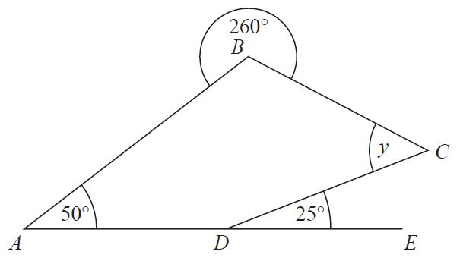

*ABCD* is a quadrilateral.

A*DE* is a straight line.

Find the size of the angle marked *y*.

Give a reason for each stage of your working.

……………………º

**(Total for Question 13 is 4 marks)**

**14** (a) Work out  × 

…..……………

**(1)**

(b) Work out  + 

…..……………

**(2)**

**(Total for Question 14 is 3 marks)**

**15**Kate is *x* years old.

Lethna is 3 times as old as Kate.

Mike is 4 years older than Lethna.

Write down an expression, in terms of *x*, for Mike’s age.

…..………………………… years

**(Total for Question is 15 is 2 marks)**

**16** The table shows some information about the weights of protein, fibre and carbohydrate in a

breakfast cereal.

The table is incomplete.

|  |  |  |
| --- | --- | --- |
|  | **Weight in grams** | |
|  | **Large serving of cereal** | **Small serving of cereal** |
| Protein | 15 | 6 |
| Fibre | ............... | 4 |
| Carbohydrate | 65 | ............... |

Complete the table.

**(Total for Question 16 is 4 marks)**

**17** Write the ratio 150 : 450 in the form 1 : *n* where *n* is a whole number.

…..……………

**(Total for Question 17 is 2 marks)**

**18** A shop has two offers.

**Without a Store card**

 off normal prices

**With a Store card**

45% off normal prices

Laura is going to buy a coat in the shop.

The normal price of the coat is £90

Laura would pay less with a Store card than she would pay without a Store card.

How much less?

£…………………….

**(Total for Question 18 is 4 marks)**

**19** Work out 41.7 × 2.3

..................................

**(Total for Question 19 is 3 marks)**

**20** Expand and simplify 2(*m* – 3) + 3(*m* + 4)

.........................................

**(Total for Question 20 is 1 marks)**

**21** The scatter graph shows the age and the value of each of ten cars of the same make and model.

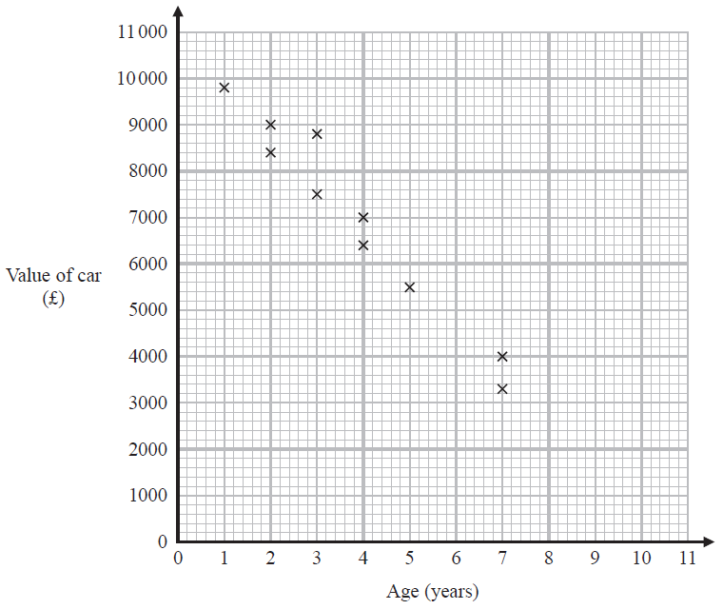

1. Describe the relationship between the value of a car and the age of the car.

…………………………………………………………………………………………………..

…………………………………………………………………………………………………..

**(1)**

1. Draw a line of best fit on the scatter graph.

**(1)**

It may not be reliable to use the line of best fit to predict the value of a car that is 10 years old.

1. Give a reason why.

…………………………………………………………………………………………………..

…………………………………………………………………………………………………..

…………………………………………………………………………………………………..

**(1)**

**(Total for Question 21 is 3 marks)**

**22** There are 270 students in Year 7

Each student studies one of French or German or Spanish.

Of these 270 students

study French

the number who study French : the number who study Spanish = 3 : 7

42 boys study German

Of the students who study German, what percentage are boys?

You must show your working.

..................................%

**(Total for Question 22 is 5 marks)**

**23** Here are the front elevation and the side elevation of a solid prism.

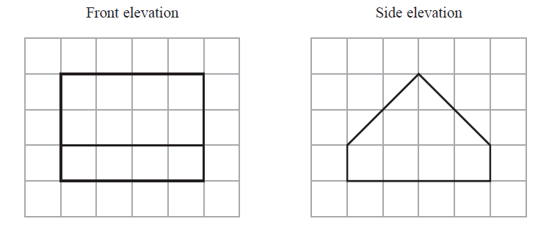

1. On the grid below, draw a plan of the solid prism.



**(2)**

(b) In the space below, draw a sketch of the solid prism.

**(2)**

**(Total for Question 23 is 4 marks)**

**24** The diagram shows a block of metal on horizontal ground.

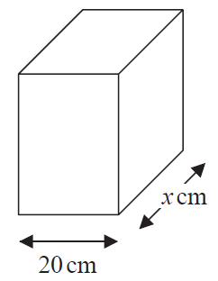

The base of the block of metal is a rectangle 20 cm by *x* cm.

The block exerts a force of 1500 newtons on the ground.

The pressure on the ground is 3 newtons/cm2

Work out the value of *x*.

…………………….

**(Total for Question 24 is 3 marks)**

**25** (a) Write 247 000 in standard form.

…..……………………...........

**(1)**

(b) Write as an ordinary number.

…..……………………...........

**(1)**

(c) Work out ×

Give your answer in standard form.

…..……………………...........

**(2)**

**(Total for Question 25 is 4 marks)**

**26** The diagram shows a trapezium *ABCD* and a square *PQRS*.

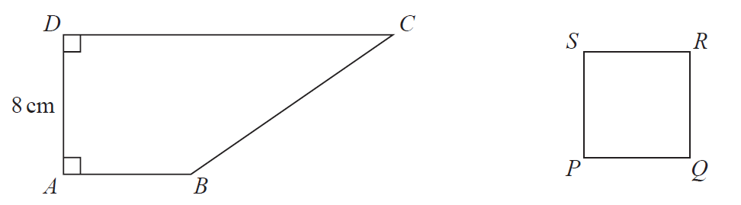

*AD* = 8 cm

*DC* = 3*AB*

The perimeter of the square is 24 cm.

The area of the square is half the area of the trapezium.

Work out the length of *AB*.

……………………. cm

**(Total for Question 26 is 4 marks)**

**27** 6 boys have a mean age of 10 years.

14 girls have a mean age of 5 years.

Work out the mean age of all 20 children.

..................................

**(Total for Question 27 is 3 marks)**

**28** Solve the simultaneous equations

*x* – 5*y* = 10

3*x* + *y* = 6

*x* = .................

*y* = .................

**(Total for Question 28 is 3 marks)**

**TOTAL FOR PAPER IS 80 MARKS**