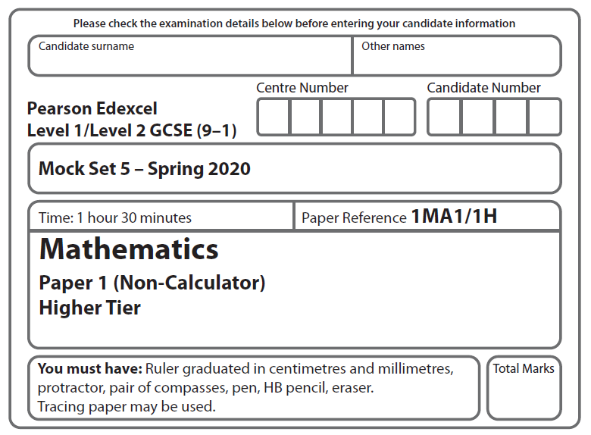

LPGS Autumn Mock Exam 2020

**Instructions**

* Use **black** ink or ball-point pen.
* **Fill in the boxes** at the top of this page with your name, centre number   
  and candidate number.
* Answer **all** questions.
* Answer the questions in the spaces provided.

*– there may be more space than you need.*

* You must **show all your working.**
* Diagrams are **NOT** accurately drawn, unless otherwise indicated.
* **Calculators may not be used.**

**Information**

* The total mark for this paper is 80
* The marks for **each** question are shown in brackets

*– use this as a guide as to how much time to spend on each question.*

**Advice**

* Read each question carefully before you start to answer it.
* Try to answer every question.
* Check your answers if you have time at the end.

**S66509A**

**Answer ALL questions.**

**Write your answers in the spaces provided.**

**You must write down all the stages in your working.**

**1** Expand and simplify 2(*m* – 3) + 3(*m* + 4)

.........................................

**(Total for Question 1 is 2 marks)**

**2** The scatter graph shows the age and the value of each of ten cars of the same make and model.

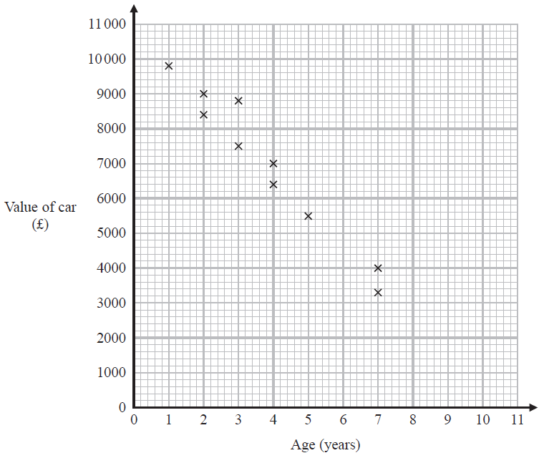

Insert proof 2 graph

1. Describe the relationship between the value of a car and the age of the car.

…………………………………………………………………………………………………..

…………………………………………………………………………………………………..

**(1)**

1. Draw a line of best fit on the scatter graph.

**(1)**

It may not be reliable to use the line of best fit to predict the value of a car that is 10 years old.

1. Give a reason why.

…………………………………………………………………………………………………..

…………………………………………………………………………………………………..

…………………………………………………………………………………………………..

**(1)**

**(Total for Question 2 is 3 marks)**

**3** There are 270 students in Year 7

Each student studies one of French or German or Spanish.

Of these 270 students

 study French

the number who study French : the number who study Spanish = 3 : 7

42 boys study German

Of the students who study German, what percentage are boys?

You must show your working.

..................................%

**(Total for Question 3 is 5 marks)**

**4** Here are the front elevation and the side elevation of a solid prism.

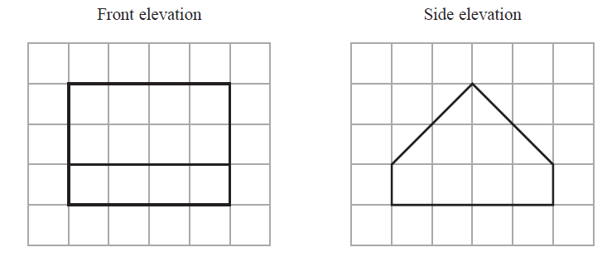

1. On the grid below, draw a plan of the solid prism.



**(2)**

(b) In the space below, draw a sketch of the solid prism.

**(2)**

**(Total for Question 4 is 4 marks)**

**5** The diagram shows a block of metal on horizontal ground.

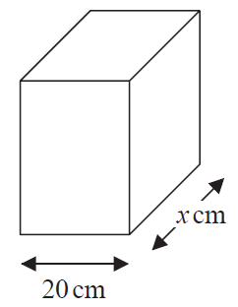



The base of the block of metal is a rectangle 20 cm by *x* cm.

The block exerts a force of 1500 newtons on the ground.

The pressure on the ground is 3 newtons/cm2

Work out the value of *x*.

…………………….

**(Total for Question 5 is 3 marks)**

**6** (a) Write 247 000 in standard form.

…..……………………...........

**(1)**

(b) Write as an ordinary number.

…..……………………...........

**(1)**

(c) Work out ×

Give your answer in standard form.

…..……………………...........

**(2)**

**(Total for Question 6 is 4 marks)**

**7** The diagram shows a trapezium *ABCD* and a square *PQRS*.

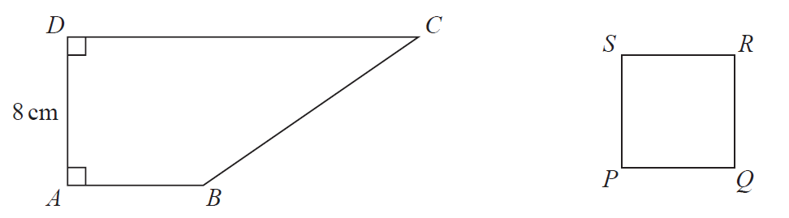

*AD* = 8 cm

*DC* = 3*AB*

The perimeter of the square is 24 cm.

The area of the square is half the area of the trapezium.

Work out the length of *AB*.

……………………. cm

**(Total for Question 7 is 4 marks)**

**8** (a) Work out an estimate for the value of

…………………….

**(2)**

(b) Is your answer to part (a) an underestimate or an overestimate?

Give a reason for your answer.

......................................................................................................................................................

......................................................................................................................................................

**(1)**

**(Total for Question 8 is 3 marks)**

**9** A company has a target to reduce the number of its stores by 40% over the next two years.

At the end of the first year it has reduced the number of its stores by 20%

If the company is going to reach its target, it must reduce the number of its stores

by another *P* % in the second year

Find the value of *P*.

…………………….

**(Total for Question 9 is 3 marks)**

**10** Here are the ages, in years, of the 19 men in a badminton club.

1. 27 30 31 32 34 35 35 36 38

40 40 42 46 47 49 51 57 58

1. On the grid, draw a box plot for this information.

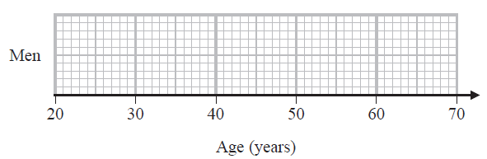

**(3)**

The box plot below shows information about the distribution of the ages of the women in the badminton club.

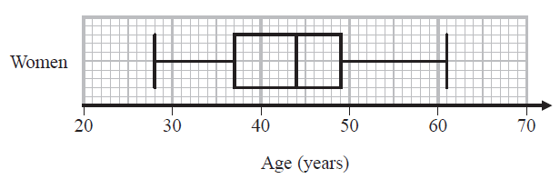

1. Compare the distribution of the ages of the men with the distribution of the ages of the women.

......................................................................................................................................................

......................................................................................................................................................

......................................................................................................................................................

......................................................................................................................................................

......................................................................................................................................................

**(2)**

**(Total for Question 10 is 5 marks)**

**11** Nadia sells small boxes of chocolates and large boxes of chocolates.

The total number of chocolates in 3 small boxes and 1 large box is 66

The total number of chocolates in 1 small box and 2 large boxes is 72

Work out the number of chocolates in each small box and the number of chocolates in each large box.

small box …………………….

large box …………………….

**(Total for Question 11 is 4 marks)**

**12** Work out the value of ×

Give your answer in its simplest form.

…………………….

**(Total for Question 12 is 3 marks)**

**13** Julie has to solve *x* 2 – 5*x +* 2 = 0

Here is the first line of her working.



The first line of Julie’s working is wrong.

What mistake has she made?

......................................................................................................................................................

......................................................................................................................................................

......................................................................................................................................................

**(Total for Question 13 is 1 mark)**

**14** Rachel has 10 sweets in a bag.

7 of the sweets are yellow.

3 of the sweets are red.

Rachel takes random sweets from the bag, one at a time, until she gets a red sweet.

She does not replace the sweets that she takes from the bag.

Rachel stops as soon as she gets a red sweet.

Work out the probability that Rachel takes no more than three sweets from the bag.

…………………….

**(Total for Question is 14 is 3 marks)**

**15** Make *x* the subject of the formula *y* = 

…………………….…………………….

**(Total for Question 15 is 4 marks)**

**16** *a*, *b*, *c* and *d* are integers.

4*a* = 5*b*

*c* = *b*

*a* : *d* = 3 : 5

Find *a* : *b* : *c* : *d*

…………………….…………………….

**(Total for Question 16 is 4 marks)**

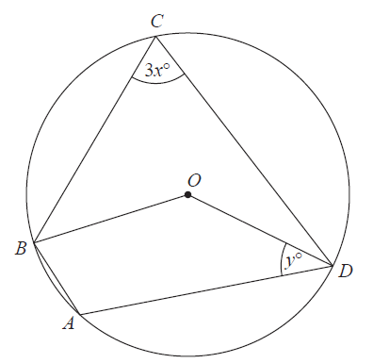**17**

*A, B, C* and *D* are points on a circle with centre *O*.

size of angle *ABO* : size of angle *ODA* = 2 : 1

Find an expression for *y* in terms of *x*.

You must show all your working.

…………………….

**(Total for Question 17 is 4 marks)**

**18** Factorise fully 3*x* 2 – 12*y* 2

…………………….

**(Total for Question 18 is 2 marks)**

**19** Show that  can be written in the form  where *h* is an integer.

**(Total for Question 19 is 4 marks)**

**20** Here is the graph of *y* = sin *x*° for –180 *x* 180

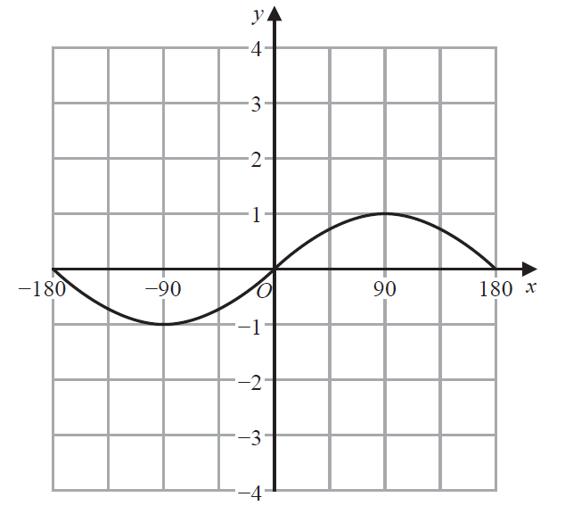

(a) On the grid above, sketch the graph of *y* = sin *x*° – 2 for –180 *x* 180

**(1)**

Here is the graph of *y* = cos *x*° for 0 *x* 360

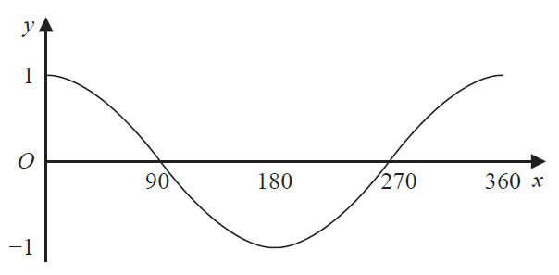

The exact value of cos 60° is 0.5

(b)  (i) Write down the exact value of cos 300°

…………………….

**(1)**

(ii) Write down one solution of the equation cos *x*° = – 0.5

…………………….

**(1)**

**(Total for Question 20 is 3 marks)**

**21** The diagram shows the lines *OX*, *OY* and *OZ*.

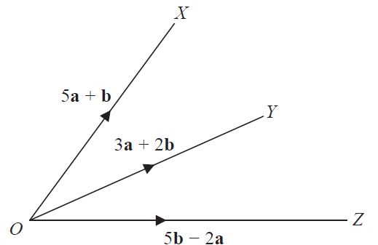

5**a** + **b**

3**a *+*** 2**b**

5**b** –2**a**

Determine whether or not *XYZ* is a straight line.

You must show how you get your answer.

**(Total for Question 21 is 3 marks)**

**22** (a) Write 3*x* 2 – 24*x* + 38 in the form *a*(*x* – *b*)2 – *c*  where *a*, *b* and *c* are integers.

…………………….

**(3)**

(b) Hence, or otherwise, write down the coordinates of the turning point on the graph

of *y* = 3*x* 2 – 24*x* + 38

(………. , ……….)

**(1)**

**(Total for Question 22 is 4 marks)**

**23** **C** is a circle with centre (0, 0)

**L** is a straight line with negative gradient.

The circle **C** and the line **L** intersect at the points *A* and *B*.

The coordinates of *A* are (– 9, 2)

The *x* coordinate of *B* is 7

Find an equation of **L**.

…………………….

**(Total for Question 23 is 5 marks)**

**TOTAL FOR PAPER IS 80 MARKS**