****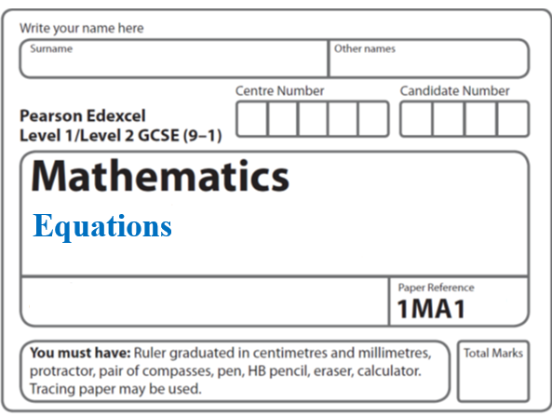**Instructions**

**Solving equations: Quadratics**

* Use **black** ink or ball-point pen.
  + **Fill in the boxes** at the top of this page with your name,  
    centre number and candidate number.
* Answer **all** questions.
* Answer the questions in the spaces provided  
  *– there may be more space than you need.*
* You must **show all your working.**
* Diagrams are **NOT** accurately drawn, unless otherwise indicated.
* If your calculator does not have a *π* button, take the value of *π* to be3.142

unless the question instructs otherwise.

**Information**

* The total mark for this paper is **20**. There are **4** questions.
* Questions have been arranged in an ascending order of mean difficulty, as found by all students in the June 2017–November 2019 examinations.
* The marks for **each** question are shown in brackets  
  *– use this as a guide as to how much time to spend on each question.*

**Advice**

* Read each question carefully before you start to answer it.
* Keep an eye on the time.
* Try to answer every question.
* Check your answers if you have time at the end.

**1** f(*x*) = 4sin *x*°

(*a*)Find f(23)

Give your answer correct to 3 significant figures.

.......................................................

**(1)**

g(*x*) = 2*x* – 3

(*b*)Find fg(34)

Give your answer correct to 3 significant figures.

.......................................................

**(2)**

h(*x*) = (*x* + 4)2

Ivan needs to solve the following equation h(*x*) = 25

He writes

(*x* + 4)2 = 25

*x* + 4 = 5

*x* = 1

This is not fully correct.

(*c*)Explain why.

......................................................................................................................................................

......................................................................................................................................................

**(1)**

**(Total for Question 1 is 4 marks)**

**__________________________________________________________________________**

**2** Solve (*x* – 2)2 = 3

Give your solutions correct to 3 significant figures.

...........................................................................................................

**(Total for Question 2 is 2 marks)**

**___________________________________________________________________________**

**3** (a) Solve 3*x*2 = 108

.......................................................

**(2)**

(b) Factorise *x*2 − 2*x* − 35

.......................................................

**(2)**

*u* =  + 2

(c) Make *t* the subject of the formula.

.......................................................

**(3)**

**(Total for Question 3 is 7 marks)**

**___________________________________________________________________________**

**4** For all values of *x*

f(*x*) = 2*x* – 3 and g(*x*) = *x*2 + 2

(a)Find g(−4)

.......................................................

**(1)**

(b)Show that gf(*x*) = 4*x*2 − 12*x* + 11

**(2)**

(c)Solve fg(*x*) = gf(*x*)

.......................................................

**(4)**

**(Total for Question 4 is 7 marks)**

**___________________________________________________________________________**

**TOTAL MARKS FOR PAPER: 20**