**GCSE Mathematics**

**Practice Tests: Set 14**

**Paper 1F (Non-calculator)**

**Time: 1 hour 30 minutes**

You should have: Ruler graduated in centimetres and millimetres, protractor, pair of compasses, pen, HB pencil, eraser, calculator. Tracing paper may be used.

**Instructions**



* Use **black** ink or ball-point pen.
* **Fill in the boxes** at the top of this page with your name,  
  centre number and candidate number.
* Answer **all** questions.
* Answer the questions in the spaces provided

– *there may be more space than you need*.

* **Calculators may not be used.**
* Diagrams are NOT accurately drawn, unless otherwise indicated.
* You must **show all your working out.**

**Information**

* The total mark for this paper is 80
* The marks for **each** question are shown in brackets  
  – *use this as a guide as to how much time to spend on each question*.

**Advice**

* Read each question carefully before you start to answer it.
* Keep an eye on the time.
* Try to answer every question.
* Check your answers if you have time at the end.

**Answer ALL questions.**

**Write your answers in the spaces provided.**

**You must write down all the stages in your working.**

**1** Write  as a decimal.

.......................................................

**(Total for Question 1 is 1 mark)**

**___________________________________________________________________________**

**2** Solve *x* + 5 = 12

*x* = .......................................................

**(Total for Question 2 is 1 mark)**

**___________________________________________________________________________**

**3** Simplify 5*c* × *d*

.......................................................

**(Total for Question 3 is 1 mark)**

**___________________________________________________________________________**

**4**Write 0.6 as a percentage.

.......................................................%

**(Total for Question 4 is 1 mark)**

**___________________________________________________________________________**

**5**Change 3 litres into millilitres.

.......................................................millilitres

**(Total for Question 5 is 1 mark)**

**___________________________________________________________________________**

**6** Write  as a fraction in its simplest form.

.......................................................

**(Total for Question 6 is 2 marks)**

**___________________________________________________________________________**

**7** *c* = 4

*d* = 7

Work out the value of 3*c* + 2*d*

.......................................................

**(Total for Question 7 is 2 marks)**

**___________________________________________________________________________**

**8**The table gives the minimum temperature for January 2018 in each of six cities.

|  |  |
| --- | --- |
| **City** | **Minimum**  **temperature(°C)** |
| Barcelona | 3 |
| Donetsk | −10 |
| Mexico City | −1 |
| Mombasa | 22 |
| New York | −15 |
| Sydney | 15 |

(*a*)Which of these six cities has the lowest minimum temperature?

.......................................................

**(1)**

(*b*)Work out the difference between the minimum temperature of Donetsk and the

minimum temperature of Sydney.

.......................................................°C

**(1)**

The minimum temperature in Edmonton for January 2018 was 50 °C less than the

minimum temperature in Mombasa for January 2018

(*c*)Work out the minimum temperature in Edmonton for January 2018

.......................................................°C

**(1)**

**(Total for Question 8 is 3 marks)**

**___________________________________________________________________________**

**9** The pictogram shows information about the number of books sold in a shop each day

from Monday to Thursday last week.

|  |  |  |  |  |
| --- | --- | --- | --- | --- |
| **Monday** |  |  |  |  |
| **Tuesday** |  |  |  |  |
| Key: | represents  20 books |
| **Wednesday** |  |  |
| **Thursday** |  |  |
|  |  |
| **Friday** |  |  |  |  |

(*a*)How many books were sold on Wednesday last week?

.......................................................

**(1)**

35 books were sold in the shop on Friday last week.

(*b*)Show this information on the pictogram.

**(1)**

Last week

some books were sold in the shop on Saturday

no books were sold in the shop on Sunday

a total of 500 books were sold in the shop.

(*c*)Work out the number of books that were sold in the shop on Saturday last week.

.......................................................

**(3)**

**(Total for Question 9 is 5 marks)**

**___________________________________________________________________________**

**10**Here is a list of numbers.

|  |  |  |  |  |  |  |  |
| --- | --- | --- | --- | --- | --- | --- | --- |
| 1 | 17 | 21 | 25 | 26 | 31 | 39 | 64 |

From this list, write down

(*a*)an even number

.......................................................

**(1)**

(*b*)a multiple of 3

.......................................................

**(1)**

(*c*)a prime number

.......................................................

**(1)**

(*d*)a cube number

.......................................................

**(1)**

**(Total for Question 10 is 4 marks)**

**___________________________________________________________________________**

**11** Simplify 8*k* + 5*m* – 2*k* + 6*m*

.......................................................

**(Total for Question 11 is 2 marks)**

**___________________________________________________________________________**

**12**The diagram shows three points, *A*, *B* and *C*, marked on a grid.

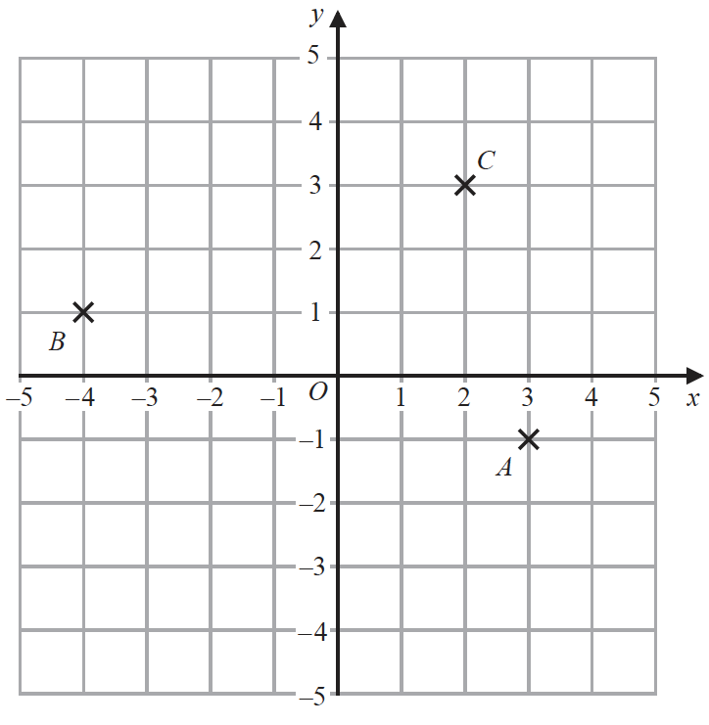

(*a*)Write down the coordinates of point *A*.

(............................ , ............................)

**(1)**

The coordinates of the point *D* are (–2, –4)

(*b*)On the grid, mark with a cross (✕) the position of *D*.

Label the cross *D*.

**(1)**

(*c*)Find the coordinates of the midpoint of *BC*.

(............................ , ............................)

**(2)**

(*d*)On the grid, draw the line with equation *x* = 4

**(1)**

**(Total for Question 7 is 5 marks)**

**___________________________________________________________________________**

**13** (*a*)Write down the mathematical name of this 3-D shape.



.......................................................

**(1)**

Here is a solid cuboid.



(*b*)(i) How many faces has the cuboid?

.......................................................

(ii) How many vertices has the cuboid?

.......................................................

**(2)**

(*c*)Work out the volume of the cuboid.

....................................................... cm3

**(2)**

**(Total for Question 13 is 5 marks)**

**___________________________________________________________________________**

**14** The numbers from 1 to 14 are shown in the Venn diagram.



(*a*)List the members of the set *A*  *B*

............................................................................................................

**(1)**

A number is picked at random from the numbers in the Venn diagram.

(*b*)Find the probability that this number is in set *A* but is **not** in set *B*.

.......................................................

**(2)**

**(Total for Question 14 is 3 marks)**

**___________________________________________________________________________**

**15** There are only blue bricks and white bricks in a box.

The ratio of the number of blue bricks to the number of white bricks is 3 : 7

What fraction of the bricks in the box are blue bricks?

.......................................................

**(Total for Question 15 is 1 mark)**

**___________________________________________________________________________**

**16**Paula asks 16 members of her class the number of pets they each have.

Here are her results.

|  |  |  |  |  |  |  |  |
| --- | --- | --- | --- | --- | --- | --- | --- |
| 1 | 2 | 2 | 4 | 0 | 1 | 2 | 1 |
| 3 | 3 | 4 | 1 | 1 | 0 | 3 | 2 |

(*a*)Complete the frequency table for her results.

|  |  |  |
| --- | --- | --- |
| **Numberofpets** | **Tally** | **Frequency** |
| 0 |  |  |
| 1 |  |  |
| 2 |  |  |
| 3 |  |  |
| 4 |  |  |

**(2)**

(*b*)Write down the mode for the number of pets.

.......................................................

**(1)**

(*c*)Work out the range for the number of pets.

.......................................................

**(1)**

**(Total for Question 16 is 4 marks)**

**___________________________________________________________________________**

**17** Here is a polygon with five sides.



(*a*)Write down the mathematical name of a polygon with five sides.

.......................................................

**(1)**

(*b*)Measure the size of the angle marked *x*.

.......................................................°

**(1)**

Two sides of the polygon are parallel.

(*c*)On the polygon, mark with arrows (>>) this pair of parallel lines.

**(1)**

**(Total for Question 17 is 3 marks)**

**___________________________________________________________________________**

**18** On the grid, draw the graph of *y* = 7 – 4*x* for values of *x* from −2 to 3

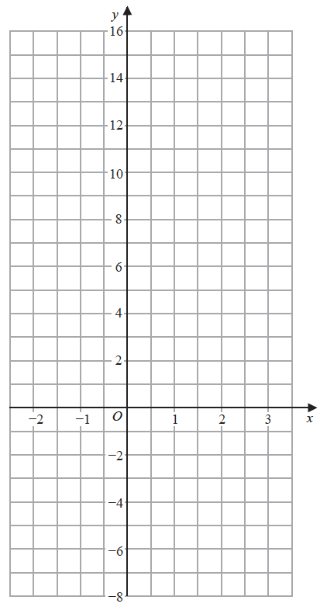

**(Total for Question 18 is 3 marks)**

**___________________________________________________________________________**

**19** There are 6 eggs in a small box of eggs.

There are 12 eggs in a large box of eggs.

Alex buys *g* small boxes of eggs and *h* large boxes of eggs.

He buys a total of *T* eggs.

Write down a formula for *T* in terms of *g* and *h*.

.......................................................

**(Total for Question 19 is 3 marks)**

**___________________________________________________________________________**

**20**(*a*)Write down all the factors of 9

.......................................................

**(1)**

(*b*)Find the lowest common multiple (LCM) of 15 and 70

.......................................................

**(2)**

**(Total for Question 20 is 3 marks)**

**___________________________________________________________________________**

**21**

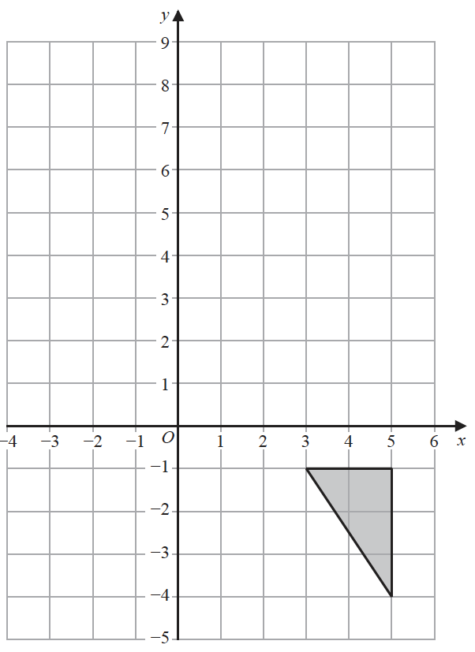

On the grid, reflect the shaded triangle in the line with equation *y* = 2

**(Total for Question 21 is 2 marks)**

**___________________________________________________________________________**

**22**(*a*) Show that 

**(2)**

(*b*) Show that 

**(Total for Question 22 is 4 marks)**

**___________________________________________________________________________**

**23** Solve 5(4 – *x*) = 7 – 3*x*

*x* = .......................................................

**(Total for Question 23 is 3 marks)**

**___________________________________________________________________________**

**24**

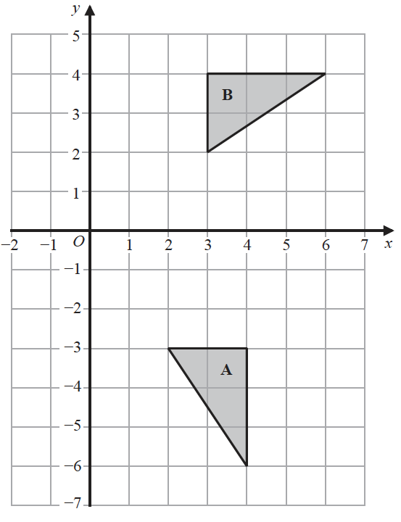

Describe fully the single transformation that maps triangle **A** onto triangle **B**.

......................................................................................................................................................

......................................................................................................................................................

......................................................................................................................................................

**(Total for Question 24 is 3 marks)**

**___________________________________________________________________________**

**25**Solve the inequality 4*x* + 7 > 2s

.......................................................

**(Total for Question 25 is 2 marks)**

**___________________________________________________________________________**

**26** Solve the simultaneous equations

4*x* + 3*y* = 17

*x* + 2*y* = 5

Show clear algebraic working.

*x* = .......................................................

*y* = .......................................................

**(Total for Question 26 is 3 marks)**

**___________________________________________________________________________**

**27** Make *y* the subject of the formula *c* = 5*y* – *h*

.......................................................

**(Total for Question 27 is 2 marks)**

**___________________________________________________________________________**

**28** Factorise fully 16*m*3*g*3 + 24*m*2*g*5

.......................................................

**(Total for Question 28 is 2 marks)**

**___________________________________________________________________________**

**29**(*a*)Simplify *g*6 × *g*4

......................................................

**(1)**

(*b*)Simplify (3*cd*4)2

.......................................................

**(2)**

**(Total for Question 29 is 3 marks)**

**___________________________________________________________________________**

**30**(*a*) Factorise *y*2 – 2*y* – 48

.......................................................

**(2)**

(*b*) Hence solve *y*2 – 2*y* – 48 = 0

.......................................................

**(1)**

**(Total for Question 30 is 3 marks)**

**TOTAL FOR PAPER IS 80 MARKS**

**BLANK PAGE**