**Speed Distance Time**

**Instructions**

* Use **black** ink or ball-point pen.
  + **Fill in the boxes** at the top of this page with your name,  
    centre number and candidate number.
* Answer **all** questions.
* Answer the questions in the spaces provided  
  *– there may be more space than you need.*
* You must **show all your working.**
* Diagrams are **NOT** accurately drawn, unless otherwise indicated.
* If your calculator does not have a *π* button, take the value of *π* to be3.142

unless the question instructs otherwise.

**Information**

* The total mark for this paper is **60**. There are **16** questions.
* Questions have been arranged in an ascending order of mean difficulty, as found by all students in the June 2017–November 2019 examinations.
* The marks for **each** question are shown in brackets  
  *– use this as a guide as to how much time to spend on each question.*

**Advice**

1. Read each question carefully before you start to answer it.
2. Keep an eye on the time.
3. Try to answer every question.
4. Check your answers if you have time at the end.

**1** Emily drives 186 miles in 3 hours.

(*a*)What is her average speed?

...................................................... mph

(**2**)

Sarah drives at an average speed of 58 mph for 4 hours.

(*b*)How many miles does Sarah drive?

...................................................... miles

(**2**)

(**Total for Question 1 is 4 marks**)

___________________________________________________________________________

**2** Here is the gauge for the fuel tank of a car.

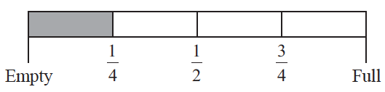

The fuel tank holds 52 litres of fuel when the tank is full.

The tank is  full of fuel.

Work out how many more litres of fuel are needed to fill the tank.

Emily drives 186 miles in 3 hours.

....................................................... litres

**(Total for Question 2 is 3 marks)**

**___________________________________________________________________________**

**3** Here is part of a train timetable.

|  |  |  |  |
| --- | --- | --- | --- |
| **Brighton** | 07 22 | 07 29 | 07 32 |
| **London** | 09 00 | 08 32 | 08 48 |

Graham gets to the station in Brighton at 07 15

(*a*)Work out how many minutes he has to wait until 07 22

....................................................... minutes

**(1)**

(*b*)Work out how long it will take the 07 22 train to get to London.

.......................................................................................

**(2)**

**(Total for Question 3 is 3 marks)**

**___________________________________________________________________________**

**4** This is part of a bus timetable between Bury and Manchester.

|  |  |  |  |  |  |  |
| --- | --- | --- | --- | --- | --- | --- |
| **Bury** | 08 25 | 08 55 | 09 15 | 09 30 | 09 45 | 10 05 |
| Whitefield | 08 34 | 09 04 | 09 24 | 09 39 | 09 54 | 10 14 |
| Heaton Park | 08 46 | 09 16 | 09 36 | 09 51 | 10 06 | 10 27 |
| Cheetham | 08 56 | 09 26 | 09 46 | 10 01 | 10 16 | 10 37 |
| **Manchester** | 09 05 | 09 35 | 09 55 | 10 10 | 10 25 | 10 48 |

(*a*)How many minutes should the 08 25 bus take to go from Bury to Manchester?

....................................................... minutes

(**1**)

Daniel goes from Whitefield to Manchester by bus.

Daniel takes 17 minutes to get from his house to the bus stop in Whitefield.

He takes 15 minutes to get from the bus stop in Manchester to work.

Daniel has to get to work by 10 am.

He leaves his house at 8.45 am.

(*b*)Does Daniel get to work by 10 am?

You must show all your working.

(**3**)

(**Total for Question 4 is 4 marks**)

**___________________________________________________________________________**

**5** Here is part of a train timetable from Lostock to Preston.

|  |  |  |  |  |  |
| --- | --- | --- | --- | --- | --- |
| Lostock | 07 46 | 08 16 |  | 08 46 | 08 57 |
| Horwich | 07 50 | 08 20 | 08 39 | 08 50 | 09 01 |
| Blackrod | 07 53 |  |  | 08 53 |  |
| Adlington | 07 57 | 08 25 |  | 08 57 |  |
| Chorley | 08 02 | 08 30 | 08 47 | 09 02 | 09 09 |
| Buckshaw | 08 06 | 08 33 |  | 09 05 |  |
| Leyland | 08 15 | 08 40 |  | 09 12 |  |
| Preston | 08 20 | 08 49 | 08 59 | 09 17 | 09 22 |

(*a*) How long should the 07 46 train take to go from Lostock to Buckshaw?

....................................................... minutes

**(1)**

Ariz wants to go from Horwich to Leyland by train.

He gets to the station at Horwich at 08 30.

(*b*) What is the earliest time he can get to Leyland?

.......................................................

**(1)**

Mike wants to go from Blackrod to Preston by train.

He needs to get to Preston by 09 25.

(*c*)What is the latest train he can get from Blackrod?

.......................................................

**(1)**

**(Total for Question 5 is 3 marks)**

**___________________________________________________________________________**

**6** Ruth left her home at 9 am and walked to the library.

She got to the library at 10 30 am.

Ruth walked at a speed of 4 mph.

(*a*)Work out the distance Ruth walked.

....................................................... miles

**(2)**

Ruth got to the library at 10 30 am.

She stayed at the library for 50 minutes.

Then she walked home.

Ruth took 1 hours to walk home.

(*b*)At what time did Ruth get home?

.......................................................

**(2)**

**(Total for Question 6 is 4 marks)**

**___________________________________________________________________________**

**7** In October Sally drove 560 miles in her car.

The car travelled 34.5 miles for each gallon of petrol used.

Petrol cost £1.08 per litre.

1 gallon = 4.55 litres.

Work out the cost of the petrol the car used in October.

£.......................................................

**(Total for Question 7 is 4 marks)**

**___________________________________________________________________________**

**8** Nimer was driving to a hotel.

He looked at his Sat Nav at 13 30

|  |  |
| --- | --- |
| Time | 13 30 |
| Distance to destination | 65 miles |

Nimer arrived at the hotel at 14 48

Work out the average speed of the car from 13 30 to 14 48

You must show all your working.

.......................................................mph

**(Total for Question 8 is 4 marks)**

**___________________________________________________________________________**

**9** Chrissy drew this graph to show the percentage of buses that got to a bus stop on time

for six months.



(*a*)Write down **one** thing that is wrong with the graph.

......................................................................................................................................................

.....................................................................................................................................................

**(1)**

(*b*)Describe the trend in the percentage of buses that got to the bus stop on time.

......................................................................................................................................................

**(1)**

**(Total for Question 9 is 2 marks)**

**___________________________________________________________________________**

**10** Steve drove from his home to his friend’s house.

He stayed at his friend’s house and then drove home.

Here is Steve’s travel graph.

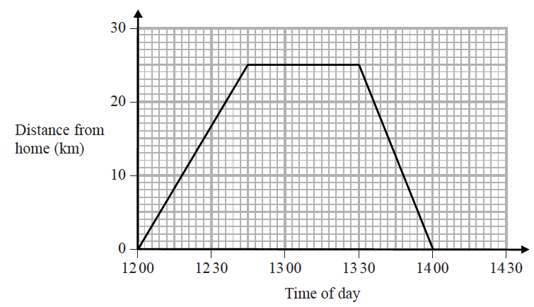

(*a*)For how many minutes did Steve stay at his friend’s house?

....................................................... minutes

**(1)**

(*b*)What was Steve’s average speed on his journey home?

....................................................... km/h

**(2)**

**(Total for Question 10 is 3 marks)**

**___________________________________________________________________________**

**11** Arshad delivers parcels on his bike.

He starts from his home.

Here is the travel graph for the first 40 minutes of Arshad’s journey.



(a) What time did Arshad start his journey?

.........................................

**(1)**

Arshad had to stop to deliver each parcel.

(b) How long, in minutes, did his first stop take?

......................................... minutes

**(1)**

(c) What is the distance between the two stops shown on the travel graph?

......................................... km

**(2)**

At 1340, Arshad stopped for 10 minutes to deliver his last parcel.

He then cycled home at a steady speed.

Arshad got home at 1415

(d) Complete the travel graph to show this information.

**(2)**

**(Total for Question 11 is 6 marks)**

**___________________________________________________________________________**

**12** Olly drove 56 km from Liverpool to Manchester.

He then drove 61 km from Manchester to Sheffield.

Olly’s average speed from Liverpool to Manchester was 70 km/h.

Olly took 75 minutes to drive from Manchester to Sheffield.

(*a*)Work out Olly’s average speed for his total drive from Liverpool to Sheffield.

...................................................... km/h

**(4)**

Janie drove from Barnsley to York.

Janie’s average speed from Barnsley to Leeds was 80 km/h.

Her average speed from Leeds to York was 60 km/h.

Janie says that the average speed from Barnsley to York can be found by working out the

mean of 80 km/h and 60 km/h.

(*b*)If Janie is correct, what does this tell you about the two parts of Janie’s journey?

......................................................................................................................................................

......................................................................................................................................................

**(1)**

**(Total for Question 12 is 5 marks)**

**___________________________________________________________________________**

**13** A plane travels at a speed of 213 miles per hour.

(*a*)Work out an estimate for the number of seconds the plane takes to travel 1 mile.

...................................................... seconds

**(3)**

(*b*)Is your answer to part (*a*)an underestimate or an overestimate?

Give a reason for your answer.

......................................................................................................................................................

......................................................................................................................................................

**(1)**

**(Total for Question 13 is 4 marks)**

**___________________________________________________________________________**

**14** On Monday, Tarek travelled by train from Manchester to London.

Tarek’s train left Manchester at 08 35

It got to London at 11 05

The train travelled at an average speed of 110 miles per hour.

On Wednesday, Gill travelled by train from Manchester to London.

Gill’s train also left at 08 35 but was diverted.

The train had to travel an extra 37 miles.

The train got to London at 11 35

Work out the difference between the average speed of Tarek’s train and the average speed

of Gill’s train.

......................................... miles per hour

**(Total for Question 14 is 4 marks)**

**___________________________________________________________________________**

**15** Buses to Ashby leave a bus station every 24 minutes.

Buses to Barford leave the same bus station every 20 minutes.

A bus to Ashby and a bus to Barford both leave the bus station at 7 30 am.

When will a bus to Ashby and a bus to Barford next leave the bus station at the same time?

.......................................................

**(Total for Question 15 is 3 marks)**

**___________________________________________________________________________**

**16** The distance from the Earth to the Sun is 1.496 × 1011 metres.

The speed of light is 3 × 108 metres per second.

(a) Show that, correct to 3 significant figures, light will take 0.139 hours to travel from the Sun to the Earth.

**(3)**

1 googol is 1 × 10100

Danesh says,

When I multiply 1.496 × 1011 by 6.68 × 109

I get nearly 1 googol because 1.496 × 1011 × 6.68 × 109 = 9.99 × 1099

Is Danesh correct?

(b) Give a reason for your answer.

......................................................................................................................................................

......................................................................................................................................................

**(1)**

**(Total for Question 16 is 4 marks)**

**___________________________________________________________________________**

**TOTAL MARKS FOR PAPER: 60**