**GCSE Mathematics**

**Practice Tests: Set 7**

**Paper 1F (Non-calculator)**

**Time: 1 hour 30 minutes**

You should have: Ruler graduated in centimetres and millimetres, protractor, pair of compasses, pen, HB pencil, eraser. Tracing paper may be used.

**Instructions**

* Use **black** ink or ball-point pen.
* **Fill in the boxes** at the top of this page with your name,  
  centre number and candidate number.
* Answer **all** questions.
* Answer the questions in the spaces provided

– *there may be more space than you need*.

* **Calculators must not be used.**
* Diagrams are NOT accurately drawn, unless otherwise indicated.
* You must **show all your working out.**

**Information**

* The total mark for this paper is 80
* The marks for **each** question are shown in brackets  
  – *use this as a guide as to how much time to spend on each question*.

**Advice**

* Read each question carefully before you start to answer it.
* Keep an eye on the time.
* Try to answer every question.
* Check your answers if you have time at the end.

**Answer ALL questions.**

**Write your answers in the spaces provided.**

**You must write down all the stages in your working.**

**1.** (a) Write the following numbers in order of size.

Start with the smallest number.

|  |  |  |  |  |
| --- | --- | --- | --- | --- |
| −8 | 10 | −12 | 5 | 2 |

.......................................................................................................................................

**(1)**

(*b*) Write the following numbers in order of size.

Start with the smallest number.

|  |  |  |  |
| --- | --- | --- | --- |
| 1.085 | 1.58 | 1.805 | 1.508 |

.......................................................................................................................................

**(1)**

**(Total for Question 1 is 2 marks)**

**___________________________________________________________________________**

**2.** Write 27% as a fraction in its simplest form.

.......................................................

**(Total for Question 2 is 1 mark)**

**___________________________________________________________________________**

**3.** Write 2589 correct to the nearest 100

.......................................................

**(Total for Question 3 is 1 mark)**

**___________________________________________________________________________**

**4.** In the space below, draw a parallelogram.

**(Total for Question 4 is 1 mark)**

**___________________________________________________________________________**

**5.** Find the number that is exactly half way between –6 and 8

.......................................................

**(Total for Question 5 is 2 marks)**

**___________________________________________________________________________**

**6.** How many minutes are there in 4 hours?

.......................................................

**(Total for Question 6 is 2 marks)**

**___________________________________________________________________________**

**7.** 60 people each took a driving test one day.

The ratio of men to women was 1:2.

of the 60 people failed their test.

17 of the men passed their test.

(a) Use this information to complete the frequency tree.



**(3)**

(b) Find the probability that a man failed his driving test on this day.

.......................................................

**(2)**

**(Total for Question 7 is 5 marks)**

**___________________________________________________________________________**

**8.** The water in a fish tank is treated by using 5 millilitres of AquaGuard for every 10 litres of water in the tank.

(a) Write down the ratio of the volume of AquaGuard used to the volume of water in the tank.

Give your answer in the form 1 : *n*

1 : .........................................

**(2)**

A tank contains 96 litres of water.

(b) Work out the volume of AquaGuard that should be used.

Give your answer in millilitres.

......................................... millilitres

**(2)**

**(Total for Question 8 is 4 marks)**

**___________________________________________________________________________**

**9.** In a school, there are 320 girls and 500 boys.

(a) Write down the ratio of the number of girls to the number of boys.

Give your ratio in its simplest form.

.........................................

**(2)**

In a different school, there is a total of 640 children.

In this school, the ratio of the number of girls to the number of boys is 7 : 9

(b) How many boys are there in this school?

.........................................

**(2)**

**(Total for Question 9 is 4 marks)**

**___________________________________________________________________________**

**10.** There are 60 students at a college.

20 students study both French and Spanish.

13 students study French but not Spanish.

A total of 43 students study Spanish.

(a)Complete the Venn diagram for this information.



**(3)**

One of the students at the college is to be selected at random.

(b)Write down the probability that this student studies neither French nor Spanish.

.......................................................

**(1)**

**(Total for Question 10 is 4 marks)**

**___________________________________________________________________________**

**11.** (i) Measure the length of PQ.

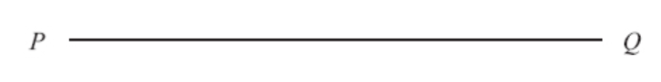

PQ = ………………………….cm

**(1)**

(ii) Mark with a cross (×) the midpoint of the line PQ.

**(1)**

(iii) Draw a line perpendicular to the line PQ that passes through point P.

**(1)**

**(Total for Question 11 is 3 marks)**

**___________________________________________________________________________**

**12.** Beatrice has some books.   
Caroline has two times as many books as Beatrice.   
Dolly has seven more books than Caroline.

They have a total of 57 books.

Dolly says,

“If I give some books to Beatrice, each of us will have the same number of books.”

Is Dolly correct?   
You must show how you get your answer.

.........................................

**(Total for Question 12 is 3 marks)**

**___________________________________________________________________________**

**13.** The diagram shows a rectangular wall.



Fiona is going to cover the wall with rectangular tiles.

Each tile is 60 cm by 30 cm.

 of the tiles will be white.

Some of the tiles will be green.

The rest of the tiles will be blue.

The ratio of the number of green tiles to the number of blue tiles will be 1 : 3

(a)Assuming there are no gaps between the tiles, how many tiles of each colour will Fiona need?

white tiles .........................................

green tiles .........................................

blue tiles .........................................

**(5)**

Fiona is told that she should leave gaps between the tiles.

(b)If Fiona leaves gaps between the tiles, how could this affect the number of tiles she needs?

......................................................................................................................................................

......................................................................................................................................................

**(1)**

**(Total for Question 13 is 6 marks)**

**___________________________________________________________________________**

**14.**

**

Phone calls cost £ *y* for *x* minutes.

The graph gives the values of *y* for values of *x* from 0 to 5

(a) (i) Give an interpretation of the intercept of the graph on the *y*-axis.

......................................................................................................................................................

......................................................................................................................................................

(ii) Give an interpretation of the gradient of the graph.

......................................................................................................................................................

......................................................................................................................................................

**(2)**

(b)Find the equation of the straight line in the form *y* = *m x* + *c*

..................................................................................

**(3)**

**(Total for Question 14 is 5 marks)**

**___________________________________________________________________________**

**15.** *ABCDE* is a pentagon.

**

Work out the area of *ABCDE*.

......................................... cm2

**(Total for Question 15 is 5 marks)**

**___________________________________________________________________________**

**16.** The pie chart shows information about the types of fish Simon caught on Saturday.

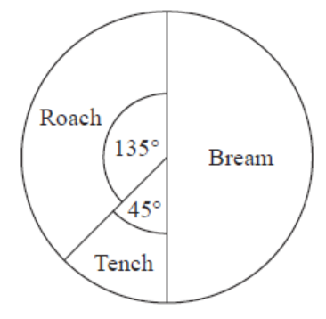

Simon caught 2 tench.

(a)  Work out the total number of fish Simon caught.

...........................................................

**(2)**

This pie chart shows information about the types of fish Asif caught on Saturday.

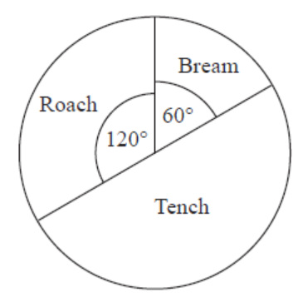

Debbie says,

“The pie charts show that Simon caught more roach than Asif caught on Saturday.”

(b)  Is Debbie correct?   
Explain your answer.

...............................................................................................................................................

...............................................................................................................................................

**(1)**

**(Total for Question 16 is 3 marks)**

**___________________________________________________________________________**

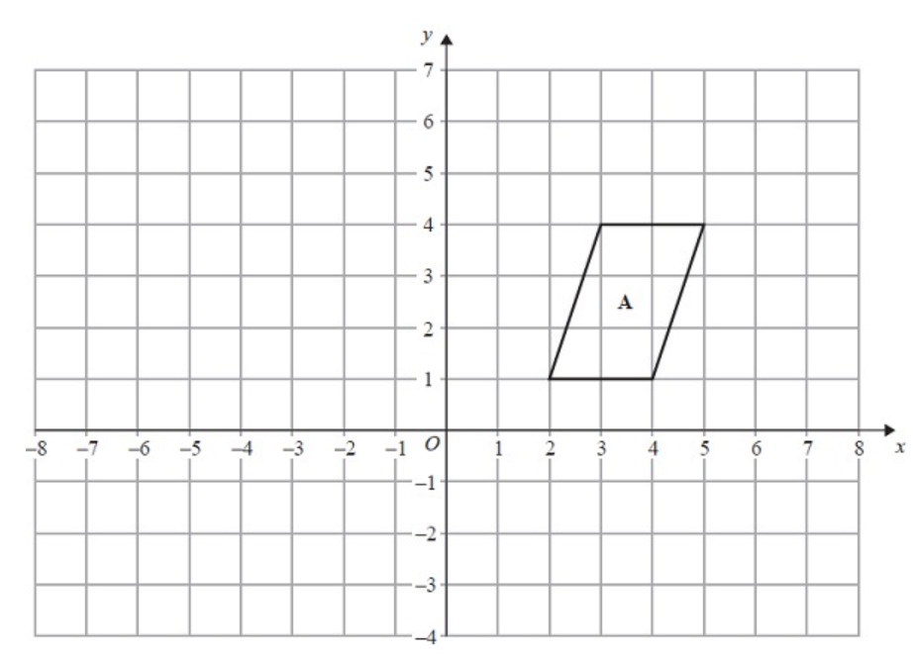**17.**

Translate shape **A** by the vector .

**(Total for Question 17 is 1 mark)**

**___________________________________________________________________________**

**18.** Solve 2.5 = 

*x* = .......................................................

**(Total for Question 18 is 1 mark)**

**___________________________________________________________________________**

**19.** The size of the largest angle in a triangle is 5 times the size of the smallest angle.   
The other angle is 29° less than the largest angle.

Work out, in degrees, the size of each angle in the triangle.   
You must show your working.

......................... ° , ......................... ° , .........................°

**(Total for Question 19 is 5 marks)**

**___________________________________________________________________________**

**20.** (*a*) Simplify, leaving your answers in index form,

(i) 78 × 73 × 7

................................

(ii) (47)2

................................

**(2)**

(*b*)  = 54

Find the value of *n*.

*n* = ................................

**(2)**

**(Total for Question 20 is 4 marks)**

**___________________________________________________________________________**

**21.** Find the highest common factor (HCF) of 147, 42 and 252

.............................................................................................

**(Total for Question 21 is 2 marks)**

**___________________________________________________________________________**

**22.** The total weight of 3 identical video games is 525 g.

Work out the total weight of 5 of these video games.

....................... g

**(Total for Question 22 is 2 marks)**

**___________________________________________________________________________**

**23.** The perimeter of a triangle is 90 cm.

The lengths of the sides of the triangle are in the ratios 3 : 5 : 7

Work out the length of the longest side of the triangle.

.................................... cm

**(Total for Question 23 is 3 marks)**

**___________________________________________________________________________**

**24.** There are

*x* stamps in a small packet

(*x* + 3) stamps in a medium packet

and (*x* + 4) stamps in a large packet

The total number of stamps in the three packets is *N*.

(i) Write down an equation for *N* in terms of *x*.

Give your equation in its simplest form.

.......................................................

**(2)**

There is a total of 61 stamps.

(ii) Work out the number of stamps in the medium packet.

.......................................................

**(3)**

**(Total for Question 24 is 5 marks)**

**___________________________________________________________________________**

**25.** (a) Write 75 000 in standard form.

.......................................................

**(1)**

A computer can carry out a simple calculation in 1 picosecond where

1 picosecond = 10–12 seconds.

(b) Write down in standard form the time, in seconds, for this computer to carry out 75 000 simple calculations.

....................................................... seconds

**(2)**

**(Total for Question 25 is 3 marks)**

**___________________________________________________________________________**

**26.** Write 420 as a product of its prime factors.

...............................................................................................

**(Total for Question 26 is 3 marks)**

**TOTAL FOR PAPER: 80 MARKS**