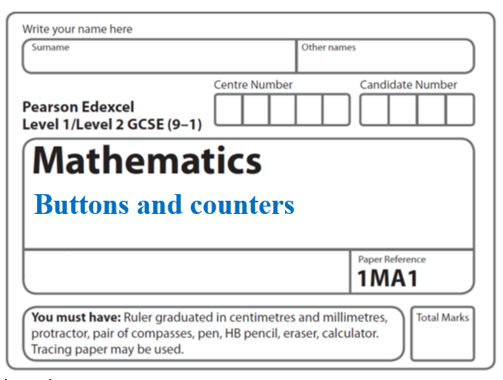**Instructions**

* Use **black** ink or ball-point pen.
  + **Fill in the boxes** at the top of this page with your name,  
    centre number and candidate number.
* Answer **all** questions.
* Answer the questions in the spaces provided  
  *– there may be more space than you need.*
* You must **show all your working.**
* Diagrams are **NOT** accurately drawn, unless otherwise indicated.
* If your calculator does not have a *π* button, take the value of *π* to be3.142

unless the question instructs otherwise.

**Information**

* The total mark for this paper is **26**. There are **7** questions.
* Questions have been arranged in an ascending order of mean difficulty, as found by all students in the June 2017–November 2019 examinations.
* The marks for **each** question are shown in brackets  
  *– use this as a guide as to how much time to spend on each question.*

**Advice**

* Read each question carefully before you start to answer it.
* Keep an eye on the time.
* Try to answer every question.
* Check your answers if you have time at the end.

**1** There are 9 counters in a bag.

7 of the counters are green.

2 of the counters are blue.

Ria takes at random two counters from the bag.

Work out the probability that Ria takes one counter of each colour.

You must show your working.

.......................................................

**(Total for Question 1 is 4 marks)**

**___________________________________________________________________________**

**2** There are only red counters, blue counters and purple counters in a bag.

The ratio of the number of red counters to the number of blue counters is 3 : 17

Sam takes at random a counter from the bag.

The probability that the counter is purple is 0.2

Work out the probability that Sam takes a red counter.

.......................................................

(**Total for Question 2 is 3 marks**)

**___________________________________________________________________________**

**3** There are some counters in a bag.

The counters are red or white or blue or yellow.

Bob is going to take at random a counter from the bag.

The table shows each of the probabilities that the counter will be blue or will be yellow.

|  |  |  |  |  |
| --- | --- | --- | --- | --- |
| **Colour** | red | white | blue | yellow |
| **Probability** |  |  | 0.45 | 0.25 |

There are 18 blue counters in the bag.

The probability that the counter Bob takes will be red is twice the probability that the

counter will be white.

(*a*)Work out the number of red counters in the bag.

.......................................................

(**4**)

A marble is going to be taken at random from a box of marbles.

The probability that the marble will be silver is 0.5.

There must be an even number of marbles in the box.

(*b*)Explain why.

......................................................................................................................................................

......................................................................................................................................................

(**1**)

(**Total for Question 3 is 5 marks**)

**___________________________________________________________________________**

**4** There are only red counters and blue counters in a bag.

Joe takes at random a counter from the bag.

The probability that the counter is red is 0.65

Joe puts the counter back into the bag.

Mary takes at random a counter from the bag.

She puts the counter back into the bag.

(*a*)What is the probability that Joe and Mary take counters of different colours?

..............................................................

**(2)**

There are 78 red counters in the bag.

(*b*)How many blue counters are there in the bag?

..............................................................

**(2)**

**(Total for Question 4 is 4 marks)**

**___________________________________________________________________________**

**5** There are *p* counters in a bag.

12 of the counters are yellow.

Shafiq takes at random 30 counters from the bag.

5 of these 30 counters are yellow.

Work out an estimate for the value of *p*.

.......................................................

**(Total for Question 5 is 2 marks)**

**___________________________________________________________________________**

**6** There are only blue counters, yellow counters, green counters and red counters in a bag.

A counter is taken at random from the bag.

The table shows the probabilities of getting a blue counter or a yellow counter or a green counter.

|  |  |  |  |  |
| --- | --- | --- | --- | --- |
| **Colour** | blue | yellow | green | red |
| **Probability** | 0.2 | 0.35 | 0.4 |  |

(*a*)Work out the probability of getting a red counter.

......................................................

**(1)**

(*b*)What is the least possible number of counters in the bag?

You must give a reason for your answer.

............................................................................................................................................................................................................................................................................................................

**(2)**

**(Total for Question 6 is 3 marks)**

**___________________________________________________________________________**

**7** There are only *r* red counters and *g* green counters in a bag.

A counter is taken at random from the bag.

The probability that the counter is green is 

The counter is put back in the bag.

2 more red counters and 3 more green counters are put in the bag.

A counter is taken at random from the bag.

The probability that the counter is green is 

Find the number of red counters and the number of green counters that were in the bag originally.

red counters.......................................................

green counters.......................................................

**(Total for Question 7 is 5 marks)**

**TOTAL MARKS FOR PAPER: 26**