**Expand and factorise, and solve Quadratics**

**Foundation Tier**

**Instructions**

* Use **black** ink or ball-point pen.
  + **Fill in the boxes** at the top of this page with your name,  
    centre number and candidate number.
* Answer **all** questions.
* Answer the questions in the spaces provided  
  *– there may be more space than you need.*
* You must **show all your working.**
* Diagrams are **NOT** accurately drawn, unless otherwise indicated.
* If your calculator does not have a *π* button, take the value of *π* to be3.142

unless the question instructs otherwise.

**Information**

* The total mark for this paper is **52**. There are **19** questions.
* Questions have been arranged in an ascending order of mean difficulty, as found by all students in the June 2017–November 2019 examinations.
* The marks for **each** question are shown in brackets  
  *– use this as a guide as to how much time to spend on each question.*

**Advice**

1. Read each question carefully before you start to answer it.
2. Keep an eye on the time.
3. Try to answer every question.
4. Check your answers if you have time at the end.

**1** (*a*)Expand 5(2*m* – 3)

.......................................................

**(1)**

(*b*)Factorise 3*n* + 12

.......................................................

**(1)**

**(Total for Question 1 is 2 marks)**

**___________________________________________________________________________**

**2** Expand 4*e*(*e* + 2)

.......................................................

(**Total for Question 2 is 2 marks**)

**___________________________________________________________________________**

**3** (*a*)Factorise 4*m* + 12

.......................................................

**(1)**

|  |  |  |  |
| --- | --- | --- | --- |
| expression | equation | formula | identity |
| inequality | term | factor | multiple |

(*b*)Choose two words from the box above to make this statement correct.

5*y* is a ...................................................... in the ...................................................... 3*x* + 5*y*

**(2)**

**(Total for Question 3 is 3 marks)**

**___________________________________________________________________________**

**4** Factorise fully 9*b* – 3*b*2

.......................................................

**(Total for Question 4 is 2 marks)**

**___________________________________________________________________________**

**5** *x* – 1 = 2

Work out the value of 2*x*2

.......................................................

**(Total for Question 5 is 3 marks)**

**___________________________________________________________________________**

**6** (*a*)Expand and simplify (*x* + 5)(*x* – 9)

.......................................................

**(2)**

(*b*)Factorise fully 9*x*2 + 6*x*

.......................................................

**(2)**

**(Total for Question 6 is 4 marks)**

**___________________________________________________________________________**

**7** Expand and simplify 5(*p* + 3) – 2(1 – 2*p*)

.......................................................

(**Total for Question 7 is 2 marks**)

**___________________________________________________________________________**

**8** (*a*)Factorise 5 – 10*m*

......................................................

**(1)**

(*b*)Factorise fully 2*a*2*b* + 6*ab*2

......................................................

**(2)**

**(Total for Question 8 is 3 marks)**

**___________________________________________________________________________**

**9** (*a*)Complete the table of values for *y* = *x*2 – *x* – 6

|  |  |  |  |  |  |  |  |
| --- | --- | --- | --- | --- | --- | --- | --- |
| *x* | –3 | –2 | –1 | 0 | 1 | 2 | 3 |
| *y* | 6 |  |  | – 6 |  |  |  |

(**2**)

(*b*)On the grid, draw the graph of *y* = *x*2 – *x* – 6 for values of *x* from –3 to 3.

(**2**)



(*c*)Use your graph to find estimates of the solutions to the equation *x*2 – *x* – 6 = –2

.................................................................................

(**2**)

**(Total for Question 9 is 6 marks)**



**10** Expand 6(2*m* −3)

.........................................

**(Total for Question 10 is 1 marks)**

**___________________________________________________________________________**

**11** Expand 2*x*(3 – *x*)

.......................................................

**(Total for Question 11 is 1 marks)**

**12** (a) Factorise *x*2 – 169

.......................................................

**(1)**

(b) Expand and simplify (3*x* + 2)(2*x* – 1)

.......................................................

**(2)**

**(Total for Question 12 is 3 marks)**

**___________________________________________________________________________**

**13** Expand and simplify (*x* + 3)(*x* – 1)

..................................................................................

**(Total for Question 13 is 2 marks)**



**14** Factorise *x*2 – 16

..................................................................................

**(Total for Question 14 is 1 mark)**

**___________________________________________________________________________**

**15** Factorise *x*2 + 3*x* – 4

......................................................

**(Total for Question 15 is 2 marks)**

**16** (*a*)Expand and simplify (5*x* + 2)(2*x* – 3)

...............................................................................................

**(2)**

(*b*)Factorise *x*2 + 4*x* + 3

...............................................................................................

**(2)**

**(Total for Question 16 is 4 marks)**

**___________________________________________________________________________**

**17** (*a*)Solve 2*x*2 = 72

......................................................

**(2)**

(*b*)Expand and simplify (2*x* + 1)(3*x* – 2)

......................................................

**(2)**

(*c*)Factorise *x*2 + 6*x* + 9

......................................................

**(1)**

**(Total for Question 17 is 5 marks)**

**___________________________________________________________________________**

**18** Here is the graph of *y* = *x*2 – 2*x* – 3

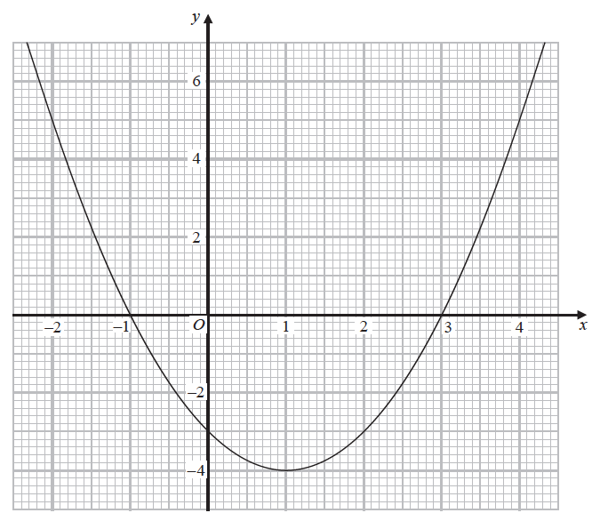

(*a*)Write down the coordinates of the turning point on the graph of *y* = *x*2 – 2*x* – 3

(....................... , .......................)

**(1)**

(*b*)Use the graph to find the roots of the equation *x*2 – 2*x* – 3 = 0

..........................................................................................

**(2)**

**(Total for Question 18 is 3 marks)**

**19** Solve *x*2 + 5*x* – 24 = 0

............................................................................................................

**(Total for Question 19 is 3 marks)**

**TOTAL MARKS FOR PAPER: 52**