****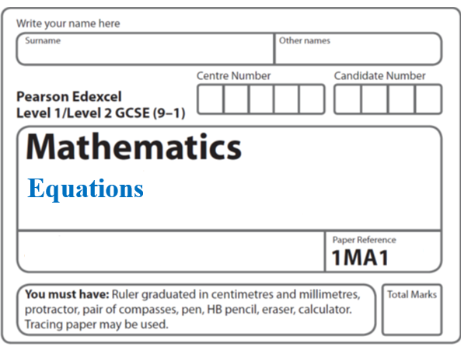**Instructions**

**Inequalities: Shaded regions**

* Use **black** ink or ball-point pen.
  + **Fill in the boxes** at the top of this page with your name,  
    centre number and candidate number.
* Answer **all** questions.
* Answer the questions in the spaces provided  
  *– there may be more space than you need.*
* You must **show all your working.**
* Diagrams are **NOT** accurately drawn, unless otherwise indicated.
* If your calculator does not have a *π* button, take the value of *π* to be3.142

unless the question instructs otherwise.

**Information**

* The total mark for this paper is **12**. There are **4** questions.
* Questions have been arranged in an ascending order of mean difficulty, as found by all students in the June 2017–November 2019 examinations.
* The marks for **each** question are shown in brackets  
  *– use this as a guide as to how much time to spend on each question.*

**Advice**

* Read each question carefully before you start to answer it.
* Keep an eye on the time.
* Try to answer every question.
* Check your answers if you have time at the end.

**1**



Write down the three inequalities that define the shaded region.

.......................................................

.......................................................

.......................................................

**(Total for Question 1 is 4 marks)**

**___________________________________________________________________________**

**2** On the grid, shade the region that satisfies all these inequalities.

*y* > 1 *x* + *y* < 5 *y* > 2*x*

Labe the region **R**.



**(Total for Question 2 is 3 marks)**

**___________________________________________________________________________**

**3** For her maths homework, Helen answered the following question.

Shade the region that is defined by all these inequalities.

*x* + *y* ≤ 6 *y* ≥ 0 *y* ≤ *x* + 2

Here is Helen’s answer.

**

Helen made some mistakes when she answered the question.

Write down two mistakes Helen made.

1....................................................................................................................................................

2....................................................................................................................................................

**(Total for Question 3 is 2 marks)**

**___________________________________________________________________________**

**4** On the grid show, by shading, the region defined by the inequalities

|  |  |  |
| --- | --- | --- |
| *x* < 4 | 2*x* + *y* > 6 | *y* > |

Label the region **R**.



**(Total for Question 4 is 3 marks)**

**TOTAL MARKS FOR PAPER: 12**