**Transformations**

**Instructions**

* Use **black** ink or ball-point pen.
  + **Fill in the boxes** at the top of this page with your name,  
    centre number and candidate number.
* Answer **all** questions.
* Answer the questions in the spaces provided  
  *– there may be more space than you need.*
* You must **show all your working.**
* Diagrams are **NOT** accurately drawn, unless otherwise indicated.
* If your calculator does not have a *π* button, take the value of *π* to be3.142

unless the question instructs otherwise.

**Information**

* The total mark for this paper is **22**. There are **10** questions.
* Questions have been arranged in an ascending order of mean difficulty, as found by all students in the June 2017–November 2019 examinations.
* The marks for **each** question are shown in brackets  
  *– use this as a guide as to how much time to spend on each question.*

**Advice**

1. Read each question carefully before you start to answer it.
2. Keep an eye on the time.
3. Try to answer every question.
4. Check your answers if you have time at the end.

**1** On the grid, reflect the shaded shape in the mirror line.



**(Total for Question 1 is 1 mark)**

**___________________________________________________________________________**

**2**



Rotate shape **A** 180° about (1, 0)

**(Total for Question 2 is 2 marks)**

**___________________________________________________________________________**

**3**

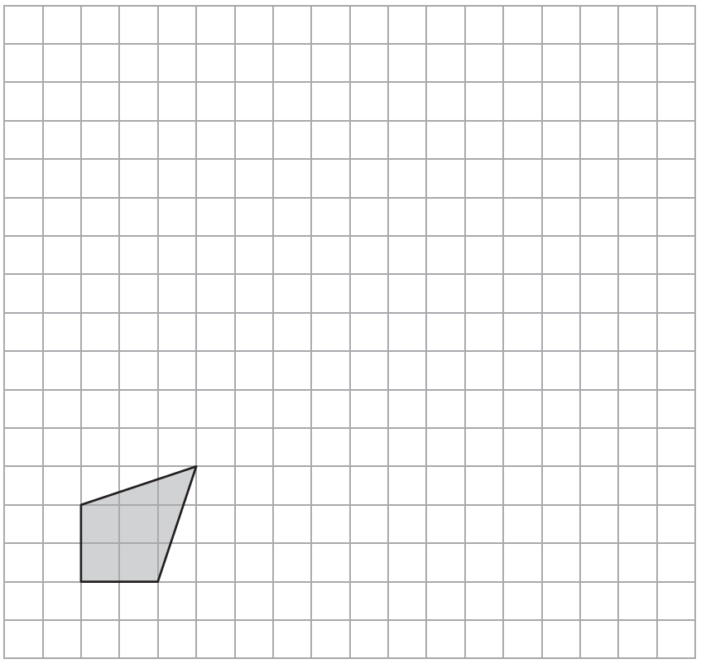

On the grid, draw an enlargement of the shaded shape with a scale factor of 3

**(Total for Question 3 is 2 marks)**

**___________________________________________________________________________**

**4**



Describe fully the single transformation that maps shape **A** onto shape **B**.

......................................................................................................................................................

**(Total for Question 4 is 2 marks)**

**___________________________________________________________________________**

**5**



Describe fully the single transformation that maps shape **A** onto shape **B**.

......................................................................................................................................................

**(Total for Question 5 is 2 marks)**

**___________________________________________________________________________**

**6**

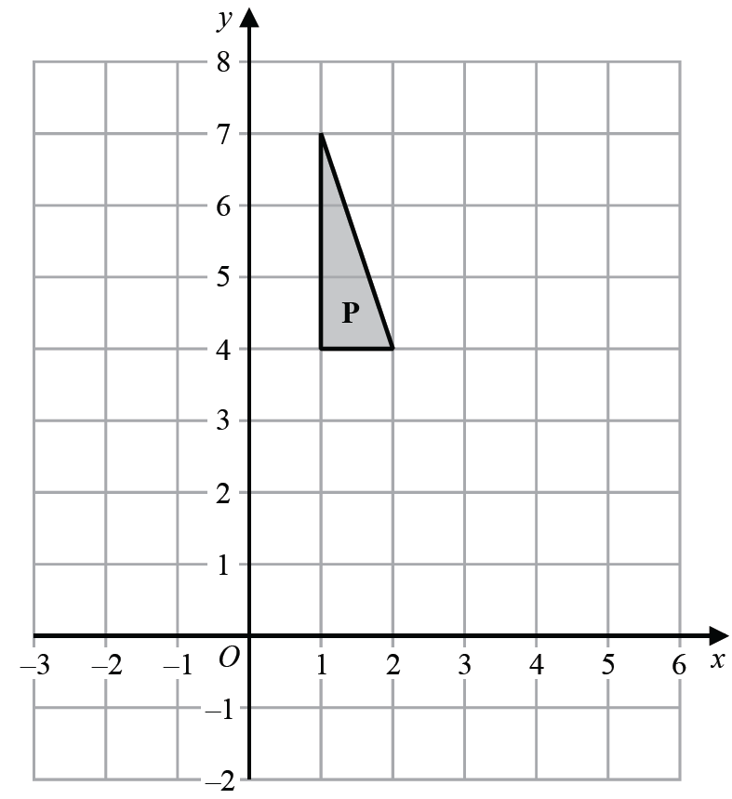

Reflect shape **P** in the line *y* = 3

**(Total for Question 6 is 2 marks)**

**___________________________________________________________________________**

**7**



Describe fully the single transformation that maps shape **A** onto shape **B**.

......................................................................................................................................................

......................................................................................................................................................

(**Total for Question 8 is 2 marks**)

**___________________________________________________________________________**

**8**



(*a*)Rotate shape **A** 90° clockwise about centre *O*.

**(2)**

(*b*)Describe fully the single transformation that maps triangle **B** onto triangle **C**.

......................................................................................................................................................

......................................................................................................................................................

**(2)**

**(Total for Question 7 is 4 marks)**

**___________________________________________________________________________**

**9**



(*a*)Rotate trapezium **T** 180° about the origin.

Label the new trapezium **A**.

**(1)**

(*b*)Translate trapezium **T** by the vector 

Label the new trapezium **B**.

**(1)**

**(Total for Question 9 is 2 marks)**

**___________________________________________________________________________**

**10**

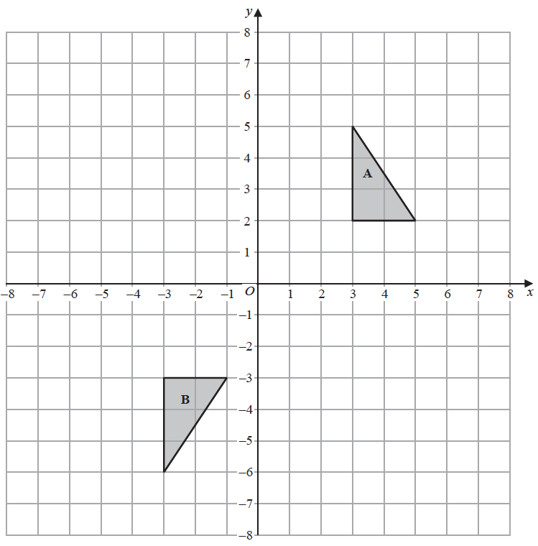

Shape **A** can be transformed to shape **B** by a reflection in the *x*-axis followed by a

translation **

Find the value of *c* and the value of *d*.

*c* = .......................................................

*d* = .......................................................

**(Total for Question 10 is 3 marks)**

**TOTAL MARKS FOR PAPER: 22**